Matabele Rebellion Grave Catalogue A-L

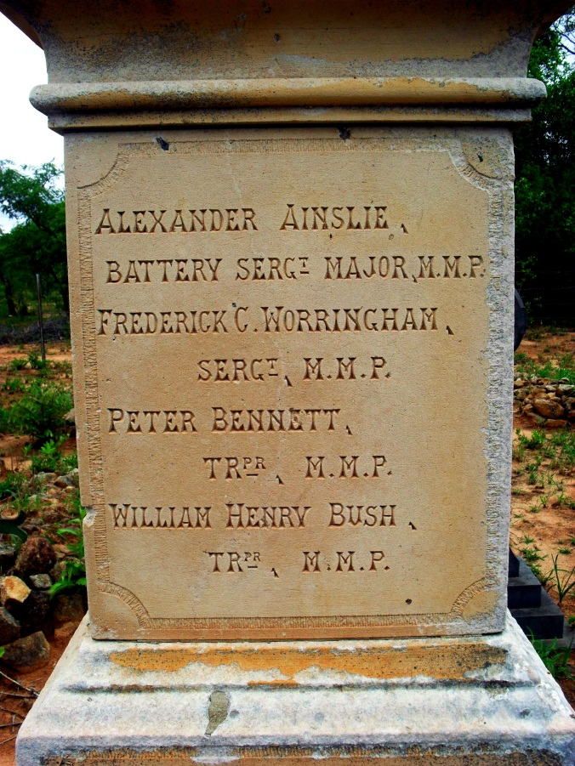
AINSLIE, Batt. Sgt Maj Alexander
Fort Umlugulu Cemetery, Matopos, Bulawayo

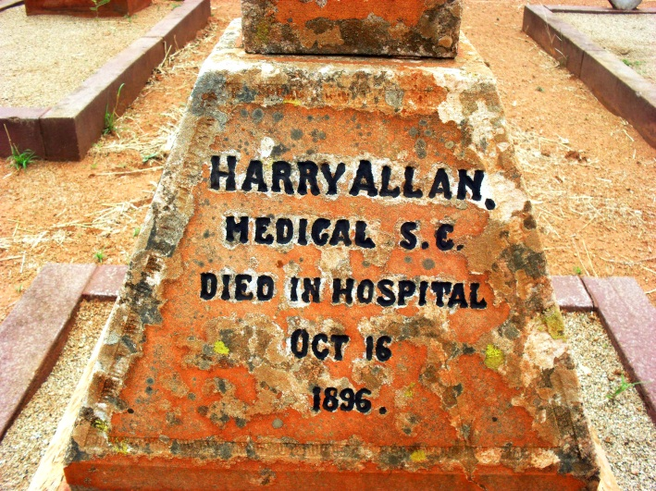

ALLAN, Harry
Bulawayo General (Pioneer) Cemetery

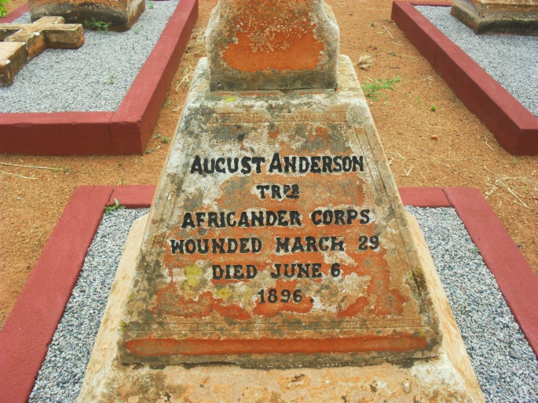

ANDERSON, Tpr August
Bulawayo General (Pioneer) Cemetery

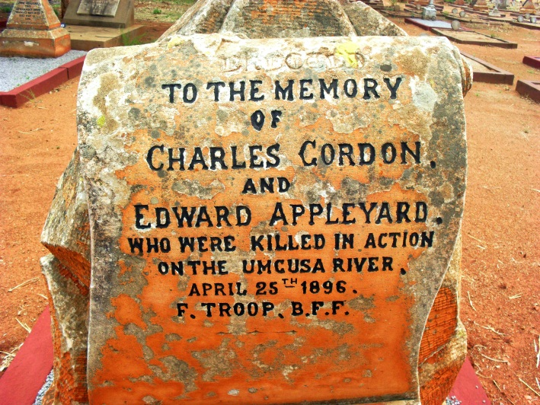
APPLEYARD, Tpr Edward
Bulawayo General (Pioneer)Cemetery

NO PIC
ARNOLD, Tpr James Carlisle
Gweru (Gwelo) Cemetery

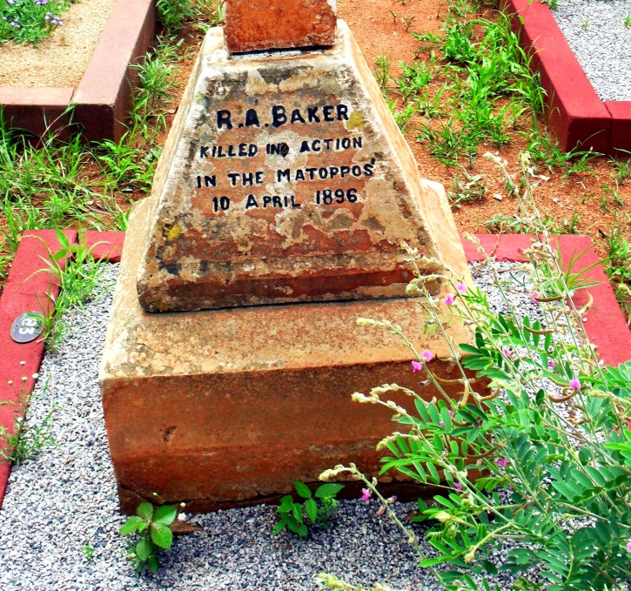
BAKER, Tpr Richard Arthur
Bulawayo General (Pioneer)Cemetery

NO PIC
L/Cpl BARNES, Christmas Watson
Chivhu (Enkeldoorn)

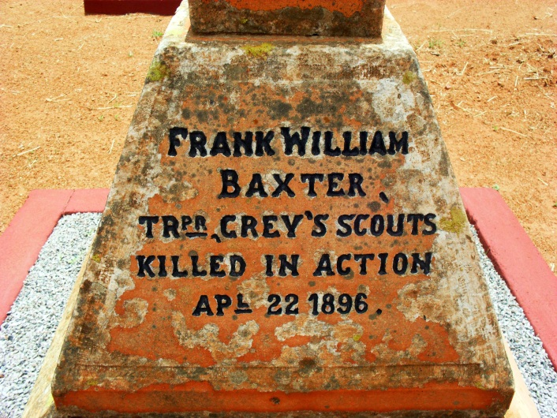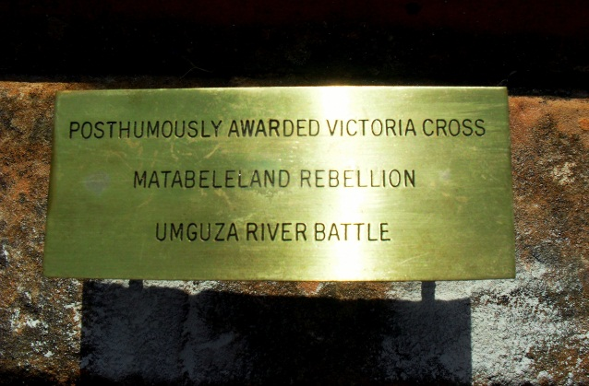
BAXTER, Tpr Frank William VC (Post)
Bulawayo General (Pioneer)Cemetery

NO PIC

BEATTY-POWNALL, Tpr William Charles
Mberengwa (Belingwe)

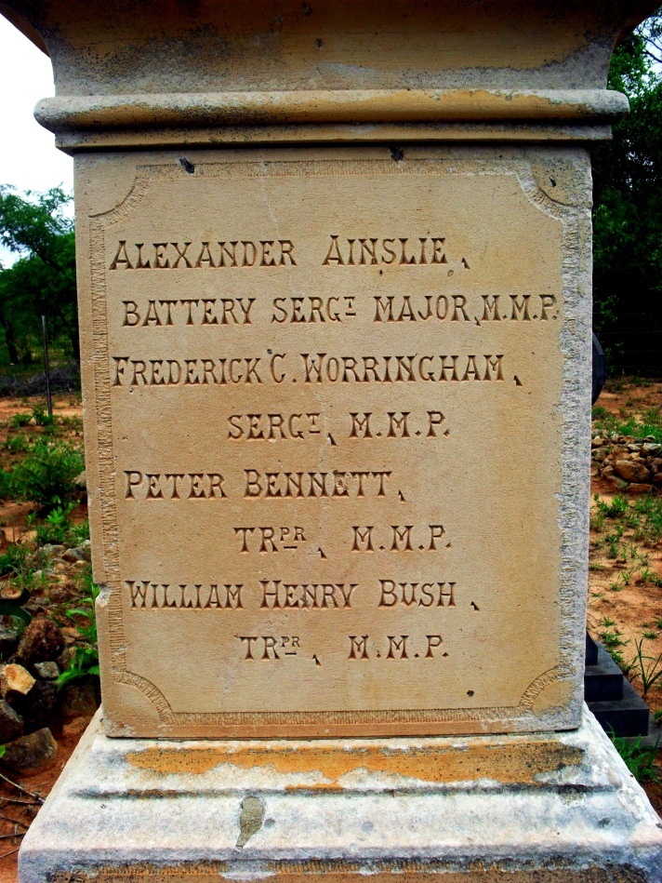

Bennett, Tpr Peter
Fort Umlugulu Cemetery, Matopos, Bulawayo
NO PIC

BERGQVIST, Tpr Gustav Robert
Mberengwa (Belingwe)

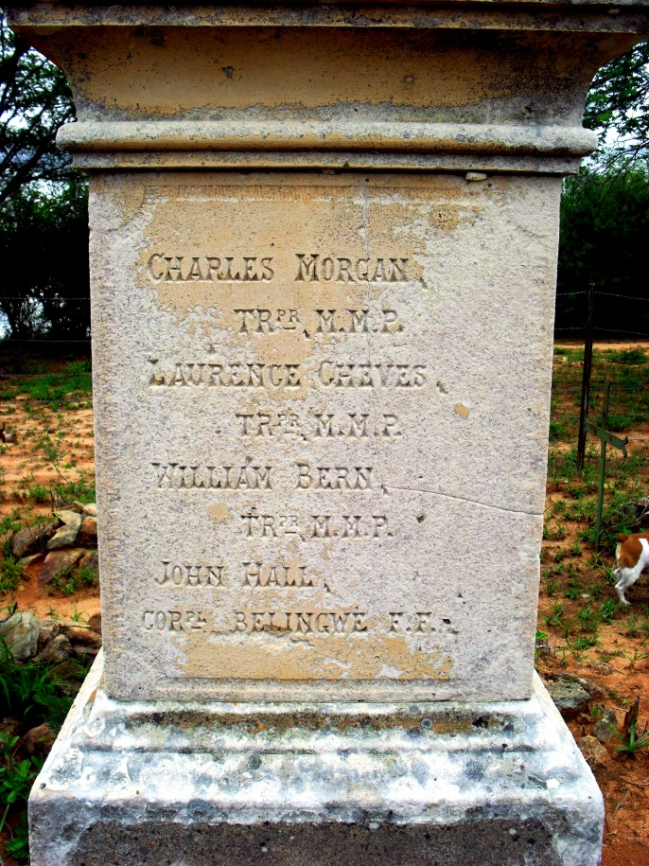

BERN, Tpr William
Fort Umlugulu Cemetery, Matopos, Bulawayo

NO PIC

BIVAND, Tpr Herbert George
Unknown burial place – Midlands?

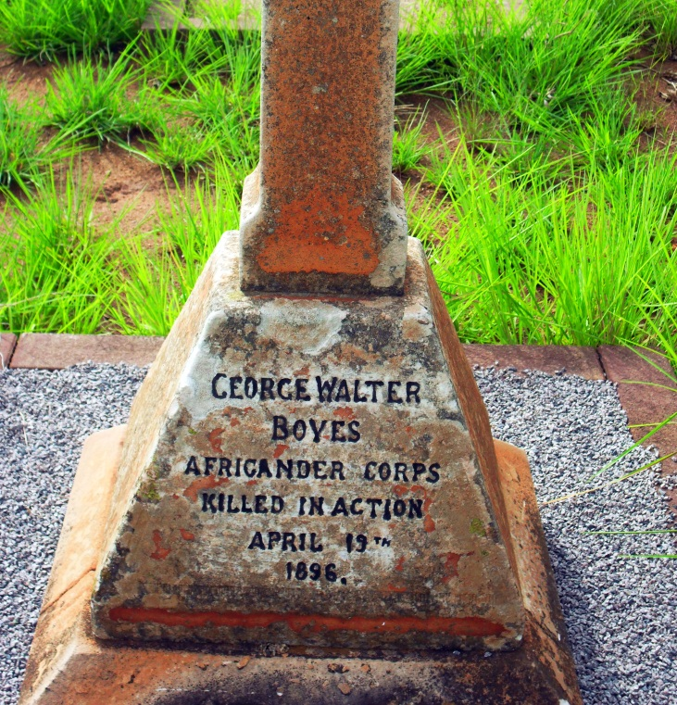

BOYES, Tpr George Walter
No known grave as amaNdebele captured his body

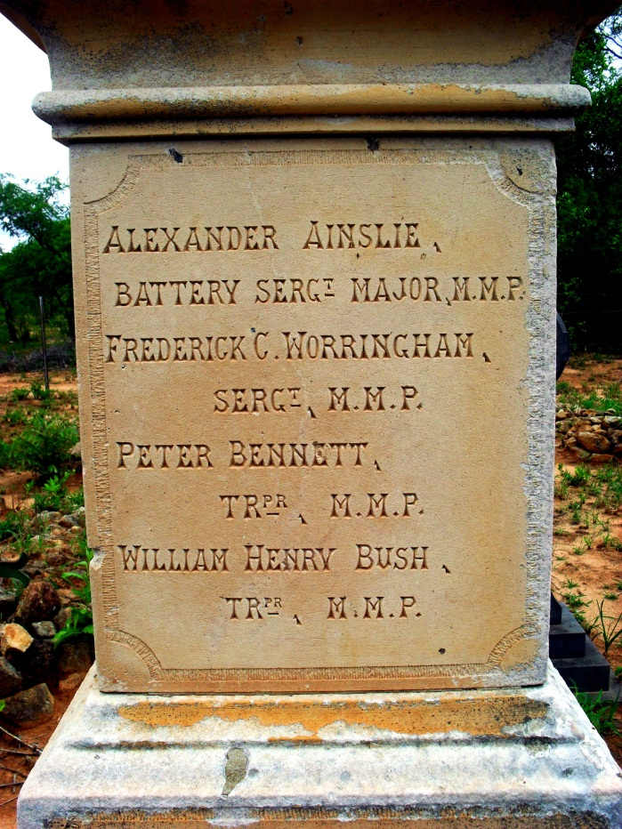

BUSH, Tpr William Henry
Fort Umlugulu Cemetery, Matopos, Bulawayo

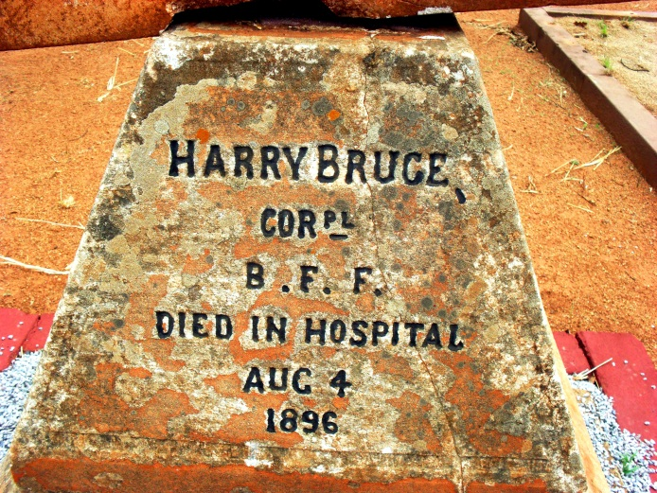
BRUCE, Cpl Harry
Bulawayo General (Pioneer)Cemetery

NO PIC

CABESPINE, Tpr Frederick Victor
Hope Fountain, south of Bulawayo

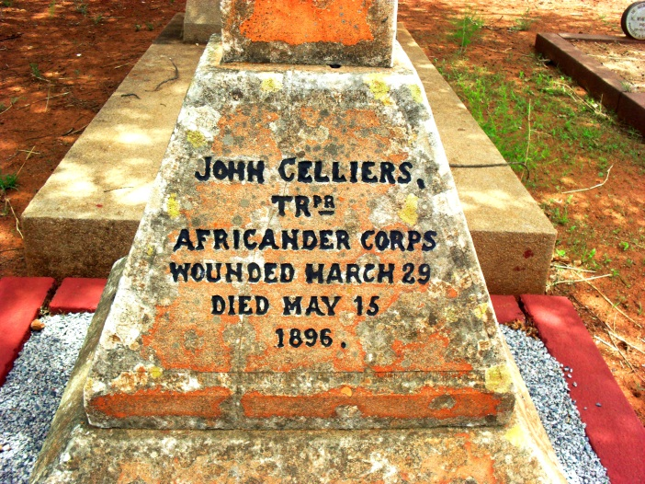
CELLIERS, Tpr John
Bulawayo General (Pioneer)Cemetery

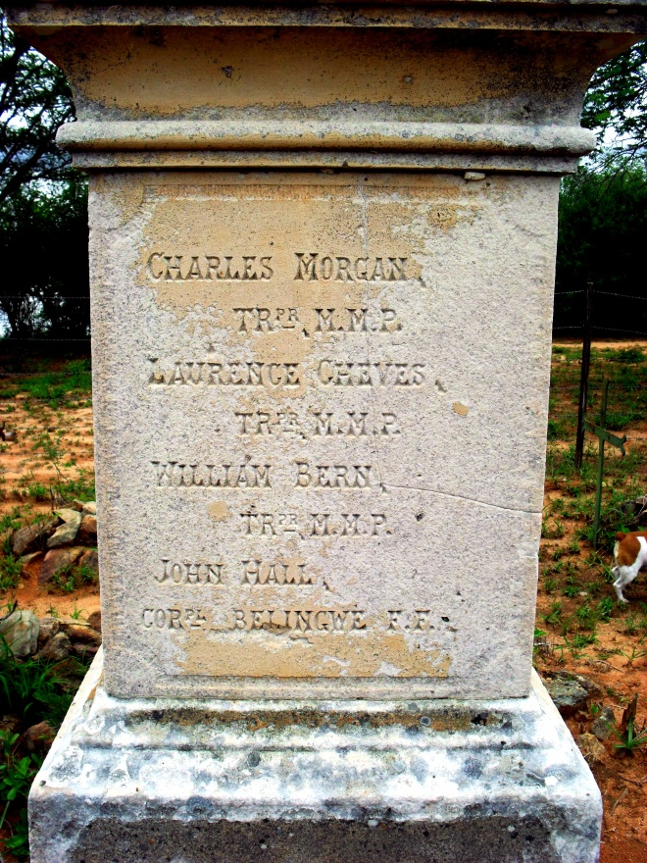
CHEVES, Tpr Laurence
Fort Umlugulu Cemetery, Matopos, Bulawayo

NO PIC

CLARKE, William Herbert
Unknown unit, rank, place of burial

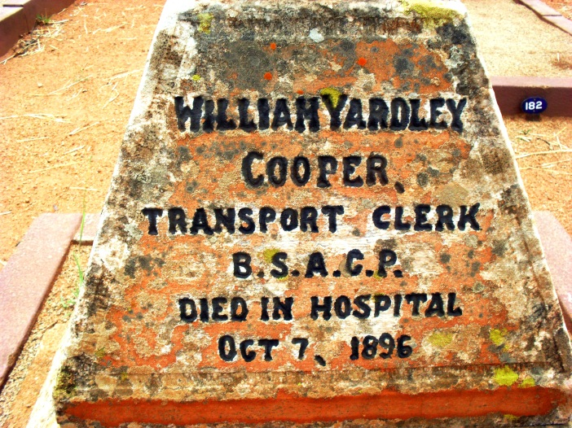

COOPER, Clerk William Yardley
Bulawayo General (Pioneer)Cemetery

NO PIC

CORNEY, Tpr George
Shangani?

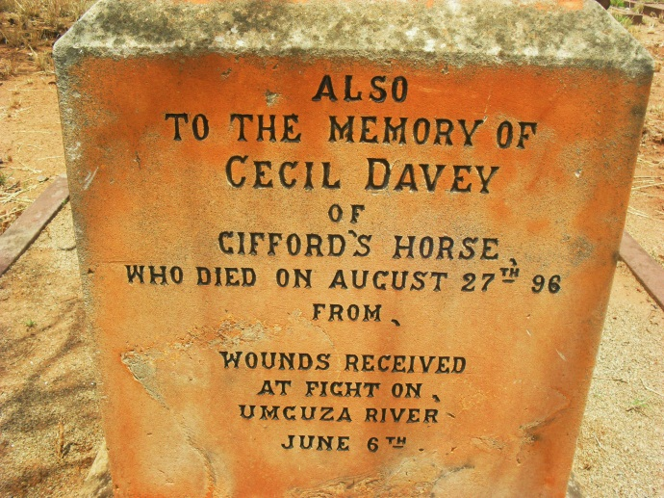

DAVEY, Tpr Cecil
Bulawayo General (Pioneer)Cemetery

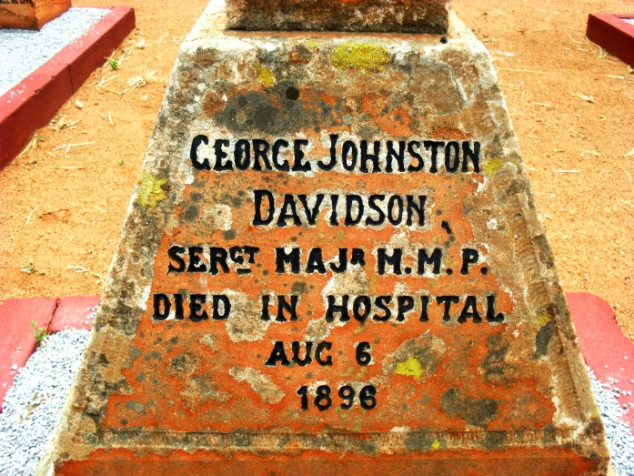

DAVIDSON, Sgt Maj George Johnston
Bulawayo General (Pioneer)Cemetery

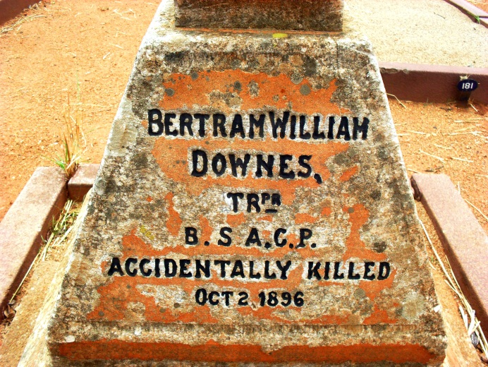

DOWNES, Tpr Bertram William
Bulawayo General (Pioneer)Cemetery

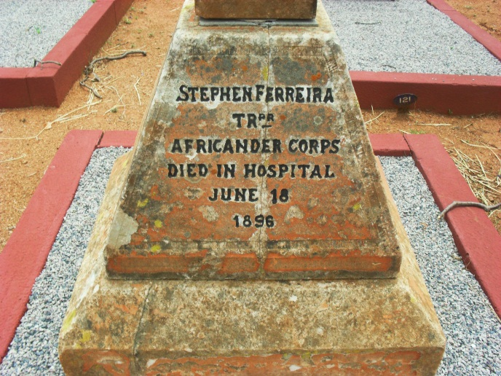
FERRIERA, Tpr Stephen
Bulawayo General (Pioneer)Cemetery

NO PIC

FITCHETT, Tpr Tylden
Ft Mangwe?

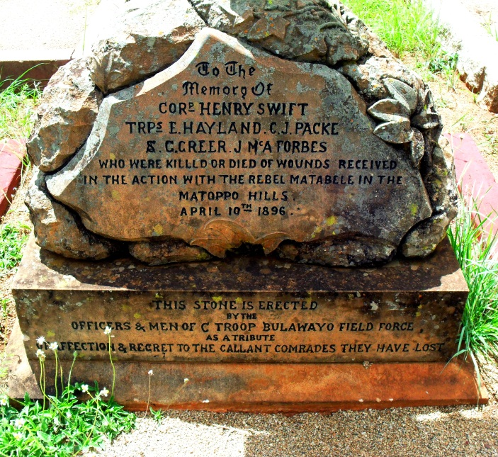

FORBES, Tpr J McAinsch
Bulawayo General (Pioneer)Cemetery

NO PIC

FROUD, Cpl Absolom
Near Belingwe Laager

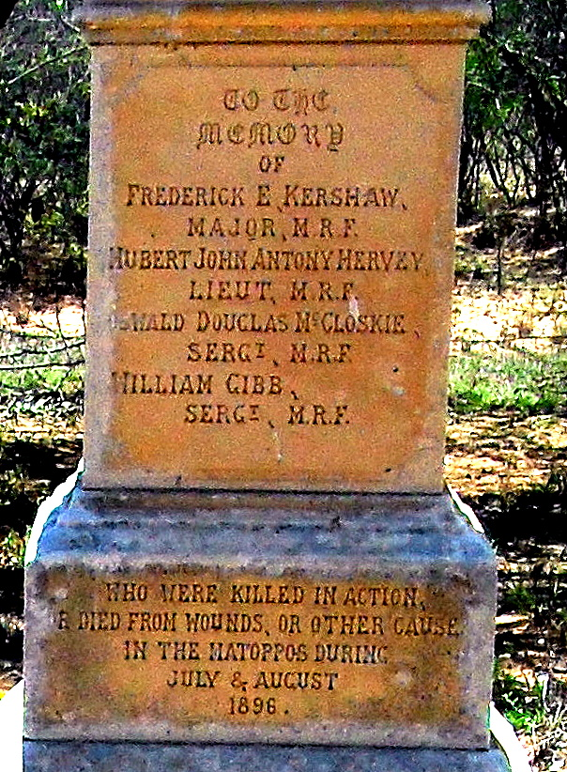

GIBB, Sgt William
Fort Umlugulu Cemetery, Matopos, Bulawayo

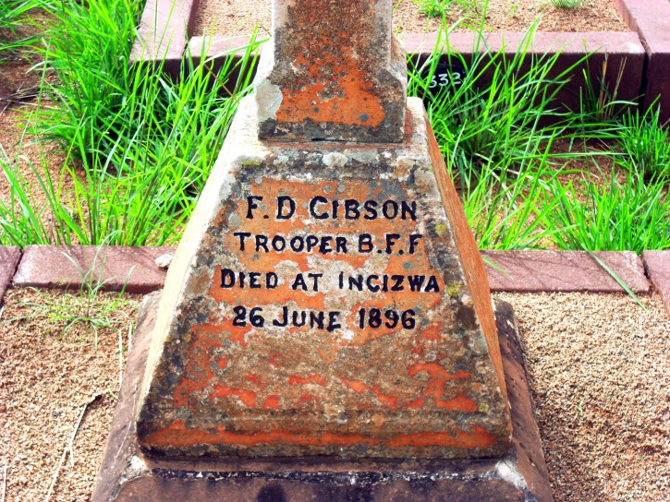

GIBSON, Tpr F.D.
Unknown; along Insiza River?

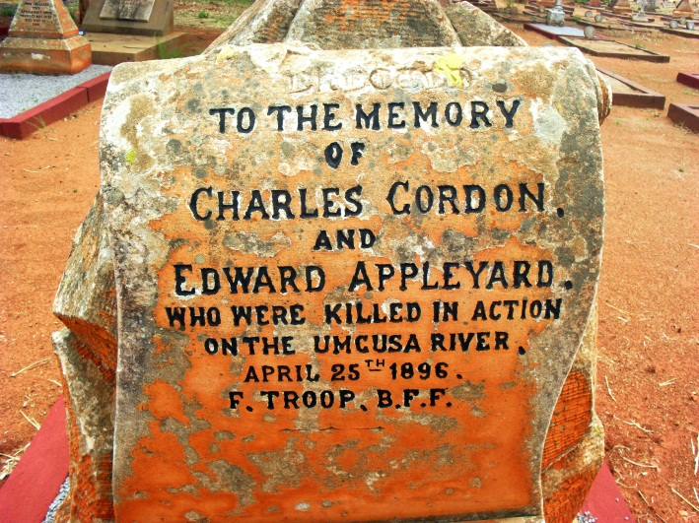
GORDON, Tpr Charles
Bulawayo General (Pioneer)Cemetery

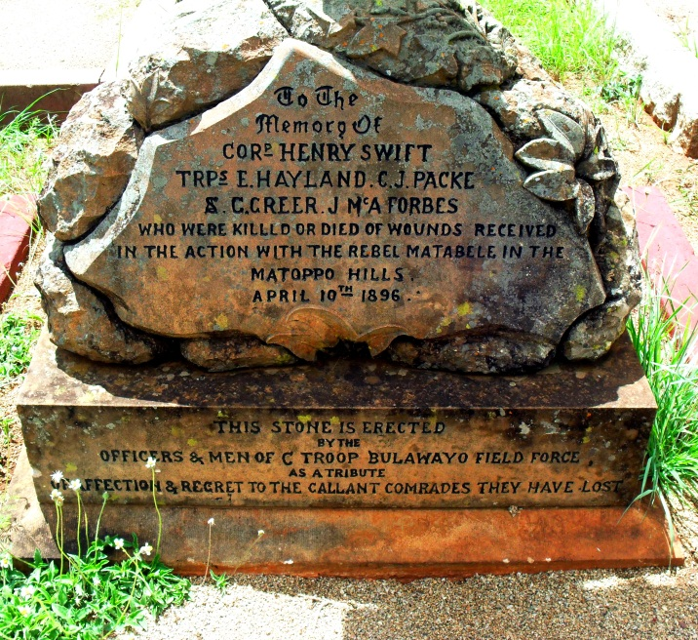

GREER, Tpr Stuart George
Bulawayo General (Pioneer)Cemetery

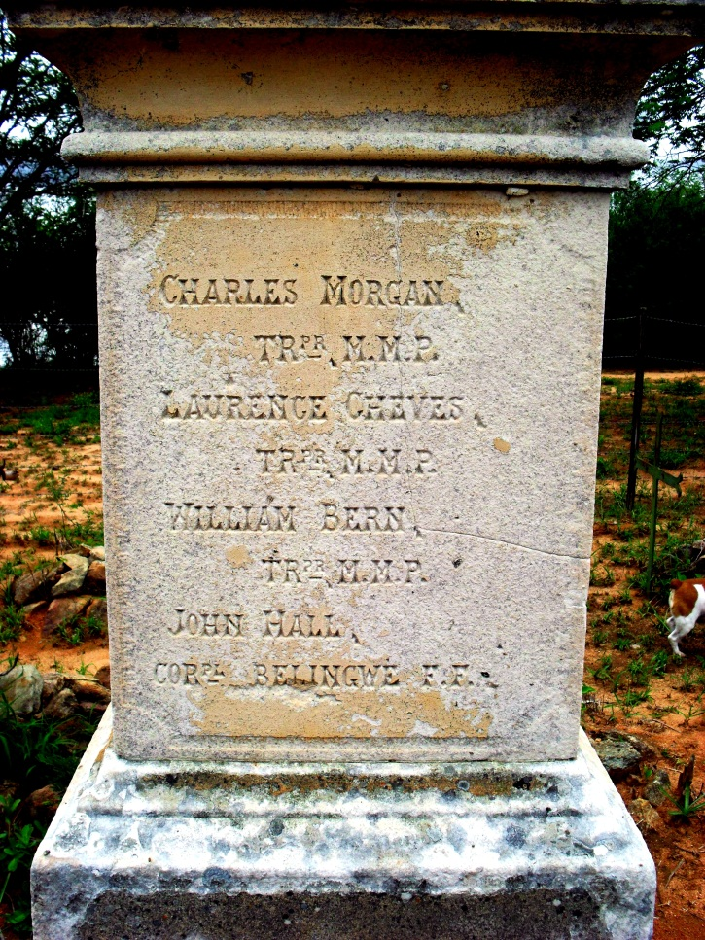

HALL, Cpl John
Fort Umlugulu Cemetery, Matopos, Bulawayo

NO PIC

HARPER, Tpr John William
Malema Camp, Matopos?

NO PIC

HAY, Tpr Carrick
Matopos? KIA Khami

NO PIC

HAYES, Cpl Dan Joseph
Unknown. KIA Sinango Kopje. Gwelo?

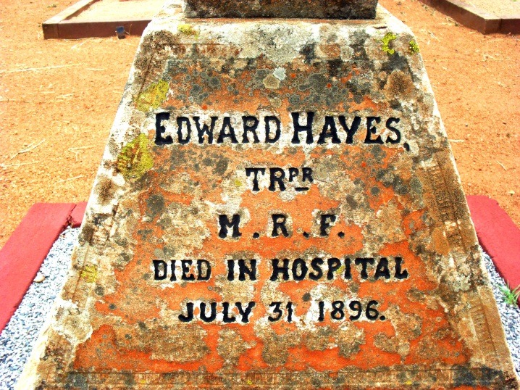
HAYES, Tpr Edward
Bulawayo General (Pioneer)Cemetery

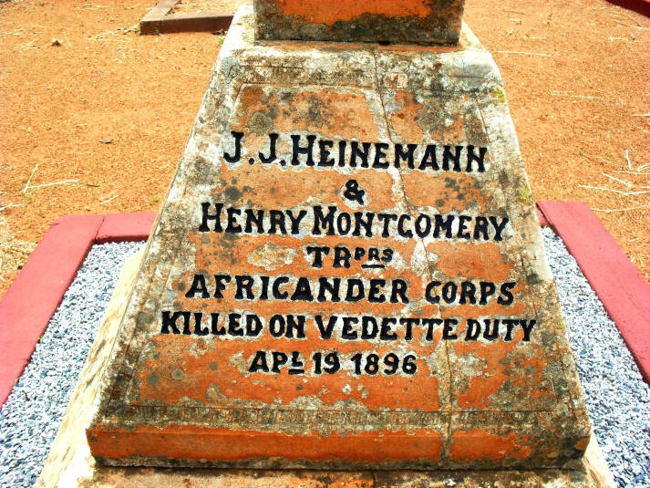
HEINNEMAN, Tpr J.J.
Bulawayo General (Pioneer)Cemetery

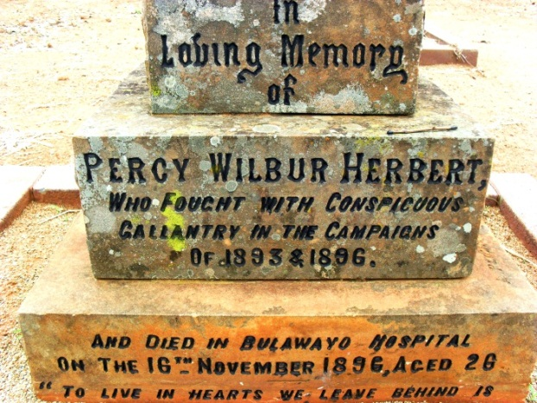
HERBERT, Percy Wilbur - surname?
Bulawayo General (Pioneer)Cemetery
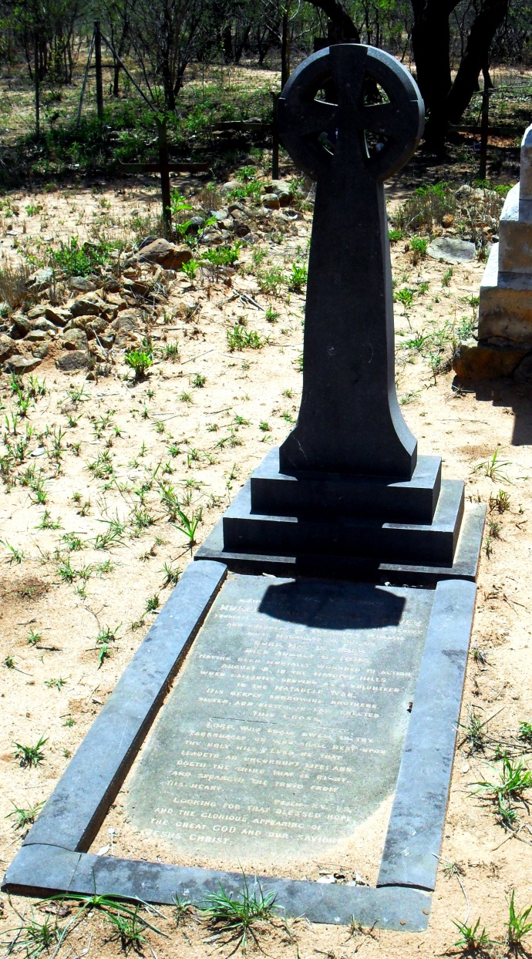
HERVEY, Lt Hubert John Anthony
Fort Umlugulu Cemetery, Matopos, Bulawayo

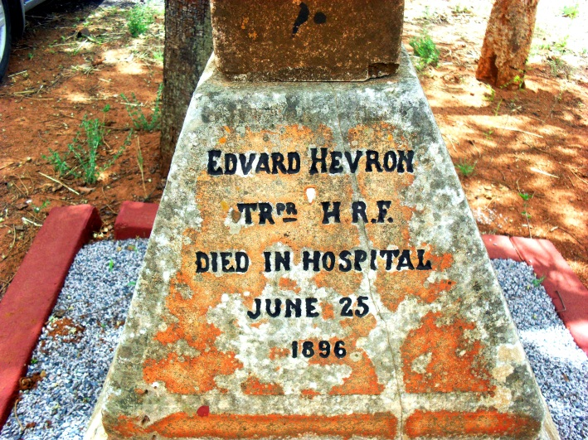
HEVRON, Tpr Edward
Bulawayo General (Pioneer)Cemetery

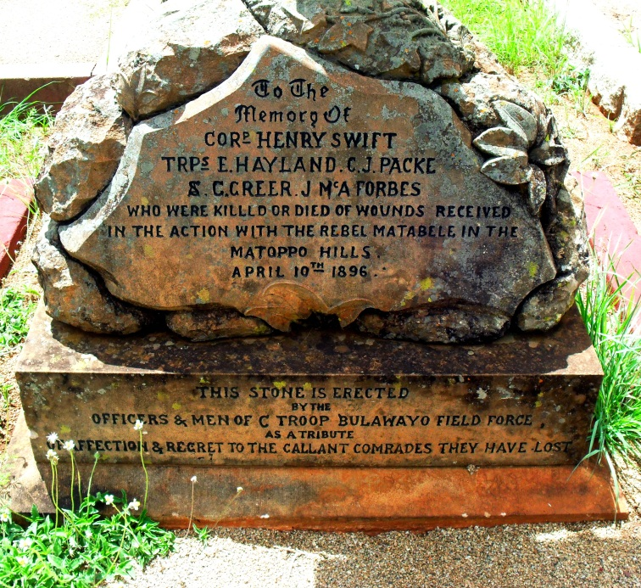

HEYLAND, Tpr Edward Langford
Bulawayo General (Pioneer)Cemetery
(Note spelling)

NO PIC

HILL, Tpr John Hall
Near West's Store on the Hunter's Road, north of Nyati
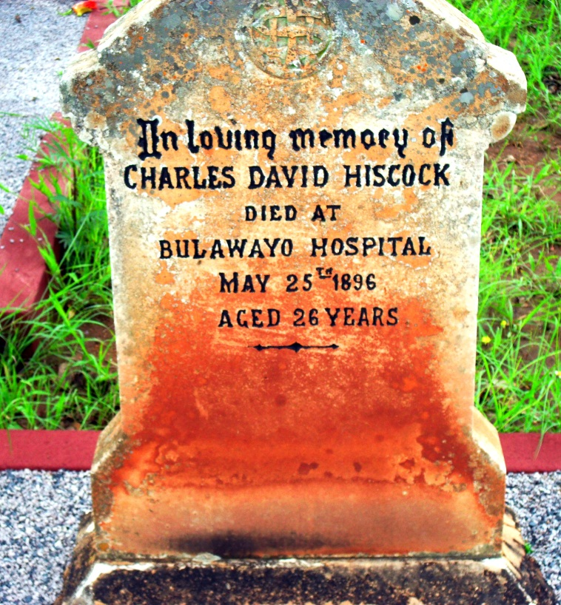

HISCOCK, Tpr Charles David
Bulawayo General (Pioneer)Cemetery

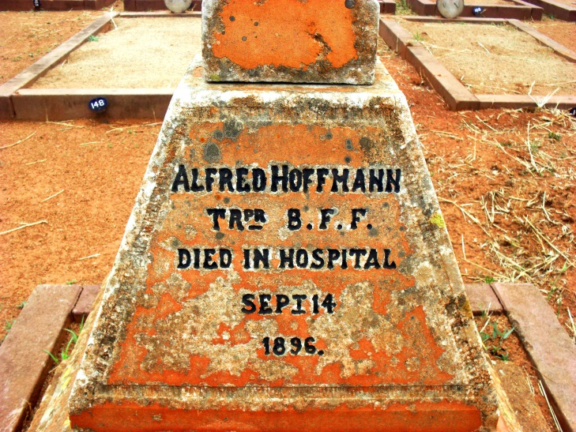
Hoffmann, Tpr Alfred
Bulawayo General (Pioneer)Cemetery

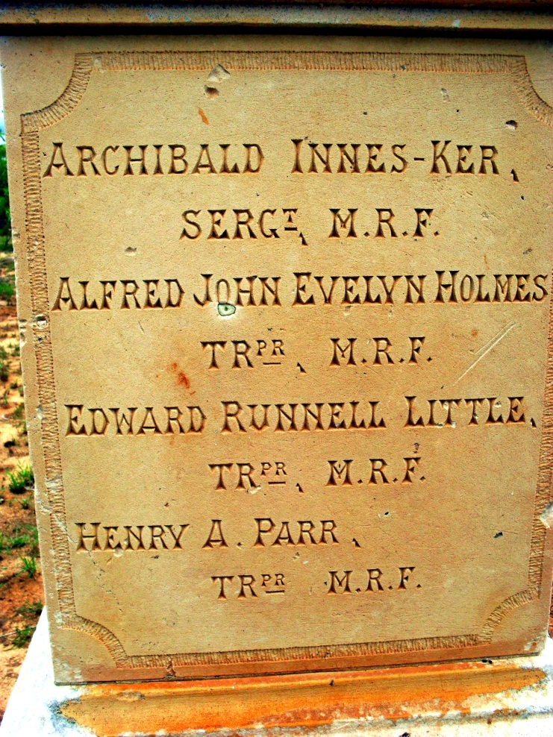

HOLMES, Tpr Alfred John Evelyn
Fort Umlugulu Cemetery, Matopos, Bulawayo

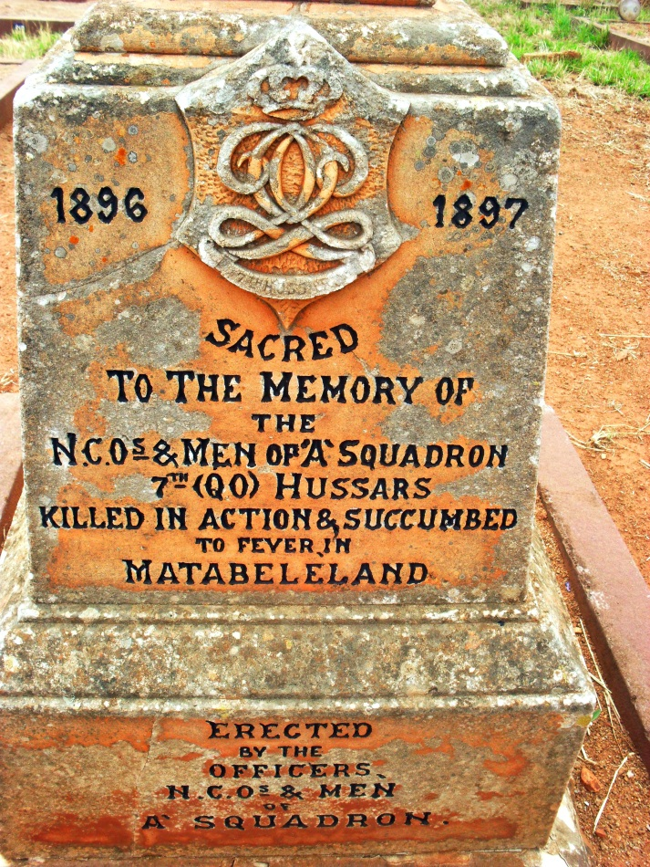

HUSSARS, 7th Queen’s Own, Memorial to ‘A’ Squadron
‘A’ Squadron Memorial in the Bulawayo General Cemetery

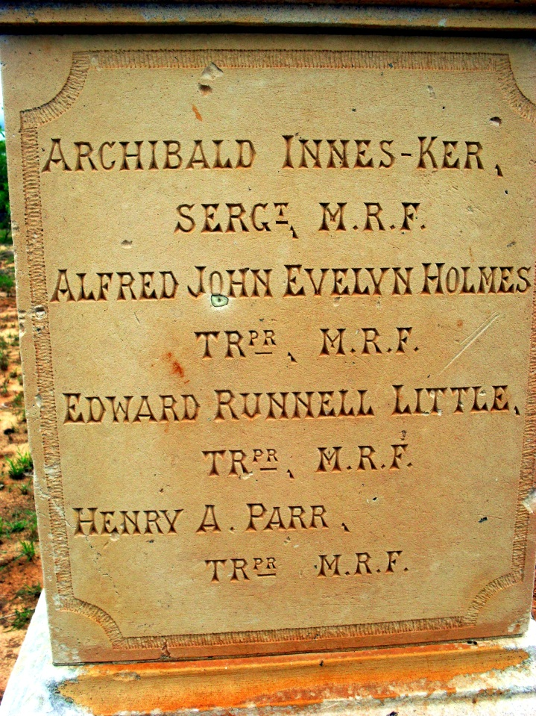

INNES-KERR, Sgt Archibald
Fort Umlugulu Cemetery, Matopos, Bulawayo

NO PIC

JAY, Tpr Leonard
Gweru (Gwelo ) Cemetery

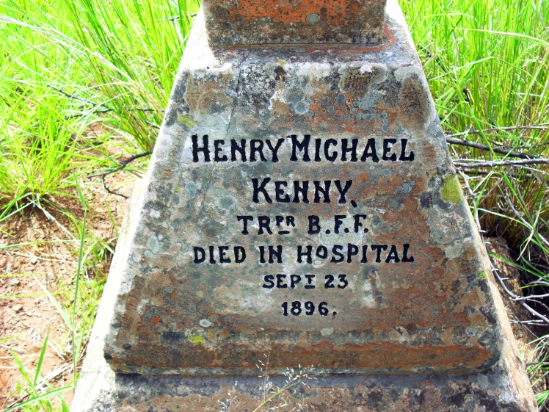

KENNY, Tpr Henry Michael
Bulawayo General (Pioneer)Cemetery

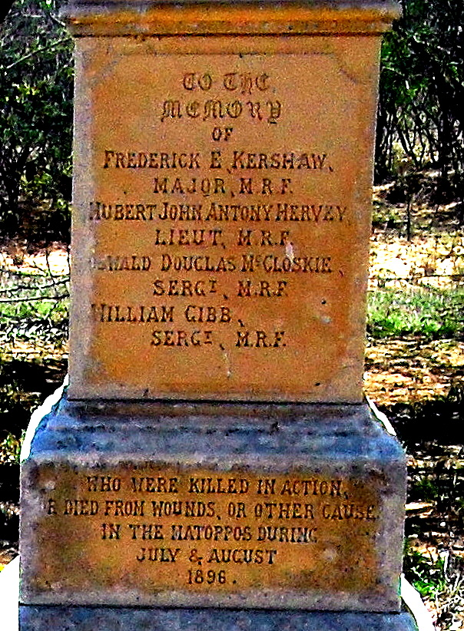

KERSHAW, Maj Frederick E.
Fort Umlugulu Cemetery, Matopos, Bulawayo

NO PIC

KRIECHBAUM, Tpr George
Gweru (Gwelo) Cemetery

NO PIC

LANGTON, Tpr Thomas Courtney
Unknown; north of Insiza

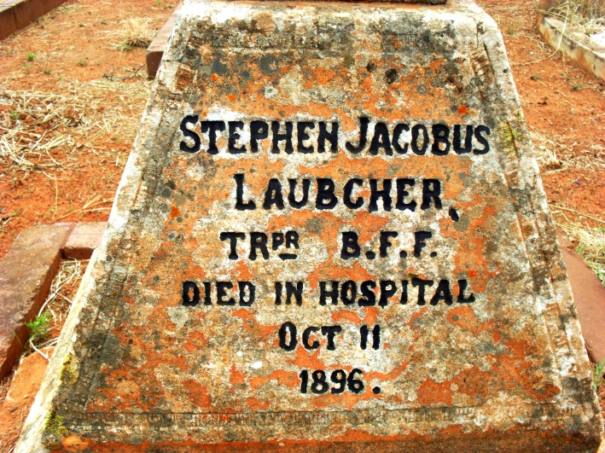
LAUBCHER, Tpr Stephen Jacobus
Bulawayo General (Pioneer)Cemetery

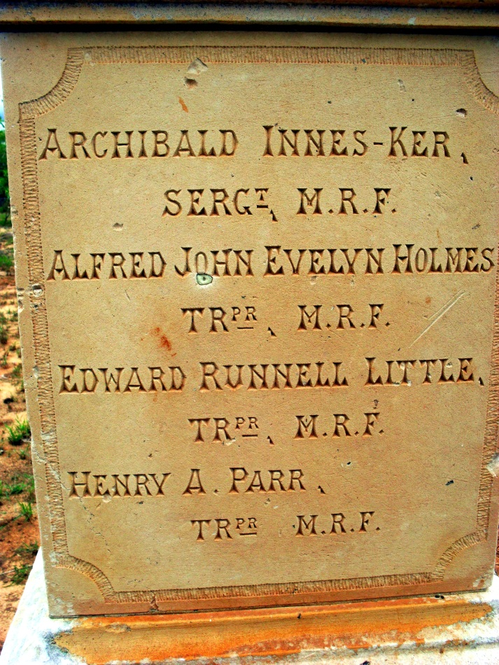

LITTLE, Tpr Edward Runnell
Fort Umlugulu Cemetery, Matopos, Bulawayo

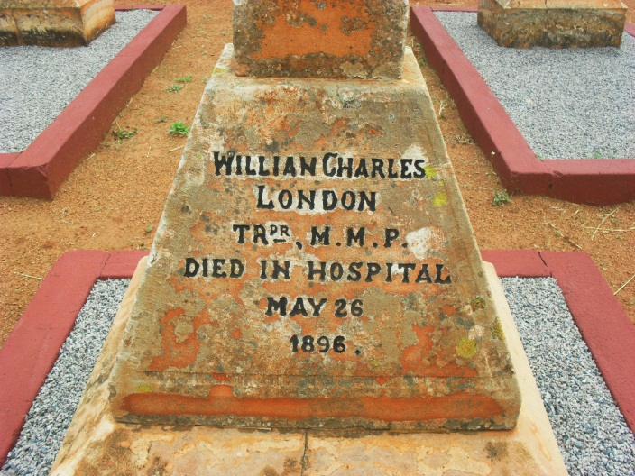
LONDON, Tpr William Charles
Bulawayo General (Pioneer)Cemetery

NO PIC

LONGTON, Frank
Gweru (Gwelo) Cemetery

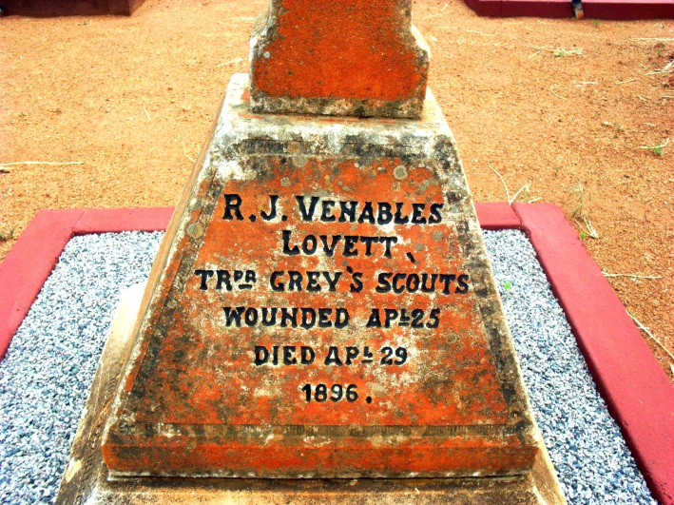
LOVETT, Tpr Rowland Joseph Venables
Bulawayo General (Pioneer)Cemetery

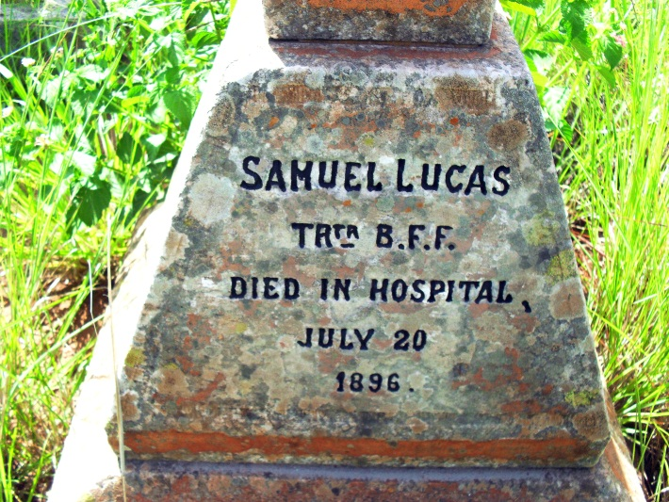
LUCAS, Tpr Samuel
Bulawayo General (Pioneer)Cemetery

LUMSDEN, Capt James William Montgomerie
Bulawayo General (Pioneer)Cemetery

