l 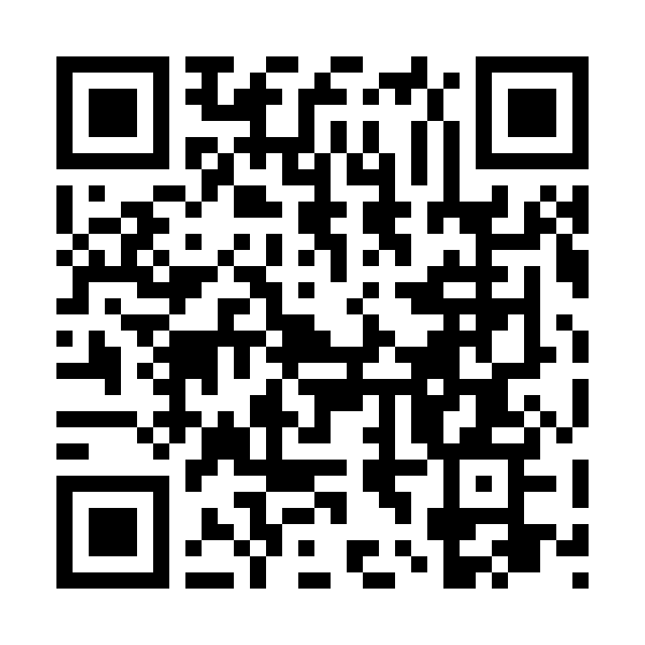
Catholic Church cluster of Davenport
St. Francis of Assisi – Harrington
Immaculate Conception Catholic Church – Davenport
St. Michael Catholic Church – Reardan
St. Kateri Tekawitha Catholic Church – Ford
Sacred Heart Catholic Church – Wellpinit
Mailing Address: Immaculate Conception Catholic Church - Davenport
1310 Adams St., Davenport, WA 99122-9454
(509)725-1761
Office manager: Jackie – icdavenport@dioceseofspokane.org
Immaculateconceptiondavenport.org
Any information for the bulletin needs to be to Jackie
Pastor – Fr. Brian Sattler – bsattler@dioceseofspokane.org
Sacramental requests: Call Fr. Brian 503-989-7585

The Holy Sacrifice of the Mass
Daily Tues., Wed., Fri. Davenport at 9am, Reardan Thurs. 9am.
Saturday Harrington mass at 5:30pm - Sunday Rosary at 8am in Davenport
Davenport at 8:30am, Reardan at 10:30am, Ford 12:30pm 12:30 pm (1st-2nd-3rd Sunday in Ford) (4th Sunday in Wellpinit)
Confessions – half hour before Sunday Mass.
Fr. Brian’s Reflection:
Sunday, March 1, 2026, 2nd Sunday Lent A
Mass 7153, 5:30 PM Saturday Vigil St. Francis intention Pro Populo, Kim Do 13, Dave 14, Dean 14, Joan Ryan+ 21, Melvin Egbert+ 24, Angie Brinkmann+ 24, Jackie 36, and Carol Hildebrandt 47
Mass 7154, 8:30 AM Immaculate Conception intention Pro Populo, Kim Do 14, Dave 15, Dean 15, Joan Ryan+ 22, Melvin Egbert+ 25, Angie Brinkmann+ 25, Jackie 37, and Carol Hildebrandt 48
Mass 7155, 10:30 AM St. Michael intention Pro Populo, Kim Do 15, Dave 16, Dean 16, Joan Ryan+ 23, Melvin Egbert+ 26, Angie Brinkmann+ 26, Jackie 38, and Carol Hildebrandt 49
Mass 7156, 12:30 PM St. Kateri intention Pro Populo, Kim Do 16, Dave 17, Dean 17, Joan Ryan+ 24, Melvin Egbert+ 27, Angie Brinkmann+ 27, and Jackie 39
Genesis 12:1-4a/Psalm 33/2 Timothy 1:8b-10/Matthew 17:1-9
The Lord through Genesis is teaching us to follow his direction in our lives. The Psalmist is encouraging us to pray for mercy and to trust in the Lord. The Holy Spirit through 2 Timothy is revealing to us that we are saved by Jesus and calls us to a holy way of life. Our Father is proclaiming Jesus is his Son with whom he is well pleased, and Jesus encourages us to not be afraid of Him. Father empower all your children to believed we are saved by Jesus the Son of God and strengthen us to trust in your mercy, so we lead a holy way of life. I ask you this in Jesus. Amen. Most Holy Virgin Mary pray for us. St. Joseph pray for us. St. Francis pray for us. St. Michael pray for us, St. Kateri pray for us.

Stations of Cross Friday’s 5:30 PM Immaculate Conception and St. Michaels
Station of the Cross may be done at home. I encourage you to pray this devotion.

HAPPY LENT!

Mass Intentions:
Mar 30………Sat, 5:30 Joan Ryan+
Mar 1.……….Sun 8:30, 10:30, 12:30 Dean Loberg
Mar 3, …..….Tue, 9:AM Angie Brinkman+
Mar 4.…...….Wed, 9:AM Kim Do
Mar 5.……....Thu 9:AM Jackie
Mar 6.…..……Fri, 9:AM Dave Young

