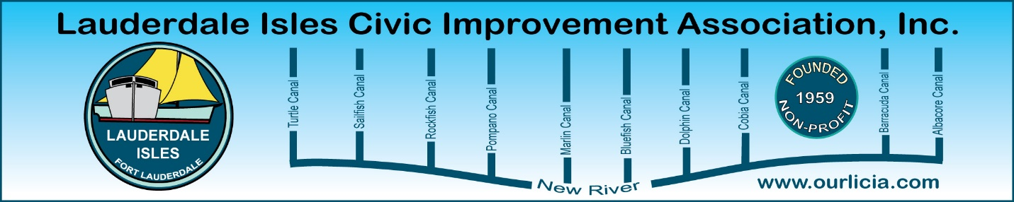

Minutes of the Lauderdale Isles Civic Improvement Association General Meeting Nov. 21, 2024.
The meeting was called to order by Earl Prizlee at 7:05pm.
Board attendees: Earl Prizlee, Geoff Rames, Diana Steeger, Karen Rames, Dawn Hanna, Trent Simpson, Julie Gordon, Dick Cahoon, Eric Silva and Glo Knowles. Absent: Penny Shea, Aynsley Geramanis, Andrew Silverman, Jackie Zumwalt, Joann Kratky
Earl welcomed everyone and gave an overview of the Meeting Agenda for the evening.
LIWMD Waterway Cleanup: Geoff shared photos and a brief overview of the great day we had.
FLPD report: Officer Jackson said there were 3 Part 1 crimes that occurred since our last report. There were 2 residential burglaries. A delivery person dropped off a package and then stole it, all caught on the ring camera. Another person came in through the bathroom window and a neighbor saw it happen but didn’t call 911. Third crime was an auto burglary. Jack Daniels and a firearm were taken from an unlocked car. Officer Jackson reminded us it is holiday time and packages will be stolen that are delivered so keep aware of delivery times and ask a neighbor to hold your package once delivered if you won’t be home. Officer Jackson offered to arrange for the IT Cyber Crime Prevention unit to do a presentation at our next meeting if we want.
Earl Prizlee updates: Regarding the traffic speed meter, Earl said data is recorded and he will review and identify what times he sees offenses occurring. He will ask the Police to be pro-active at these times to enforce the laws about speeding, passing in a no-passing zone and other offenses he discovers.
Earl advised the traffic light by the school is under County supervision. Residents advised that as soon as they get to the light, it turns red and then green right away. Earl will email the Transportation Mobility team to determine if this is a malfunction or if this is set up to do this on purpose.
Earl advised the damaged railing on Riverland Road is on the schedule to be fixed.
Code Compliance report: Inspector Matthew Flescher provided an update for August 19-November 19. There are 5 cases pending, 14 closed and 47 currently pending compliance. There are 6 Vacation Rental cases for operating without a certificate. Much conversation about the site triangle lack of view from each lane. Matthew will drive down each lane to see what needs to be cut. In the meantime, he advised we should make a report and have a case filed for those that are particularly hard to see for immediate attention.
Community Center update: Earl shared a slide with the timeline and advised there will be a stakeholder meeting in March 2025 where residents can ask questions and provide feedback and have input. A question was raised regarding the noise that will be heard by neighbors on Whale Harbor Lane and Earl said the noise issue will be addressed.
District 4 Commissioner: Geoff provided a review of the recent election stats showing how the 4 Commissioners fared along with stats for the Mayor. Many were surprised our current Commissioner Warren Sturman came in 3rd place.
Riverland Road Traffic Calming: Earl advised $1 million is earmarked for Riverland Road traffic calming and the project has been funded. He congratulated Geoff for bringing this to Commissioner Sturman’s attention as it was not in the current budget but slated for 2027 budget.
2025 Board Election: We welcome new Board members Eric Silva, Lane trustee for Tortugas Lane, and Rick Cunningham, Lane Trustee for Duck Key Lane. Glo Knowles will be Lane Trustee for Sugarloaf Lane.
Executive Board:
President: | Earl Prizlee
Vice-President: | Geoff Rames
Secretary: | Karen Rames
Treasurer: | Diana Steeger
Board of Directors (Lane Reps)
Andros: | Trent Simpson
Bimini: | Aynsley Germanis
Cat Cay: | Dick Cahoon
Duck Key: | Rick Cunningham
Flamingo: | Penny Shea
Gulfstream: | Geoff Rames
Key Largo: | Jackie Zumwalt
Marathon: | Julie Gordon
Nassau: | Joann Kratky
Okeechobee: | Andrew Silverman
Sugarloaf: | Glo Knowles
Tortugas: | Eric Silva
Whale Harbor: | Dawn Hanna

Since no nominations were received from the neighborhood during the designated period and as we previously communicated that nominations would not be accepted from the floor at the meeting, the above slate was presented to the membership for a formal vote. The vote was unanimous.

Mark Haggrty, Floodplain Manager, Community Rating System presentation: Our guest speaker for this meeting provided an in-depth presentation about the differences between Stormwater Management, Floodplain Management and Public Works. Mark said flooding is the most widespread disaster. He talked about the 4 canals that drain Lake Okeechobee and how important they are. Provided info about the FEMA Map Service Center website and who to call for information. He agreed that the Strategic Communications Department needs to improve their methods of communication as no one was aware there were meetings they could attend to understand about the changes to the flood map and how it affects our neighborhood. Mark says one of his projects is to move us from class 7 with the 15% discount to class 5 to get a 25% discount on our flood insurance. This will take 3-5 years to accomplish. Mark’s contact info: 954-828-6133
mhaggerty@fortlauderdale.gov

Flanigan’s Gift card was awarded.
The meeting ended at 8:30pm.
Respectfully submitted by Karen Rames, Secretary

