**You are invited to Participate in our Back Country Horsemen of New Mexico Northwest Chapter** (a 501(c)(3) non-profit organization)

* Come to our meetings where we have speakers on topics of current interest to horsemen.
* Receive the National Back Country Horsemen of America newsletter every three months.
* Inform us of issues of concern to you and let us inform you of issues that have been brought to BCHNM’s attention for consideration and/or action.
* Be involved in service projects that will improve areas used by back country riders, and assist agencies in managing public lands.
* Participate in educating public land users in low impact methods to preserve our wilderness areas.

**Check with us for dates and locations of our next meeting or activity.**

**Hope to see you soon!!**

* Work to maintain our heritage of pack and saddle stock use of public lands.
* 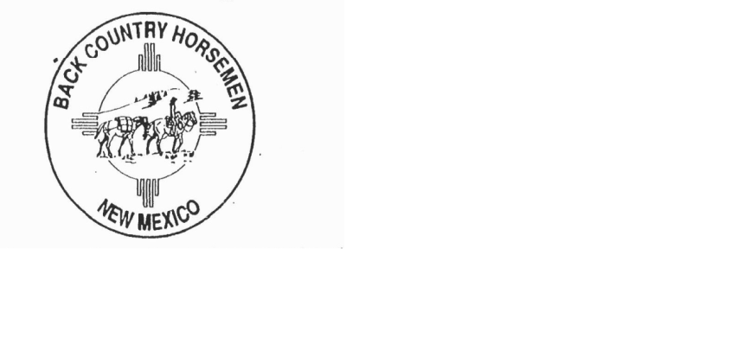Participate in scheduled recreational activities.

**Northwest Chapter is a part of the Back Country Horsemen of America**

The Purpose of the organization is:

1. To perpetuate the common sense and enjoyment of horses and mules in America’s back country and wilderness.
2. To work to ensure that public lands remain open to recreational stock use.
3. To assist the agencies responsible for the management of public lands.
4. To educate, encourage and solicit active participation in wise and sustaining use of the back country resources by horsemen and the general public, commensurate with our heritage.
5. To foster and encourage the formation of additional Back Country Horsemen Chapters.

**Back Country Horsemen of America, Northwest Chapter of New Mexico PO Box 2774 Corrales New Mexico 87048-9998**

**Melissa Bruch - President 505-261-4667** –[**mbangel2me@yahoo.com**](mailto:mbangel2me@yahoo.com) **Jennifer Tena - Vice President 505-379-2242** – [**aquanm3@yahoo.com**](mailto:aquanm3@yahoo.com)

**Chapter email:** [**bchnmnwchapter@outlook.com**](mailto:bchnmnwchapter@outlook.com) **You can pay dues on PayPal if you like, just request an invoice.**

**Facebook:** [**https://www.facebook.com/groups/1435730639979972/**](https://www.facebook.com/groups/1435730639979972/)[**www.bchnm.org**](http://www.bchnm.org/) **for a calendar and chapter information**

**(keep this page for your information and give us the other page)**

**MEMBERSHIP APPLICATION—BACK COUNTRY HORSEMEN OF AMERICA—NORTHWEST CHAPTER OF NEW MEXICO**

|  |  |  |  |  |  |
| --- | --- | --- | --- | --- | --- |
| **Name** | **Phone**  **2nd phone** | **Email address** | **Address** | **Minor?** | **Is there anything we should know about you?’** |
|  |  |  |  |  |  |
|  |  |  |  |  |  |
|  |  |  |  |  |  |
|  |  |  |  |  |  |

**Dues for 2025 are $50 for an individual and $75 for a family. Children over 18 may be included in family membership or join as an individual member. I/we, realize there are inherent risks involved in all activities with equine animals and I/we hereby release BCHA/NWC/BCHNM and its officers, directors, and membership from liability for any accident, injury, or death that may occur to myself/ourselves or my/our equine by participation in any BCHA/BCHNM/NWC activity, in accordance with EQUINE LIABILITY ACT SJC/SENATE BILL 268.a.a. 1993. It is the recommendation of the BCHNM NW Chapter that children under the age of 18 wear an equestrian-approved helmet. If you are the parent of a child under the age of 18 who is working/riding on a BCHA/NM/NW Chapter event and you choose not to require your child to wear a helmet, by signing below you are accepting the responsibility of any injury, accident or death that may occur to your child during the event; and, further agree to hold the BCHA/NM/NW Chapter, its Officers, Directors, and membership harmless.**

**Signature_________________________________________________________Date___________________________**

**Signature_________________________________________________________Date___________________________**

**Signature_________________________________________________________Date___________________________**