CORNPLANTER TOWNSHIP
136 Petroleum Center Road
Oil City, PA 16301
(814) 676-1744
ACH Automatic Withdrawal Authorization Form
You can pay your bill with a simple automated payment plan. It’s easy to set-up, and your payments will take care of themselves. Just complete and sign the form below to get started!

Please complete the information below:

I ____________________________ authorize Cornplanter Township to debit my bank account
(Print Full Name)

shown below for Water/Sewer, and/or Street Light Utility Payments.

Service Address____________________________ Phone# ________________________
City, State, Zip ____________________________ Email ________________________

Account Type: Checking Savings
Name on Acct _______________________________
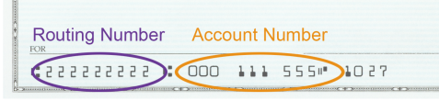
Bank Name _______________________________
Account Number _______________________________
Bank Routing # _______________________________
Bank City/State _______________________________

SIGNATURE DATE

I understand that this authorization will remain in effect until the debt is fully discharged or I cancel it in writing which ever comes first, and I agree to notify the business in writing of any changes in my account information or termination of this authorization at least 15 days prior to the next billing date. If the above noted payment date falls on a weekend or holiday, I understand that the payment may be executed on the next business day. I understand that because this is an electronic transaction, these funds may be withdrawn from my account as soon as the above noted periodic transaction dates. In the case of an ACH Transaction being rejected for Non Sufficient Funds (NSF) I understand that Cornplanter Township will not make any additional attempts to process the charge and agree that I am subject to a $25.00 fee. I acknowledge that the origination of ACH transactions to my account must comply with the provisions of U.S. law. I will not dispute the company’s recurring billing with my bank so long as the transaction corresponds to the terms indicated in this agreement.

