1ST ANNUAL

ROSWELL RANCHERS SELECT SALE
Presented by Roswell Livestock Auction
APRIL 9, 2016

FEATURING:
21 - HORSES
33 - CHAROLAIS BULLS
300 – 2 YEAR OLD ANGUS & ANGUS PLUS PAIRS &
BRED HEIFERS
30 – FRESH CORRIENTE ROPING STEERS
70 – FRESH ROPING CALVES
3 – STOCK DOGS
SCHEDULE OF EVENTS:
9:00 A.M. – 1:00 P.M – All cattle will be available for preview at
Roswell Livestock Auction
9:00 A.M. – Horse and Stock dog preview to be announced
1:00 P.M. – Sale starts at Roswell Livestock Auction
ORDER OF SALE:
2 year old Angus & Angus Plus pairs & bred heifers
Charolais Bulls
Horse Sale
Stock Dog Sale
Corriente Roping steers
Roping Calves
INDEX
Lot # | Owner’s Name | Animal
 | CAZA RANCHES – ARTESIA, NM | 300 ANGUS BRED HEIFERS & PAIRS
1-25 | BILL KING RANCH, MORIARTY, NM | 20 CHAROLAIS BULLS
26-35 | GRAU RANCH – GRADY, NM | 6 CHAROLAIS BULLS
36-45 | BILL SIMS – EUNICE, NM | 6 CHAROLAIS BULLS
1 | KIM CHESSER | HADIEE GUN
2 | CHANCE GAINER | CEE BEES BALLIO
3 | CASEY HATLEY | DRIFTER
4 | CORY ROWLAND | TROY DUN
5 | DICKIE MCINTOSH | LARNED SHOWSOFF GIN
6 | SHANNON MOORE | GO ROUND
7 | ADAM SCHULTE | BABYDOLL
8 | BOBBY VAUGHN | LISTONIC
9 | COLE BURSON | SATIN LIL SUGAR
10 | C W MORRIS | DOCS NOEL
11 | KOLYN DUTTON | SMOKE
12 | DAVE MCINTOSH | SOCKS
13 | WESLEY GRAU | TEXAS SILVER COYOTE
14 | WAYNE METCALF | SIXES WIMPY
15 | DENNIS KLINGHAGEN | DOCS QUICK PEP UP
16 | SAM COBERLY | CATTS KIKN A LIL ACE
17 | CADE HOOTEN | LUCKY CHOICE HAND
18 | JERRIVON THOMAS | RBS PEPPY SAN VILLA
19 | JARROD HARRAL | JACKS DARLIN GEMINI
20 | KELLY HATLEY | CHILDRESS DOC PEPPY
21 | ROSENDO APODACA | MARIACHI
22 | E C CATTLE | HAIDEE GUN
 | NATE CATER – CALLIE | STOCK DOG
 | KORKY HARE – TAZ | STOCK DOG
 | BRAD ODER - ROCK | STOCK DOG
 |  | CORRIENTE STEERS
 | D K BOYD RANCHES | ROPING CALVES

HORSE SALE
1 | HAIDEE GUN | 5159751
 | 2008 BAY GELDING | KIM CHESSER
 |  | Peppy San Badger
 | Haidas Little Pep
 |  | Doc’s Haida
HAIDAS SAN SMOKE
4245484
 |  | Mr Gun Smoke
 | Jo Ell Smoke
 |  | Jo Ell San
 |  | Freckles Playboy
 | Young Gun
 |  | Lenaette
SQUEEKY GUN
3435676
 |  | Tivio Tramp
 | Mr Tivio Squeeker
 |  | Squeekin Jane
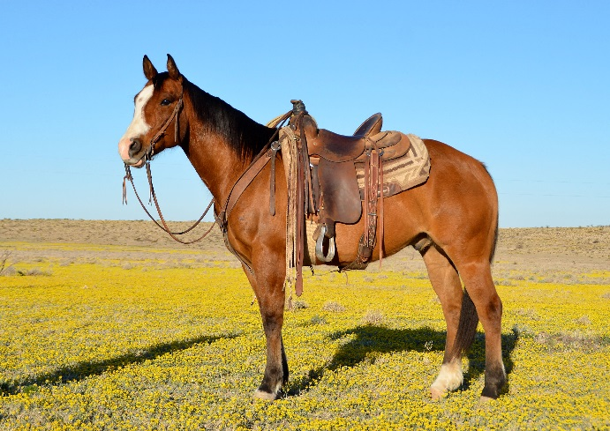
I’ve owned “Kid” for the last 6 years. He is gentle, has great conformation and is 100% sound. He is easy to shoe, rides around nicely and has a big stop. Easy to look at, with neat coloring, looks like a bay with the dorsal stripe of a Dun. We’ve used him in all aspects of ranch work and he has been Tye’s go-to ranch using/ day working horse for the past four years. Handles himself well in rough and rocky country. Tye has started heeling on him and he has the potential to be a top end heel, breakaway, or calf roping horse. Great prospect with the potential for anything from a ranch horse to a timed event or performance horse. “Kid” is a fun horse with lots of personality.

2 | CEE BEES BALLIO | 4896645
 | 2006 BUCK GELD | CHANCE GAINER
 |  | Fritz Command
 | Cee Bee Command
 |  | Jay Bee’s Best
CEE BEES PEPPY
3424693
 |  | Peppys Humo
 | Peppys Apree
 |  | Saucy Bar Flit
 |  | Classy Doc Bar
 | Cola Cowboy
 |  | Ben’s Velveteen
CALM COMMOTION
2992298
 |  | Harmac Bull
 | Miss Harmac
 |  | Okie Stormy

“Fritz” is a 10 year old Buckskin gelding. He stands 14.2 hands and weighs 1200 pounds. He has a good mane, tail, and lots of foot and bone. He has done everything you can do on the ranch. Drug calves to the fire, roped cattle outside, and sorted in the pens. “Fritz” is started in the arena on both ends but is making a better head horse. He will be hauled to a few jackpots before the sale. 100% sound and gentle.
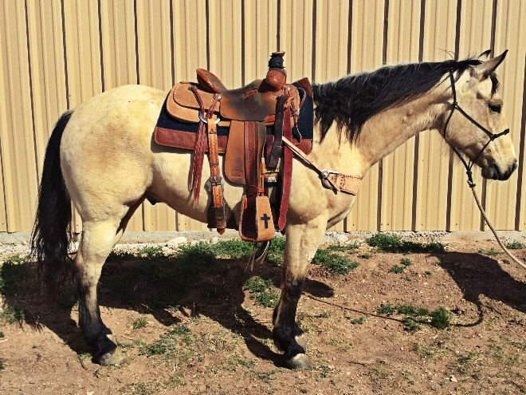

3 |  | DRIFTER |  | GRADE
 | 8 YEAR OLD PALOMINO GELD |  |  | CASEY HATLEY
Drifter has been in the family for the past four years. If you are looking for one can do it all, here he is. He has been hauled to jackpots on both ends. He scores well, plenty of run, rate, and a strong finish then take him home Monday morning go do your daily ranch work from doctoring calves to dragging them to the fire. Not many like him, 100% sound.

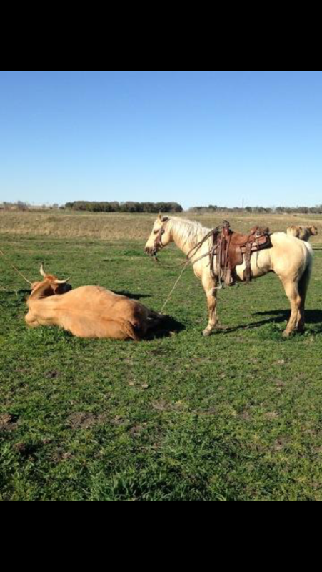

4 | TROY DUN |  | X0631670
 | 2004 DUN GELD |  | CORY ROWLAND
 |  |  | Nero’s Bracket
 | Nero’s Roan
 |  |  | Watterson Fish
NEROS FIDDLING DUDE
3834817 |  |  | Sporty Jay
 | Sporty Miss Dude
 |  |  | Miss Karen Kay
 |  |  | Mr San Peppy
 | Mr Gold Peppy
 |  |  | Bill’s Vanette
QUEEN CURLEY SUE
X0534844
 |  |  | King of Kings
 | Queen Hellaina
 |  |  | Hellaina Marie

If you are looking for a big horse that will cover country, this is him. He has been used in all phases of ranch work. He has had a lot of cattle roped on him outside. Started on the head side. Willing to please, smooth to ride, gentle and sound. Ready to go ranch, ride or rope.

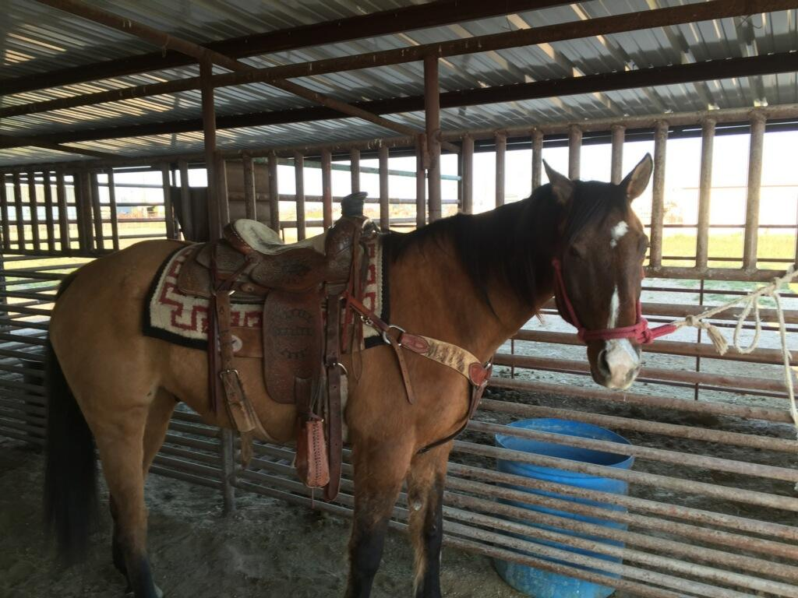

5 | LARNED SHOWSOFF GIN | 5018397
 | 2007 SORREL MARE | DICKIE MCINTOSH
 |  | Preferred Pay
 | Preferred Gin
 |  | Model Gin
BECACO DIAMOND GIN
3458274 |  | Some Six
 | Becaco Ss Fo
 |  | Becaco Bar Fose
 |  | Stats Jimmy
 | Showtime Stats
 |  | Roguish Bars Miss
LARNEDS EASY MOVER
3816152 |  | Strictly Easy
 | Easy Caliente Larned
 |  | Caliente Tequilla

Really nice mare with a lot of ability and a willing attitude. Has been used a lot outside and roped on in the arena.
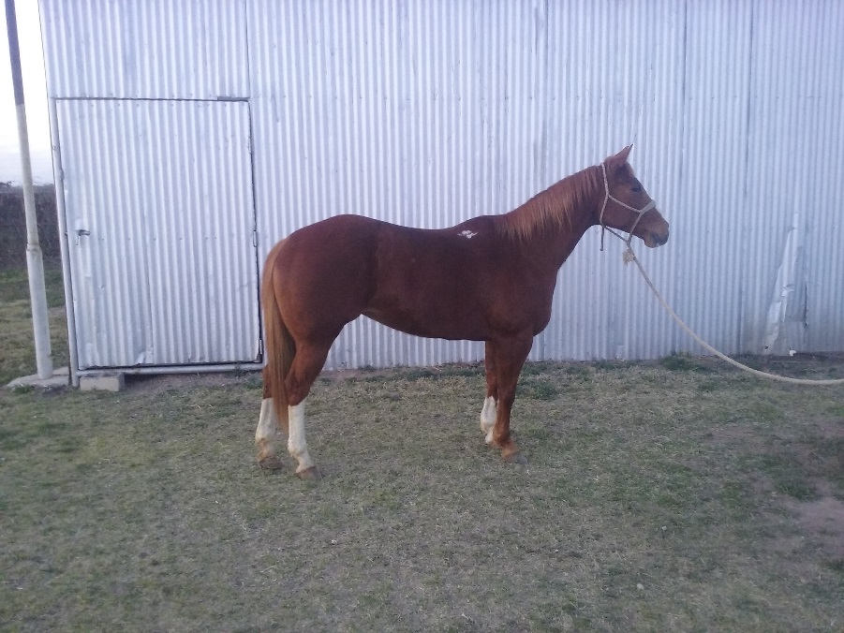

6 | GO ROUND | GRADE
 | 5 YEAR OLD SORL GELD | SHANNON MOORE

Real nice young horse with a big future ahead of him. We looked after wheat cattle on him all winter and day worked on him. He is started in the arena and would be a nice horse to take to the ranch or to the arena.

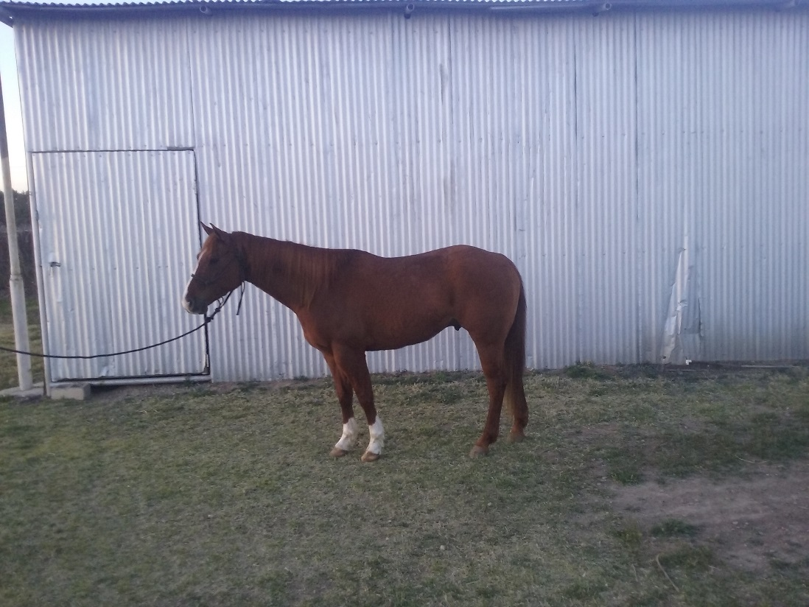

7 | BABY DOLL | GRADE
 | 8 YEAR OLD BAY MARE | ADAM SCHULTE

“Baby Doll” is an 8 year old mare out of Playgun bred stock but will be sold as grade. She is a good gentle horse that is an easy keeper. “Baby Doll” has been ridden in a feed yard for six years. She is good with gates and mud. She has a good eye and is very cowy. She has had a lot of wheat pasture calves roped on her and she has also started heading and heeling in the arena. She is sound, super gentle and ready to go to work.

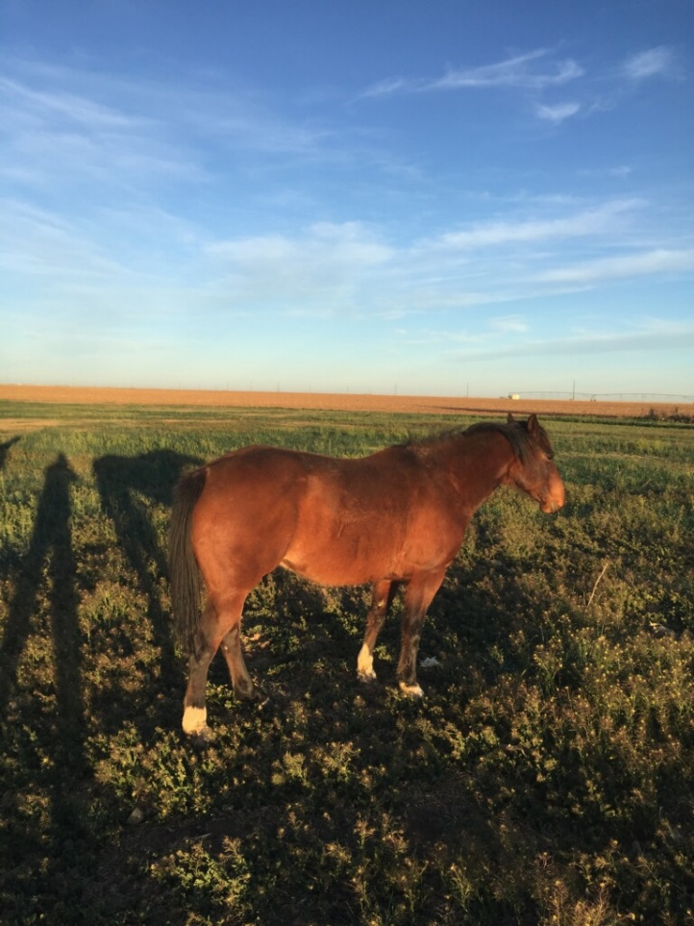

8 | LISTONIC | 4667219
 | 2005 SORL GELD | BOBBY VAUGHN
 |  | Smart Little Lena
 | Smart Chic Olena
 |  | Gay Sugar Chic
LISTO POLLITO LENA
3086836
 |  | Doc’s Remedy
 | I’m Dee Remedy
 |  | Miss Yucca Dee Bar
 |  | Doc’s Remedy
 | Reminic
 |  | Fillinic
PEPPYNIC KIST
3598035
 |  | Peppy San Badger
 | Peppys Sunkist
 |  | Naranja Sequnda

Very versatile horse with a great disposition and fun to ride. You can do just about anything on him. Carries his head low and moves smooth and easy. He has been used mainly as a heel horse and calf horse. He has also been used outside and in the branding pen. He is gentle, easy to catch and shoe. He will be the same every time you put your saddle on him.
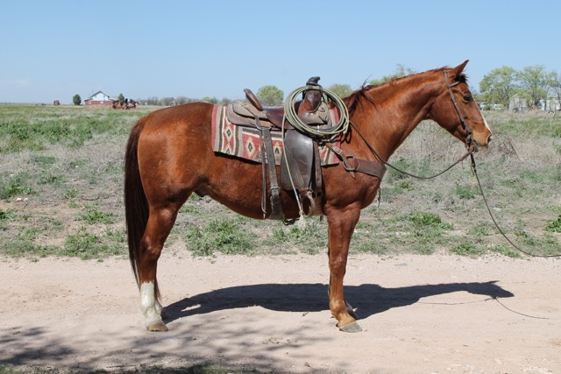

9 | SATIN LIL SUGAR | 4000447
 | 2000 CHESTNUT GELD | COLE BURSON
 |  | Sugar Bars
 | Satin ‘N’ Sugar
 |  | Angel Note
SATIN SUGARITO
3528452
 |  | Peppy Chex Doc
 | Peppys Sweet Rose
 |  | Ima Sugar Chick
 |  | Sugar Bars
 | Satin ‘N’ Sugar
 |  | Angel Note
LIL SUGAR BONITA
3201705
 |  | Milford One
 | Gentle Impression
 |  | All I Do
Good with his feet and loads easily. Quiet in cattle. Has been ridden in ranch rodeos and outside a lot. Gentle.
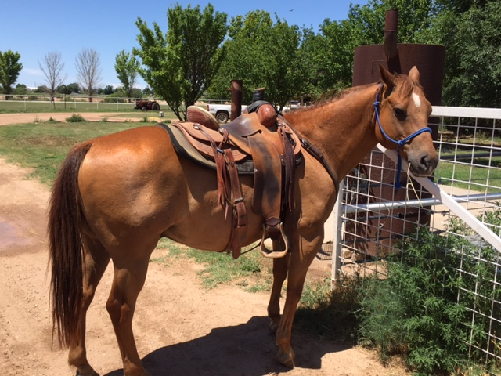

10 | DOCS NOEL | 4748306
 | 2005 BUCKSKIN GELD | C W MORRIS
 |  | Gay Bar King
 | Somekinda Magic
 |  | Poco Miss Solis
DOCS RAZMATAZ
3827028
 |  | Pajarito Doc
 | Graygo Sunshine
 |  | Razmataz Jet
 |  | Winning Hit
 | Quarter Hit
 |  | Star Lady Kay
TEDS CHEQUITA
2579182 |  | Spanish Mac
 | Spanish Lita
 |  | Bellita Sue
“Shiner” is an easy keeper that everyone wants to ride when they show up at the house. Go rope both ends or gather cattle in the rocks and rough country. You can leave him sitting for as long as you want, then cinch him up and lope off. Kids have ridden him at play days and we have used him at a few ranch rodeos. Hauls and shoes easily. (Four black hooves) You can ride off like Marshal Dillion on this guy.
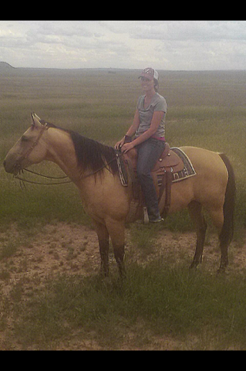

11 |  | SMOKE | GRADE
 | 12 YR OLD GRULLA GELD |  | KOLYN DUTTON

“Smoke” is an all-around horse. You can head, heel, and breakaway rope on him. You can run barrels, poles and tie goats on him. He has had a lot of cattle doctored on him outside. Travels good and is handy to have around.

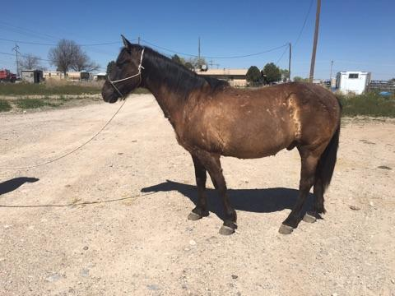

12 |  | SOCKS | GRADE
 | 7 YEAR OLD BROWN GELD |  | DAVE MCINTOSH

Nice gentle ranch horse. Has had a little bit of everything done on him. He has been used at Roswell Livestock Auction. Has been used to drag calves and has been roped off some in the arena.

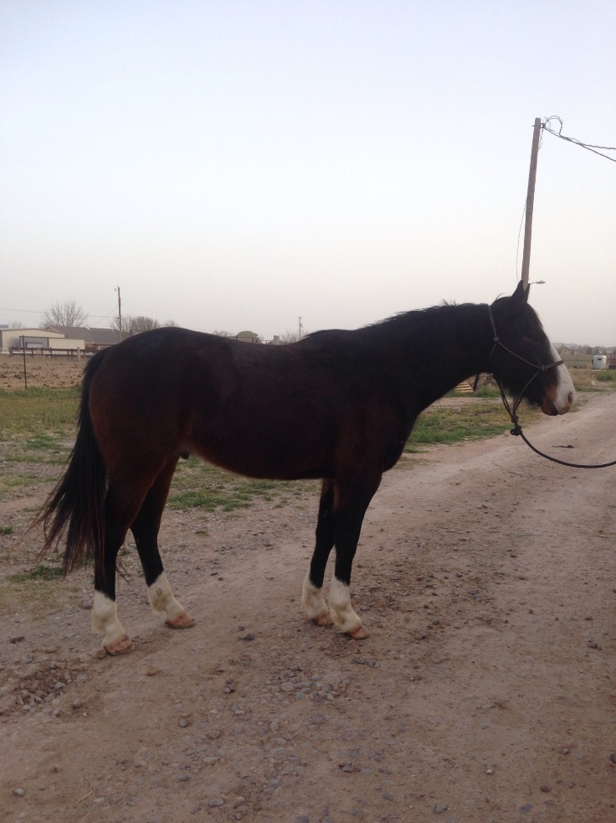

13 | TEXAS SILVER COYOTE | 4452039
 | 2003 GRAY GELD | WESLEY GRAU
 |  | Deck Trouble Bar
 | Deck Trouble Skipbar
 |  | Princess Yen
MR GRAY COYOTE
3592674 |  | Coyote Colonel
 | Miss Hickory Coyote
 |  | Hickory Dickory Miss
 |  | Strait Silver
 | Turnin Silver
 |  | Turnin Around
MISS TEXAS SILVER
3513936
 |  | Gamblin Ticket
 | Texas Ticket
 |  | Texas Holly Bee

“Tejas” has done everything on a ranch. He has a laid back personality, but responds well to leg pressure. Has been shod a lot and can get the job done. Can strip calves, pen bulls, and drag calves. We have owned him since he was weaned. Good horse, handles really well, and he is sound in every way.
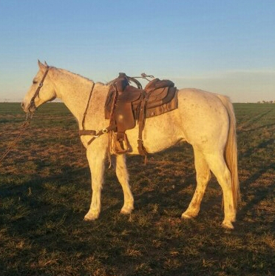

14 | SIXES WIMPY | 4590649
 | 2004 SORREL GELD | WAYNE METCALF
 |  | DANNY CAMP, AGENT
 |  | Nu Cash
 | Nu Chex To Cash
 |  | Amarillo Chex
WIMPYS LITTLE STEP
3863115
 |  | Fourty Seven
 | Leolita Step
 |  | Step Lite
 |  | Doc O’Lena
 | Tanquery Gin
 |  | Gin Echols
NATURAL SENSE
3554482
 |  | Coe Badger Two
 | Natural
 |  | Miss Cee Bar 99

Very Nice gelding 14.2 hands tall. He will spin a hole in the ground. Have been roping calves on him at the numbered calf ropings. He has a great stop and will get back on that rope. Super horse, anyone would love to own him. Sound, gentle, and the kind.

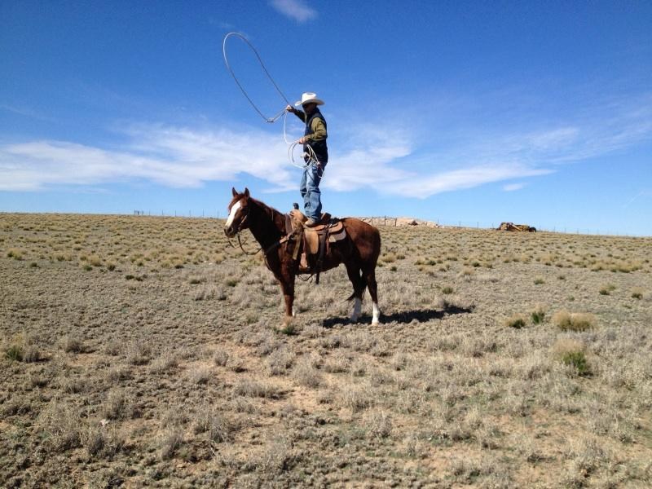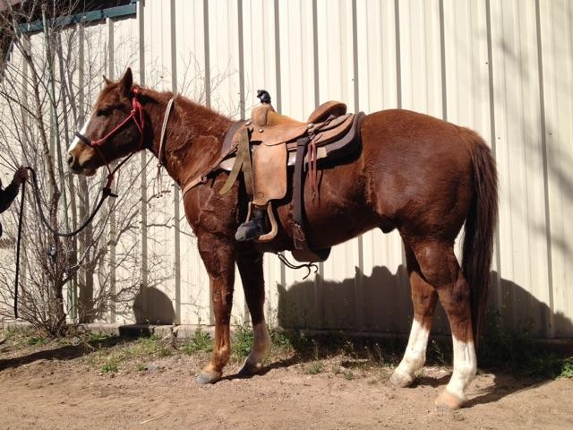

15 | DOCS QUICK PEP UP | 5412050
 | 2011 GRAY GELD | DENNIS KLINGHAGEN
 |  | Tee J Badger Boy
 | Dels cutter Jay bar
 |  | Jay Missy
DOCS QUICK PEP UP
3409925 |  | Brays Badger Bar
 | Pretty Bonnie Zero
 |  | Pretty Bonnie Bray
 |  | Doc’s Hickory
 | Pep Up Hickory
 |  | Escondida Peppy
DOCS PEPPY HICKORY
3966885 |  | Salty Doc One
 | Quick Gray Girl
 |  | Quick Charlotte
“Cutter” is a really built gray quarter horse gelding. Only a 5 year old, he rides low headed and quiet. He needs a little more outside riding but is coming along really well. I’ve roped a few calves in the lane & have followed the Hot Heels on him. He has never offered to buck and want to please. Sells 100% sound. We’ve enjoyed having him around.
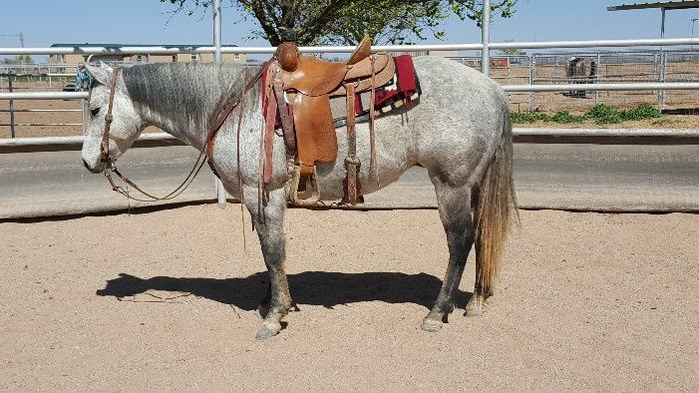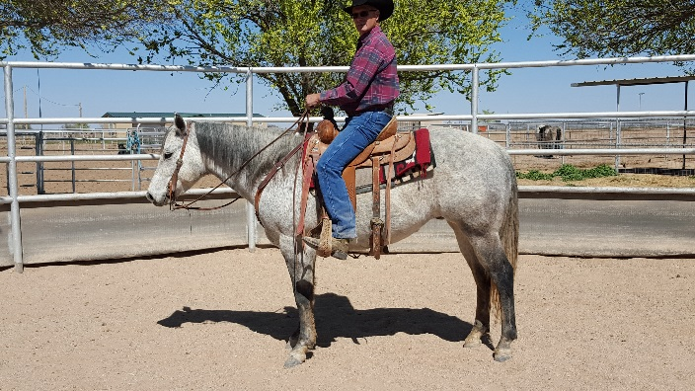

16 | CATT KIKN A LIL ACE | 5418323
 | 2010 SORREL GELD | SAM COBERLY
 |  | High Brow Hickory
 | High Brow Cat
 |  | Smart Little Kitty
SOPHISTICATED CATT
4342421
 |  | Peppys Boy 895
 | Shania Cee
 |  | Lynx Melody
 |  | Doc’s Hickory
 | SR Hallmarked
 |  | Doc’s Serendipity
LIL HOLY HALLMARK
3030431
 |  | Doc O Lena Twist
 | Little Girls Gremlin
 |  | Biggirlsdontcray

Bred up, fancy horse. Do it all on this one. Sort, cut, rope or ride, this horse will do it all. Really cowy and will ride around. Doctor cattle, drag calves, then haul him to the ranch sorting or cutting and win. Started very well on the heel side. Very willing to please and ready to be finished and go any direction. Sound and Gentle.

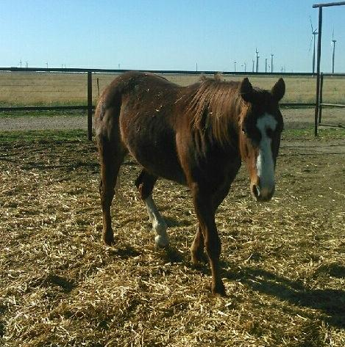

17 | LUCKY CHOICE HAND | 4355168
 | 2003 CHESTNUT GELD | CADE HOOTEN
 |  | Hired Hand’s Rey
 | Hired Hand’s Dee
 |  | HH Dee
HIRED HAND LUCKY
2522595
 |  | Lucky Roan King
 | Lucky Roan Miss
 |  | Explosive Snoopy
 |  | El Rey Rojo
 | Bolsa Rojo
 |  | La Bolseria
BOLSA CHOICE
3885810
 |  | Lord Peppy
 | Peppy Choice
 |  | Mickie Choice

“Ed” is a using horse deluxe. He has been used in all aspects of ranch work, from riding pens, to roping bulls, He can go all day and make the outside swing. “Ed” is sound and sane. He has been used extensively on a yearling operation and tied down a bunch of calves. He has the good looks to go with his ability.
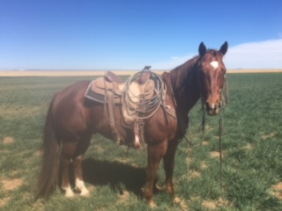

18 | RBS PEPPY SAN VILLA | 4963906
 | 2007 PALOMINO GELD | JERRIVON THOMAS
 |  | Peppy San
 | Imapeppysandoc
 |  | Doc’s Madonna
REBS PEPPY SAN
3490207
 |  | Doc’s Tom Thumb
 | Mame Baby
 |  | Cutter’s Mame
 |  | Mr San Peppy
 | Peppy San Badger
 |  | Sugar Badger
PEPPY SAN VILLA
3057982
 |  | Doc Holliday
 | Holliday Villa
 |  | Marvilla Alejos

This is a super broke gelding. He has been used in the feed yard, wheat fields and has had lots of cattle roped on him outside. He has lots of cow and is an easy keeper. Sound and Gentle.
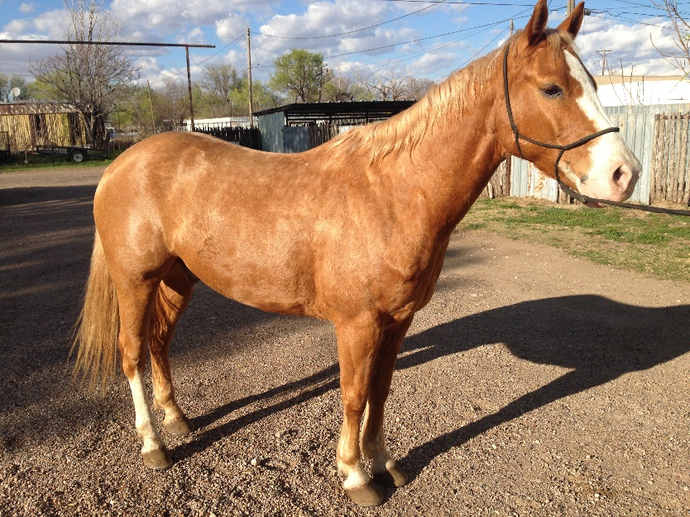

19 | JACKS DARLIN GEMINI | 5336764
 | 2010 SORREL GELD | JERROD HARRAL
 |  | Two Eyed Jack
 | Jack Two Star
 |  | Starabar
JACKS BLUE BONITA
3807631 |  | Mr Gray Bonita
 | Bonita Blue Barby
 |  | Higgins Gal Two
 |  | Joe Country
 | Masterful Hancock
 |  | Masterful Leona
MASTERFUL DARLING
4111669
 |  | Smoky Sundance
 | Darling Sundance
 |  | Eds Darling Deck

Has been used for general ranch work. He has been used to doctor wheat and grass cattle. Sound and Gentle.

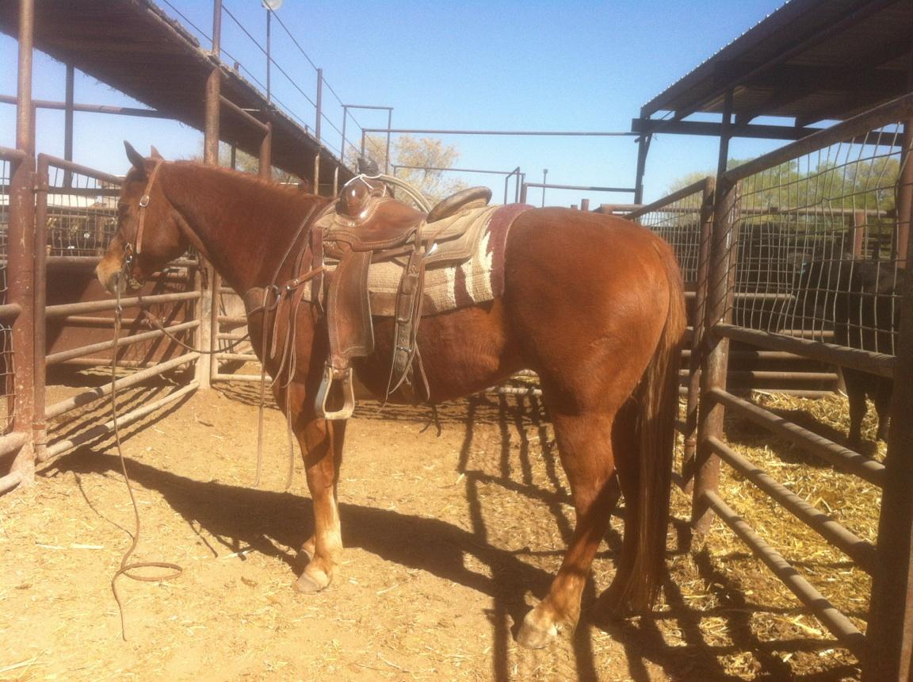

20 | CHILDRESS DOC PEPPY | APHA 1024827
 | 2012 BLK TOBIANO GELD | KELLY HATLEY
 |  | Peppy San Cuss
 | KG Hockley Peppy San
 |  | Frecklescolord ReyJay
CHILDRESS BLACK PEPPY
APHA971864 |  | Cutters Judge
 | Nan Badger Two
 |  | Rocking Badge
 |  | Poco Judge Texas
 | Cutters Judge
 |  | Miss Black Chance AQHA
LENA CUTTER DOC
APHA691223 |  | Doc’s Stinger AQHA
 | Doc Olena Sting
 |  | Naomis Cat AQHA

“Pepper” has had a lot of cattle doctored on him. He has been used on big drives. We have been heading on him for the last six months and he is ready to be hauled to ropings. 100% sound and gentle, Very nice prospect.
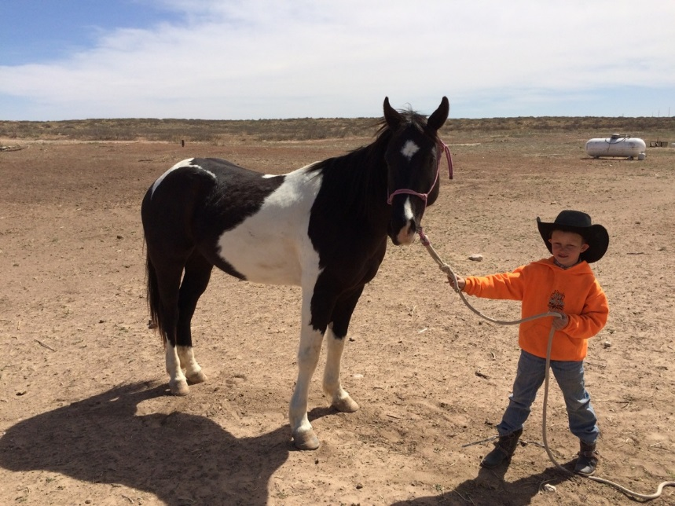

21 | MARIACHI | GRADE
 | 6 YR OLD RED ROAN GELDING | ROSENDO APODACA

14 ½ hands. Been used in feedlot and outside. Knows all the cowboy work. Real Gentle. 100% sound.

22 | CLASSY POCO OJOS | 4797406
 | 2004 PALOMINO GELD | E C CATTLE
 |  | Poco Bueno
 | Poco Ojos Grande
 |  | Wimpy’s Ojos
POCO OJOS DIEGO
3844470
 |  | Poco Diego
 | Poco Chulura
 |  | Chula Duquesa
 |  | Sassy Doc
 | Poco Gay Doc
 |  | Miss Gay Space
SHEZA CLASSY SASSY
2645439
 |  | String’s of Gold
 | Strings of Amber
 |  | Amber Mine

“Bandido” very gentle Palomino gelding with all the chrome you could ask for. Been used outside extensively, drug calves, and caught cattle outside. Stands 14.1 weighs 1075. He’s been headed and heeled on in the arena. Loads and hauls well, stands good to shoe, and very easy to catch. Sells 100% sound.

