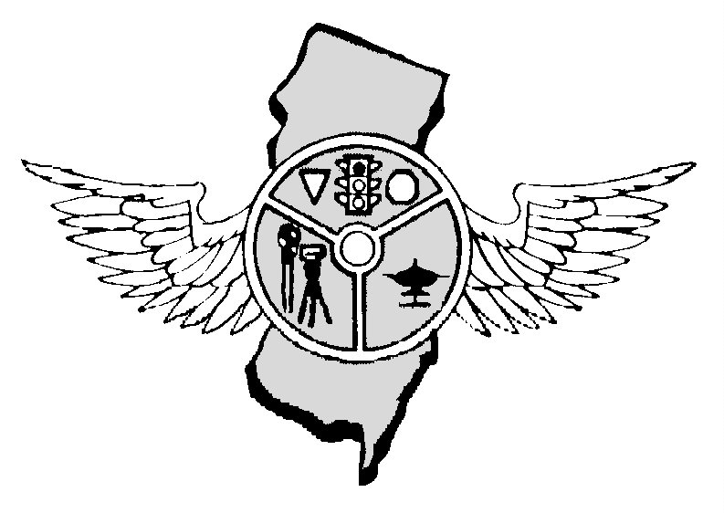

JANUARY 2017 OUR 42nd YEAR

Timothy Franco, President Tony Parenti, Executive Director, Editor Nick Schock, First Vice-President Mark Wilson, Operations Secretary
NJPTOA - P.0. Box 664, Voorhees, NJ 08043 - 856-220-1433 – njptoa@hotmail.com. Website – njptoa.org
REGULAR BUSINESS MEETING: January 4, 2017, beginning 10:00 A.M., at AAA Mid-Atlantic, Hamilton, NJ. SPEAKER: Brian Ferry presentation for Laser Technology, Inc.
PRESIDENT’S MESSAGE: Now with the Holidays behind us it’s time to get back to work - where does the time go? It seems like only a day or two ago I was bringing in the year 2016 and here we are into 2017. I wish I had a crystal ball so I could predict what the year 2017 will bring to law enforcement. Early indicators appear we are in for a good year. Looks like our Training Course on Commercial Vehicle Enforcement for Municipal Police Officers is a big hit with 70 officers registering from 38 different departments. More classes will be scheduled in 2017. For more information or register for an upcoming class check with our Training Coordinator at rlmax@att.com. The new NJTR-1 has been posted on our website. Unless circumstances go beyond control the new report will go in effect on 1 January 2017. I am going to ask our Training Coordinator, Richard Maxwell, to schedule classes on the report as soon as possible. If you have any suggestions for other type of training classes please let us or the Training Coordinator know. Stay Safe - Tim
REDUCE CRASH RISK: Here are some tips drivers can use to help reduce the risk of a crash while driving in the winter: Plan your trip - Check weather forecasts and possible construction areas along your route, plan fuel and meal locations, and allow extra time for traffic delays. Compensate for poor traction by slowing down and making all movements gently - never drive faster than conditions allow. Double or triple your following distance and "never" tailgate. Try to build as much separation between you and other vehicles. Keep at least a ten second following distance when driving on snow and ice covered roads. Avoid driving in packs. Black Ice: Black Ice is a weather phenomenon in which an extra thin layer of ice forms on the road. Its shine can fool drivers into thinking it’s water. This shiny ice surface is one of the most slippery road conditions. Black ice is likely to form first under bridges & overpasses, in shady spots & at intersections. Get in the habit of easing up on bridges. Bridges & overpasses are often the most dangerous in the winter since they freeze before roadways. Brake gently to avoid skidding. If you begin to skid: Take your foot off the gas and shift to neutral. Next steer in the direction you want your car to go. Before the rear wheels stop skidding, shift to drive and gently press the accelerator. Do not slam on the brakes. Stay alert....keeping window slightly open to provide fresh air is a good idea. Turn on your lights and keep them clean. Turn OFF the cruise control - Don't use cruise control or overdrive on icy roads. Drivers need to be aware of becoming overconfident if they have antilock brakes. If the brakes happen to lock, release them to avoid sliding, and helps regain steering. Watch for melting or hard-packed snow and strong side winds. Check for ice by feeling the back of your outside mirror and watching the spray off tires. Watch for trailers pushing you on curves and turns. Shifting roadway product and icy roads are not a good combination. Drivers should monitor shipper's loading procedures to ensure weight has been evenly distributed within their tractor trailer. Don't ask your vehicle to do more than it can. If you don't feel comfortable driving, Park it.
LAW OFFICERS KILLED IN LINE OF DUTY: Reports indicate approximately 115 police officers were killed so far in 2016 with 48 of them in auto crashes (nearly 50 percent) 48 were killed by gunfire, and 17 percent from other sources. . TRAINING COORDINATOR REPORT: Richard Maxwell reports that the Commercial Vehicle Enforcement for Municipal Officers Class on 11/14 at AAA in Hamilton was full - 70 people and 38 different agencies attending. He is putting on more classes in 2017. Anyone interested may contact him at rlmax@aol.com. GOVERNOR SIGNS CLASS 3 SPECIAL OFFICER BILL: The Governor signed Senate Bill 2983 into law on November 30, 2016 and is now Chapter 68 S-86. The new law establishes Class Three special law enforcement officers to provide security in public and nonpublic schools and county colleges.
2017 MEMBERSHIP TARRIF NOW DUE: Police Departments are charged for membership dues and the department may send as many as they desire to our meetings but entitled to only one vote. Please arrange payment as soon as possible so we can put dues collection behind us and concentrate on other business. A bill for 2017 membership dues is attached to this newsletter. Thank you
As of December 19, 2016 there were 580 traffic fatalities in NJ compared to 462 during the same period in 2015, AN INCREASE OF 118 DEATHS.
COUNTY | 2016 | 2015 | CHANGE | COUNTY | 2016 | 2015 | CHANGE
Atlantic | 40 | 27 | +13 | Bergen | 35 | 36 | -01
Burlington | 48 | 42 | +06 | Camden | 34 | 38 | -04
Cape May | 12 | 11 | +01 | Cumberland | 31 | 18 | +13
Essex | 43 | 32 | +11 | Gloucester | 27 | 27 | -0-
Hudson | 26 | 24 | +02 | Hunterdon | 11 | 05 | +06
Mercer | 19 | 17 | +02 | Middlesex | 40 | 35 | +05
Monmouth | 49 | 40 | +09 | Morris | 19 | 15 | +04
Ocean | 40 | 36 | +04 | Passaic | 20 | 23 | -03
Salem | 14 | 09 | +05 | Somerset | 16 | 24 | -08
Sussex | 12 | 10 | +02 | Union | 26 | 30 | -04
Warren | 14 | 07 | +07
Deaths:Driver 317/263 Passenger 89/76; Pedalcyclist 18/10; Pedestrian 156/138. Crashes 550/454
THANKSGIVING ROAD DEATHS: 2016 – 5. Winslow, Passenger Car Driver, Passenger Car Passenger. Hackensack, Pending Passenger Car Passenger. Teaneck, Pending Passenger Car Driver. Ringwood Boro, Pending Passenger Car Driver. 2015- 12. Pohatcong Motorcycle Driver. Brick, Pedestrian. Maurice River Township, Passenger Car Driver. Holmdel. Passenger Car Passenger. Atlantic City Expressway, Passenger Car Driver. Long Branch, Pedestrian. Mount Holly, Passenger Car Driver. Voorhees, Passenger Car Driver. Bernards. Pedestrian, two Passenger Car Passengers Quinton, Passenger Car Passenger.
DELIMMA OF AUTOMATIC CARS: Self-driving cars are coming sooner than most people think. NHTSA is pushing for automatic cars as soon as possible in order to remove crash-prone drivers from the highway .But what happens to the Traffic Officer? What will become of the "traffic stop"? Will we be able to cite an occupant? He or she is not driving. Who gets the equipment violation? The vehicle manufacturer or Google since they will probably own the cars. Drivers wouldn’t be operating or maintaining the cars, and couldn’t be charged with failing to signal or driving with a broken taillight. If you or your neighbor has a recent model car with adaptive cruise control, lane assist, and collision avoidance, it already possesses the technology to drive itself. That means police departments need to begin to develop tactics and equipment that aren’t dependent on cruising and pulling people over. Such stops, along with traffic crashes, account for nearly 50 percent of all police-public encounters. Then there’s the more controversial pretext stop, where officers pull a motorist over for a violation in order to investigate a potentially more serious crime. For cops, it’s one of the most valuable tools of policing. Cameras at traffic lights and speed monitors are already rendering police cruising obsolete. Along with providing 24/7 traffic enforcement at a fraction of the cost of police, the cameras are capturing video of more serious violations as they occur. The experts agree, however, that innovations will make it far easier for police to quickly get to a scene. Google has already received a patent on light detection and recognition technology directing its driverless vehicles to clear the way for emergency vehicles.
SCHOOL BUS DRIVER HAD BAD DRIVING RECORD: The school bus driver who caused a horrific Baltimore crash that killed 6 people a few months ago was speeding, had a history of seizures and was involved in at least a dozen previous smash-ups, the feds say. Bus driver Glenn Chappell, 67, was among those killed when his yellow school bus careened into an oncoming MTA commuter bus on November 1, 2016. SUN VISORS: Sun visors on new cars will soon be covered by one more irremovable government warning sticker. Congress came up with the idea in a 2012 law that required information about filing safety complaints be provided in each vehicle's owner's manual, along with a card or sticker in the glove box or another "accessible" location -- lawmakers left the details up to NHTSA. NHTSA decided that the sun visor was a better location because it is much more prominent. The agency is taking public comment on the proposal until January 27, 2017. The proposal will take effect one year after the final rule is published in the Federal Register.
HOW SAFE ARE CARS WITH KEY FOB? A device that allows thieves to steal cars that use key fobs is now available. The device which allows a person to open car doors, start vehicles, and drive them away suggests criminals now have the technology locate and bypass the keyless theft prevention countermeasures. The device is about the size of a smartphone and is used to capture a signal from a nearby key fob and use the signal to gain entry. The device was tested on used cars at dealerships, an auto auction, and other cars. In 19 of its 35 tests the device opened the vehicle. In 18 of these 19 entrees it was able to start the vehicle and drive away.

NEXT MEETING: JANUARY 4, 2017 – AAA BUILDING IN HAMILTON, NJ !
REMEMBER TO WEAR YOUR SAFETY BELTS AND BULLETPROOF VEST WHILE ON DUTY

NJ Police Traffic Officers Association
PO Box 664
Voorhees, NJ 008043
856-220-1433
E-MAIL: njptoa@hotmail.com

2017 INVOICE

DATE | ITEM | AMOUNT
1/1/2017 | Annual Membership Dues for Police Department | $50.00
 | TOTAL: | $50.00

DATE: 1/1/2017 SIGNED: Timothy Franco, President.
Our Tax ID number is 22-2344113
Copies of purchase orders can be faxed to 856-783-0012 or scanned for an e-mail and sent to NJPTOA@Hotmail.com.

Note: If you would like to receive the newsletter by e-mail instead of by postal mail, please send your request to njptoa.tparenti@gmail.com

(Please check mailing label. Correct if necessary by phone call, text, or e-mail)

