RSAI Leadership Meeting Agenda September 18, 2018
2:00 PM

Agenda:

- Voting:
- Motion 1: approve minutes of the August 15 RSAI Leadership Group Meeting.
- Motion 2: approve the financial report and bills paid, including amount due to ISFIS for 85% of FY 2018 dues less ISFIS discount (total $48,025 -
$400 = $47,625) and additional regional meeting cost reimbursement, postage, brochure printing, for a total of $49,512.61 of which $1,887.61 was approved at the August Leadership Group meeting, for a balance of
$47,625.
- Motion 3: approve of the RSAI priorities for the 2019 Legislative Session,
including request for Iowa's Medicaid plan to cover telehealth services for students with mental health needs in the RSAI menial health priority for the 2019 legislative Session.

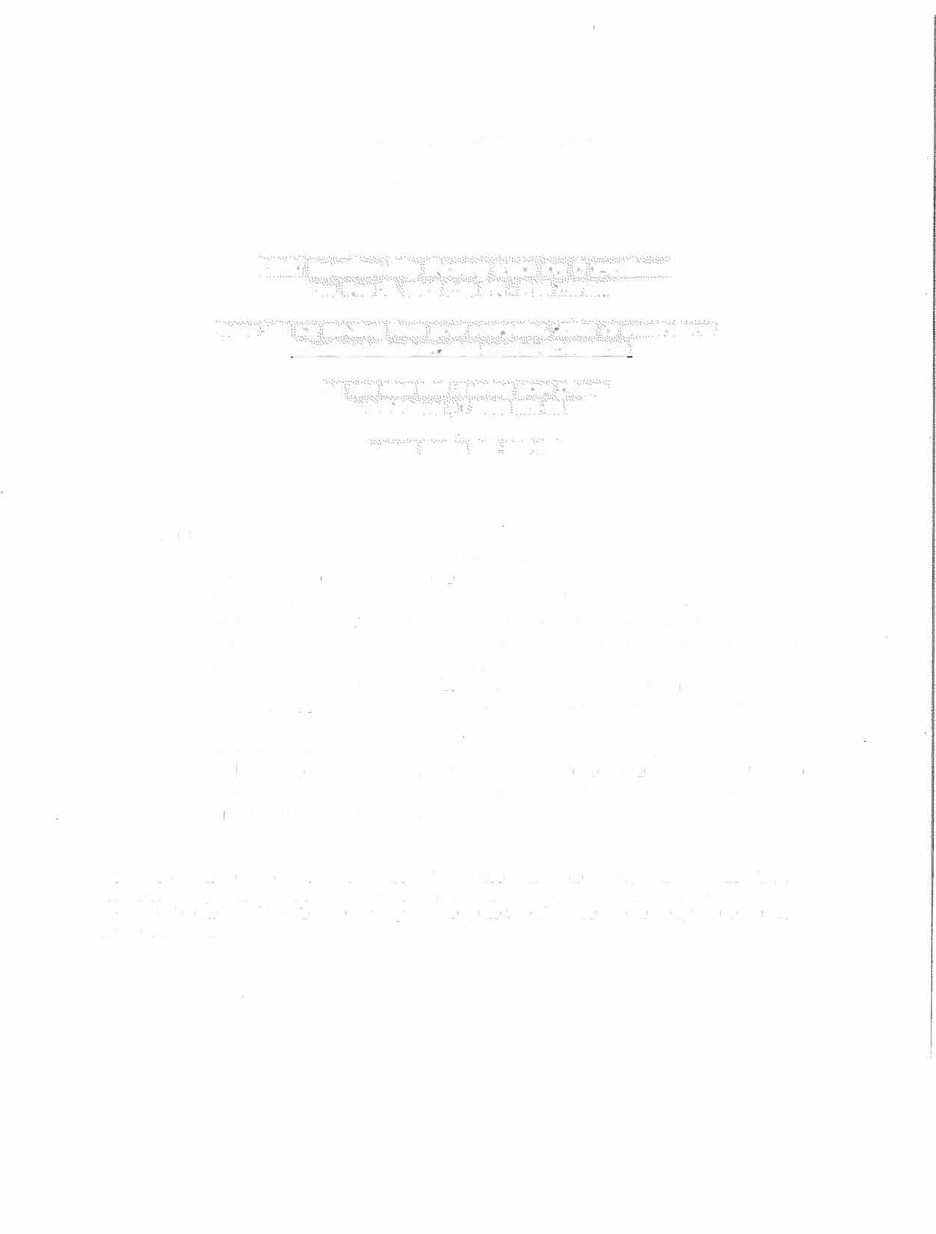
Adjourn

Please reply with your electronic vote and we will announce at the gotomeeting at 2:00 on Tuesday. You are welcome to join the meeting if you'd like to vote in person, but it's not necessary. If you plan tojoin, here's the info and we'lljust do sound through the computer, so if you want to call in by phone, use the information below:

