Mars UP Church
Come Holy Spirit, Come
Before the Service – Speak to God!
During the Service – Let God speak to you!
After the Service – Speak to each other!

(*Please stand, if able)
Welcome and Mars Messages

Prelude

Apostles’ Creed
I believe in God the Father Almighty, Maker of heaven and earth; and in Jesus Christ His only Son our Lord; who was conceived by the Holy Ghost, born of the Virgin Mary, suffered under Pontius Pilate, was crucified, dead and buried; He descended into hell; the third day He rose again from the dead; He ascended into heaven, and sitteth on the right hand of God the Father Almighty; from thence He shall come to judge the quick and the dead. I believe in the Holy Ghost, the holy catholic church; the communion of saints; the forgiveness of sins; the resurrection of the body; and the life everlasting. Amen.

Gloria Patri
Glory be to the Father, and to the Son, and to the Holy Ghost. As it was in the beginning, is now and ever shall be,
world without end.
Amen. Amen.

The
Lord’s Prayer

Our Father,
who art in heaven,

hallowed be Thy
name,

Thy kingdom come,
Thy will be done,
on earth
as it is in heaven.

Give us this day
our daily bread;

and forgive us
our debts,
as we forgive
our debtors;

and lead us not
into temptation,
but deliver us
from evil.

For Thine
is the kingdom,
and the power,
and the glory,
forever. Amen.

The Doxology

Praise God
from whom
all blessings flow;
praise Him
all creatures
here below;
praise Him above,
ye heavenly host;
praise Father, Son,
and Holy Ghost.
Amen.

The Call to Worship

Leader: From shore to shore---

People: Let God’s praise be sung.

Leader: From mountains high to valleys low--

People: Let the echo of praise resound.

Leader: From the mouths of children and the prayers of the
saints—

People: Let thanksgiving abound.

Leader: For great is our God

People: And greatly to be praised.

Pastoral Invocation

*Hymn 225
Come, Christians Join to Sing

Prayer of Confession
Look deep, Loving God, and see us as we really are – yearning to be close to you, yet fearful of what you may ask; desiring to be faithful, yet hesitant to go the extra mile; wanting to be loving, yet resistant to caring in particular situations. Loving God, we are a tangled vine. Prune us and train us to grow in your holy ways.

*Assurance of Pardon
*Gloria Patri

Passing of the Peace
Leader: May the peace of Jesus Christ, the love of God, & the fellowship of the Holy Spirit be with you all.
People: and also with you

Scripture Psalm 33
Matthew 2nd

Morning Message Rev. Robert Kennedy
“Christmas in July”

*Hymn 343
“Amazing Grace”

Prayers of the People and Lord’s Prayer

Offering
*Doxology
*Offering Prayer

*Hymn 250
“O Little Town of Bethlehem”

*Benediction

*Congregational Response (Everyone sings)
May the Peace of the Lord Christ
go with you, whenever He may send you.

May He guide you through the wilderness,
protect you through the storm.

May he bring you home rejoicing
at the wonders He has shown you.

May he bring you home rejoicing
once again into our doors.

Church Staff
Rev. Brian Hauser
Pastor
pastor@mars-up.org
724-689-3412

Ms. Jamie Daugherty
Choir Director & Organist
JamieD0714@gmail.com

Mrs. Shelly Bocheff
Administrative Assistant
marsup@mars-up.org

AV TEAM
Alma Staskiewicz, Lisa Barbour, Marie Matthews, Bill Guesman, John Ivory, Keith Nichols, Mike Bocheff, Herb Wellman

Mars United Presbyterian Church

232 Crowe Ave
PO Box 805
Mars, Pennsylvania 16046
724-625-1365
www.mars-up.org
marsup@mars-up.org

Church Office Hours:
Mon -Thurs from 9 a.m. -2:30 p.m.
Morning Worship:
10:00 am

5th Sunday after Pentecost

Prayer of Preparation
Lord, we come to you today with so many things on our hearts.

You call us to be in relationship of trust and love with you and you offer healing to us for those portions of our lives that are broken and injured.

Help us to be open to your mercy and healing love. For we ask this in Jesus’ Name.
AMEN.

*Postlude

Lisa Foster would like to thank everyone for the many cards, prayers and thoughtful words of comfort during the passing of her sister, Beth.

Please welcome Rev. Robert Kennedy today to the pulpit. We are blessed to have his talents with us today.

Mars United Presbyterian Church
Welcome!

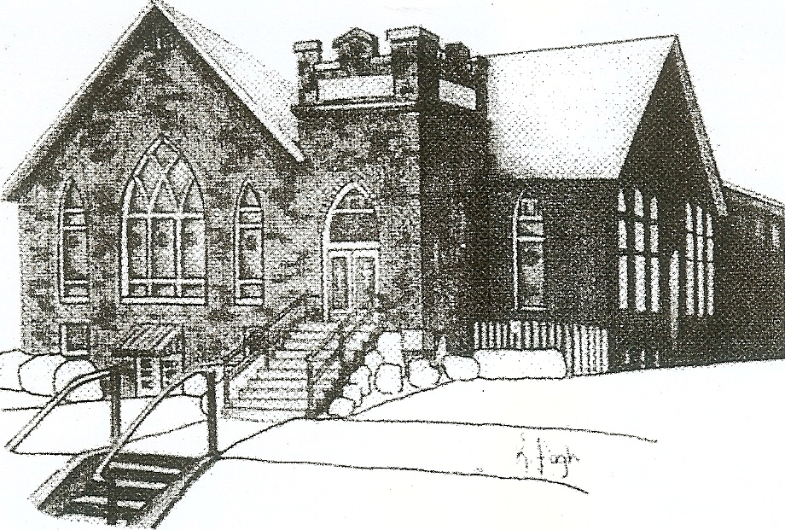
We are your hometown church: Faithful to Tradition, Loving in Fellowship, & Reaching for Tomorrow!

July 10, 2022

We welcome you and we are glad you’ve chosen to Worship with us today!

CALENDAR: July 10, 2022 – July 17, 2022

Church Office Hours: Monday -Thursday from 9 a.m. – 2:30 p.m.

Today, July 10, 2022 Guest Minister Rev. Robert Kennedy
VOLUNTEERS☺

LAST SUNDAY’S In-House ATTENDANCE:

LAST SUNDAY’S OFFERING:
Operating Funds:
Kindness Offering:
Mission:
Memorial:

Tarry N Talk Hosts
Deacons Committee
10:00 a.m. THE MORNING WORSHIP SERVICE
Monday, July 11, 2022
6:30 pm Griefshare
Tuesday, July 12, 2022
9:00 am A team
7:00 pm AA Meeting
7:00 pm Stewardship Meeting
Wednesday, July13, 2022
9:00 am Material Girls
Thursday, July 14 2022
Friday, July 15, 2022
Saturday, July 16, 2022
Sunday, July 17, 2022
10:00 am THE MORNING WORSHIP SERVICE

Welcome to all who are Worshiping with us today!
Guests
We sincerely hope our service is a blessing to you. We ask that our guests please take a few minutes to complete one of the Connect Cards found in the pew holder.

Should you have questions regarding any aspect of our church, including membership, please contact Pastor Brian or the church office during the week at 724-625-1365. Thank you for being with us today.

PRAYER – JOYS & CONCERNS
Lou Beckwith Kennedy (Great Granddaughter of Marlene Edwards
Patty Jackson Paige Barbour (daughter of Andrew and Steph Barbour
Reid Christopher Hall (June Stirling’s nephew) Maria Elizabeth McKaveney (June Stirling’s niece)
Lindy McCartney (Lisa Barbour’s Sister) Isabel Boynton
Lisa Foster and family

ANNOUNCEMENTS
Bulletins are printed Thursday mornings; let us know if you have an announcement…

SAVE THE DATE Mars UP church annual picnic will be held Sunday, September 11th at Adams Township Park. We will also be celebrating Rally Day this Sunday. More Details to Follow!!

GRIEFSHARE SUMMER MEETINGS Griefshare will continue to hold one monthly meeting during the summer. Meetings will be held on July 11th, and August 8th. The fall session will resume on September 12th at 6:30 For more information, please contact Denise @ ddemarco5@yahoo.com
COMING THIS FALL Mothers of Preschoolers (MOP) group starting at Mars UP Church. To register or questions contact church office or Ashley Hauser at 814-270-9101. More details to follow!!
SAVE THE DATE Sunday, September 18th we welcome Michael Kelly Blanchard, storyteller and musician. Michael will be joining us for worship at 10 a.m. and will also be back at 6:30 for an evening of music and drama. For more information on Michael, please visit his website, michaelkellyblanchard.com.

