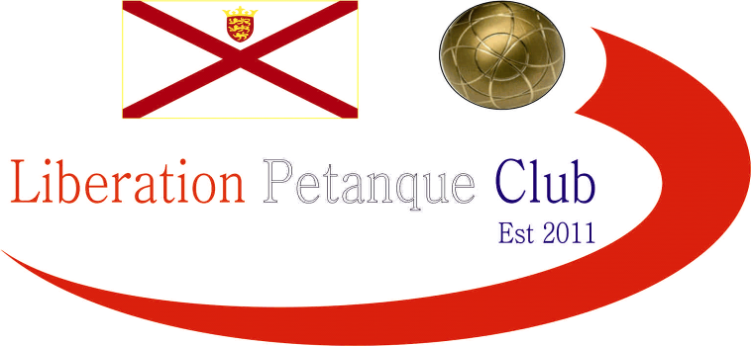

2022
International Triples Open

Just eleven teams took part in our first International Triples Open after a late withdrawal in our first weekend of competitions.

A good start for Island Triples champions Matt Buesnel, Laurent Pellaton & Geoffroy Buffetrille winning 13 – 6 over local players Andrew Limbrick, Stephen Leathem & Roy Noel.

Good wins also for Callum Stewart, Paul Bell & Toby Northern 13 – 7 over Jay Geldert, Tony Griffiths & Dave Snook and Neil Selby, James Gennoe & Ross Payne also 13 – 7 over Gareth Smart, Clifton Gonsalves & Jim Page.

Wins for all three Scottish trios as John Wilson, Robert Stronach & Derek Adam won 12 – 10 over Gary Cowburn, Wendy Ritzema & Colin Myers and Michael Watt, Laura Adam & Alec Davie beat Cassie, Jean & Alex Stewart 13 – 8. The latter trio of Shirley Legge, Lynn Jenkins & Gemma Foster had a bye.

Round two saw some big wins as Derek, John & Robert beat Callum, Paul & Toby 13 – 1, Colin Gary & Wendy beat Jay, Dave & Tony 13 – 2 and Geoffroy, Laurent & Matt beat Michael, Laura & Alec 13 – 3.

A good win for Cassie, Jean & Alex 13 – 10 over Gareth, Clifton & Jim.

Round three saw a huge result for James, Neil & Ross winning 13 – 1 over Geoffroy, Laurent & Matt to make it three from three. A big win also for Derek, John & Robert 13 – 3 over Cassie, Jean & Alex.

Callum, Paul & Toby recovered to win 13 – 10 over Gareth, Clifton & Jim.

Round four saw James, Neil & Ross lose to John, Derek & Robert who now topped the Swiss rankings after four rounds with four wins.

The first thirteen zero of the International Triples Open saw Shirley, Lynn & Gemma beat Callum, Paul & Toby. Another defeat also for Geoffroy, Laurent & Matt over Colin, Gary & Wendy for back-to-back defeats.

Welsh team Jay, Tony & Dave got their second win after a bye in Round three winning comfortably 13 – 3 over Michael, Alec & Laura.

With eight out of eleven making it into the Main competition plenty to play for in the final round.

Top spot went to Derek Adam, John Wilson & Robert Stronach with five wins from five winning 13 – 3 against fellow Scottish team of Shirley Legge, Gemma Foster & Lynn Jenkins who finished fourth.

Geoffroy, Laurent & Matt made their opportunity count winning thirteen zero against Cassie, Jean & Alex to finish sixth, with the latter finishing last. James, Neil & Ross recovered winning 13 – 5 against Colin, Gary & Wendy to finish second with the latter finishing third.

Welshman Gareth & Jim playing with Englishman Clifton, won 13 – 0 over Welsh Trio of Dave, Jay & Tony to get into the Main in seventh.

Callum, Paul & Toby win over Andrew, Stephen & Roy gave them fifth spot with Andrew, Stephen & Roy taking the last sport in the Main by six points on points difference.

Well Done to Scottish trio of John Wilson, Robert Stronach and Derek Adam topped the rankings winning all five matches.

Final Swiss Rankings

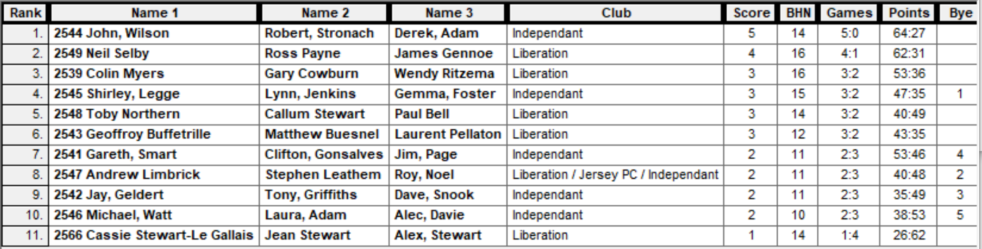

The Main Competition

Quarter Finals

Ranked 1st John, Robert & Derek v Andrew, Stephen & Roy Ranked 8th

Ranked 2nd Neil, Ross & James v Gareth, Clifton, Jim Ranked 7th

Ranked 3rd Colin, Gary & Wendy v Geoffroy, Laurent & Matt Ranked 6th

Ranked 4th Shirley, Lynne & Gemma v Callum, Paul & Toby Ranked 5th

Well, what a surprise in the quarter-finals as top ranked team of John, Robert and Derek who only conceded an average of just 5.5 points per game- in the Swiss qualifying rounds were timed out losing to Andrew, Stephen & Roy 11 – 8! As the Swiss Curse truck again. They had only won two of their five matches with a minus points difference of eight.

The second ranked team of Neil, Ross & James struggled against the Welsh team of Gareth and Jim who were playing with Englishman Clifton, but they did run out winners in the end 13 – 11.

Third ranked team of Colin, Gary & Wendy could not repeat their qualifying form as favourites Geoffroy, Laurent & Matt won comfortably 13 – 4 gaining revenge for their 13 – 3 loss in Round four.

The final quarter-final saw a repeat of round two with Gemma, Lynn & Shirley having beaten their opponents Callum, Paul & Toby 13 – 0. They started off where they finished leading 5 – 0 before Callum, Paul & Toby finally got on the scoreboard, a big shot by Toby firing the coche out for four points followed by a carreaux on the next end turned the match around as they ran out 13 – 7 winners.

The Main Competition

Semi Finals

Ranked 2nd Neil, Ross & James v Geoffroy, Laurent & Matt Ranked 6th

Ranked 5th Callum, Paul & Toby v Andrew, Stephen & Roy Ranked 8th

Well, the first semi-final was a battle of skill all the way to 13 – 12 in favour of Geoffroy, Laurent & Matt as the latter trio gain another revenge after losing to their opponents 13 – 1! In round three.

The second semi-final was running away from Andrew, Stephen & Roy who were losing heavily before a spirited fight back, but several missed chances saw Callum, Paul & Toby close out the match 13 – 11.

Third place went to Neil Selby, Ross Payne and James Gennoe beating Andrew, Stephen & Roy 13 – 3.

The final started off well for Callum, Paul & Toby picking up three points on the first end, but they struggled to keep a grip on the game with Geoffroy, Laurent & Matt running out 13 – 6 winners.

2022 – Winners – Matthew Buesnel, Geoffroy Buffetrille & Laurent Pellaton

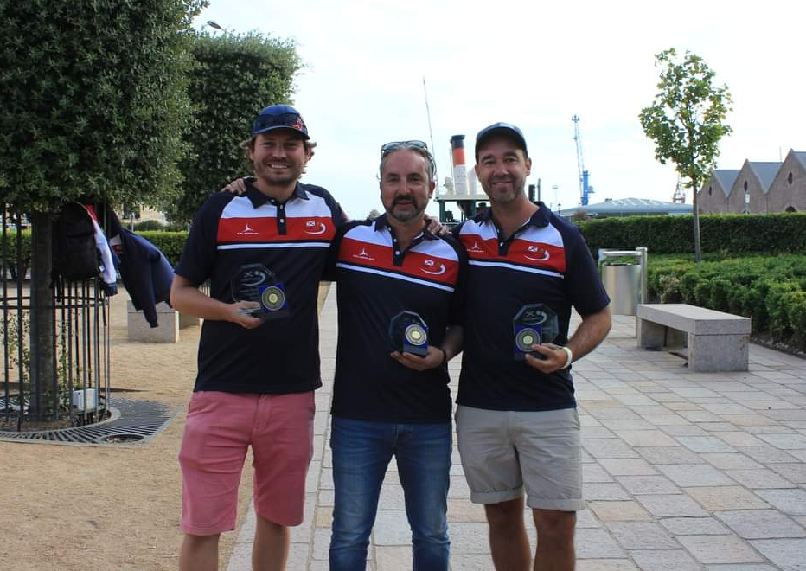

The Plate Competition

Semi Finals

Ranked 9th Jay, Tony & Dave v BYE Ranked 12th

Ranked 10th Michael, Laura & Alec v Cassie, Jean & Alex Ranked 11th

Due to only eleven teams the Plate went straight to the Semi-Finals with Jay, Tony & Dave being the highest ranked team in the plate getting a bye straight to the final.

In the other semi-final Alex, Cassie & Jean hit top form winning comfortably 13 – 1 over Michael, Laura & Alec who finished third as a result.

The final of the Plate was a close match, but it was the Welsh team of Jay Geldert, Tony Griffiths and Dave Snook who ran out winners 13 – 10.

2022 – Plate Winners – Dave Snook, Tony Griffiths, and Jay Geldert

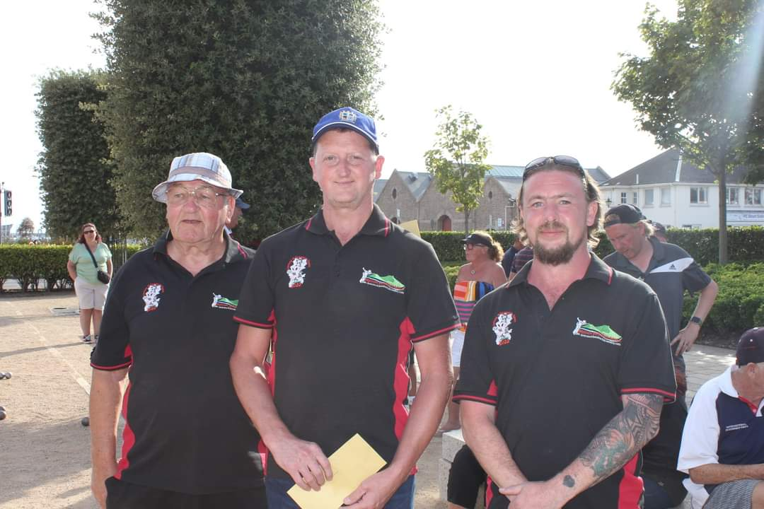

Thanks to all those who helped, especially Dawn Buckley on the day to make it another great competition.

Sponsored by



CoinShares | Digital Asset Investment Strategies for Professionals 🚀

Club email address - liberationpc@gmail.com

Club Website - www.liberationpetanque.co.uk

Kind Regards

Toby Northern

Chairman

Liberation Petanque Club

