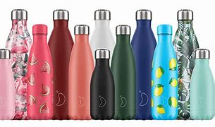
Sunday Club at home Lent
Hi Everyone hope you are all safe and well.
Would you believe that it is now week 3 of Lent?
I hope you are enjoying the activities.
Today we are going to explore the story of the Women at the Well.
So……… let’s explore!
The Story of the Women at the Well
- For younger Children
https://www.youtube.com/watch?v=6Vf3rqnoG5c
- for older Children
https://www.youtube.com/watch?v=QszHeIUsbTQ
Reflection on the Story
I hope you enjoyed the stories. They are all about being thirsty. I am sure that in your house like mine, there are lots of water bottles. I have them filled with water in the fridge, in my office, in the car and many other places. I like the colourful bottles they make me smile. I like drinking other things but my favourite drink when l am thirsty is water. The one thing these bottles have all in common is that they carry water, not quite as big as the Women at the Well had with her but they still hold water.
We are bit like the bottles, we are all different on the outside but more important is what we are filled with on the inside.
We can discover all about this in the story today.
Jesus was talking to a woman at the well, there are a couple of reasons why this seemed quite strange that Jesus would talk to her. For one thing she was a woman, and in those days, women were not really seen as being equal to men. Also, she was a Samaritan and Jesus would not be likely to talk to her, as that meant she was an outcast, someone you wouldn’t normally speak to. Also, she had done things in her life which she shouldn’t have done. She might have felt ashamed about that, and might have been worried about speaking to Jesus and wondered why he was talking to her.
But just as Jesus knows us, he knew this woman and he knew what she had done in her life and he told her he did. He said it didn’t matter. Because he could fill her with the living water given by the spirit. She went and told all her friends and more people came to listen and when they listened, they then followed Jesus and were all filled with the living water.
So, there are two types of water, the water we get from the tap and the Living water that comes from knowing Jesus and loving Jesus and having him in your life.
This is an image of a well in Jesus time. As you can see it was a hole in the ground that was supported by a wall being
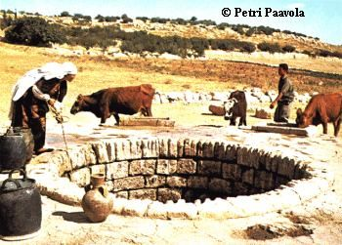

built up the walls of the well to stop it falling in on its self.
People would travel a long way to get water.
They would carry the large Jars on their heads which were very heavy.
- This is an image of a woman carrying a water Jar.
It was a Samarian woman who met Jesus at the well. And it was this woman who Jesus asked for a cup of water.
The woman was shocked because Samarians didn’t mix with the Jews and in fact were like outsiders, and Jewish people would walk pass them.
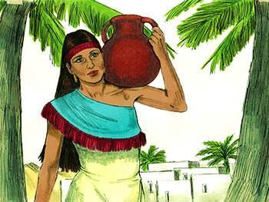
The man asked Jesus why he was asking her for water and commented that he didn’t even have a bucket.
I wonder ………
Who you would ask for a cup of water?

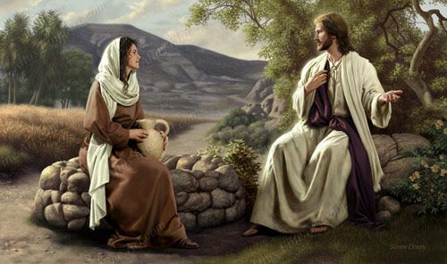
It is possible this is what it looked like when Jesus was talking to this woman.

Jesus was giving this woman a message. No matter what you have done in the past God Loves you and knows all about you. And the thirst-quenching water that the spirt gives us quenches out thirst for God and Jesus.

Songs
- God’s Love is Big
https://www.bing.com/videos/search?q=god%27s+love+is+big+youtube&&view=detail&mid=45FDBF3AE34BB5F557A345FDBF3AE34BB5F557A3&&FORM=VRDGAR

- Nothing too big
https://www.bing.com/videos/search?q=nothing%27s+too+big+doug+horley&&view=detail&mid=E943C405DDA4EC1E4E93E943C405DDA4EC1E4E93&&FORM=VRDGAR&ru=%2Fvideos%2Fsearch%3Fq%3Dnothing%2527s%2Btoo%2Bbig%2Bdoug%2Bhorley%26qpvt%3Dnothing%2527s%2Btoo%2Bbig%2Bdoug%2Bhorley%26FORM%3DVDRE
- Prayers
Lent bag activity
Using your water drop in your bag
Take your water droplet and write on the droplet with a felt tip the name of the person who you want God to fill with the living water. You can keep using this droplet because you can wipe it off and put someone else on the droplet.
When you have added the name hang the droplet up somewhere that you can see it to remind you to pray for the person that you put on the droplet.

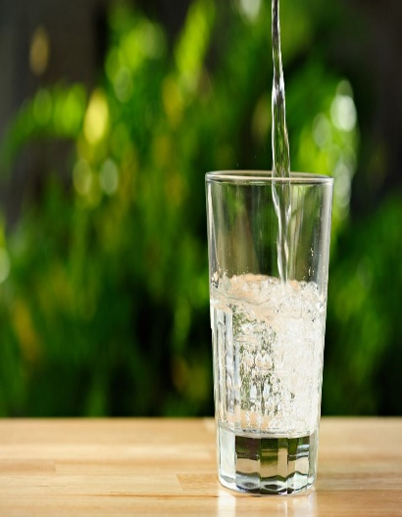
Prayer
- You will need
A bowl
A jug of water
Some stones (you
could use the stone
in your bag)
- What to do
Place the bowl on a table (not on the edge of the table in case it falls)
Then pour the water into the bowl from the jug.
Then add a stone at a time and pray for your family, your friends, the people that you miss, the things that you have done wrong this week.
You can add any other prayers that you want.

Prayer for clean water
We also need to pray for people who don’t have clean water to drink.
Hold your water droplet in your hand and say this pray.
Dear Lord
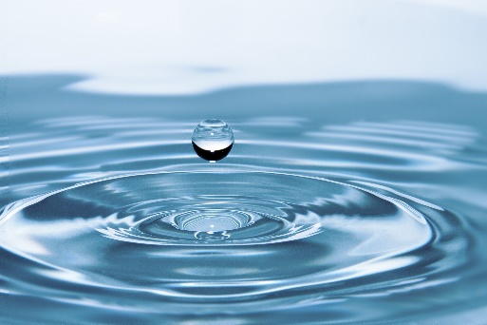
Please give clean fresh water to all children and adults in the world. Then when they are no longer thirsty fill them with the living water.

- Children saying the Lord’s Prayer
https://www.bing.com/videos/search?q=children+saying+the+Lords+Pryaer+video&docid=608016895576902480&mid=0208E402B68D0C636A680208E402B68D0C636A68&view=detail&FORM=VIRE

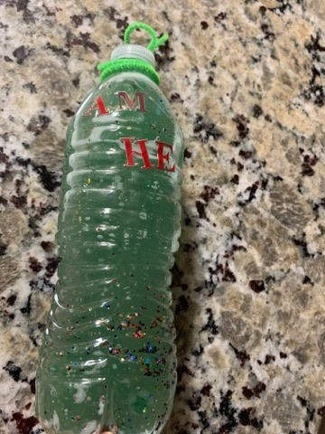
Activities
A lava lamp
- You will need
Plastic water bottle
Cooking Oil
Stickers (optional)
Glitter or food colouring (optional)
Alka-Seltzer tablet (optional)

- Fill the water bottle about a third of the way with water
- Carefully pour oil into the remainder of the bottle, until almost full.
- Add a few drops of food colouring and/or glitter for extra decoration.
- For extra “living water” fun, add an Alka-Seltzer tablet, broken into pieces.
- Tightly screw the cap onto the bottle (hot glue may be helpful). Decorate the outside with stickers, if you like, and a verse caption. Shake around (carefully) to watch the “living water” move and separate!

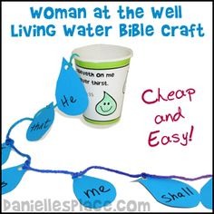
You will need
A paper cup
Paper (blue or White)
Colouring Pencils & scissors
Wool
Something to make a hole

What to do
First make some water droplets (7) and make holes in the top of each one. If they are white write one of these words on each of the droplets “If you believe will never go thirsty”
Then thread them onto the wool in order then make a hole in the bottom of the paper cup and thread the wool through the hole and tie a knot in the end, make sure that it is secure.
Then pile the words into the cup and then tip the cup upside down and watch the words tumble out.

Water droplet Biscuits
Ingredients
- 180g unsalted butter (room temperature)
- 180g caster sugar
- 1 medium egg
- 360g plain flour
- 1/2 tsp
- vanilla extract
Method
- Add the butter and sugar to a large mixing bowl. Beat with an electric mixer, or take it in turns with the kids to cream the butter and sugar together with a wooden spoon until pale and fluffy.
- Beat in the egg, followed by the flour and vanilla. Bring together with your hands to form a ball of biscuit dough. Wrap the dough in clingfilm and chill in the fridge for one hour.
- Preheat the oven to 180°C/160°C fan/Gas Mark 4. Line two baking trays with baking paper.
- Remove the dough from the fridge, and roll out onto a floured surface until the dough is about 0.5cm thick. Then

- cut out water droplets (use the water droplet in your bag) out of the dough.
- Space the biscuits out on the trays. Bake for 10-12 minutes, or until lightly golden.
- Remove from the oven and cool on their trays for 10 minutes before transferring to a wire rack to cool completely.

- Decorate

