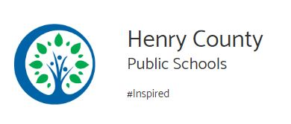
The second graders at Campbell Court got to visit an awesome petting ranch called Infinity Acres. The ranch is a locally operated non-profit near Martinsville, Virginia directed by two amazing people, Llama Laura and Rancher Rick, who know so much about the animals they care for. It was so exciting for the children to be up close and personal with exotic animals that they only read about in books or see on television and other media.
Upon arrival, we were greeted by friendly staff. First we were organized into to three groups and given a schedule of the different areas we would be experiencing. My children went to the “small animals” area first where Rancher Rick let us handle a rabbit and corn snake. We touched a turtle too. We were even allowed to take pictures holding the corn snake! Next it was time to visit the “large animals” area. We took turns walking alpacas, a miniature pony and donkey through an obstacle course. We also got to feed the “fainting goats” their lunch. My colleagues and I got to feed a wallaby and kangaroo. Then we saw parakeets, an owl and some sugar gliders . . . well we didn’t get to see much of them because we learned that they were nocturnal! Saddle-Up Susie is a retired teacher that volunteers to help meet the school learning on field trips. After that we listened to a story about owls. We got to make pine cone bird feeders to take with us. Rancher Rick took us on a hay ride in a wagon! We walked down to a pond and were given food to feed the fish. There are also playground areas on the ranch. Those areas came in handy as we waited for our turn to go on the hayride. And as we finished our own lunches, we got to play in the play area.
Our visit was the perfect opportunity for the children to interact with certain animals they don’t see on a daily basis and to see how they are cared for. The tour of the ranch was well organized. The activities were child friendly and held the children’s attention. There was never a dull moment at Infinity Acres! I can’t wait to take another group again!

Bonita G. Reynolds
Second Grade Teacher
Campbell Court Elementary School
Henry Co. Public Schools, Virginia

