5/4/2017

1,000 Year Old Jerusalem and Riyadh Tav Revealed by YaHuWaH Elohim

Our heavenly Father is amazing. When we think there's nothing more to be revealed about a subject, He sends more information.

Yesterday, 5/3/2017, I went through 5,000 years of solar eclipse information, looking for the total solar eclipses that went over Jerusalem and Mecca.

The last total solar eclipse to pass over Jerusalem was on 8/20/993 AD, over 1,000 years ago.

It was during the 1,000th year from 8/20/993 AD that David Koresh and about 75 other members of his congregation were burned alive in their church building in Waco, Texas, by agents of the United States government on 4/19/1993.

The Rare Jerusalem Total Solar Eclipses

The very next total solar eclipse to pass over Jerusalem will do so on 8/8/2241 AD. Interestingly, the Roman calendar year 2241 AD is the Hebrew year 6001 on the Hillel calendar! That means that the very next solar eclipse to pass over Jerusalem will do so during the 1st year ("day") of the 7th, 1000 year "day" period from the creation of the earth according to the Hillel calendar that most Jewish people observe today. That particular fact isn't the reason for this article, so we'll move on.

The information revealed in this article was prepared on 5/3/2017. I heard today on 5/4/2017 that it was announced in the news media that President Donald Trump was scheduled to make his first international visit with heads of State first in Riyadh,Saudi Arabia, and then Jerusalem, Israel, and then to other countries.

The information below from YaHuWaH Elohim fits in with President Trump's scheduled 1st international visit.

Revelation of the Jerusalem Tav

Below is a graphic showing a Paleo Hebrew "Tav" or "X" ordained to be inscribed on the earth at a certain time by our Creator Elohim. The 1st total solar eclipse passed over Jerusalem on 8/20/993 AD. The 2nd solar Eclipse passed over Riyadh, Saudi Arabia, on 4/7/1000 AD exactly 2422 days after the eclipse that passed over Jerusalem. Riyadh is the current capital of Saudi Arabia.

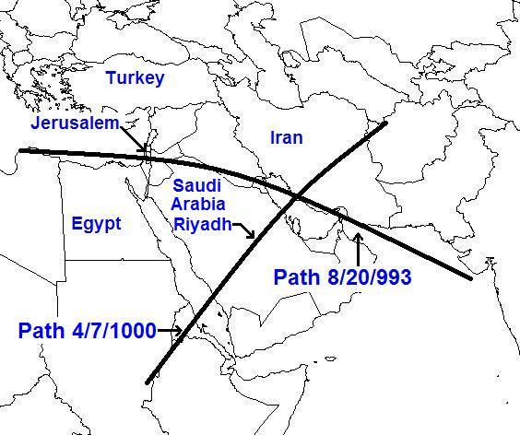
The above information was given to me by YaHuWaH Elohim on 5/3/2017.

Below is the precise path over Jerusalem on 8/20/993 AD.

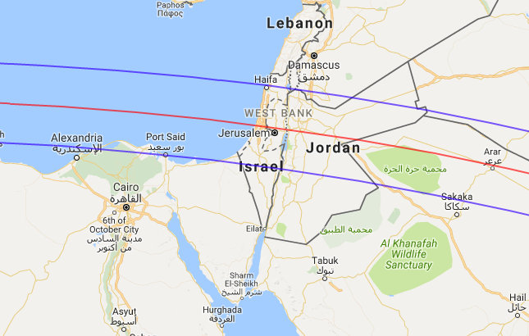
Image courtesy Fred Espenak at http://www.eclipsewise.com

Below is the precise path over Riyadh on 4/7/1000 AD.

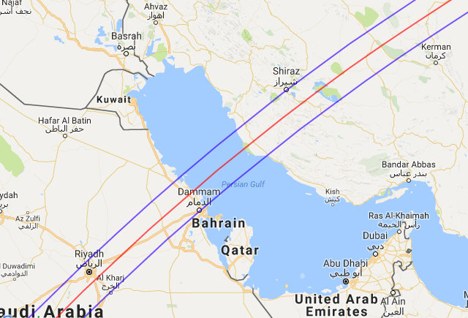
Image courtesy Fred Espenak http://www.eclipsewise.com

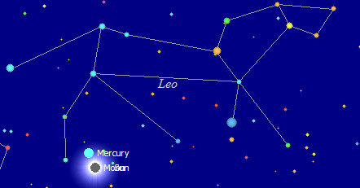
Above: The constellation Leo, symbolic of the Lion of Judah, as it appeared in the daytime sky in Jerusalem during the solar eclipse of 8/20/993 AD.

Like the Tavs that have been inscribed on the earth by our Creator Elohim beginning in 1999, the first solar eclipse reveals the constellation Leo and the King Star Regulus, both signifying Israel's Messiah. During the solar eclipse of 8/20/993 AD the sky went dark in the daytime and the stars of the constellation Leo appeared near the eclipsed sun to observers in Jerusalem.

Below: The constellation Aries, the Ram, as it appeared in the sky in the daytime during the solar eclipse of 4/7/1000 AD. The solar eclipse marked the precise astronomical beginning of the biblical month of Aviv (Nisan), the 1st month of the Hebrew year.

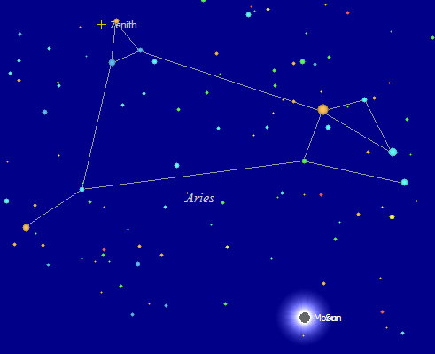
Above: The constellation Aires the lamb, or ram, appears near the eclipsed sun as the sky goes dark in the daytime in Riyadh on 4/7/1000 AD.

The constellation Aries is a symbol of YAHUSHUA, Israel's Messiah, as the innocent and perfect sacrifice lamb.

The constellation Aries is also a symbol of the ram that was caught in a thorn bush by its horns and offered as sacrifice by Abraham in place of his son Isaac.

Below: graphic presentation of YaHuWaH 's sacrifice lamb symbolically caught by His horns in the thorn bush:

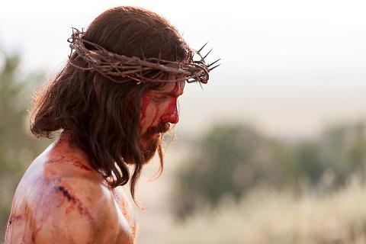
Photo courtesy LDS.org

Note that both constellations, Leo and Aries, revealed in the "Tav" mentioned above are symbols of Israel's King Moshiach, the Lion and the Lamb.

The Paleo Hebrew Tav is also an ancient Hebrew "end mark".

These solar eclipses were a warning from YaHuWaH Elohim to the Jewish and Islamic peoples of that day a thousand years ago, and also to us now as President Trump prepares to soon visit first Riyadh and then Jerusalem on official business.

Although it's over a thousand years old, the above information from YaHuWaH Elohim appears to be timely and prophetically pertinent in regards to our current world situation.

