Published March 30, 2015

V-E Day events planned in Warren, St. Clair Shores

By Brian Louwers brianlouwers@candgnews.com Home
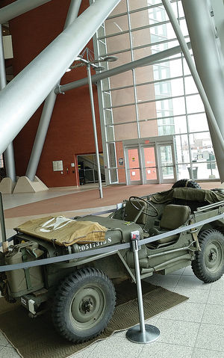
A 1942 Willy’s Jeep from the Detroit Arsenal of Democracy Museum in St. Clair Shores has been parked in Warren’s City Hall atrium ahead of the event on May 8. (Photo by Brian Louwers)
WARREN/ST. CLAIR SHORES — On May 8, 1945, German forces laid down their arms to end World War II in Europe. That date, V-E Day as it is now remembered, marked the end of the bloodiest conflict in European history, and also the beginning of the end of the most destructive war the world has ever known. Events planned in Warren and St. Clair Shores next month will commemorate the 70th anniversary. At 2 p.m. on May 8, the city of Warren will recognize all veterans of the U.S. military with a commemorative program at City Hall. Mayor Jim Fouts said special emphasis will be placed on veterans of World War II.
More than 16 million soldiers, sailors, airmen and Marines took up arms in the U.S. military during the war. It is thought that fewer than a million remain today.
Fouts said his mother’s four brothers served during the Second World War.
“My mother’s oldest brother, Dutch, was killed in the D-Day invasion,” Fouts said. “I grew up around adults who were veterans of World War II. I’ve grown to admire and like them. I’ve found the World War II vets to be people who are very private, very patriotic.”
World War II veterans and their families wishing to take part in the commemoration during the city’s V-E Day event are directed to call the city’s events hotline at (586) 574-4515.
Fouts said U.S. Marine Staff Sgt. Marcus Bawol, who grew up in Warren and was one of 11 servicemen killed in a helicopter crash off the coast of Florida on March 10, will also be recognized during the ceremony.
“I think it’s appropriate not just to honor the heroes of the past, but to honor those heroes of the present,” Fouts said.
A 1942 Willy’s Jeep from the Detroit Arsenal of Democracy Museum in St. Clair Shores has been parked in Warren’s City Hall atrium ahead of the event on May 8. John Lind, director of the museum, said other vehicles will be on display during the ceremony.
The Detroit Arsenal of Democracy Museum, located at 22960 W. Industrial Drive in St. Clair Shores, will host its own event to commemorate V-E Day during the museum’s regular hours on May 9.
The museum is open to the public from 10 a.m.-5 p.m. on Saturdays, and is available for private showings and group tours by appointment.
Lind said coordinating to support special events, including the event at Warren’s City Hall, is important because the veterans who fought in World War II are passing away each day.
“Unlike any other mayor, Mayor Fouts has taken the lead in honoring our veterans,” Lind said. “That’s a great thing.”
Lind said these events are especially important for young people, who won’t get many more chances to meet World War II veterans. He said the event May 9 at the museum will provide visitors with an opportunity to interact with the men who were there when the war was raging, and when it ended. “This is a once-in-a-lifetime opportunity,” Lind said.
Although V-E Day ended the fighting in Europe during World War II, all hostilities officially ended on Sept. 2, 1945, when the Japanese surrendered to the Allies. Additional programs at the museum this summer will spotlight key events leading up to the final surrender.

