WELCOME TO
HOLY SPIRIT LUTHERAN CHURCH
A Member of the Evangelical Lutheran Church in America, New Jersey Synod
1220 Bayshore Rd., Villas, NJ 08251, 609-886-2414,
holyspiritlutheran@comcast.net, holyspiritvillas.com, facebook.com/holyspiritvillas
Vicar Vince Piekarski can be contacted at any time for conversation or prayer through call or text at 412-225-0287, or through email at vpie8282@gmail.com.
SUNDAY, FEBRUARY 8TH, 2026
FIFTH SUNDAY AFTER EPIPHANY
10:30AM WORSHIP SERVICE WITH HOLY COMMUNION


We, the Evangelical Lutheran Church of the Holy Spirit, are People of God, who
are called by the Holy Spirit to pray, worship, joyfully proclaim Jesus Christ,
and compassionately witness and serve others in Christian Love.


We are glad that you joined us for Worship today! Thank you for enriching our time together! We would like to get to know you better, and for you to get to know us better too. Brochures, welcome gifts, prayer shawls, Bibles, and other items are available throughout the church. We would be happy to show you around and share about our ministries. Please do not hesitate to speak up and ask questions.
Also, please make sure you sign-in on our clipboard on the podium in the lobby.


Our Worship Services are conducted in coordination with our Conference Call.
Join us at 657-390-7423 or 701-802-5170, with access code 8221190#.
You may need to dial 1 first depending on your phone plan. After logging in please announce your name and feel free to talk with others until we get started.


SANCTUARY CANDLE FOR FEBRUARY
Given to the Glory of God & In Memory of JAMES P. ROONEY
by Del McKenna & Children.
ALTAR CANDLES FOR FEBRUARY
Given to the Glory of God & In Memory of CLAIRE MILLER
by Jean, Phil, & Bob Zimmerman.
CONFERENCE CALL CHECK-IN, WELCOME, & ANNOUNCEMENTS
(Vicar (V), Assistant (A), Reader (R), and Congregation (C).)

INTRODUCTION
A. Light shines in the darkness for the upright, the psalmist sings. Isaiah declares
that when we loose the bonds of injustice and share our bread with the hungry,
the light breaks forth like the dawn. In another passage from the Sermon on the
Mount, Jesus, the light of the world, calls his followers to let the light of their good
works shine before others. Through baptism we are sent into the world to shine
with the light of Christ.

PRELUDE
(Music offered by our Organist at the start of our Worship Service.)
O For A Thousand Tongues To Sing

CHIMES
(Music offered by our Organist at the start of our Worship Service.)
Alleluia

V. We invite you to stand as you are able.

CONFESSION & FORGIVENESS
(All may make the sign of the cross, the sign that is marked at baptism.)
V. Blessed be the holy Trinity, ☩ one God,
the Creator of heaven and earth,
the Word who spoke life into being,
the Wind stirring the waters.
C. Amen.

V. Let us turn in confession to the one who knows us completely.

(Silence is kept for reflection.)

V. Mighty God, lover of justice,
C. you call us to life in community,
but we have served our own interests at the expense of our neighbors.
We have sown deceit where honesty was needed.
We say the right words, but our hearts are far from you.
Turn us to seek your face.
Knit us together and give us the mind of Christ,
that we may do justice, love mercy,
and walk humbly with you, our God.
Amen.

V. The former things have passed away,
and new things God now declares:
Like a spring of water that never fails,
God covers you in the righteousness of Christ,
and forgives your sin in ☩ Jesus’ name.
May the Spirit give you strength to live for others,
and bless you with the gift of peace.
C. Amen.

GATHERING HYMN
(We invite you to sing along.)
With One Voice—Blue Book
718—Here in This Place, Gather Us In

APOSTOLIC GREETING
V. May the grace of our Lord Jesus Christ, the love of God,
and the communion of the Holy Spirit be with you all.
C. And also with you.

KYRIE
V. In peace, let us pray to the Lord.
C. Lord, have mercy.

V. For the peace from above, and for our salvation, let us pray to the Lord.
C. Lord, have mercy.

V. For the peace of the whole world, for the well-being of the church of God,
and for the unity of all, let us pray to the Lord.
C. Lord, have mercy.

V. For this holy house, and for all who offer here their worship and praise,
let us pray to the Lord.
C. Lord, have mercy.

V. Help, save, comfort, and defend us, gracious Lord.
C. Amen.
HYMN OF PRAISE
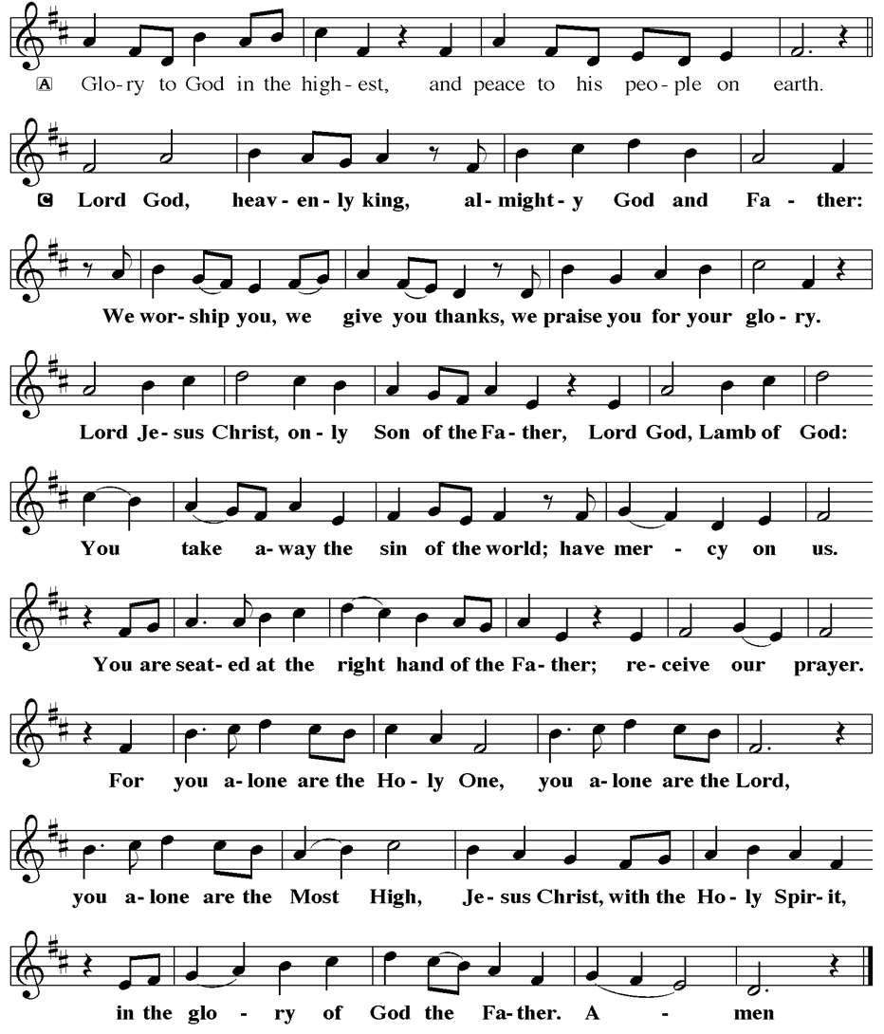
PRAYER OF THE DAY
V. The Lord be with you.
C. And also with you.

V. Let us pray,
Lord God, with endless mercy you receive the prayers of all who call upon you.
By your Spirit show us the things we ought to do, and give us the grace and
power to do them, through Jesus Christ, our Savior and Lord.
C. Amen.

(We invite you to be seated for our Readings and Psalm.)

FIRST READING
Shortly after the return of Israel from exile in Babylon, the people were troubled
by the ineffectiveness of their fasts. God reminds them that outward observance
is no substitute for genuine fasting that results in acts of justice, such as feeding
the hungry, sheltering the homeless, and clothing the naked.

R. Our First Reading is from the 58th Chapter of Isaiah (Verses 1-9a [9b-12]).

R. 1 Shout out; do not hold back!
Lift up your voice like a trumpet!
Announce to my people their rebellion,
to the house of Jacob their sins.
2 Yet day after day they seek me
and delight to know my ways,
as if they were a nation that practiced righteousness
and did not forsake the ordinance of their God;
they ask of me righteous judgments;
they want God on their side.
3 “Why do we fast, but you do not see?
Why humble ourselves, but you do not notice?”
Look, you serve your own interest on your fast day
and oppress all your workers.
4 You fast only to quarrel and to fight
and to strike with a wicked fist.
Such fasting as you do today
will not make your voice heard on high.
5 Is such the fast that I choose,
a day to humble oneself?
Is it to bow down the head like a bulrush
and to lie in sackcloth and ashes?
Will you call this a fast,
a day acceptable to the Lord?

6 Is not this the fast that I choose:
to loose the bonds of injustice,
to undo the straps of the yoke,
to let the oppressed go free,
and to break every yoke?
7 Is it not to share your bread with the hungry
and bring the homeless poor into your house;
when you see the naked, to cover them
and not to hide yourself from your own kin?
8 Then your light shall break forth like the dawn,
and your healing shall spring up quickly;
your vindicator shall go before you;
the glory of the Lord shall be your rear guard.
9a Then you shall call, and the Lord will answer;
you shall cry for help, and he will say, “Here I am.”
[9b If you remove the yoke from among you,
the pointing of the finger, the speaking of evil,
10 if you offer your food to the hungry
and satisfy the needs of the afflicted,
then your light shall rise in the darkness
and your gloom be like the noonday.
11 The Lord will guide you continually
and satisfy your needs in parched places
and make your bones strong,
and you shall be like a watered garden,
like a spring of water
whose waters never fail.
12 Your ancient ruins shall be rebuilt;
you shall raise up the foundations of many generations;
you shall be called the repairer of the breach,
the restorer of streets to live in.]

R. This is the Word of the Lord.
C. Thanks be to God.

PSALM
R. Our Responsorial Psalm is from the 112th Psalm (Verses 1-9 [10]).
C. Light shines in the darkness for the upright. (Ps. 112:4)

R. 1 Hallelujah! Happy are they who fear the Lord
and have great delight in God’s commandments!
2 Their descendants will be mighty in the land;
the generation of the upright will be blessed.
3 Wealth and riches will be in their house,
and their righteousness will last forever.
4 Light shines in the darkness for the upright;
the righteous are merciful and full of compassion.
C. Light shines in the darkness for the upright. (Ps. 112:4)

R. 5 It is good for them to be generous in lending
and to manage their affairs with justice.
6 For they will never be shaken;
the righteous will be kept in everlasting remembrance.
7 They will not be afraid of any evil rumors;
their heart is steadfast, trusting in the Lord.
8 Their heart is established and will not shrink,
until they see their desire upon their enemies.
9 They have given freely to the poor, and their righteousness stands fast forever;
they will hold up their head with honor.
[10 The wicked will see it and be angry; they will gnash their teeth and pine away;
the desires of the wicked will perish.]
C. Light shines in the darkness for the upright. (Ps. 112:4)

SECOND READING
Though people such as the Corinthians are enamored with human philosophy
and wisdom, Paul continuously presents God’s hidden wisdom which is Jesus
Christ crucified. True spiritual maturity involves judging ourselves and others in
light of God’s revelation in the cross.

R. Our Second Reading is from the 2nd Chapter of 1st Corinthians
(Verses 1-12 [13-16]).

R. 1 When I came to you, brothers and sisters, I did not come proclaiming the
testimony of God to you with superior speech or wisdom. 2 For I decided to know
nothing among you except Jesus Christ and him crucified. 3 And I came to you in
weakness and in fear and in much trembling. 4 My speech and my proclamation
were made not with persuasive words of wisdom but with a demonstration of the
Spirit and of power, 5 so that your faith might rest not on human wisdom but on
the power of God.

6 Yet among the mature we do speak wisdom, though it is not a wisdom of this
age or of the rulers of this age, who are being destroyed. 7 But we speak God’s
wisdom, a hidden mystery, which God decreed before the ages for our glory
8 and which none of the rulers of this age understood, for if they had, they would
not have crucified the Lord of glory. 9 But, as it is written,
“What no eye has seen, nor ear heard,
nor the human heart conceived,
what God has prepared for those who love him”—

10 God has revealed to us through the Spirit, for the Spirit searches everything,
even the depths of God. 11 For what human knows what is truly human except
the human spirit that is within? So also no one comprehends what is truly God’s
except the Spirit of God. 12 Now we have received not the spirit of the world but
the Spirit that is from God, so that we may understand the gifts bestowed on us
by God. [13 And we speak of these things in words not taught by human wisdom
but taught by the Spirit, interpreting spiritual things to those who are spiritual.

14 Those who are unspiritual do not receive the gifts of God’s Spirit, for they are
foolishness to them, and they are unable to understand them because they are
spiritually discerned. 15 Those who are spiritual discern all things, and they are
themselves subject to no one else’s scrutiny.
16 “For who has known the mind of the Lord
so as to instruct him?”
But we have the mind of Christ.]

R. This is the Word of the Lord.
C. Thanks be to God.

V. I invite you to stand as you are able, and I invite you to announce the Gospel
Acclamation with me.

GOSPEL ACCLAMATION
C. Alleluia. Jesus says, I am the light of the world; whoever follows me will
have the light of life. Alleluia. (John 8:12)

GOSPEL READING
In the Sermon on the Mount, Jesus encourages his followers to be the salt of the
earth and the light of the world, doing good works and keeping God’s
commandments.

V. The Holy Gospel According to Matthew, the 5th Chapter (Verses 13-20).
C. Glory to you, O Lord.

V. [Jesus said:] 13 “You are the salt of the earth, but if salt has lost its taste, how can
its saltiness be restored? It is no longer good for anything but is thrown out and
trampled under foot.

14 “You are the light of the world. A city built on a hill cannot be hid. 15 People do
not light a lamp and put it under the bushel basket; rather, they put it on the
lampstand, and it gives light to all in the house. 16 In the same way, let your light
shine before others, so that they may see your good works and give glory to your
Father in heaven.

17 “Do not think that I have come to abolish the Law or the Prophets; I have come
not to abolish but to fulfill. 18 For truly I tell you, until heaven and earth pass
away, not one letter, not one stroke of a letter, will pass from the law until all is
accomplished. 19 Therefore, whoever breaks one of the least of these
commandments and teaches others to do the same will be called least in the
kingdom of heaven, but whoever does them and teaches them will be called
great in the kingdom of heaven. 20 For I tell you, unless your righteousness
exceeds that of the scribes and Pharisees, you will never enter the kingdom of
heaven.”

V. This is the Gospel of the Lord,
C. Praise to you, O Christ.

(We invite you to be seated.)

SERMON
(Delivered by Vicar Vince Piekarski.)

(Following the Sermon, we invite you to stand as you are able.)

HYMN OF THE DAY
(We invite you to sing along.)
Lutheran Book of Worship—Green Book
265—Christ, Whose Glory Fills the Skies

APOSTLES’ CREED
V. God has made us his people through our Baptism into Christ. Living together in
trust and hope let us confess our faith together using the Apostles’ Creed.
C. I believe in God, the Father almighty,
creator of heaven and earth.

I believe in Jesus Christ, God’s only Son, our Lord,
who was conceived by the Holy Spirit,
born of the Virgin Mary,
suffered under Pontius Pilate,
was crucified, died, and was buried;
he descended to the dead.
On the third day he rose again;
he ascended into heaven,
he is seated at the right hand of the Father,
and he will come to judge the living and the dead.

I believe in the Holy Spirit,
the holy catholic church,
the communion of saints,
the forgiveness of sins,
the resurrection of the body
and the life everlasting.
Amen.

PRAYERS OF INTERCESSION
V. As God’s beloved children united in Christ, let us pray for the church, the whole
human community, and the well-being of the earth, our home.

(A brief silence.)

A. Your church does ministry in many and various ways. Keep the baptized true to
the mind of Christ, that our works and witness bring hope to a troubled world.
Merciful God,
C. receive our prayer.
A. Your marvelous creation cries out to you. Restore polluted air, soil, and water
sources to wholeness. Guard honeybees, elephants, great whales and songbirds
from harm, and renew the face of the earth. Merciful God,
C. receive our prayer.

A. Your people in every nation suffer injustice, poverty, and the threat of violence.
Guide those in authority to govern with compassion, and bring peace to war
zones. We pray for our enemies. Merciful God,
C. receive our prayer.

A. Your blessings are poured out for all in need. Help and heal any who experience
trauma, discrimination, disease, hunger, abuse, or persecution. Comfort those
who are sick or grieving; especially:
BettyAnn Rich-White (Church Member)
Chip & Marie Hand (Church Members)
Lynn Bargstadt (Church Member)
Frank Ford (Church Member)
Carol Amundsen (Church Member)
Kim McGinley (Church Member)
Anthony DeLuca (Church Member)
Frank Brunner (Church Member)
Joan Sommerman (Church Family)
Arleen Kinka (Church Family)
Rick Lang (Church Family)
Suzie Clark (Rose Lang's Friend)
Francis Clock (Dianna DeNote’s Family)
Andrew Hudak (Rose Lang’s Friend)
Viena Murtha (Bob Fritsch’s Friend)
Sharon Waicus (Skip & Bonnie Millard's Friend)
Karen O'Brien (Paul Bowker's Friend)
Dustin Irizzary (Mary Melnicoff's Family)
The Bryan Family (Wanda Bryan's Family)
Craig Brearey (Judy Brannan & Mary Melnicoff's Friend)
Sarah Dutton (Frank Ford's Family)
Christina McNasby (Fran Green’s Family)
Mark Stephen Dennis (Diana DeNote's Family)
Bill Lodge (Skip & Bonnie Millard's Friend)
Ron Anderson (Bill Kelly's Friend)
Bud Brearey (Judy Brannan & Mary Melnicoff's Friend)
Mary Skain (Kathy Poehler's Friend)
Robert Chaplin (Mary Melnicoff's Friend)
Jack Wieckouski (Theresa & Kim McGinley's Family)
Carolyn Santarpio (Bob Fritsch's Friend)
Harry (Judy Brannan's Friend)
Janet K (Philomena Noak's Friend)
Michael Hart (Diana DeNote's Friend)
Rocco Leonard DeNote (Diana DeNote's Family)
Sherri Lynn (Bob Fritsch's Friend)
John Bannco (Bob Fritsch's Friend)
Nancy Pazarinie (Bob Fritsch's Family)
Jane & Paul Eiben (Rose Lang's Friend)
Joe DiMassimo (Judy Brannan & Mary Melnicoff's Friend)
Denny Papst (Rose Lang’s Friend)
Mike & Alice Rhoades (Rose Lang’s Friends)
Chris (Judy Brannan's Friend)
Helen Ehlers (Judy Brannan's Friend)
Leanne Bueth (Joan Kilcoyne's Family)
Janett MacFarlane (Carol Amundsen's Friend)
Thish Kelly (Theresa & Kim McGinley's Family)
Edward Chapleski (Allison Call's Family)
Scott Levin (Rose Lang's Friend)
Alice Ann Dennis (Diana DeNote's Family)
Nancy Taylor (Ted & Diane Bell's Family)
Santa Isabel Lutheran Church (Elizabeth, NJ)
Messiah Lutheran Church (Oakland, NJ)
Joyce Thompson (TDPWC Member)
Barbara Paynter (Leon Stitt’s Family)
Ruth (Anthony & Vincent Bruno's Family)
William T Hodgetts (Pastor William Hodgetts’ Family)
Paul Bowker (Church Member)
BettyAnn & Bill Whitman (Mary Melnicoff's Friends)
Bob Poole (Kathy Poehler's Family)
David Smith (Heather & Vicar Vince Piekarski’s Family)
Joe Smith (Heather & Vicar Vince Piekarski's Family)
Barbara Hoitink (Lucas & Sabrina Munson's Family)
Kathy Raynor (Philomena Noak & Mary Melnicoff’s Friend)
Jordan (Carol Amundsen's Friend)
Jeremy Pochatko (Vicar Vince Piekarski's Friend)
Ann Wieckouski (Theresa & Kim McGinley's Family)
Rich (Kim McGinley's Friend)
Gloria Sutton (Church Member)
Elizabeth McCafferty (Mary Melnicoff's Friend)
Amy Johnson (Ted Bell's Sister)
Jerry & Marlana (Carol Amundsen's Friend)
Theresa Dolan (Joan Kilcoyne's Family)
Sandy Bloomberg (Judy Brannan's Family)
Simon (Carol Amundsen's Family)
Bill Ransing & Family (Frank Ford’s Friends)
Barbara Brosius (Philomena Noak's Friend)
Barbara Schmiedel (Bob Fritsch's Family)
Cathy Bell (Ted & Diane Bell's Family)
Doreen Kinzler (Church Member)
Linda Stonelake (Kathy & Butch Poehler's Friend)
Anne Pfaff (Bonnie Millard & Vicki Rinier's Friend)
(Additional Names Added Prior to the Worship Service.)
A. Merciful God,
C. receive our prayer.

A. Your wisdom guides this congregation and its ministries. Sustain our ordained
leaders, staff, lay leaders, and volunteers. Form us to be salt and light for the
neighbors we serve, following the example of Christ. Merciful God,
C. receive our prayer.

A. Your saints rejoice at your heavenly banquet. We give thanks for their lives of
faith, trusting that we also will be embraced by your eternal love. Merciful God,
C. receive our prayer.

(Here other intercessions may be offered.)

V. Watch over all of us who are worried and suffering, and especially those whose
names we now say aloud or hold within our hearts (pause). Merciful God,
C. receive our prayer.

V. Confident that the Holy Spirit receives our prayers and answers us, we commend
all for whom we pray to God’s loving-kindness made known to us in Christ Jesus
our Savior.
C. Amen.

SHARING OF THE PEACE
V. May the peace of the Lord be with you always.
C. And also with you.
V. Now, let us share God’s Peace with one another.



(Please respect your neighbor if they desire to still only offer a peace sign or wave.)

(Following the Sharing of the Peace, we invite you to be seated.)

OFFERING
V. We now worship God with our tithes and offerings, wine and bread for use in holy
communion, and monetary gifts to support our ministry for service in God’s name.
Our Ushers will be around to your pews to pass the Offering Plates.

(Ushers come forward to get the Offering Plates from the Assistant.)

(Vicar and Assistant prepare the Altar for Communion.)

OFFERING SONG
(We invite you to sing along.)
Worship & Praise
156—What Have We to Offer?
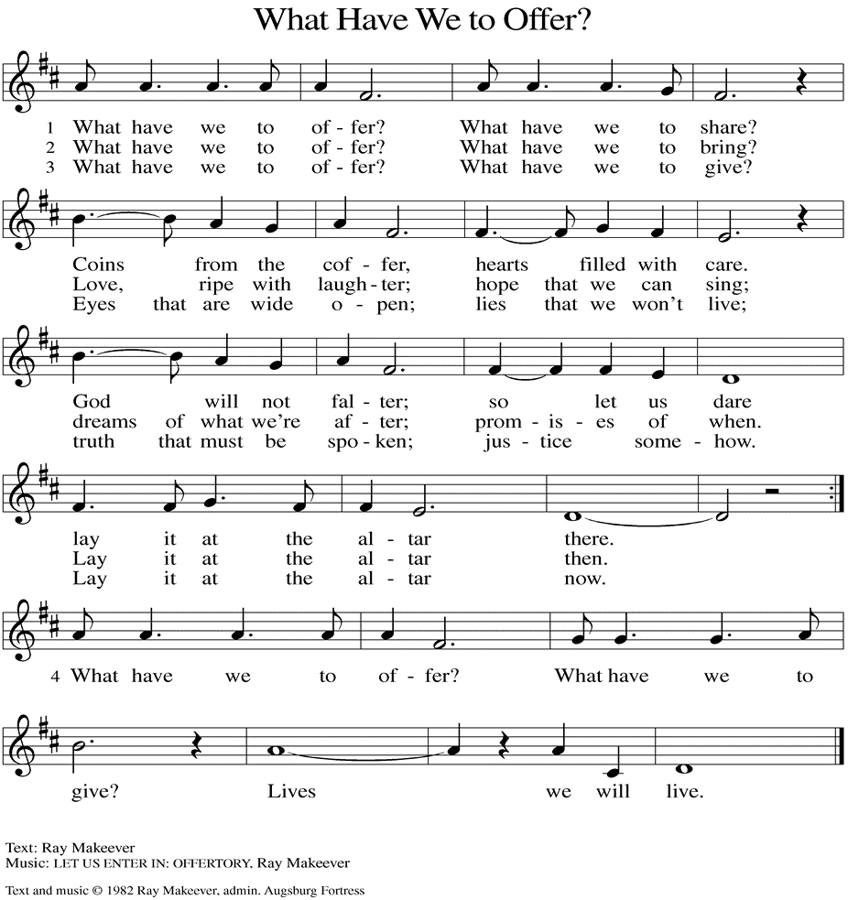
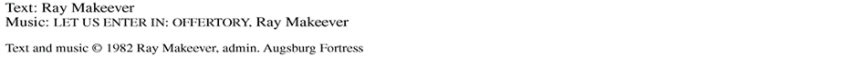

(Usher(s) brings the Tithes and Offerings up front to the Assistant.)

V. We invite you to stand as you are able.

OFFERING PRAYER
V. Let us pray,
God of majesty,
no eye has seen, no ear has heard
what you have prepared for those who love you,
yet in this meal you reveal the wideness of your mercy.
Use what we have gathered
to feed us with the reign of God come near,
Jesus Christ, our Savior and Lord.
C. Amen.

GREAT THANKSGIVING
V. The Lord be with you.
C. And also with you.

V. Lift up your hearts.
C. We lift them to the Lord.

V. Let us give thanks to the Lord our God.
C. It is right to give him thanks and praise.

V. It is indeed right and salutary that we should at all times and in all places offer
thanks and praise to you, O Lord, holy Father, through Christ our Lord; who rose
beyond the bounds of death and, as he promised, poured out your Spirit of life
and power upon the chosen disciples. At this the whole earth exults in boundless
joy. And so, with the Church on earth and the hosts of heaven, we praise your
name and join their unending hymn:

SANCTUS
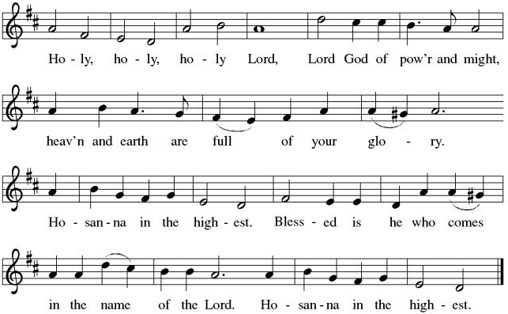

THE EUCHARISTIC PRAYER
V. Blessed are you, Lord of heaven and earth, in mercy for our fallen world you gave
your only Son, that all those who believe in Him should not perish, but have
eternal life. We give thanks to you for the salvation you have prepared for us
through Jesus Christ. Send now your Holy Spirit into our hearts that we may
receive our Lord with a living faith as He comes to us in His holy supper.
C. Amen. Come, Lord Jesus.

V. In the night in which he was betrayed our Lord Jesus took bread,
he gave thanks; broke it, and gave it to his disciples, saying:
Take and eat; this is my body, given for you.
Do this for the remembrance of me.

V. Again, after supper, He took the cup, he gave thanks,
and gave it for all to drink, saying:
This cup is the new covenant in my blood,
shed for you and for all people for the forgiveness of sin.
Do this for the remembrance of me.

THE LORD’S PRAYER
(We ring the bell throughout the Lord’s Prayer at all services to
invite those in the community to join in praying the Lord’s Prayer.)
V. May we now join with one another and pray together as Jesus has taught us.
C. Our Father, who art in heaven, hallowed be thy name, thy kingdom come,
thy will be done, on earth as it is in heaven. Give us this day our daily
bread; and forgive us our trespasses, as we forgive those who trespass
against us; and lead us not into temptation, but deliver us from evil. For
thine is the kingdom, and the power, and the glory, forever and ever.
Amen.

LAMB OF GOD

(We invite you to be seated.)

HOLY COMMUNION
V. Communion here is pretty simple, and all who are baptized and believe in Jesus
Christ are welcome at the table.

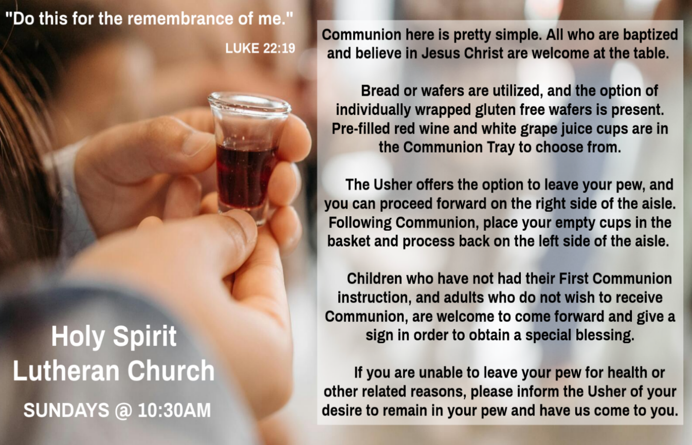

INVITATION TO COMMUNION
V. Here is the Lamb of God who takes away the sin of the world!
Come to the table; taste and see.
C. Amen.

(Distribution of Holy Communion)

COMMUNION HYMN
(Please enjoy various music offered by our Organist during your
quiet time, prayer, and reflection following Holy Communion.)

(Vicar and Assistant remove Communion Vessels from the Altar.)

V. We invite you to stand as you are able.

POST COMMUNION BLESSING
V. May the body and blood of our Lord Jesus Christ strengthen us and keep us
always in His grace.
C. Amen.
POST COMMUNION CANTICLE
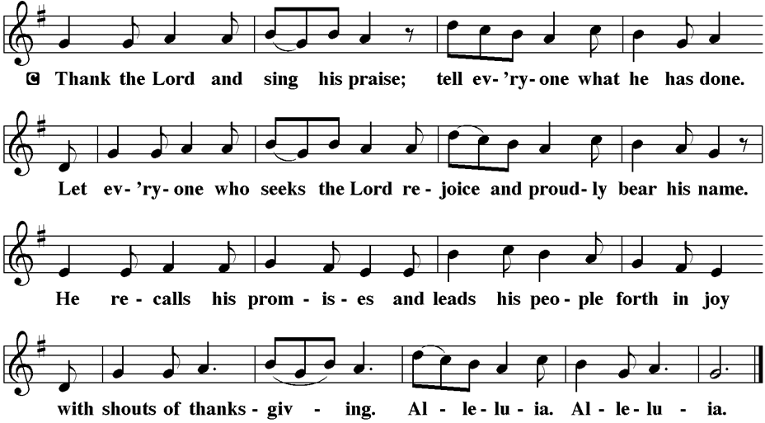

PRAYER AFTER COMMUNION
A. Let us pray,
Radiant God,
we have seen your glory in the face of Jesus Christ.
In the sacrament of his body and blood
you have drawn us to your heart.
Send us from this table with delight,
that our lives may reflect the beauty of your love,
and bear witness to all we have seen and heard,
through Jesus Christ, our Savior and Lord.
C. Amen.

BLESSING
V. May the triune God,
who has put a new song in your mouth
and tuned your heart for praise
☩ bless you now and forever.
C. Amen.

SENDING HYMN
(We invite you to sing along.)
Lutheran Book of Worship—Green Book
405—Lord of Light

(Assistant extinguishes the Altar Candles half way through the Sending Hymn.)

(Vicar processes out once the Altar Candles have been extinguished.)

(We invite you to be seated.)

BIRTHDAYS, ANNIVERSARIES, & ANNOUNCEMENTS
(Offered by Assistant and Congregation.)

BIRTHDAYS
12th Frank Ford
12th Allison Hopkins
12th Ed Cox
13th Randy Yarwasky

DISMISSAL
A. Go in peace. Do justice. Love mercy.
C. Thanks be to God.

POSTLUDE
(Music offered by our Organist as we depart following our Worship Service.)
Jesus Calls Us O’er The Tumult

LICENSES & EXPIRATION DATES
Worship Service Content is used via permission through Augsburg Fortress Liturgies Annual License #SB144368. The next Subscription Renewal Date is 2/28/2026.
Our Hymns and Worship Music are used via permission through CCLI One
License #11327166. The next Subscription Renewal Date is 1/31/2027.


CONFIRMATION & SUNDAY SCHOOL
“Here We Stand” allows our young folks to go through a 2-year process focusing on the Bible and Luther’s Small Catechism. Classes are on Sundays from 9-10AM.

WORSHIP MINISTRY
The most important thing we do each week is gather together as God's people to Worship. God is the center and focus of everything we do. Participating in Worship is active, as Liturgy means the work and actions of the people gathered. Everything we do during the week to prepare for Worship, and everything we do as we Assist in leading Worship is important. We are thankful for all the wonderful work being done. If you have questions, or are interested in any position, reach out to Vicar Vince.
Sign-up sheets are located on the bulletin board between the church offices.

ANNUAL CONGREGATIONAL MEETING
We will discuss and review things, vote on a new budget, nominate and vote in new council members, and so much more. Please join us THIS, Sunday, February 8th.
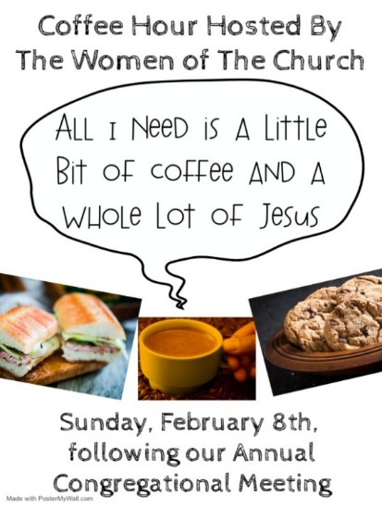
BIBLE STUDY & FAITH DISCUSSIONS
Bible Study & Faith Discussions focuses on various readings, books, Bible verses, people of faith, and other general topics. Group Members offer various points of view while being respectful and supportive of one another. Join us on Tuesdays at 6PM.

FOOD PANTRY
Open every Thursday, and the last Saturday of every month, from 10AM to 1PM. 134 people were served in January and 134 people have been served in 2026. Donations can be dropped in the outdoor drop-box, in the money jug in the back of the Church, mailed into the Church Office, or placed in the Offering Plate. Volunteers are needed. Sign-up sheets are located on the bulletin board between the church offices. If you have questions or need training see Heather, Vicar Vince, or Bonnie.
A special thank you goes out to all who donate, pray, and help in any way!

Thursday, 2/12 | Thursday, 2/19 | Thursday, 2/26
Joe & Garnet | Patti & Bob | Tori & Patti

COMMUNITY FOOD DONATIONS, DELIVERIES, & MORE
North Cape May Acme provides us with Expiring, Recently Expired, and Slightly Damaged Food and Items. Kathy delivers on Saturdays in the community, brings items to church and the food pantry, and to the Branches Outreach in Rio Grande.

BULLETIN ENTRY DEADLINE
The Bulletin is printed on Thursdays during Church Office Hours. Changes need to be submitted to Vicar Vince no later than Thursday by 4PM. Thank you!

CHURCH OFFICE HOURS
Open Thursdays from 6PM to 8PM. It is open to serve the Congregation, the Community, and to handle the business of the Church. Feel free to stop in to talk, pick-up or drop off something, pray in the Sanctuary, or for whatever reason.

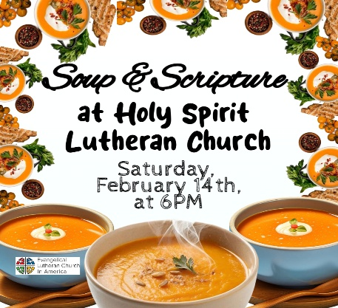
NEW 2026 CHURCH DIRECTORY
2025 Church Directories are by the Church Office on the bookshelves. We continue keeping it updated, but we undoubtedly miss a few changes or have made a few errors. If you have changes or updates, please inform the Church Office to keep us up to date. Our 2026 Directory will be available sometime later in February.

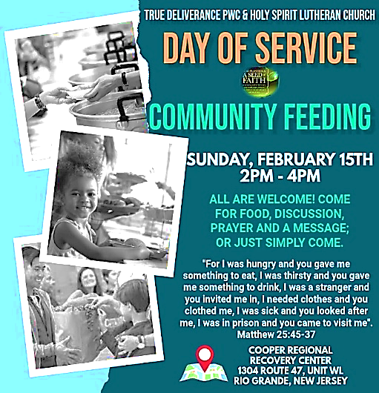

CHURCH COUNCIL
Share your comments, concerns, questions, or joys with one of our Church Council Members who can bring them back to our meetings. Visitors are always welcome to attend and listen to what is going on in and around the church. Join us In- Person or on our Conference Call at our next Meeting on Tuesday, February 17th, at 6PM.

ASH WEDNESDAY AT BROOKDALE & HOLY SPIRIT
Vicar Vince will be preaching at Brookdale Senior Living in Cape May Court House, on Wednesday, February 18th, at 1PM. Holy Communion will follow the service.
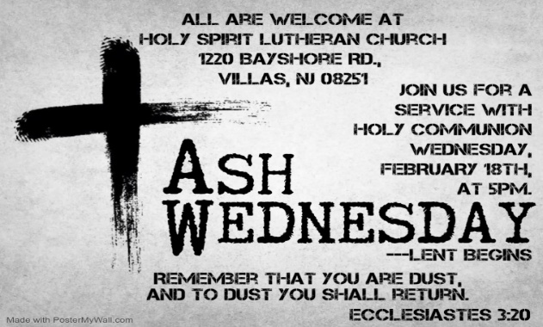
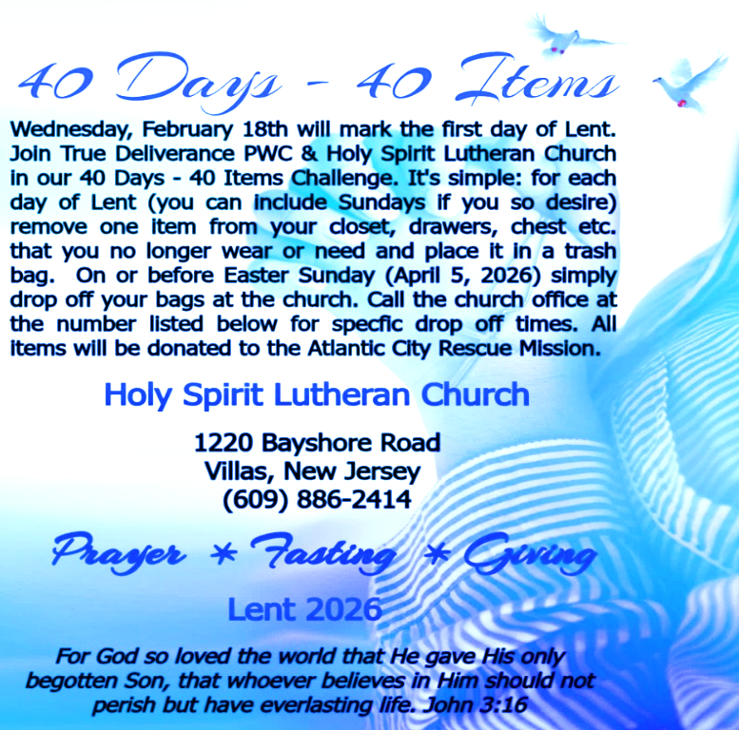

MISSION DISTRICT MEETING
Our annual meeting of the Southern Mission District will be on Saturday, February 21st, at 10am at Christ Lutheran Church in Whiting. The partial agenda for our time together is election of a clergy member to the Synod Council. We will be joined by Bishop Christa Compton. Please see Vicar Vince if you would like to attend.

DONATION STATION
Get on the train and place all purchased items in the specified project donation bins located on the counter by the front doors. See Heather for more information.


WOMEN OF THE CHURCH
They will be on Winter Break and will Resume Meetings on Monday, March 2nd, at 6PM. New members are always welcome to attend! Contact Judy for more info.

NEWSLETTER
Collect information, stories, pictures, and reports for our next publication. Everything needs submitted to Vicar Vince in-person or via email at vpie8282@gmail.com.
The deadline for information to be submitted for Spring is Sunday, March 15th.
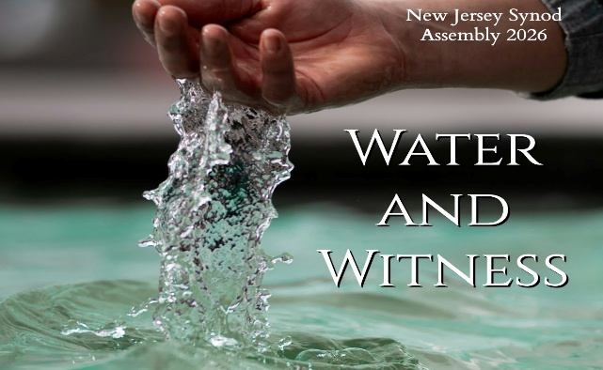
Our NJ Synod Assembly transitions back to a one-day event on Saturday, May 30th, 2026. Mary & Judy are considering attending with Vicar Vince.

TITHES, OFFERINGS, & ENVELOPES
We worship God with our tithes and offerings. We hear in scripture, “Each of you must give as you have made up your mind, not reluctantly or under compulsion, for God loves a cheerful giver.” (2 Corinthians 9:7) Envelopes can be dropped in the offering plate, mailed to the church, or dropped in the locked mailbox. Thanks for your support in the mission of our church, its ministries, the NJ Synod, etc!

SPACE AVAILABLE
​​​​​Interested in utilizing our Fellowship Hall for a Party or Event? There is a suggested $50 refundable security deposit, and it is $250 for facility use. No alcohol or games of chance permitted due to ELCA policy. Please contact Vicar Vince for more info.

ED GREEN CAPITAL IMPROVEMENT FUND
We are seeking out a new fundraiser at this time. We also have the donation bin in the back of the church and we have our Annual Church Rummage Sale to raise funds. Thanks for your continued donations, prayers, and support!

HOME COMMUNION MINISTRY
A Minister is available if you have a loved one, or if you desire services. We look forward in sharing the Word and Holy Communion! Please inform Vicar Vince, Kathy, or the Church Office so plans can be made for visits.

PRAYER SHAWL MINISTRY
Prayer Shawls, Lap Quilts, Scarves, and other items have been made with love. Blessed items are located in the Narthex, and are free for anyone. Members of the group continue working at home on new stitches and patterns. We are blessed to be able to continue collecting new items. We have a donation station of yarn and other items located in the Narthex. You can find some new supplies for your next creation!
PRAYER LIST
Our Prayer List continues to lengthen and we realize the important need for prayers and healing. Sometimes the unfortunate result is that someone has passed away, and the words “The Family & Friends of” appear before someone’s name. However, sometimes we forget names are still on the list and their health has improved and they can be removed. Please share various stories as we continue to pray for strength and healing. Names can be added or removed from the list on the clipboard in the Narthex prior to the Worship Service, by calling the church office, or addressing it on the Conference Call. Please let us know the relation to the person(s) you listed so we can be more mindful with our prayers.

LIBRARY
New books are added to our library from time to time. Several are borrowed and read and exchanged. Who knows, you might find one particularly interesting and share that with someone as well. Reading is a great way to pass spare time, learn, and explore. You may find some fresh ideas for prayer, ways to grow more spiritually, ways to grow closer to God, or some opportunities to understand our faith more. We also have an extended library located in Vicar Vince’s office. There are Bibles of various translations, books from his personal collection, books inherited from Pastor Leah, movies, past Bible Study Curriculums, and more. Visit the library between the church offices, or just ask to be able to check things out.

FAVORITE HYMNS
Carol is willing to play some of your favorite hymns for the Prelude & Postlude each Sunday during our Worship Service. Feel free to let her know of your suggestions.

INTERESTED IN BECOMING A NEW MEMBER
Have you been attending our church for a while? Have you just recently returned to church after being away for a bit? Maybe you transitioned from another church,
or just started to recently attend our church. We are glad to have you, and would love to have you as a member of our Congregation. See Vicar Vince for more info.

BAPTISM
We are a church whose unity is in Jesus Christ, who gathers us around word and water, wine and bread. Baptism is a significant part of our faith journey as we come from the baptismal waters to live a new life as children of God. Our baptism sets us out on a lifelong journey that is characterized by our relationship to God, our relationship to our faith community, our relationships in our community and the wider world. Living our baptismal covenant means living a life of growth in the faith practices of discipleship. Please see Vicar Vince for more information.
FIRST COMMUNION
Although no particular age for first communion is prescribed by The Use of the Means of Grace, one guideline is offered. Because admission to the Sacrament is by invitation of the Lord to the baptized, "baptized children begin to commune on a regular basis at a time determined through mutual conversation that includes the pastor/vicar, the child, and the parents or sponsors involved, within the accepted practices of the congregation.” Each congregation is encouraged to ask the question of readiness for first communion, establish their own policies regarding age and practice, and accompany that practice with catechesis appropriate to the age of the communicant. If anyone has questions, please see Vicar Vince.

JERSEY JOTTINGS
There is a weekly e-newsletter connecting our synod together with weekly prayer, upcoming events, synod and churchwide activities, mission stories, congregational activities, & more. Sign up at www.njsynod.org/stay-connected or download the app.

VICE PASTOR UPDATE
Pastor William Hodgetts continues to attend our Church Council Meetings
and provides Supervision and Support to Vicar Vince.

WHAT IS THE EVANGELICAL LUTHERAN CHURCH IN AMERICA?
The ELCA was formed in 1987 by the merger of three Lutheran Church bodies –
the ALC (American Lutheran Church), the LCA (Lutheran Church in America), and the AELC (Association of Evangelical Lutheran Churches). Learn more at elca.org.

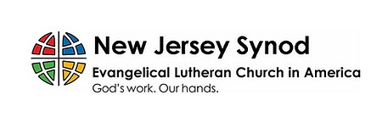
The New Jersey Synod is a geographical grouping of Evangelical Lutheran Church in America (ELCA) congregations that share the mission and ministry of the Church on the New Jersey territory. It is one of 65 synods in the ELCA. The NJ Synod is comprised of 143 congregations, which include over 45,000 baptized members.

VICAR VINCE’S DAY OF REST
A day of rest can have physical, mental, and spiritual benefits. “Mittwoch,” German for mid-week, or Wednesday, is the day that Vicar Vince will use to recharge and do some other things. Please do not hesitate to reach out if there is an emergency!

VICAR APPOINTMENT ON MARCH 19TH, 2023
A Memorandum of Understanding on the Matter of Pastoral Appointment
In Theological Education for Emerging Ministries (TEEM) Candidacy
TO: Congregation Council, Holy Spirit Lutheran Church, Villas
FROM: The Rev. Tracie L. Bartholomew, Bishop, New Jersey Synod

Dear Brother and Sisters in Christ,
This memorandum is in support of your discussions with Vincent Piekarski as pastor of Holy Spirit, Villas. Because this is not the usual pattern for completing the educational and candidacy requirements for ordination, it is my hope that this memorandum will both provide guidelines and engage in conversation with those who are invested in this process.

I would say at the outset that because Vincent is an outstanding candidate for the Ministry of Word and Sacrament, we will all want to do whatever is necessary to assure that his placement serves the mission of the church in the best possible fashion.

The following notes reflect my own understanding of this matter:
(1) The appointment for Vincent will begin on April 1, 2023. At this time, Vincent
will assume all responsibilities of a regularly called pastor, including presiding at
the Sacrament of Holy Communion and Baptism at Holy Spirit, Villas.
(2) A pastoral appointment in the TEEM process is an option for completing
seminary educational requirements and the steps of the candidacy process.
Upon completion of the candidacy process and seminary education, the
candidate may receive and accept a call to ordained ministry from the
congregation where the appointment is being served.
(3) This appointment is jointly supervised by the Office of the Bishop and the TEEM
pastor’s seminary. A mentoring relationship with a local pastor is required for the
length of this appointment.
(4) The synod of candidacy origin will be responsible for the approval process.
(5) Upon approval for ordination, the congregation would be expected to extend a
call to the pastoral appointee.
(6) Compensation for the TEEM pastor will be according to the guidelines of the New
Jersey Synod. All normal forms of compensation should be in place for the term
of the appointment, including stipulation that base salary and housing shall be in
accord with synod guidelines for first call at time of ordination.
(7) The ELCA Portico benefit plan for lay persons in full-time church service should
be used for the pastoral appointee up to the time of ordination, whereupon the
benefit package is to be converted to the plan for ELCA clergy.

(8) A decision for Pastoral Appointment is made with the agreement of a synod and
its candidacy committee, and the ELCA, normally represented by the regional
staff person of each in consultation with the seminary and its Director for
Contextual Education.
(9) Pastoral Appointment in a TEEM Candidacy is an option that is to serve the
mission of the Church in a particular and vital way and is not to be viewed or
used as a means to circumvent the normal candidacy process and/or first call
placement process.

In the specific case of Vincent, the New Jersey Synod remains responsible for the candidacy and approval process, and has agreed to this proposal for Appointment at Holy Spirit, Villas.

Continued blessings to both Holy Spirit and Vincent Piekarski as you embark on this journey of mutual ministry. As partners in ministry, we walk with you and rejoice in this new relationship.

2025 FINANCIAL STANDING
DECEMBER INCOME | $18,368.12
DECEMBER SPENDING | $6,154.14
DECEMBER GAIN OR (LOSS) | $12,213.98
2025 INCOME | $89,570.50
2025 SPENDING | $81,652.42
2025 GAIN OR (LOSS) | $7,918.08
ED GREEN CAPITAL IMPROVEMENT FUND | $2,058.55
FOOD PANTRY FUND (SOCIAL MINISTRY) | $13,621.22
CD | $26,414.45

TRUE DELIVERANCE PRAISE & WORSHIP CENTER
TDPWC utilizes our facilities from 1-4PM on Sundays. TDPWC hosts or assists with other events. TDPWC hosts a Prayer Line on Mondays, Wednesdays, & Fridays at 5PM on the Conference Call 1-657-390-7957; & Bible Study on Thursdays at 6:30PM on Zoom. See Rev. Brooks for more information.

JUST FRIENDS
The group promotes a spirit of fellowship among adults 50 years and older. Bring your own lunch, beverages and deserts are provided. Everyone is welcome. The group meets in Our Lady Star of The Sea Parish Hall on the last Wednesday of the month from 12Noon to 2PM from September through May. For information, please call Martine Simonis 609-884-5312 x 110.
ADDITIONAL OFFERINGS FROM OUR FRIENDS & NEIGHBORS
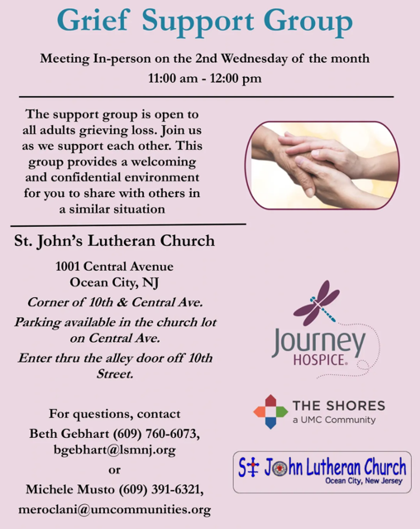

CHURCH STAFF & VOLUNTEERS
VICAR
Vicar Vince Piekarski
VICE PASTOR
Pastor William Hodgetts
ORGANIST & PIANIST
Carol Amundsen
CHURCH OFFICE, SUNDAY SCHOOL, & FOOD PANTRY
Heather Piekarski
CHURCH COUNCIL PRESIDENT
Mary Melnicoff
CHURCH COUNCIL VICE PRESIDENT
Judy Brannan
CHURCH COUNCIL TREASURER
Bonnie Millard
CHURCH COUNCIL SECRETARY
Vicki Rinier
CHURCH PROPERTY
Wayne Rand

