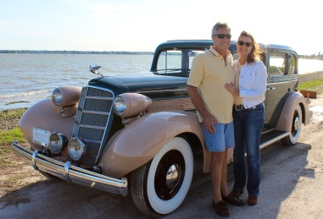
Real Restorations
By Pistorius Collectible Autos

We have been taking you through a process of restoration, step by step, from the cataloguing of the disassembly of your vehicle, to the video and photo documentation, and the sequential bagging and labeling of parts, body work and preparing for painting. It is now time to pay attention to the lineup of all the body panels, doors, trunk lid, hood and more. This part of your restoration is going to make or break your end result.
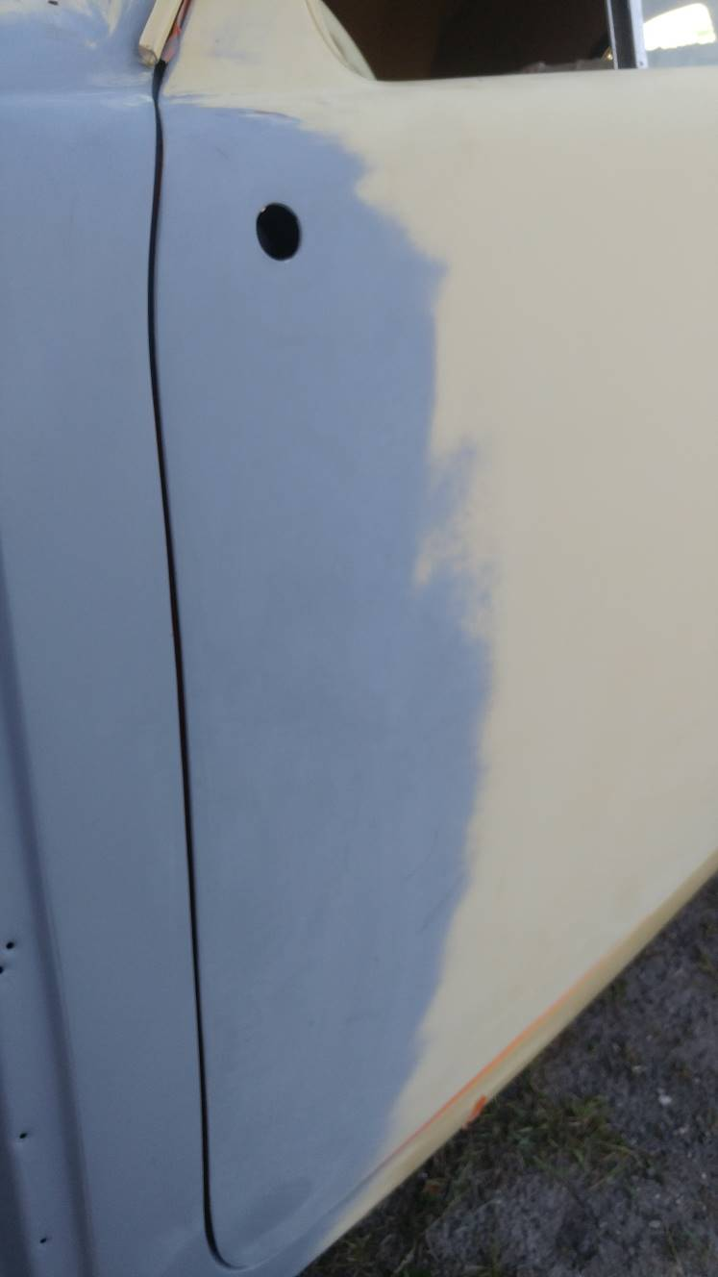The golden rule is having everything assembled after the different panels were repaired. Start with doors- lift up doors to see if hinges have play. Maybe it is a wood frame and the screw holes are worn out. Repair this first. Once your door hinges have no play make sure they line up with the body. Use shims at hinges to bring doors out or take away material to bring it in. Doors can be very tricky and we will talk more about that later.
Now go from fender to hood and check your gap. I use anything like wood or plastic and stick in the cars opening to get the entire gap the same.
Sometimes you have to slot holes to move panels into the right place.
Hood and trunk lid alignment need shims at hinges to make them fit properly.
Last but not least, stand back and look at your car from a distance. Also use your measuring tape if in doubt to make sure panels are symmetric.
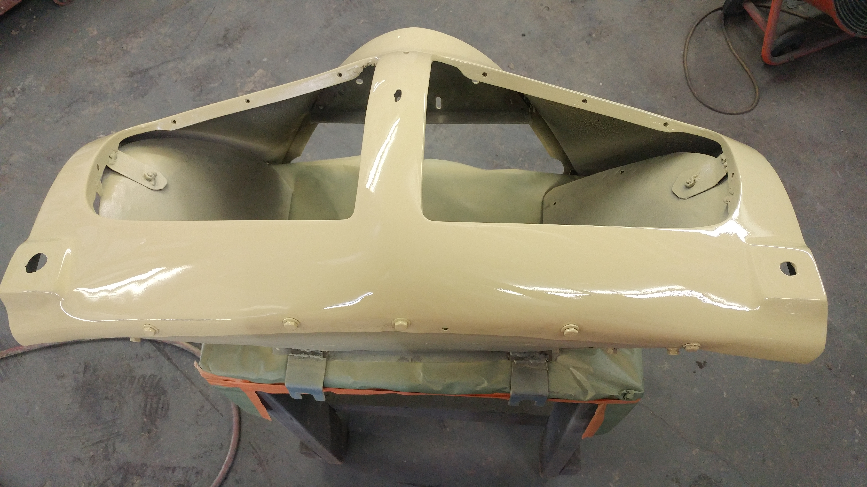Next time let’s talk about doors!
In the case of the 1941 Hupmobile that we are now restoring in our shop, this car had major gaps to compensate for, as well as nose piece issues. After resolving these, she has already received her first coat of paint and looking a little closer to her former glory.
Cheers!
Brando & Joanne Pistorius

