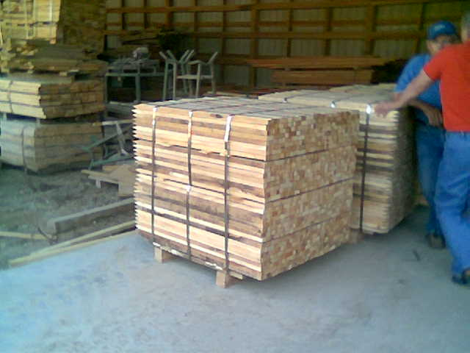

Hardwood Stakes Available In Different Sizes

