May 30, 2021
First Sunday after Pentecost

Gathering
The Holy Spirit calls us together as the people of God.

Welcome

Prelude: Take My Life (Marley)

Meditation

Strange Yet Familiar
by Tor Kristian Berg

The words sat there
Familiar yet strange
As if they stared back at me
With a squint and a nod

They are common words
Just like these
That mark a page and tell
A story familiar yet strange

I should know this story
Old women told it to me long ago
With voices of wonder and awe
As if I should know it too

Many find it strange to have
So many words marked on pages
Telling the story of an unseen God
Who failed

And died
And rose
And loved
And loved
Strange yet familiar

Gathering Song: When Morning Gilds the Skies (ELW 853)

Greeting/ Prayer of the Day
The grace of our Lord Jesus Christ, the love of God,
and the communion of the Holy Spirit be with you all.
And also with you.

Almighty Creator and ever-living God: we worship your glory, eternal Three-in-One, and we praise your power, majestic One-in-Three. Keep us steadfast in this faith, defend us in all adversity, and bring us at last into your presence, where you live in endless joy and love, Father, Son, and Holy Spirit, one God, now and forever.
Amen.

Hymn of Praise: There Is a Redeemer (W&P 140)
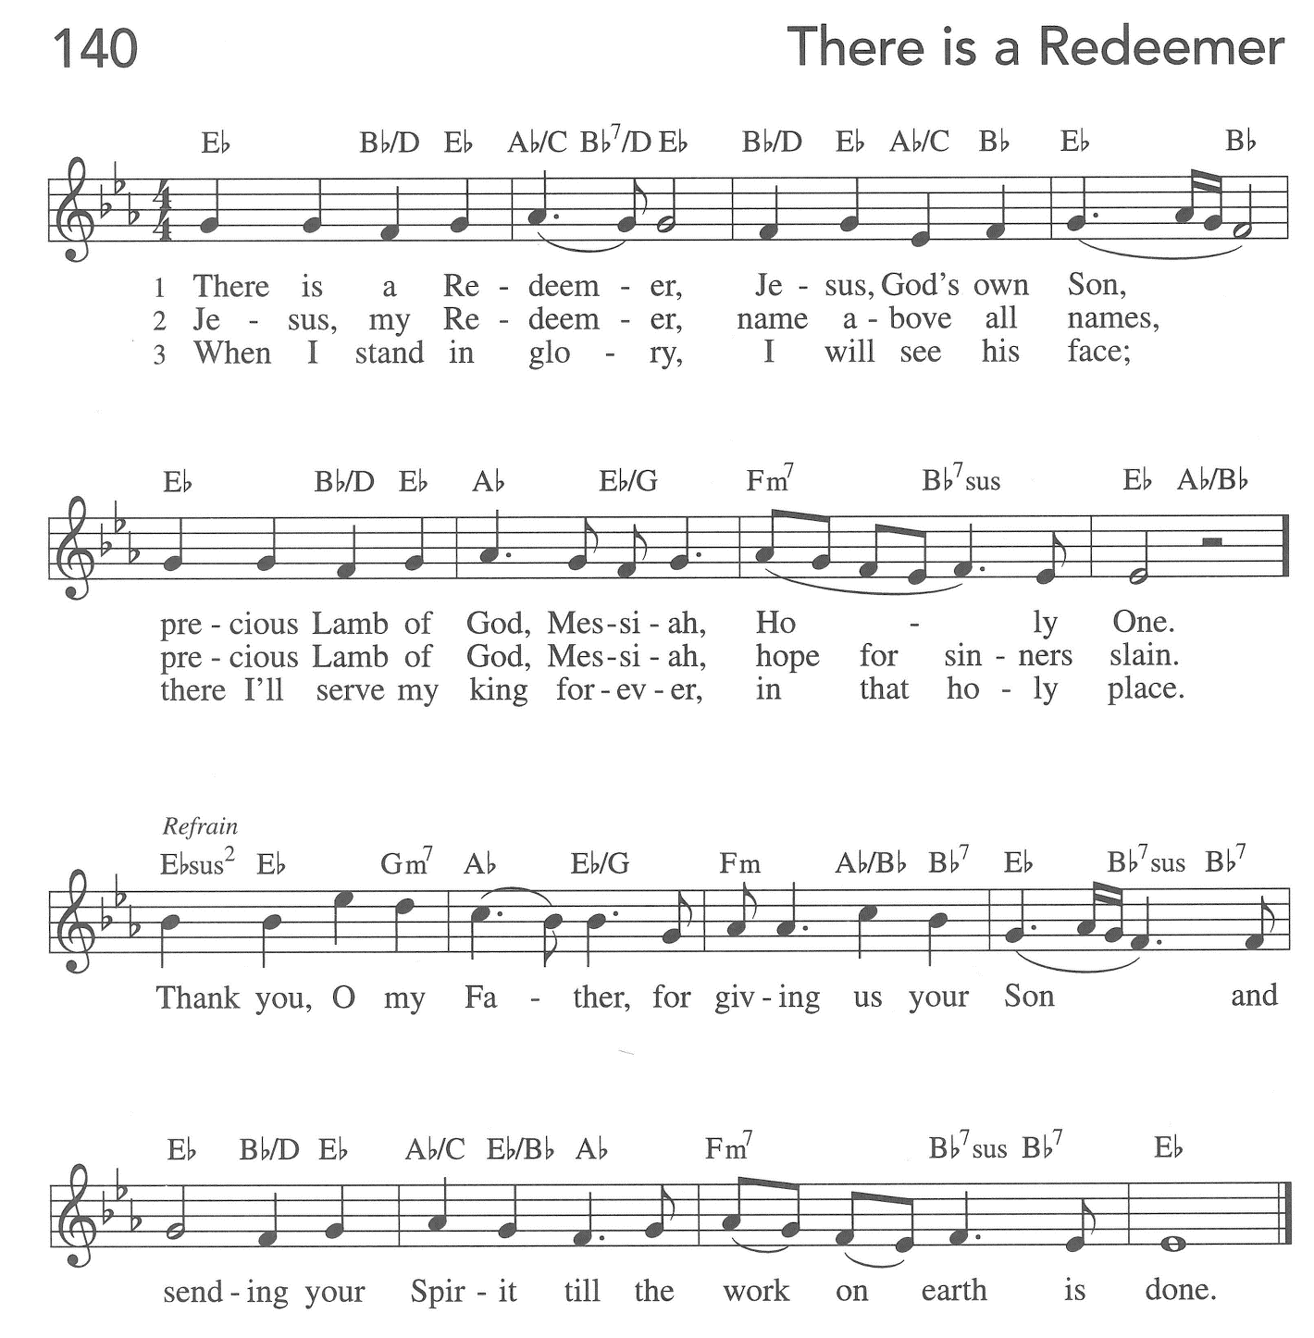
Text and Music: Keith and Melody Green
Text and Music © 1982 Birdwing Music/Cherry Lane Music Publishing Co., Inc., Admin. By Emi Christian Music Publishing

Word
God speaks to us in scripture reading, preaching, and song.
The Word: Galatians 1
¹Paul an apostle — sent neither by human commission nor from human authorities, but through Jesus Christ and God the Father, who raised him from the dead — ²and all the members of God's family who are with me,
To the churches of Galatia:
³Grace to you and peace from God our Father and the Lord Jesus Christ, ⁴who gave himself for our sins to set us free from the present evil age, according to the will of our God and Father, ⁵to whom be the glory forever and ever. Amen.
⁶I am astonished that you are so quickly deserting the one who called you in the grace of Christ and are turning to a different gospel — ⁷not that there is another gospel, but there are some who are confusing you and want to pervert the gospel of Christ. ⁸But even if we or an angel from heaven should proclaim to you a gospel contrary to what we proclaimed to you, let that one be accursed! ⁹As we have said before, so now I repeat, if anyone proclaims to you a gospel contrary to what you received, let that one be accursed!
¹⁰Am I now seeking human approval, or God's approval? Or am I trying to please people? If I were still pleasing people, I would not be a servant of Christ.
¹¹For I want you to know, brothers and sisters, that the gospel that was proclaimed by me is not of human origin; ¹²for I did not receive it from a human source, nor was I taught it, but I received it through a revelation of Jesus Christ.
¹³You have heard, no doubt, of my earlier life in Judaism. I was violently persecuting the church of God and was trying to destroy it. ¹⁴I advanced in Judaism beyond many among my people of the same age, for I was far more zealous for the traditions of my ancestors. ¹⁵But when God, who had set me apart before I was born and called me through his grace, was pleased ¹⁶to reveal his Son to me, so that I might proclaim him among the Gentiles, I did not confer with any human being, ¹⁷nor did I go up to Jerusalem to those who were already apostles before me, but I went away at once into Arabia, and afterwards I returned to Damascus.
¹⁸Then after three years I did go up to Jerusalem to visit Cephas and stayed with him fifteen days; ¹⁹but I did not see any other apostle except James the Lord's brother. ²⁰In what I am writing to you, before God, I do not lie! ²¹Then I went into the regions of Syria and Cilicia, ²²and I was still unknown by sight to the churches of Judea that are in Christ; ²³they only heard it said, "The one who formerly was persecuting us is now proclaiming the faith he once tried to destroy." ²⁴And they glorified God because of me.
Word of God,
word of life.

Response to the Word: Jesus Loves Me (Anna Warner/William B. Bradbury)
Hazel Baker, Soloist, Ukulele
Children's Sermon: Roger Steinke
Sermon
Hymn of the Day: This Is My Song (ELW 887)

Reception of New Members
Rite of Holy Baptism
God, who is rich in mercy and love, gives us a new birth into a living hope through the sacrament of baptism. By water and the Word God delivers us from sin and death and raises us to new life in Jesus Christ. We are united with all the baptized in the one body of Christ, anointed with the gift of the Holy Spirit, and joined in God's mission for the life of the world.
Presentation of the Baptismal Candidate:
I present Haven Marie Conricode for baptism.
Presentation of those who desire to membership in FLC:
I present Meiqi, Andrew and Michele for membership in FLC.
Called by the Holy Spirit, trusting in the grace and love of God, do you desire to have your child baptized into Christ?
Response: I do.
As you bring Haven to receive the gift of baptism, you are entrusted with responsibilities:
to live with her among God's faithful people,
bring her to the word of God and the holy supper,
teach her the Lord's Prayer, the Creed, and the Ten Commandments,
place in her hands the holy scriptures,
and nurture her in faith and prayer,
so that Haven may learn to trust God,
proclaim Christ through word and deed,
care for others and the world God made,
and work for justice and peace.
Do you promise to help Haven (Meiqi, Andrew, and Michele) grow in the Christian faith and life?
Response: I do.
Sponsors, do you promise to nurture Haven in the Christian faith as you are empowered by God's Spirit, and to help them live in the covenant of baptism and in communion with the church?
Response: I do.
People of God, do you promise to support Haven (Meiqi, Andrew, and Michele) and pray for them in their new life in Christ?
We do.

Profession of Faith
I ask you to profess your faith in Christ Jesus, reject sin, and confess the faith of the church.
Do you renounce the devil and all the forces that defy God,
the powers of this world that rebel against God,
and the ways of sin that draw you from God?
Response:
I renounce them.
Do you believe in God the Father?
I believe in God, the Father almighty, creator of heaven and earth.
Do you believe in Jesus Christ, the Son of God?
I believe in Jesus Christ, God’s only Son, our Lord,
who was conceived by the Holy Spirit,
born of the virgin Mary, suffered under Pontius Pilate,
was crucified, died, and was buried; he descended to the dead.
On the third day he rose again; he ascended into heaven,
he is seated at the right hand of the Father,
and he will come to judge the living and the dead.
Do you believe in God the Holy Spirit?
I believe in the Holy Spirit, the holy catholic church,
the communion of saints, the forgiveness of sins,
the resurrection of the body, and the life everlasting.
Thanksgiving at the Font
The Lord be with you.
And also with you.
Let us give thanks to the Lord our God.
It is right to give our thanks and praise.
Blessed are you, O God, maker and ruler of all things. Your voice thundered over the waters at creation. You water the mountains and send springs into the valleys to refresh and satisfy all living things.
Through the waters of the flood you carried those in the ark to safety. Through the sea you led your people Israel from slavery to freedom. In the wilderness you nourished them with water from the rock, and you brought them across the river Jordan to the promised land.
By the baptism of his death and resurrection, your Son Jesus has carried us to safety and freedom. The floods shall not overwhelm us, and the deep shall not swallow us up, for Christ has brought us over to the land of promise. He sends us to make disciples, baptizing in the name of the Father, and of the Son, and of the Holy Spirit.
Pour out your Holy Spirit; wash away sin in this cleansing water; clothe the baptized with Christ; and claim your daughters and sons, no longer slave and free, no longer male and female, but one with all the baptized in Christ Jesus, who lives and reigns with you in the unity of the Holy Spirit, one God, now and forever.
Amen.
Baptism
Haven Marie, I baptize you in the name of the Father, and of the Son, and of the Holy Spirit.
Amen.
We give you thanks, O God, that through water and the Holy Spirit you give your daughters and sons new birth, cleanse them from sin, and raise them to eternal life.
Sustain Haven with the gift of your Holy Spirit: the spirit of wisdom and understanding, the spirit of counsel and might, the spirit of knowledge and the fear of the Lord, the spirit of joy in your presence, both now and forever.
Amen.
Haven, child of God, you have been sealed by the Holy Spirit and marked with the cross of Christ forever.
Amen.

Welcome
Let your light so shine before others that they may see your good works and glorify your Father in heaven.
Prayers of Intercession
Let us come before the triune God in prayer.
We pray, O God, for your holy church around the world. Revitalize and renew us, that we may be reborn once again through the waters of baptism and the blowing wind of your Spirit. Lord, in your mercy,
hear our prayer.
We give you thanks for your power revealed to us in creation; for cedar and oak trees, for rushing waters, for the echoes of thunder. Lord, in your mercy,
hear our prayer.
We pray for the nations and our leaders, that led by your Spirit, they work towards a world where all of your children enjoy peace. We pray especially for Palestine, Syria, Yemen, and Afghanistan. Lord, in your mercy,
hear our prayer.
We pray for healing for all those who suffer, especially victims and survivors of trauma or violence. Give respite to those living with PTSD or any other mental health concerns. Lord, in your mercy,
hear our prayer.
We pray for this worshiping community, that the splendor of your majesty and the holiness of your mystery may be glorified through our worship and our relationships with one another. Lord, in your mercy,
hear our prayer.
We give you thanks, O God, for those who have died in the faith especially Mark, Eloise, and Robert. We remember also those whose lives have been lost due to the horrors of war. Lord, in your mercy,
hear our prayer.
We lift our prayers to you, O God, trusting in your abiding grace.
Amen.

Peace
The peace of Christ be with you always.
And also with you.

Meal
God feeds us with the presence of Jesus Christ.

Offering/Announcements

Offertory: Take My Life, That I May Be (ELW 583)
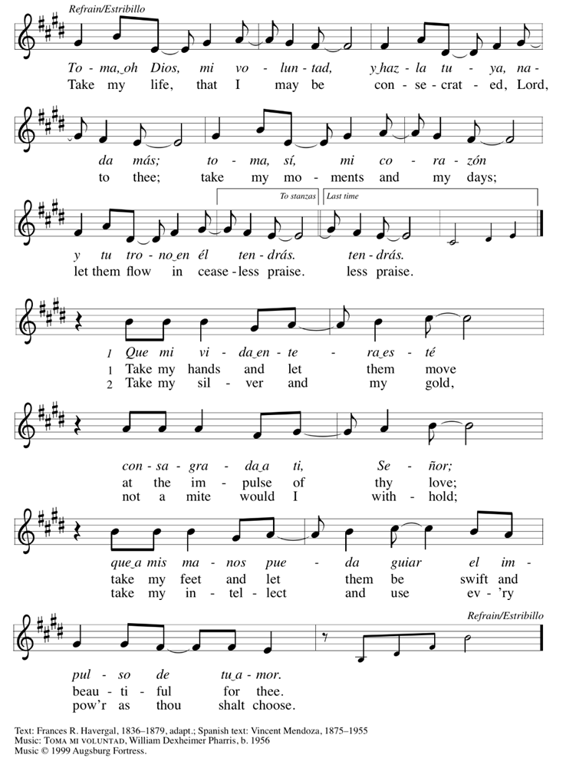
Offering Prayer
Jesus, Bread of life, you have set this table with your very self, and called us to the feast of plenty. Gather what has been sown among us, and strengthen us in this meal. Make us to be what we receive here, your body for the life of the world.
Amen.

Thanksgiving at the Table
Holy God, our Maker, Redeemer, and Healer, in the harmonious world of your creation, the plants and animals, the seas and stars were whole and well in your praise.
When sin had scarred the world, you sent your Son to heal our ills and to form us again into one.
In the night in which he was betrayed, our Lord Jesus took bread, and gave thanks; broke it, and gave it to his disciples, saying: Take and eat; this is my body, given for you.
Do this for the remembrance of me.
Again, after supper, he took the cup, gave thanks, and gave it for all to drink, saying: This cup is the new covenant in my blood, shed for you and for all people for the forgiveness of sin.
Do this for the remembrance of me.
Remembering, therefore, his acts of healing, his body given up, and his victory over death, we await that day when all the peoples of the earth will come to the river to enjoy the tree of life.
Send your Spirit upon us and this meal: as grains scattered on the hillside become one bread, so let your Church be gathered from the ends of the earth, that all may be fed with the Bread of life, your Son.
Through him all glory and honor is yours, Almighty Father, with the Holy Spirit, in your holy Church, both now and forever.
Amen

Lord’s Prayer
Lord, remember us in your kingdom and teach us to pray.
Our Father in heaven, hallowed be your name,
your kingdom come, your will be done, on earth as in heaven.
Give us today our daily bread.
Forgive us our sins as we forgive those who sin against us.
Save us from the time of trial and deliver us from evil.
For the kingdom, the power, and the glory are yours,
now and forever. Amen.

Invitation to Communion
Christ has set the table with more than enough for all. Come!

Communion
The body of Christ, given for you. The blood of Christ, shed for you.

Prayer after Communion
Jesus, Bread of life, we have received from your table more than we could ever ask. As you have nourished us in this meal, now strengthen us to love the world with your own life. In your name we pray.
Amen.

Sending
God blesses us and sends us in mission to the world.

Blessing
The blessing of God, who provides for us, feeds us, and journeys with us,
☩ be upon you now and forever.
Amen.

Sending Song: Eternal Father, Strong to Save (ELW 756)

Dismissal
Go in peace. You are the body of Christ.
Thanks be to God.

Postlude: When Morning Guilds the Sky (Cindy Berry)

All liturgy, music & lyrics in this bulletin are covered by copyright licenses for publishing & streaming.
- Copyright ©2016 Augsburg Fortress. All rights reserved. Reprinted and streamed by permission under license #SAS003678.
- Some music used with permission for publishing and streaming under CCLI License #2262125.
- Some music used with permission for publishing and streaming under LicenSing #623195.
- New Revised Standard Version Bible, copyright ©1989, Division of Christian Education of the National Council of Churches of the Churches of Christ in the United States of America. Used by permission. All rights reserved.

