**HOA Yard-of-the-Month Winner for August**

The August winner was 2427 Mallard Circle, belonging to Christina Williams. The front and side yards, on a curve, present a dauntingly large area to maintain. The property has great curb appeal with multiple flower beds with vibrant colors; healthy, edged grass; and a variety of trees and bushes. The house number is etched on decorative stone slabs. The beds by the sidewalk to the front door and in front of the wrap-around porch and side deck include roses, irises, hostas, cone flowers, and origanum rotkugel (ornamental oregano). Small pots of begonias, a whimsical flamingo, and hanging baskets enhance the porch. The yard has cherry trees, a maple tree, a variety of evergreen trees, an aspen, variegated dogwoods, and prairie grass. In the smaller zone to the left of the driveway by the mailbox are more roses, daylilies, hostas, pansies, marigolds, and a pine tree. All the gardens except the one by the mailbox are extremely water-wise. Christina says, “my yard is my way of being creative and painting a picture, and creating a feeling of peacefulness for me and my neighbors. As the gardens turn into perennial beds, the work becomes less and the enjoyment increases!”

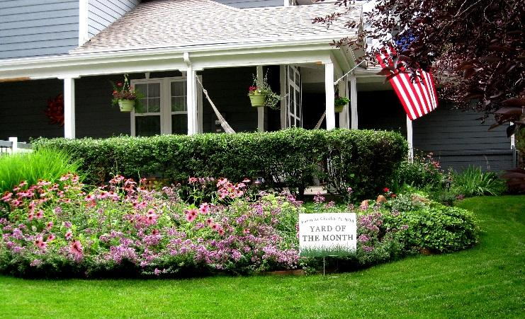

**Neighborhood Oktoberfest Including Chili and Homebrew Contests Will Be Saturday, September 30**

This is the neighborhood’s largest annual event. Starting at 4 p.m., it’s family friendly, with snacks and beverages for kids. Clothing (men’s jeans, socks, new underwear) will be collected for HOPE, a charity that provides life-sustaining support to those experiencing homelessness in Longmont and promotes self-sufficiency (www.hopeforlongmont.org). Wanted: chili contest and homebrew contest entrants. If you plan to enter or can serve as a beer judge (what fun!), email the Social Committee ([soc@fachoa.org](mailto:soc@fachoa.org)). We could use a few EZ-Ups, too (and help that day to put them up).