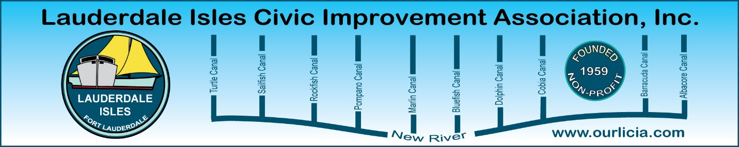
Minutes of the Lauderdale Isles Civic Improvement Association Board Meeting Zoom call September 18, 2025
The meeting was called to order by President Earl Prizlee at 7:05pm.
Roll call was taken.
Present: Earl Prizlee, Geoff Rames, Karen Rames, Dick Cahoon, Joann Kratky, Trent Simpson, Rick Cunningham, Penny Shea, Jackie Zumwalt, Dawn Hannah, Eric Silva, Glo Knowles
Absent: Aynsley Geramanis, Julie Gordon, Andrew Silverman
FLPD report: Officer Antje Jackson reported that there were no part one crimes in the neighborhood since the last meeting.
Code Compliance: Inspector Matthew Flesher reported there were 44 cases closed, 2 cases complied and 22 cases pending compliance. Cases sited include derelict vehicles, exterior lack of maintenance, overgrowth, trash and parking on lawn. Regarding Vacation Rentals, there were 5 cited for no certificate. Matthew will follow up on the trees that need to be trimmed on Riverland Road.
Treasurer report: Earl received from Andrew and will review first and then send it to the Board to approve it at the next Board Meeting.
Secretary report - Board Meeting Minutes for July and August: Dick made the motion to approve, Penny seconded the motion, and we all approved.
Green Your Routine: Dawn attended her first meeting and advised us how to complete the information for grants. We are all welcome to volunteer at city events and initiatives and need to be pre-approved to gain points. For the November 8 Waterway Cleanup, we need to submit the form 2 weeks in advance. Dawn will send the list of events we can participate in and will let us know at each Board meeting what events are coming up as a reminder.
Duck Key sign replacement: Earl said the $3600 check has been received from GEICO. He asked the sign vendor for a drawing and will share when he receives.
Next Newsletter: Geoff advised the deadline for interesting articles about our neighborhood is October 20 at the latest. Let Geoff know in advance what your article is about and the length as he is now working on the layout. Dawn is writing a Green Your Routine article about native plants. Dick offered to write an article. Geoff will include information about the Nov 8 Waterway Cleanup. Karen will include LICIA’s accomplishments this year. We need to have the newsletters delivered in the last week of October in time for the Waterway Cleanup and General meeting in November. We need to include the annual elections information in the newsletter.
General Meeting November 20: Geoff recommended we have Marty Kiar, Broward County Property Appraiser as our Guest Speaker. He will ask Julie to coordinate. Andrew, Karen and Julie will be at the registration desk to coordinate sign in and collect dues for 2026 calendar year.
November 8 Waterway Cleanup: Thanks to our volunteers who agreed to help at this event: Geoff, Karen, Earl, Penny, Trent, Eric, Dick and Rick. Set up at 8:00 and more details at next Board meeting. After the cleanup, Earl will coordinate an ice cream event at the future site of the Community Center for neighbors who are not participating in the Waterway Cleanup.
Lane sign holiday garland: Garland for the signs discussed and Dick, Penny and Rick volunteered to investigate garland options and will give us an update at our next Board meeting. November 28 at 4:30 is the day we decorate. Earl sent an invitation to mark your calendars.

Motion made by Dawn to adjourn the meeting. Dick seconded and all approved. The meeting ended at 8:35pm.
Submitted by Karen Rames, Secretary

