9/3/2016 The Hebrew Year 5777 Begins

Here is a graphic that indicates a relationship between the center dates of the Four Tavs, eight total solar eclipses that began to inscribe "X" marks on the earth in 1999, and the end of the Hebrew year 5776 on 9/2/2016.

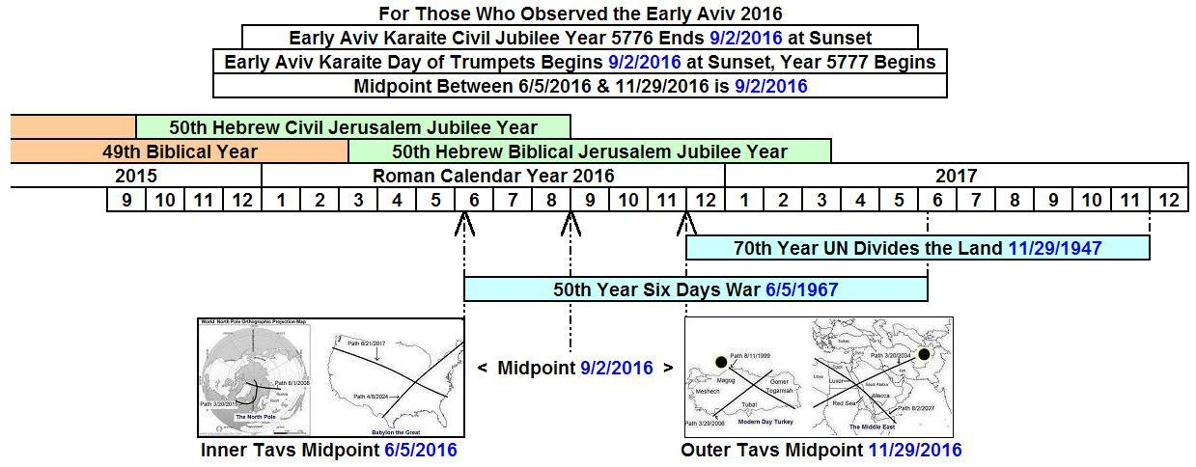

At the time of the creation of the universe, our Creator Elohim ordained these solar eclipse inscriptions to be placed upon the earth at this time in history.

Today, 9/3/2016, is the first day of the Hebrew year 5777 according to early Aviv Karaite reckoning. And today, 9/3/2016, two of the world's superpower nations, China and the United States, ratified an agreement which will strengthen a system of rising global government.

Two of the four Tavs mentioned above mark the nuclear superpower nations, Russia and the United States, having a center date of 6/5/2016 and the 49th anniversary of the Israeli Six Days War in 1967. The other two of the four Tavs mark the Islamic regions of Turkey and Saudi Arabia having a center date of 11/29/2016 and the 69th anniversary of the UN partitioning of Palestine into Jewish and Arab sections in 1947. Therefore, 6/5/2016 began a 50th year concerning Jerusalem, and 11/29/2016 will begin a 70th year concerning the partitioning of Israel by the United Nations. Both the numbers 50 and 70 are biblically significant. By their mighty powers and abilities, our Creator Elohim have pointed to these dates and times concerning Israel through a series of solar eclipses.

Additional information concerning the Four Tavs is available here: http://www.joybysurprise.com/The_Four_Tavs.html

