RSAI Legislative Update
April 8, 2021
In this RSAI Weekly Report from the 2021 Legislative Session, find information about:
- HF 605 ELL Tiered Weighting to the Governor
- HF 532 Qualified Instructional Supplement and PK Enrollment Growth Funding
- Tax Bill Moves in the Senate – SF 587 Hits State General Fund and Eliminates PERL
- Status of Charter Schools, Diversity Plans/Open Enrollment and Diversity Training Limitations
- Education Appropriations Bill Introduced: Includes Child Mental Health Funding
- Other Bills on the Move
HF 605 LEP Tiered Weighting: this bill sets two weightings to generate funding for students served in limited-English proficient programs based on proficiency. An intermediate level with a weighting of .21 and an intensive level of .25, compared to the current weighting for all LEP students at .22. The 2013 ELL Task Force recommended tiered weighting and this bill gets the policy in place. We will continue to work on weightings that approach the national average of .3 in the future. Thank your Representatives and Senators for their support of this policy that targets student need. RSAI is registered in support.
HF 532 Qualified Instructional Supplement: this bill was amended in the Senate Education and Appropriations Committees to simplify the allocation formula, with $60 per pupil for instructional days based on the number of students served, includes credit for hybrid days, includes in the count virtual days operated under a waiver from the DE, and provides for districts in virtual models due to derecho. Students in 100% options by choice are not included in the count. The formula allows for up to 90 days of instruction to meet the criteria to reach the $60 per student. Requires $1 per pupil from the school’s allocation to be paid to the AEA for PPE costs at the AEA. The amendment sets the supplement as miscellaneous income and allows the funds to be spent on anything allowable for federal pandemic fund expenditures (CARES Act, ESSER II and American Rescue Plan). The amendment also requires an appropriation up to $27.2 million to pay the costs of the supplement. If funds are not sufficient, the DE is required to prorate the funds to school districts. Preschool: the amendment also directs the SBRC to grant a modified supplemental amount (MSA) for increased preschool enrollment in the fall of 2021, based on receipt of funding (funding is intended to be provided from the federal GEERS and ESSER state funds). If districts have an ending PK balance for FY 2021 that is 25% or less of the FY 2021 PK Foundation Revenues received, the SBRC will automatically grant the requested MSA. If a district’s ending FY 2021 PK balance is greater than 25%, the district may request MSA and the SBRC will consider and may grant it. RSAI was originally opposed to the bill, which required a count of days based on a complicated count of hours, days and instructional delivery format. With the change in distribution and the addition of PK funding for enrollment growth, RSAI will change registration to support when the amendment is approved on the Senate Floor. Encourage your senators to support the amendment and the bill.
SF 587 Tax Changes, Mental Health Funding and PERL: This big tax bill has many provisions:
- Mental Health Funding System: Creates an MH/DS regional services fund. Establishes a new funding formula and creates a risk pool. Phases out county property taxes and replaces them with state appropriations. Limits growth to the state appropriations.
- Commercial and Industrial (C&I) Property Tax Relief Backfill: Eliminates property tax replacement payments to local governments and establishes a new formula for phasing out payments, FY 2023-2028.

- Schools: Increases the state school aid base to 88.4% as of the 2022-2023 school year to help mitigate the impact of the C&I backfill changes. This will increase the amount of State aid going to the foundation level and decrease the additional General Fund levy.
- PERL: Eliminates the voter-approved public education and recreation property tax levy. This provision impacts 23 school districts whose voters have approved it to pay for adult and community education, playgrounds, swimming pools and joint recreational facilities with cities.
- Triggers: Strikes the trigger requirements before the 2018 income tax changes take effect. This provision is the costliest in the bill, reducing state general fund revenues by over $270 million in FY 2023. Additionally, we do not yet know the requirements for state governments to avoid using federal pandemic funds to replace lost state revenue due to tax cuts.
- RSAI is registered opposed to this bill. Contact House members and ask them to remove the Division that eliminates the PERL levy and express concern about the impact of the tax trigger elimination on the state general fund and federal funds eligibility.
HF 813 Charter Schools: this bill was approved on party lines in the Senate Appropriations Committee Thursday afternoon. Asks Senators to improve the bill with four key amendments: 1) charters should be subject to Public Records Chapter 22, 2) Founding members should be Iowans, 3) charter schools should pay the public school the prorated amount of state aid for students that withdraw or are expelled from the charter schools and 4) administrators should be licensed. See an updated Call to Action on Charter Schools in the Senate here. RSAI is opposed to this bill, now on the Senate Calendar.
HF 228 Diversity Plan Open Enrollment Regulation Ban: this bill bans the ability of five districts with voluntary diversity plans (Davenport, Des Moines, Postville, Waterloo and West Liberty) to regulate open enrollment out of the district based on their plans, which currently review socioeconomic status (income) or English-language learner classification as metrics to consider. None of these districts uses race as a metric, which was banned as a sole measure of consideration by a Supreme Court decision in 2007.
The goals of the diversity plans are to preserve a mix of diversity and prevent segregation of schools in these districts. There is a solid research base that shows a concentration of poverty which hits a tipping point at 50-60% and segregated schools negatively impacts student achievement, economic growth and workforce diversity for such communities. See the UEN Issue Brief explaining the issue and showing data on poverty, minority, open enrollment and certified enrollment for these districts and for similar districts without voluntary diversity plans.
The bill was amended in the Senate and passed on party lines, sending it to the House. The amendment eliminates the open enrollment application deadline, so a student may open enroll out of any of these districts at any time in the 2021-22 school year. The March 1 application deadline is reinstated for the 2022-23 school year. The amendment however, may have an error. It not withstands the entire open enrollment code section, which includes regulations on good cause, athletic eligibility, payments between districts, and the return of students to the resident district. Request of House members a better, known deadline for open enrollment requests out of these districts during the 2021-22 school year. RSAI is registered in opposition.
HF 802 Racism/Diversity Training: this bill establishes requirements for diversity training, on racism and sexism, in schools and colleges including prohibiting teaching that Iowa is fundamentally racist or sexist. The bill prohibits political subdivisions, including school districts, from providing any mandatory staff training from teaching, advocating, acting upon or promoting divisive concepts and race or sex scapegoating but does not prevent an employee or contractor who provides mandatory training from responding to questions regarding divisive concepts raised by participants in the training. The bill was expanded to cover state and local governments. The bill also prohibits teaching of divisive concepts or race or sex scapegoating in the curriculum. See the March 18 RSAI Weekly Report for a detailed description of the bill.
Senate Education Committee Chair, Sen. Sinclair, stated her intention to amend the bill on the floor during debate. We anticipate the diversity training provisions will be more similar to the Senate version, SF 487, removing the provisions of the bill applying to curriculum and limiting some of the expansions in the House. The Committee’s approval on party lines sent the bill to the Senate Calendar last week, where it remains. Ask your senators to amend the bill to eliminate the control over curriculum, which is the purview of local school districts, and to simplify the rest of the bill to make it reasonable. RSAI is registered as undecided, leaning opposed.
Education Appropriations
The Education Appropriations Bill was assigned to the House Education Appropriations Subcommittee today, but has yet to be assigned a bill number. Here’s a link to the text of the bill: https://www.legis.iowa.gov/docs/publications/SD/1218781.pdf
The Education Appropriations Bill typically includes funding for community colleges, regents, the DE, and other executive branch agencies, and a few line items impacting schools. Encouraging in this bill is the inclusion of funding for student mental health, including $1.6 million for Therapeutic Classroom Grants and $3.1 million to the AEAs for Student Mental Health Services and Mental Health First Aid Training. As you talk to representatives, ask them to maintain this commitment to student mental health. RSAI will register in support when the bill is assigned a number (unless we oppose any changes made in committee).
Bills on the Move
- SF 260 Medicaid Reimbursement for Sped Services. Requires receiving district to provide documentation for Medicaid billing to the resident district. Senate approved 47-0 (3/17). House agreed 91-0; to the Governor. RSAI supports.
- SF 517 Academic Credit for Pages: Requires high schools to give ½ unit of social studies credit to legislative pages and exempts them from PE requirements. Senate approved 44-1 (2/17) House agreed 82-9; to the Governor. RSAI supports.
- HF 315 At-Risk Children: Allows AEAs to use certain funds related to early childhood programs to use the funds for other child development programs. House approved 93-0 (2/16) Senate Agreed 44-0; to the Governor. RSAI is undecided.
- HF 317 Education Funding Requests for Children in Facilities: Changes the methodology used by schools to calculate funding requests to DE for providing education services to children in foster care, juvenile detention or residential treatment facilities. Uses the number of days children are enrolled in the district (conforms to current practice). House approved the bill 93-0 (2/10) Senate Agreed 44-0; to the Governor. RSAI is undecided.
- HF 380 Distracted Driving: Requires that driver’s education classes include provisions on distracted driving. House approved the bill 94-0 (2/10) Senate Agreed 44-0; to the Governor. RSAI is registered as undecided.
- HF 388 CDCC Services: Strikes certain outdated duties of the Child Development Coordinating Council on inventories of services for at-risk children and on the development of regional councils. House approved 94-0 (2/10) Senate agreed 44-0; to the Governor. RSAI is registered as undecided.
- HF 602 Student Activity Account Transfers: this bill authorizes school boards to transfer district general fund moneys to the student activity fund for two years only, with the authority repealed July 1, 2023. The bill was approved by the Senate Education Committee and is on the Senate Calendar. RSAI supports.
- HF 744 Protecting Free Speech: First half is about Universities. School provisions also protect student and employee intellectual freedoms in public schools.
  - Requires the school board to establish and publicize policies that protect students and faculty from discrimination based on speech.
  - Prohibits retaliation against a person who files a complaint for a violation of this section and provides whistle-blower protections if the complainant is an employee.
  - Allows disciplinary action by the BOEE against school employees for discriminatory practices.
  - Senate amendment added requirement for school boards to incorporate provisions in relation to student publications and to protect school employees who act to protect the rights of students involved with the school newspaper.
The Senate approved the bill as amended 46-0; sending it back to the House. RSAI is registered as undecided.
- HF 847 Education Flexibility, Tuition and Textbook Tax Credits and Open Enrollment: This bill was assigned to the Senate Ways and Means Committee, which makes it funnel proof. A subcommittee recommended it move forward to the full Committee. The Fiscal Note includes a detailed bill description and lists fiscal impact. The Fiscal Note is found here: https://www.legis.iowa.gov/docs/publications/FN/1218218.pdf
The House Amendment which added two operational sharing positions (special education director and work-based internship coordinator) reduced weightings, lowering a 5 to a 4 and lowering a 3 to a 2 beginning July 1, 2022 for the remaining 3 years of the current program. The Fiscal Note estimates a reduction of $2.8 million annually statewide. The following chart from the Fiscal Note shows the net impact on reduced operational sharing revenues in FY 2023, 24 and 25, the remaining three years of the program prior to its sunset.
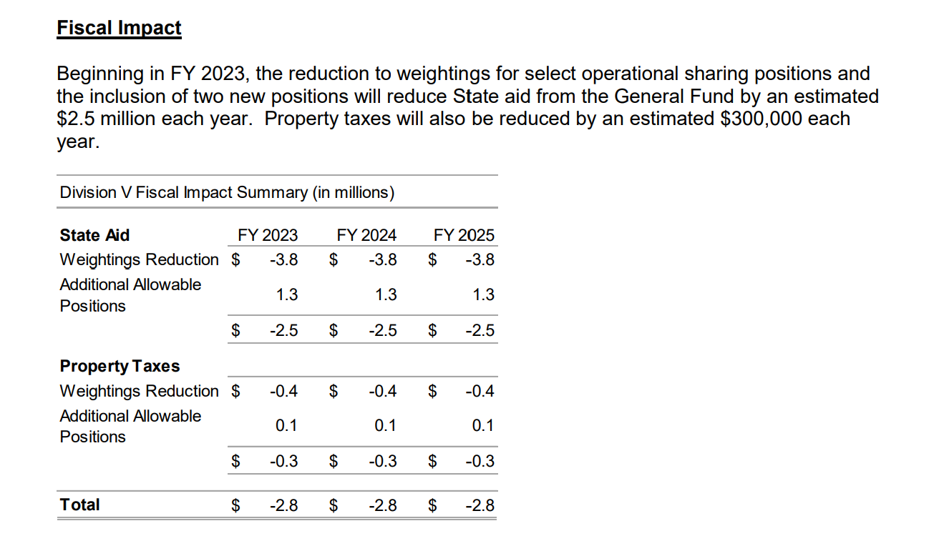
RSAI is registered as undecided, in support of some provisions allowing additional flexibility of programs and funding, and opposed to others such as the tuition and textbook tax credit and open enrollment good cause associated with a schools ESSA designation. See the March 26, 2021 weekly report for a full description of the bill. The bill is likely to be considered on a Senate Ways and Means Committee agenda next week.
Connecting with Legislators:
Find biographical information about legislators gleaned from their election websites on the ISFIS site here: http://www.iowaschoolfinance.com/legislative_bios Learn about your new representatives and senators or find out something you don’t know about incumbents.
Find out who your legislators are through the interactive map or address search posted on the Legislative Website here: https://www.legis.iowa.gov/legislators/find
To call and leave a message at the Statehouse during the legislative session, the House switchboard operator number is 515.281.3221 and the Senate switchboard operator number is 515.281.3371. You can ask if they are available or leave a message for them to call you back.
Advocacy Resources
To find Advocacy Resources such as Position Papers, RSAI Weekly Legislative Reports and video updates, RSAI Calls to Action when immediate advocacy action is required, testimony presented to the State Board of Education, the DE or any legislative committee or public hearing, and links to fiscal information that may inform your work, visit the RSAI legislative web page here: http://www.rsaia.org/legislative.html. Also, check out the new RSAI Advocacy Handbook linked here, and also available on the legislative page of the RSAI website
Thanks to our RSAI Corporate Sponsors:
Special thank you to your RSAI Corporate Sponsors (and especially RSAI’s newest sponsor Apptegy) for their support of RSAI programs and services. You can find information about how these organizations may help your district on the Corporate Sponsor page of the RSAI website at www.rsaia.org/corporate-sponsors.html.
 | www.apptegy.com
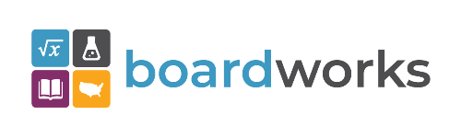 | www.boardworkseducation.com
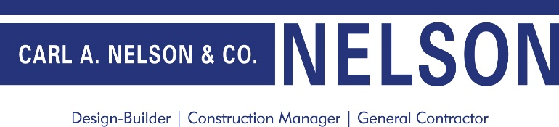 | www.carlanelsonco.com
Contact us with any questions, feedback or suggestions to better prepare your advocacy work:
Margaret Buckton, RSAI Professional Advocate, margaret@iowaschoolfinance.com , 515.201.3755 Cell

