4/6/2017 The Signs in the Global Media 4/6/2017

According to the Hebrew calendar, 4/6/2017 is the 10th day of Nisan, the day for the selection of the Passover lamb. It was on the 10th of Nisan around 30 AD when YAHUSHUA, the Messiah of YaHuWaH Elohim, rode into Jerusalem on the back of a donkey in fulfillment of Zechariah 9:9.

The Lamb of YaHuWaH , YAHUSHUA His Messiah, was inspected for imperfection by the Temple Priests for 4 days and then slaughtered on the eve of Passover on Nisan 14. YAHUSHUA was the perfect sacrifice for the sins of all mankind.

Below are listed some of the signs that appeared in the global media on Hebrew calendar Nisan 10, 2017, 4/6/2017.

1. On 4/6/2017 a sheep was slaughtered to demonstrate the Passover sacrifice inside the walls of Old Jerusalem for the very first time in about 2,000 years. We know that sacrifices that are offered in obedience to the instructions of YaHuWaH Elohim will bring His attention to bear upon the condition of His people. The altar of sacrifice is the center of Hebrew and Christian worship where sin is dealt with.

Be aware that when the daily sacrifice on an altar in Jerusalem is halted at some future date, a time of trouble will commence that is far beyond any that the world has seen previously, or will ever see again in all of history.

Link: http://www.timesofisrael.com/in-a-first-sheep-slaughtered-in-jerusalem-old-city-in-reenactment-of-passover-sacrifice/

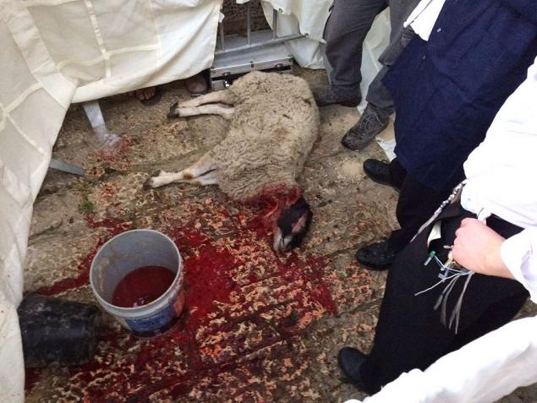
The Sheep Slaughtered in the Passover sacrifice demonstration in Jerusalem's Old City 4/6/2017
Image courtesy Alexander Fulbright/Times of Israel

2. 4/6/2017 - Russia recognizes west Jerusalem as Israel's capital, and east Jerusalem as the Palestinian capital. Link: http://www.timesofisrael.com/liveblog_entry/russia-recognizes-west-jerusalem-as-israels-capital/

YaHuWaH Elohim has stated that He will cut in pieces those who cut Jerusalem in pieces. This does not bode well for Russia, or anyone who joins Russia in this venture.

3. 4/6/2017 - The United States Senate votes to "go nuclear" in order to confirm Republican nominee Gorsuch to the United States Supreme Court. The Senate changed the number of votes required to confirm Gorsuch from 60 votes to 51 votes for the first time in 200 years. Link: http://thehill.com/homenews/senate/327591-gop-triggers-nuclear-option-gutting-filibuster-in-gorsuch-fight

Note that 60 was the base numbering system used in ancient Babylon. The nuclear option was used by the US Senate on 4/6/2017 to symbolically negate that Babylonian base 60 system, and from that we derive the coming nuclear destruction of modern Babylon the Great being publicly announced on 4/6/2017. Also note that the project during World War II that developed the first nuclear weapon was named the Manhattan Project.

4. 4/6/2017 - Article - An Israeli creates a "model universe" in Times Square, New York City. Link: http://www.timesofisrael.com/its-a-small-world-after-all-israeli-creates-a-tiny-universe-in-times-square/?utm_source=The+Times+of+Israel+Daily+Edition&utm_campaign=063c88fe1b-EMAIL_CAMPAIGN_2017_04_06&utm_medium=email&utm_term=0_adb46cec92-063c88fe1b-55467209

The creation of a model universe by an Israeli in New York City symbolically implies nuclear activity in New York City by YaHuWaH Elohim.

During the act of creation, light is divided into matter and anti-matter. That's why light was the first thing created by YaHuWaH Elohim in Genesis chapter 1.

Members of the Manhattan project learned how to destructively divide matter by splitting the atom, turning some of the matter in the atom back into the electromagnetic energy (light) from which it originally came.

5. 4/6/2017 - Article - In Canada, Christian Schools are told to allow Sodomite Clubs or close down operations. Link: https://prophecyinthenews.com/world_news/christian-schools-told-to-allow-homosexual-clubs-or-close/

Soon after he was created, man was divided into male and female by his Creator Elohim. Male and female were then instructed to join and become one flesh in order to symbolize the image of Elohim. Male joining with male and female joining with female are perversions of the symbolic balanced image of Elohim intended to be conveyed to society. A society composed of unnatural unions is unable to procreate, resulting in the death of its members.

6. 4/6/2017 - Article - Ancient 4,000 year old Dolmen found in Israel has curve with line engravings on it. Link: http://www.haaretz.com/archaeology/1.775318

Although not exactly congruent with the engravings on the Dolmen mentioned above, the curve with the line on it is reminiscent of the second "Tav" eclipse sequence that was revealed by YaHuWaH Elohim in late 2014.

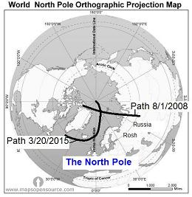
The "bow with arrow" solar eclipse Tav relates to the 4,000 year old Dolmen mentioned above that has multiple curves with lines engraved on it. The "arrow" eclipse path passed directly over the nuclear device mentioned below. Note that the bow is bent toward Russia.

Link to an explanation of the Four Tavs: http://www.joybysurprise.com/the-four-tavs.html

The straight line in the above solar eclipse path graphic above passed directly over the item in the image below located on an island north of Siberia.

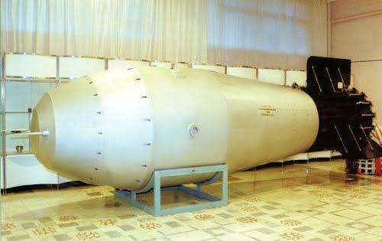
57 Megaton nuclear device

We're aware that the naming of the Manhattan project may have been a prophetic revelation from our heavenly Father. YaHuWaH Elohim has said that He "declares the end from the beginning". The "end" of the Manhattan project of World War II, a project that was intended to develop a nuclear device, may be the destruction of Manhattan by the nuclear device that was developed.

7. 4/6/2017 - The United States launched a military attack against sites in Syria. Syria is allied with Iran and Russia. We know that at some point the city of Damascus in Syria, one of the oldest continually inhabited cities on the face of the earth, will be completely destroyed in one night. - Isaiah 17

Isaiah 17:1 The burden of Damascus. Behold, Damascus is taken away from being a city, and it shall be a ruinous heap.

And the nations shall flee...

Isaiah 17:13 The nations shall rush like the rushing of many waters: but Elohim shall rebuke them, and they shall flee far off, and shall be chased as the chaff of the mountains before the wind, and like a rolling thing before the whirlwind.
14 And behold at eveningtide trouble; and before the morning he is not. This is the portion of them that spoil us, and the lot of them that rob us.

