1/20/2019 Prophetic Time Spans and the Crystal Sea

YaHuWaH Elohim is an Elohim of perfect order. The beauty and symmetry of His creation is evident all around us, from the flowers in the meadow to the galaxies in the heavens.

A prophetic year is a year of 360 days which was evident in the counting of the 5 months being 150 days in Noah's day in Genesis 8:3-4.

A 360 day prophetic year is also evident in the future 42 months (42 x 30 days = 1260) being 1260 days by comparing Revelation 12:6 with Revelation 13:5.
Daniel 7:25 also confirms the 42 months being 1260 days by the statement "...and they shall be given into his hand until a time and times and the dividing of time". The word "time" in Daniel 7:25 equates to one 360 day prophetic year.

The word "times" equates to two 360 days prophetic years. And the "dividing of time" equates to 1/2 of a 360 day prophetic year, which is 180 days. The total of the time + times + 1/2 time equals 360 + 360 + 360 + 180 days = 1260 days.

The thought came to me recently that the interior angles of a triangle always add up to 180 degrees. The number 180 reminded me of 1/2 of a prophetic year mentioned above. I prayed and asked YaHuWaH Elohim to reveal to me that which He willed for me to know concerning the triangle.

Here's some of what He's revealed so far concerning the symmetry of regular polygons and their relationship with prophetic time spans, counting the total sum of the interior angles of each regular polygon, with each one degree of angle being equated to one day.

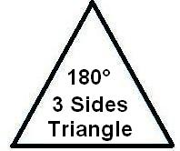

Above:The 3 interior 60 degree angles of the equilateral triangle equate with 180 days, 1/2 of a prophetic 360 day year, or 6 - 30 day prophetic months.

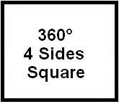

Above: The 4 interior 90 degree angles of the square equate with a complete 360 day prophetic year.

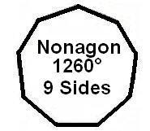

Above: The interior angles of the Nonagon equate to 1260 days, or 42 prophetic months mentioned further above.

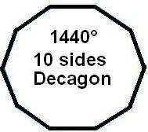

Above: One hundred Decagons equate to the 144,000 of the tribes of Israel mentioned in Revelation 7:4 , 14:1, and 14:3. The measurement of the wall of the New Jerusalem in Revelation 21:17 was 144 cubits. Note that the number 10 signifies perfection in the bible.

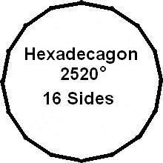

Above: The Hexadecagon, a 16 sided regular polygon with a sum interior angle measurement of 2520 degrees. The number 2520 is exactly 7 prophetic years and is twice the 1260 days symbolized by the 9 sided Nonagon mentioned above.

The number 2520 was the numerical monetary value of the coins mentioned in the Handwriting on the Wall event in ancient Babylon. Adding 2520 years onto the date of the Handwriting on the Wall, October 11, 539 BC, brings us to 10/1981 - 10/1982 AD.

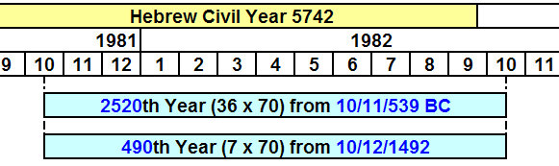

Above: Note that Christopher Columbus first sighted land in what would become New Babylon America at 2 AM on the morning of 10/12/1492 AD Julian calendar, resulting in the above timing relationship exactly 2520 years from ancient Babylon's demise on the night of 10/12/539 BC Julian calendar (after sunset on 10/11/539 BC ancient Babylon fell). The timing is precise.

Below: A graphic showing the 36th years of life from birth for Presidents Clinton, Bush, and Trump falling precisely 2520 years after the demise of ancient Babylon.

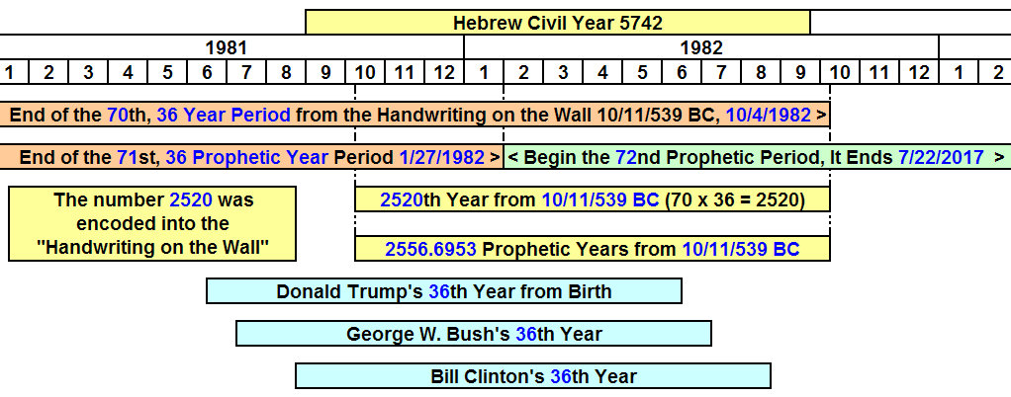

The above information reveals the hand of YaHuWaH Elohim ordering the symmetrical structure of His creation, and moving in the intimate lives of peoples in order to arrange and bring to fruition His plans on the earth.

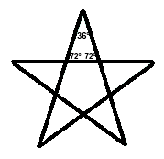

Above: The Interior angles of the points of a regular 5 pointed star equal 72 + 72 + 36 = 180 degrees. All three Presidents mentioned above observed their 72nd birthdays, twice 36, in 2018 just after the State of Israel observed its 70th anniversary of modern national sovereignty on 5/14/2018. A regular pentagon, like the one in Washington, D.C., is located in the center of the 5 pointed star above.
The two dimensional regular polygons featured above take on a crystaline aspect having different numerical values when presented in three dimensions.

Revelation 4: 6 And before the throne there was a sea of glass like unto crystal: and in the midst of the throne, and round about the throne, were four beasts full of eyes before and behind.

Summary

In the beautiful universe of YaHuWaH Elohim, geometric figures can be used to represent prophetic time spans, and transfer information to us graphically. For example, 3 squares and 1 triangle can symbolically equal 1260 days, or a time, times, and a dividing of time.

