RSAI Legislative Update
March 31, 2022
Week Twelve of the 2022 Session: Budget bills are primarily through the House (two to go) with no action yet in the Senate. Two big bills, Transparency of Instructional Materials and Governor’s School Choice, receive chamber amendment and action. This RSAI Weekly Report from the 2022 Legislative Session includes:
- House Action including Parent Transparency Bill
- Senate Action including Teacher Recruitment and Voucher Bills
- Committee Action on AEA Reorganization Bill
- Status of Appropriations Bills and the Education Budget Approved in the House
- Advocacy Action and Links to Advocacy Resources
House Action
SF 2080 School Health Screenings: applies to physical examinations and student health screenings by school districts, charter schools, or innovation zone schools. Requires written parent permission before routine health screenings. Defines health screening as invasive, including insertion or incision into the body or exposure of private parts. Makes exceptions for emerging health issues or for participation in a child abuse investigation. Specifically exempts vision, hearing or scoliosis screening. Approved unanimously in the House, sending it to the Governor. RSAI is undecided.
SF 2197 Special Education Study: establishes a task force related to special education support for students at nonpublic schools. Specifies membership of the task force and requires a report by Dec. 1, 2022. Approved unanimously by the House, sending it to the Governor. RSAI is undecided.
HF 2577 Transparency, Parent Access to Materials, Library Book Processes and Social Studies Instruction, See a complete description of this bill as amended in the House Appropriations Committee in the Mar. 24 weekly report. The bill was further amended and approved by the House 58:36, sending it the Senate, where it has been assigned to the Senate Appropriations Committee. Since the Senate amended their parents’ rights bill language to the Voucher bill, that’s a sign that the Senate is not enamored with the language in HF 2577. RSAI is undecided and has concerns about the unfunded mandate of complying with transparency provisions (training and software).
Senate Action
HF 2412 Radon Testing and Mitigation: requires testing every five years, and beginning no later than July 1, 2027, and subsequent mitigation, requires the testing and mitigation be done by certified providers or by employees trained according to DE requirements, allows SAVE to pay for both by board action (without including in the revenue purpose statement), exempts buildings if construction, renovation or a building closure will happen in the next five years. The Senate approved the bill unanimously, sending it to the Governor. RSAI is undecided.
SF 2377 Teacher Recruitment: See the March 31 RSAI Call To Action on Teacher Recruitment for a more detailed explanation of our concerns and advocacy actions. Details of the bill: creates a new fast-track Teacher Intern Program. Increases the eligibility for Teach Iowa Scholar Loan forgiveness from the top 25% to the top 30% of their class (HF 2083, on the Senate Calendar, completely eliminates that requirement). Adds the ability to use Management Fund to pay for teacher recruitment (the following limits only apply to the Management Fund – districts can still use other funds to pay for teacher recruitment):
- Prohibits a board’s recruitment plan to pay a teacher recruitment incentive that annually exceeds 10% of the minimum teacher pay ($33,500 so annual incentive is $3,350).
- Allows incentive pay to a teacher for no more than 5 years.
- Requires the board to adopt either the program for early retirement benefits or recruitment incentives, not both concurrently or payments toward both in the same budget year. Requires the board to only change course every 5 years.
- Requires a public hearing before adopting either program.

Approved 49:0 in the Senate, sending the bill to the House. The new fiscal note was filed to the bill prior to amendment (adding the limitations) yet did not anticipate a property tax increase. RSAI supports the original bill before changes on the Senate Floor. The Senate’s amendment makes this bill less flexible and viable as a recruiting tool for rural districts. RSAI is registered in support, but with the amendment, we do have some concerns that the Senate version is too limiting.
SF 2366 Wind Energy Property Taxes: Deems that the special valuation taxation of wind energy property is in lieu of other taxation and continues until the 19th assessment year if the ordinance should be repealed. Prohibits repairs on wind towers from triggering a reset on the clock (valuation increase would continue as originally determined). The Senate passed the bill as amended 47-0, sending it to the House. RSAI supports this bill.
SF 2367 Sales Tax Matters: Most of this bill doesn’t impact schools, however, the bill requires SAVE amounts owed to schools to be transferred from the Department of Revenue entirely (not estimated and followed up the next year with a true-up payment. Also requires the DOR to estimate sales tax revenue for schools annually. The Senate passed the bill 47-0, sending it to the House. RSAI is undecided.
SF 2369 Governor’s School Choice Omnibus: the Senate amended the bill with a strike after amendment that effectively re-enacts much of the bill, strikes some ideas and adds other content. RSAI remains registered opposed to this bill, even with the operational sharing changes. See the March 31 RSAI Call to Action on School Vouchers for a detailed explanation of our concerns and advocacy actions.
Continues from the original Governor’s bill:
- Education Savings Accounts: up to 10,000 vouchers (5,000 for students with IEPs and 5,000 for students from families below 400% of the federal poverty level, incoming kindergarteners, and for prior ESA recipients down the road). See the March 24th Updated Call to Action for details about this provision. A NOBA (LSA’s Notes on Bills and Amendments which highlights fiscal impact) published on the bill estimated that this provision would reduce school funding to public schools by $79.1 million, would maintain and estimated FY 2023 state General Fund appropriations of $55.2 million for Students First Scholarships, and increase a new standing unlimited appropriation of $23.9 million for the Students First Enrollment Supplement Fund. This Fund was amended out of the bill and replaced by the Students First Operational Sharing Incentives Fund, but the math works the same way. Still $23.9 million for the new fund. RSAI opposed this provision.
- Good Cause Open Enrollment: for siblings and step-siblings of students granted a good cause open enrollment. RSAI is undecided on this provision.
- Home School Special Education: allows a student enrolled in competent private instruction to dual enroll for special education services without specific permission from the AEA special education services director. RSAI is undecided on this provision.
- Social Studies/Civics: mandates the test used by the Immigration and Naturalization Service for Citizenship be the test for high school government and requires that a student score at least 70% on that test in order to graduate. Allows students to take the test multiple times. Requires public and nonpublic schools to report scores annually. Does not mention the ability to make accommodations for any students. RSAI is opposed to the high-stakes graduation requirement in this division.

Makes the following changes:
- Librarians: removes from the bill the elimination of the requirement that K-12 teacher librarians have masters’ degrees (maintains current requirements). RSAI was supportive of the Governor’s recommendation.
- Transparency and Library Books: strikes the Governor’s school transparency and librarian provisions. Adds provisions similar to SF 2205 - Creates a parental bill of rights in regard to school matters. Requires that the parents have access to information on who is teaching a child, on what the child is being taught, the right to review information and records, reasonable access to the student during the school day, and on other matters, except where prohibited by law. Prohibits schools from requiring students to engage in an activity that involves the viewing of sexually explicit material, allows parents to request their child not check out specific material from the library. RSAI prefers the Senate language to the House’s Transparency bill HF 2577.
- Mandatory Reporter and Incidents: adds language from HF 2567 - Requires certain mandatory reporters of child abuse to report such abuse regardless of the age of the child. Requires school employees who believe that another school employer is responsible for the injury to report that employee. Requires the DE to develop a process for reporting/investigating incidents where a teacher or licensed professional may have broken a law. Includes immunity provisions for school boards (no litigation for sharing information about a past employee with a potential employer or government agency.) Requires records be kept of incidents but does not make those open records. Establishes civil penalties for administrators who fail to follow procedures. BOEE: Requires the BOEE to suspend teachers who are convicted of aggravated misdemeanors. Requires BOEE to adopt rules on complaint records and on giving notice of investigations to schools. Requires districts to check a licensure database to confirm if there is a pending investigation with probable cause prior to hiring a licensed educator. RSAI supports this provision with the improved process of verification from the BOEE.
- Praxis: adds language from HF 2081 - Strikes the ability of colleges to administer a pre-professional assessment to teaching candidates (Praxis) and the requirement to use a subject assessment from a national testing program for licensure. Applies to students in teacher education programs on or before the effective date of the bill. Increases requirements for pre-teaching field experience for student teachers to 80 hours and 50 hours for teaching interns. RSAI supports this provision.
- Operational Sharing: adds new sharing incentives for small school districts funded with the equivalent of 30% of the regular program district cost in a Student’s First Operational Sharing Fund (allows up to 24 student weighting which is an increase of 3, but with a new process to request SBRC approval and requirement to demonstrate the need for the position if the current 21-student cap is exceeded, and extends Operational Sharing through July 1, 2034). Also adds SRO position at a weighting of 3 students (which is later in the statute lowered to a weighting of 2 students). RSAI supports extending these sharing incentives, but we opposed the voucher funding source and the bureaucratic hurdle of SBRC process.

- Advanced Degrees CEUs: allows master teachers to renew credentials without additional CEUs (except for evaluator training) based on the verification from their evaluator that they participated in PD. From HF 2398. RSAI supports this provision.

The Senate passed the bill as amended 31-18 (with Sen. Sweeney voting with the Democrats), sending it to the House. RSAI is registered opposed to the bill.
Committee Action
HF 2580 Area Education Agency Reorganization: HSB 727 was amended in the House Appropriations Committee, to completely strike the requirement for AEAs to reorganization. Instead , the bill sets a 12-month payment plan for state aid AEAs to minimize the need to ending balance to cash flow the organizations, creates a sparsity increase based on fewer pupils per square mile for AEAs that serve large geographic areas with fewer students, recalculate AEA costs per pupil to make the decades-long $15 million annual cut permanent. The bill also requires tracking of professional development for AEA staff and is required for both mandatory and optional PD paid for by school districts to be reported in BEDs. The bill also requests the Legislative Counsel to study teacher prep programs in the state of Iowa. The bill was approved by the committee and is on the House Calendar. RSAI is registered in support of the bill, but has some concerns remaining about the burden on school districts to report PD through the BEDS annual report.
Status of Appropriations:
HF 2575 Education Appropriations: in addition to the line item appropriations shared in the Mar. 24 weekly report, the bill was amended with the following new provisions during the House floor debate:
- Creates a new Cybersecurity Simulation Training Center at ISU (available to businesses, state government, political subdivisions including schools for training)
- Limits superintendent severance payments to the equivalent of 3 months of payment, retroactive to Jan. 1, 2022
- States authority for districts to provide $1,000 bonuses to those not covered by the Governor’s bonus plan (no money, just permission to use unobligated UAB )
- Exempts up to $1,000 teacher bonuses paid from ESSER, ARP (paid from either local district or Governor’s federal pandemic funds) or school UAB from State Income Taxes

Approved 58:36 in the House and now over in the Senate Appropriations Committee. RSAI is registered as undecided on the bill.
The following table from the IALNS Bulletin, March 30, 2022, shows the progress of appropriations bills all but two of which have been approved by the House with no action in the Senate.
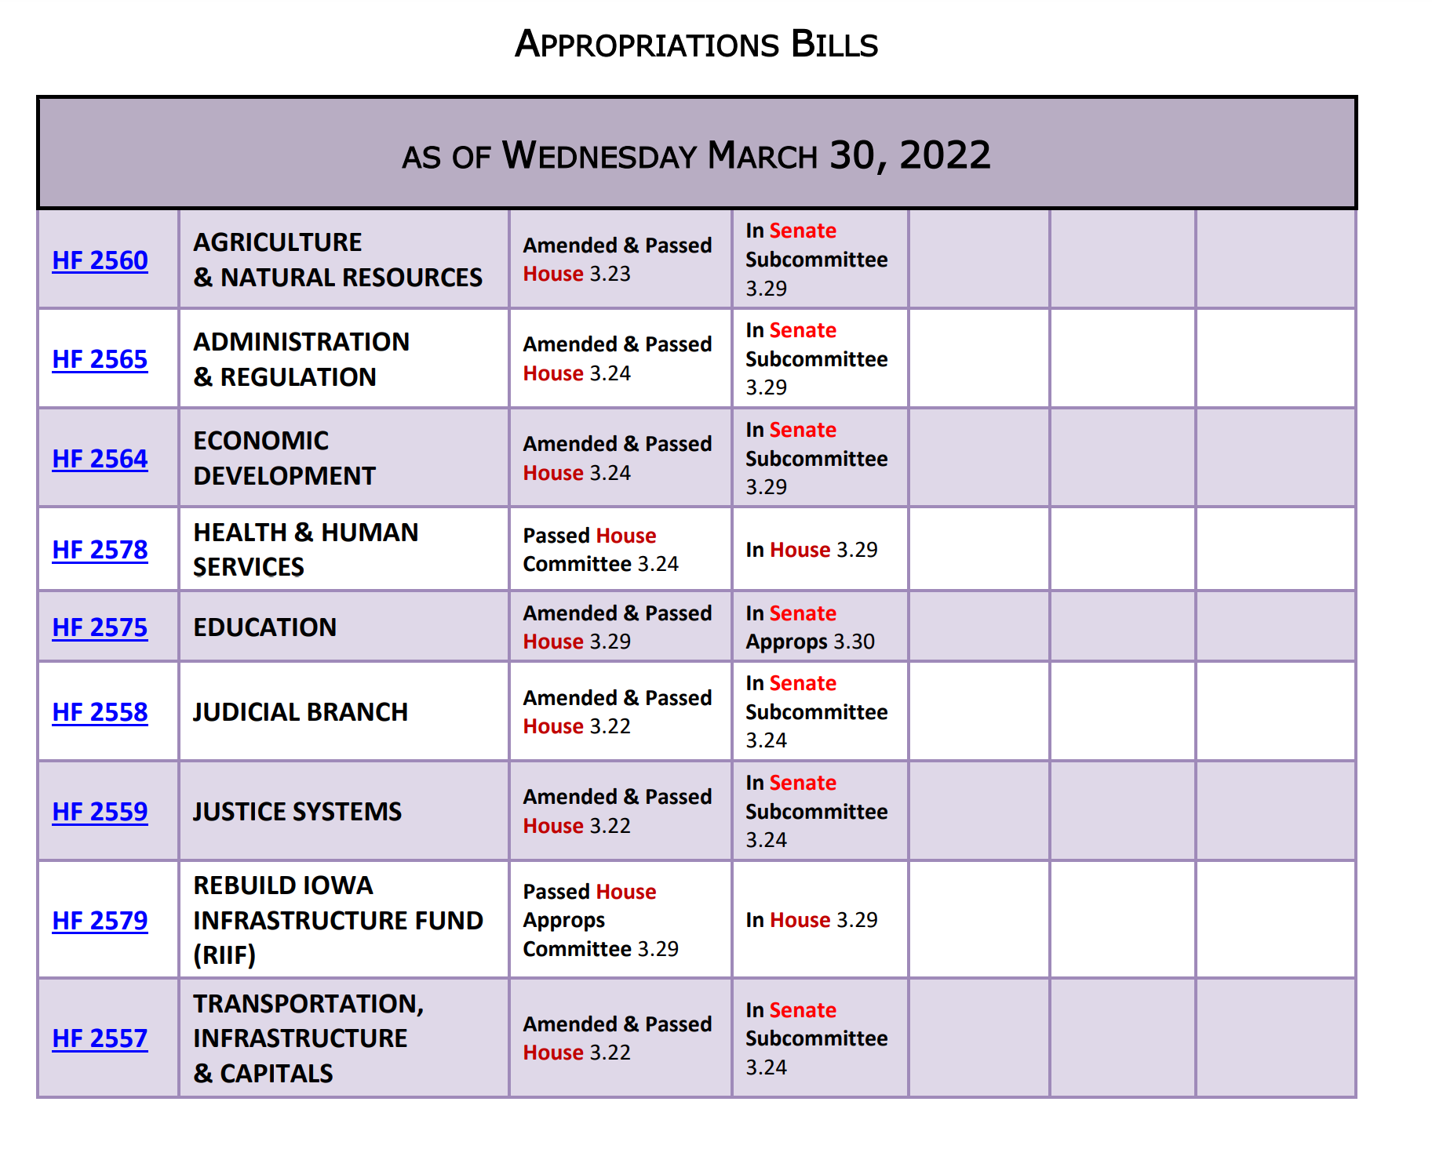
Advocacy Actions This Week:
- Always start with a thank you! See the RSAI 2021 Legislative Session Successes on the RSAI website and find one you are grateful for them accomplishing. Weigh in your support on the bills above that are moving that might benefit your districts. Say thank you for amendments that address our concerns along the way.
- Voucher Opposition in the House: See the March 31 Call to Action for specific details and advocacy action. Continue to have conversations with House legislators, but especially those on the House Appropriations Committee and reiterate key messages:
  - Taxpayer dollars should not support private, religious schools.
  - Public funds require public accountability and transparency.
  - Private and public schools do not have a level playing field. If privates are to receive public money, they must have the same regulations and requirements (accept all students, comply with education policy mandates, open meetings, public records, student achievement testing and accountability).
  - This is a slippery slope toward a costly an expansive voucher program.
  - Iowa already has many parent choice options and financial support for private schools, scholarships and tax credits to help parents making that choice.
  - The state has not been able to adequately fund one education system and should not commit to the hefty price tag of funding another.
- Teacher Recruitment: Contact all House members to fix the teacher recruitment bill, SF 2377. See the March 31 Call to Action linked above.
- Funding: advocate with the Senate to approve HF 2315, which provides $19.2 million in supplemental funding to help schools with inflationary costs. Explain that federal pandemic funds are (pick the one or two that apply to your district): 1) already exhausted, 2) obligated but waiting for labor/materials/other supply chain issues that have slowed HVAC construction or simply no applicants for instructional positions, 3) local district must have the funds to expend first, and then seek reimbursement, which can take time to properly document and obtain approval and for all districts, the federal pandemic funds are to be used through Sept. 2024, but then are gone. Adequate state funding would provide sustainability for many of the programs districts have been able to fund with the pandemic funds, but only for a limited time.

Find Representatives here: https://www.legis.iowa.gov/legislators/house
Find Senators here: https://www.legis.iowa.gov/legislators/senate
You can ask if they are available, leave a message for them to call you back, or just leave a short message such as “Continue to Oppose SF 2369 Governor’s School Choice Vouchers.” (Legislators typically return to the Capitol by noon on Monday. Feel free to reach out to them at home over the weekend).
Connecting with Legislators: To call and leave a message for a Senator, call the Senate switchboard operator number is 515.281.3371. To call and leave a message for a representative, the House switchboard operator number is 515.281-3221. You can ask if they are available or leave a message for them to call you back. You can also ask them what’s the best way to contact them during Session. They may tell you email, text message or phone call is the best way to connect with them during the Session, based on their personal preferences.
RSAI Advocacy Resources: To find Advocacy Resources such as Position Papers, RSAI Weekly Legislative Reports and video updates, RSAI Calls to Action when immediate advocacy action is required, testimony presented to the State Board of Education, the DE or any legislative committee or public hearing, and links to fiscal information that may inform your work, visit the RSAI legislative web page here: http://www.rsaia.org/legislative.html. Also, check out the newly released 2022 RSAI Advocacy Handbook, and also available on the legislative page of the RSAI website
Contact us with any questions, feedback or suggestions to better prepare your advocacy work:
*Margaret Buckton, RSAI Professional Advocate, margaret@iowaschoolfinance.com , 515.201.3755 Cell
*Dave Daughton, RSAI Grassroots Advocate, dave.daughton@rsaia.org, 641-344-5205 Cell

Thanks to our RSAI Corporate Sponsors:
Special thank you to your RSAI Corporate Sponsors for their support of RSAI programs and services. Find information about how these organizations may help your district on the Corporate Sponsor page of the RSAI website at www.rsaia.org/corporate-sponsors.html.
 | www.apptegy.com
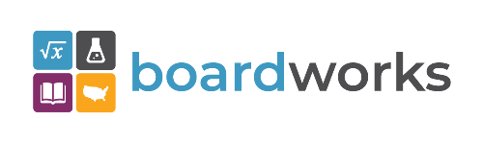 | www.boardworkseducation.com
 | www.carlanelsonco.com
 | www.classroomclinic.com
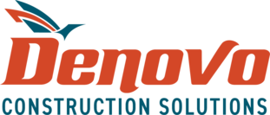 | www.teamdenovo.com
 | www.friedman-group.com
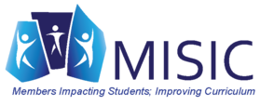 | www.misiciowa.org
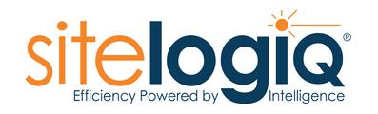 | www.sitelogiq.com
 | www.wgu.edu

