I use the Names YaHuWaH for our heavenly Father and YAHUSHUA for His Messiah, Jesus. I know this seems odd to most people. Much research went into settling on this practice. To start with, the letter "J" didn't exist 600 years ago. It's a long story, but each person likes to be called by his rightful name, and that's something to consider when talking with your best friend! More info is available on the joybysurprise.com website.

Fasting and Prayer

Fasting and prayer, at least to some extent, needs to be a part of our lifestyle in order for us to be better able to meet the challenges we'll be facing in the coming months and years. I worked in a television ministry in a church about 37 years ago. I came to find that problems associated with my work didn't bother me much when I took time out to pray a few times during the day. I also came to find that fasting a day or so each week helped my life experience.

One day as I was praying I saw a woman's face. She was blond and lying in a hospital bed. I prayed for her at that time, even though I had no idea who she was. Several days later I was sent to an electronics store to purchase some parts and there was the woman I had seen while praying. She was working as a clerk in a room off to side of the main sales room. Later that day I went to pick up one of my sons who had been visiting a friend after school. I had never been to his friends house before. When Matt came out of the house, his friends mother came to the door. It was the blond lady I had seen while praying, the one who worked at the electronics parts store. Matt said his friend's mother had been in the hospital.

We are going to need all the spiritual strength we can get in order to face what is coming on the earth. Please begin to strengthen yourself with repentance from sin, fasting, and prayer. There's a terrible time of persecution coming to YaHuWaH 's people. And YaHuWaH Elohim will show you things to come. That's His promise! To be forewarned is to be forearmed.

Yesterday I fasted. Today I have been given the knowledge written below.

The Day of Pentecost and Its Relevance to 9/11

The crucifixion of YAHUSHUA Messiah probably occurred on April 7, 30 AD. There are two years that are most probable for the crucifixion, 30 AD and 33 AD. 30 AD is most probable, and the time calculation below will help to confirm 30 AD as probably being correct. Historical accounts place John the Baptist beginning his ministry in 26 AD at the age of 30. Messiah would begin His ministry 6 months later, as He also became 30 years old. Info here: http://www.abidewithchrist.org/k6.htm

Here's a graphic of the evening of 4/6/30 AD after sunset, 4/7/30 had just begun:
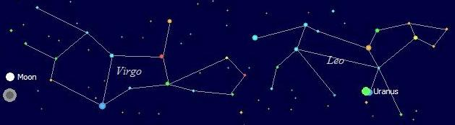

The earth's shadow is indicated below the moon. The moon is precisely full at this time, the 14th day of Aviv has just begun, and YAHUSHUA had just observed the last supper with His disciples.

Notice in the graphic above that the planet Uranus is very close to the King Star Regulus, indicative of the Messiah. The planet Uranus was visible to the naked eye, but was not tracked by observers in bible times because it appeared to move so slowly through the heavens. Uranus will come to be important in end times prophecy. But note that here at the crucifixion YaHuWaH Elohim is declaring the end from the beginning. The crucifixion of Messiah starts the birth of a new age. The unknown (at that time) but visible planet Uranus helped signal it's beginning and Uranus (from which the element Uranium derives its name) will help signal it's end.

Here's a graphic denoting the possible crucifixion and resurrection timing:

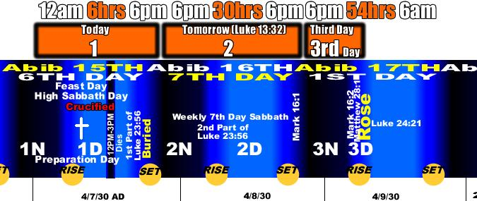

Counting the Days, Doing the Math

Prophetic years are 360 days long, as indicated in the times of Noah in the book of Genesis.

360 days X 2000 years = 720,000 days

Sunday 4/9/30 AD (Day of the Firstfruits wave offering, Resurrection Day) + 50 days inclusive = Sunday 5/28/30 AD (the Feast of Shavuot, the Day of Pentecost)

5/28/30 AD + 720,000 days (2000 years X 360 days) = 9/10/2001

9/10/2001 was the precise end of the second prophetic 2000 year "day" from the day the "church" was born, the Day of Pentecost (Feast of Shavuot, Wheat Harvest), in 30 AD.

The biblical account of 5/28/30 AD:

Acts 2:1 And when the day of Pentecost was fully come, they were all with one accord in one place.
2 And suddenly there came a sound from heaven as of a rushing mighty wind, and it filled all the house where they were sitting.
3 And there appeared unto them cloven tongues like as of fire, and it sat upon each of them.
4 And they were all filled with the Holy Ghost, and began to speak with other tongues, as the Spirit gave them utterance.
5 And there were dwelling at Jerusalem Jews, devout men, out of every nation under heaven.
6 Now when this was noised abroad, the multitude came together, and were confounded, because that every man heard them speak in his own language.
7 And they were all amazed and marvelled, saying one to another, Behold, are not all these which speak Galilaeans?
8 And how hear we every man in our own tongue, wherein we were born?
9 Parthians, and Medes, and Elamites, and the dwellers in Mesopotamia, and in Judaea, and Cappadocia, in Pontus, and Asia,
10 Phrygia, and Pamphylia, in Egypt, and in the parts of Libya about Cyrene, and strangers of Rome, Jews and proselytes,
11 Cretes and Arabians, we do hear them speak in our tongues the wonderful works of YaHuWaH .
12 And they were all amazed, and were in doubt, saying one to another, What meaneth this?

9/11/2001 was the very first day of the 3rd prophetic 1000 year "day" from the "birth" of the "called out ones", the church, on the Day of Pentecost in 30 AD.

This revelation of the 9/11/2001 prophetic date helps to confirm that the crucifixion and resurrection of the Messiah, and the outpouring of His Set-Apart Spirit did indeed occur in 30 AD.

And it helps to confirm that we're prophetically now in the "third day" when Messiah will appear!

YaHuWaH Elohim is in ultimate control of world events. Please strengthen your spiritual condition with fasting and prayer, as times are going to get extremely tough in the months ahead.

Recommended Reading:

Here's some more good stuff from Benjamin Baruch: http://www.newswithviews.com/Baruch/benjamin104.htm

