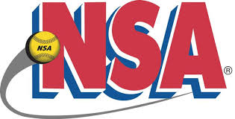 NSA Valentines Day Bash
Plex South-Ft Wayne, IN
February 2-3, 2019

16u Pool

- Michiana Lady Scrappers 3) Caledonia Chaos
- Lazers Black 4) Indiana Shockwaves

Saturday 8:00 AM Field #2 Scrappers vs Lazers Black 5-1
Saturday 9:10 AM Field #2 Scrappers vs Caledonia Chaos 9-0
Saturday 10:20 AM Field #2 Lazers Black vs Ind Shockwaves 17-0
Saturday 11:30 AM Field #2 Caledonia Chaos Ind Shockwaves 6-1
Saturday 5:30 PM Field #2 Scrappers vs Ind Shockwaves 9-1
Sunday 8:00 AM Field #1 Lazers Black vs Caledonia Chaos 7-4

All pool games are 60 minutes, drop dead, revert back if not a complete inning,
Games may end in a tie.

