Horse Project(s) Validation Form
Jim Wells County Fair 2024

_____________________________________________ _____________________________________________ ________________________________
Name Mailing Address Phone #

_____________________________________________ ____________________________________________
County Club Name

_____________________________________________ ___________________________________________
Birth Date Age as of September 1, 2024 EMAIL: __________________________

Copy Reg. Grade Horse Coggins
Horse Name Breed Reg. # Horse DOB Gender Papers ID Form Copy
Attached Attached Attached
 |  |  |  |  | Y N | Y N | Y N
 |  |  |  |  | Y N | Y N | Y N
 |  |  |  |  | Y N | Y N | Y N
 |  |  |  |  | Y N | Y N | Y N
 |  |  |  |  | Y N | Y N | Y N
 |  |  |  |  | Y N | Y N | Y N
 |  |  |  |  | Y N | Y N | Y N
 |  |  |  |  | Y N | Y N | Y N
 |  |  |  |  | Y N | Y N | Y N
 |  |  |  |  | Y N | Y N | Y N
 |  |  |  |  | Y N | Y N | Y N

Signature required: Member, your signature at the bottom verifies that the above horse project(s) are owned solely by you or your brother, sister, parent, grandparent, or legal guardian, and NOT leased, rented, borrowed or loaned.

Ownership is by 1st Saturday of August (08/03) or earlier

____________________________________________ _____________________________________________ ________________________
Member Signature Parent/Guardian Signature Date

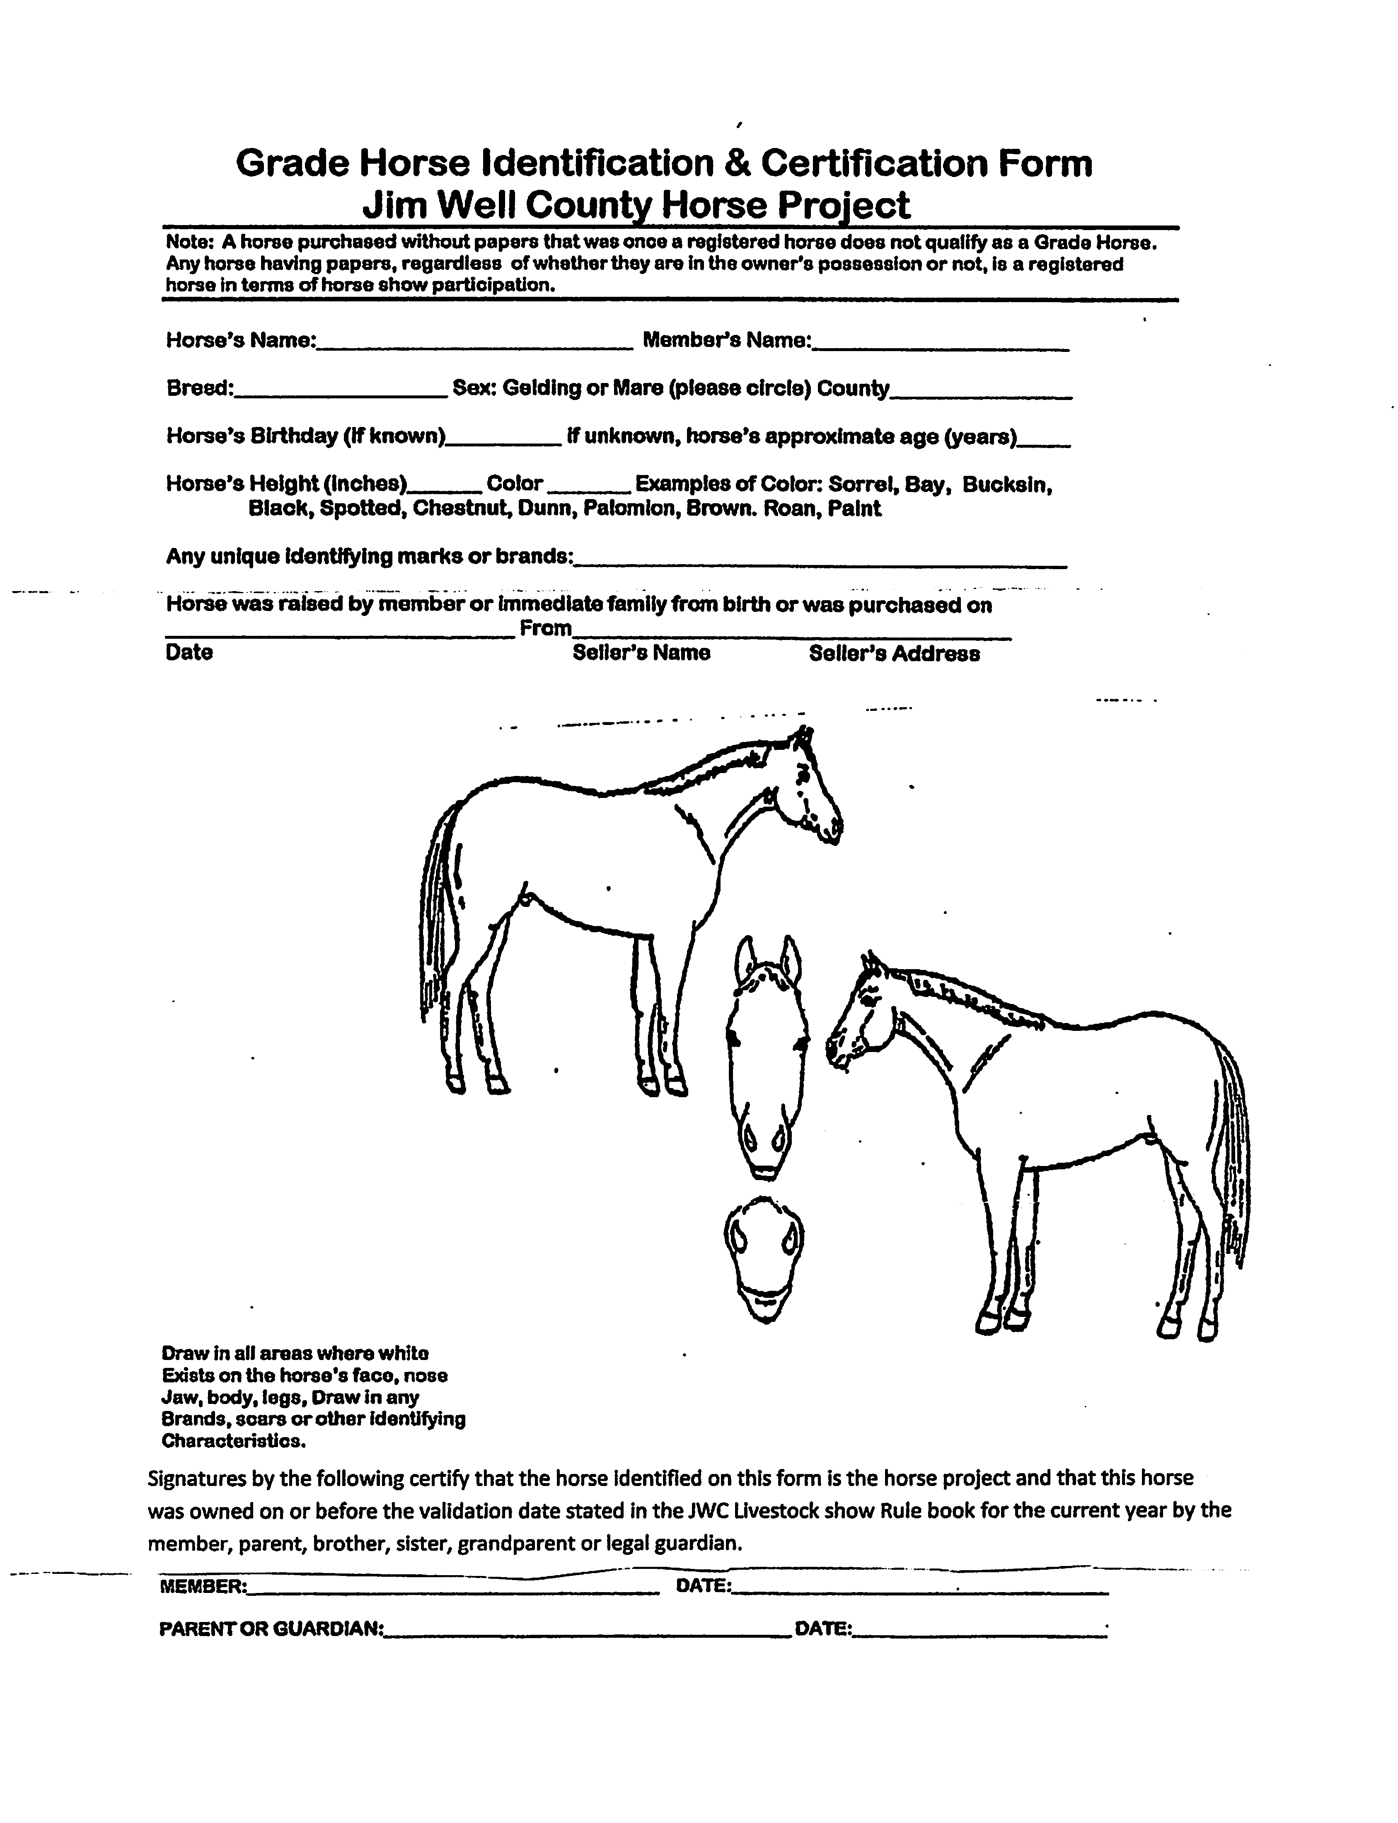
Horse Show Entry Form
One Exhibitor/One Horse per Form – NO EXCEPTIONS
Horse Show Date October 19, 2024 Registration at 8:30 a.m. Show Starts at 9:00 a.m.
Exhibitor Information (Please Print or Type) ENTRY FORM MUST BE FILLED OUT CORRECTLY OR WILL NOT BE ACCEPTED!______________________

Name: _________________________________________________________ Mailing Address: ___________________________________________________

City/Zip Code: ___________________________________________________ Phone #: __________________________________________________________

Club/FFA: ______________________________________________________ Birth Date: ____________________________________ Age: _______________

School: ________________________________________________________ Grade Level: _______________________________________________________

Horse Name: ___________________________________________________ EMAIL: __________________________________________________________

Classes are $10 Each, please check

Halter Performance Speed Roping

 | Fillies 2 yrs. and younger |  | Walk Trot * |  | Pole Bending
 | Registered Mares under 5 yrs. |  | Western Pleasure |  | Cloverleaf Barrels
 | Registered Mares 5 yrs. and over |  | Western Horsemanship |  | Figure 8 Barrels
 | Grade Mares of all ages |  | English Pleasure
 | Colts 2 yrs. and younger |  | English Equitation
 | Registered Geldings under 5 yrs. |  | Trail
 | Registered Geldings 5 yrs. and older |  | Costume
 | Grade Geldings of all ages
 | Junior Showmanship |  | ** May not ride in any other canter/lope class
 | Intermediate Showmanship
 | Senior Showmanship
__________________________________________________________________________________________________________________________________
Do not sign this if you have not read the rules as published in the Jim Wells County Livestock Show Book. By signing this, I certify that my Club leader/FFA advisor has supplied me with the Jim Wells County Show Rule Book, I have read and agree to abide by all rules in current book.

__________________________________________________________________________________________________________________________________
Exhibitor Signature Date Parent/Legal Guardian Signature Date
I certify that this is eligible in accordance with the rules in the current Jim Wells County Livestock Show Book. I have supplied the exhibitor and parent/legal guardian with a copy of the Jim Wells County Livestock Show Book. __________________________________________________________________
Club Manager/FFA Signature Date

