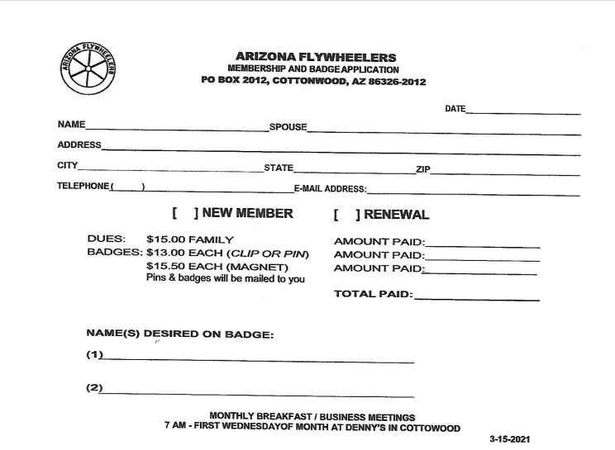

Dues
We would like to collect dues for the new year (2023) and it is time to pay your annual dues. The dues amount will be $25. per year. A dues form is included in the newsletter. Please email me with any dues questions. My email address is rench8@gmail.com or call Treasurer Ginny Rench 928-300-4899

Ginny Rench
Treasurer for the Arizona Flywheelers
P. O. Box 2012
Cottonwood, AZ 86326

.
Please make checks payable to Arizona Flywheelers and mail to:
Arizona Flywheelers, P. O. Box 2012, Cottonwood, AZ 86326
Tee shirts $ 12
polo shirts $22—24
Hats $12

