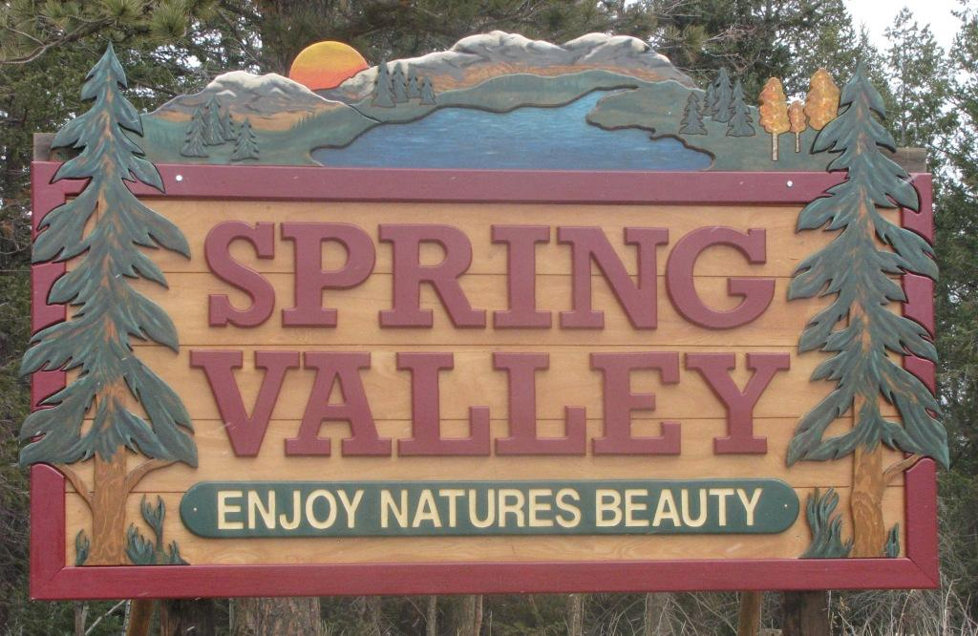

Spring Valley Property Owners and Recreational Corporation
P.O. Box 513
Divide, CO 80814
(719) 686-1825

Dear New Homeowner,

Welcome to the neighborhood! On behalf of the SVPORC Board of Directors, we’re thrilled to have you as a new Spring Valley property owner. To help you get settled, here is a quick "need-to-know" guide to our community:

- Covenants & Care: As a covenanted community, we work together to maintain property values. You should have received your filing’s covenants at closing, but you can always find them under the Declarations and Policies section of myspringvalley.org.
- Annual Dues: Statements are mailed every January. These funds cover essential maintenance for our four lakes and pavilion, property taxes, insurance, water quality and so much more.
- Fishing: Our lakes are stocked with $8,000 of fish annually! This program is self-supporting through fishing permits and day passes, meaning the fees paid by anglers go directly back into lake preservation.
- Community Events: From family activities to neighborhood get-togethers, there is always something happening. Keep an eye on the entrance signs or our website Events Calendar for updates.
- Welcome Committee: As soon as you are settled, please contact us and set up a day and time to meet with our welcome committee at the community pavilion. We have a welcome packet to present to you along with other valuable information about Spring Valley and surrounding areas.
We’re glad you’re here and hope you enjoy the beauty of Spring Valley as much as we do. We are a community of volunteers and encourage you to get involved. If you have any questions, please reach out via email at info@myspringvalley.org, or call us at (719) 686-1825. Also, we highly encourage you to visit our website at myspringvalley.org.

Sincerely,

SVPORC Board of Directors

