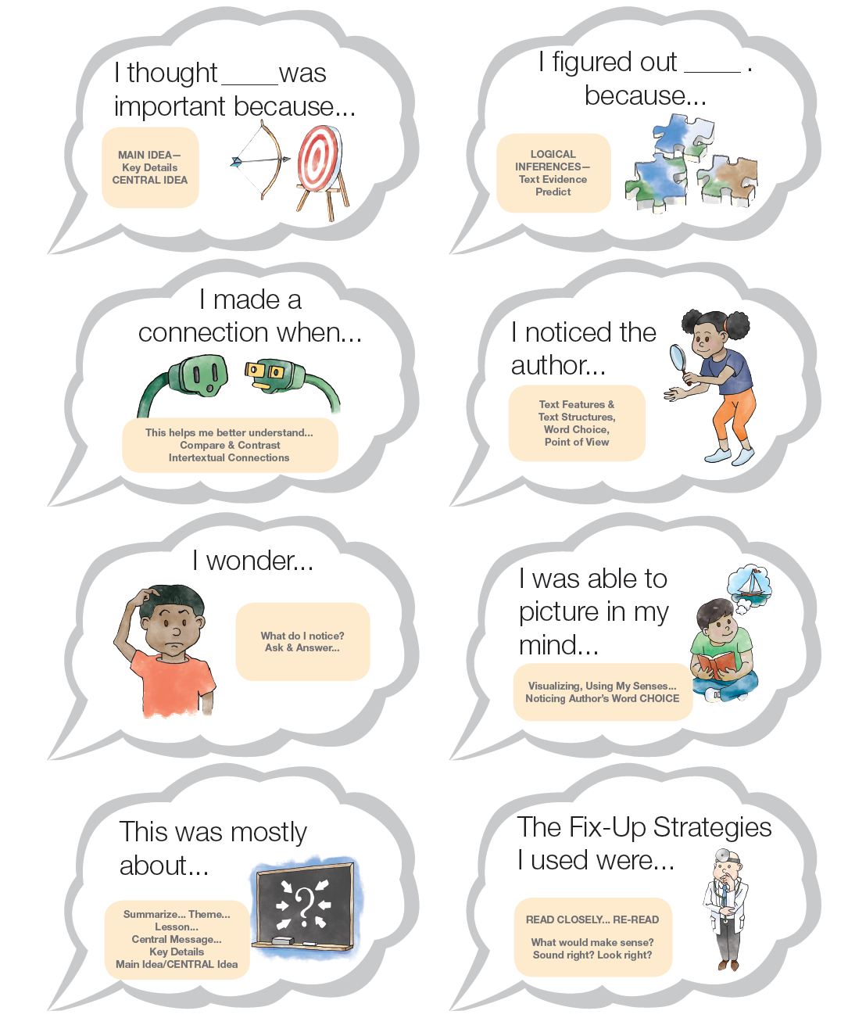
2017 ©www.kbumreading.com
THINK ALOUD CLOUDS

