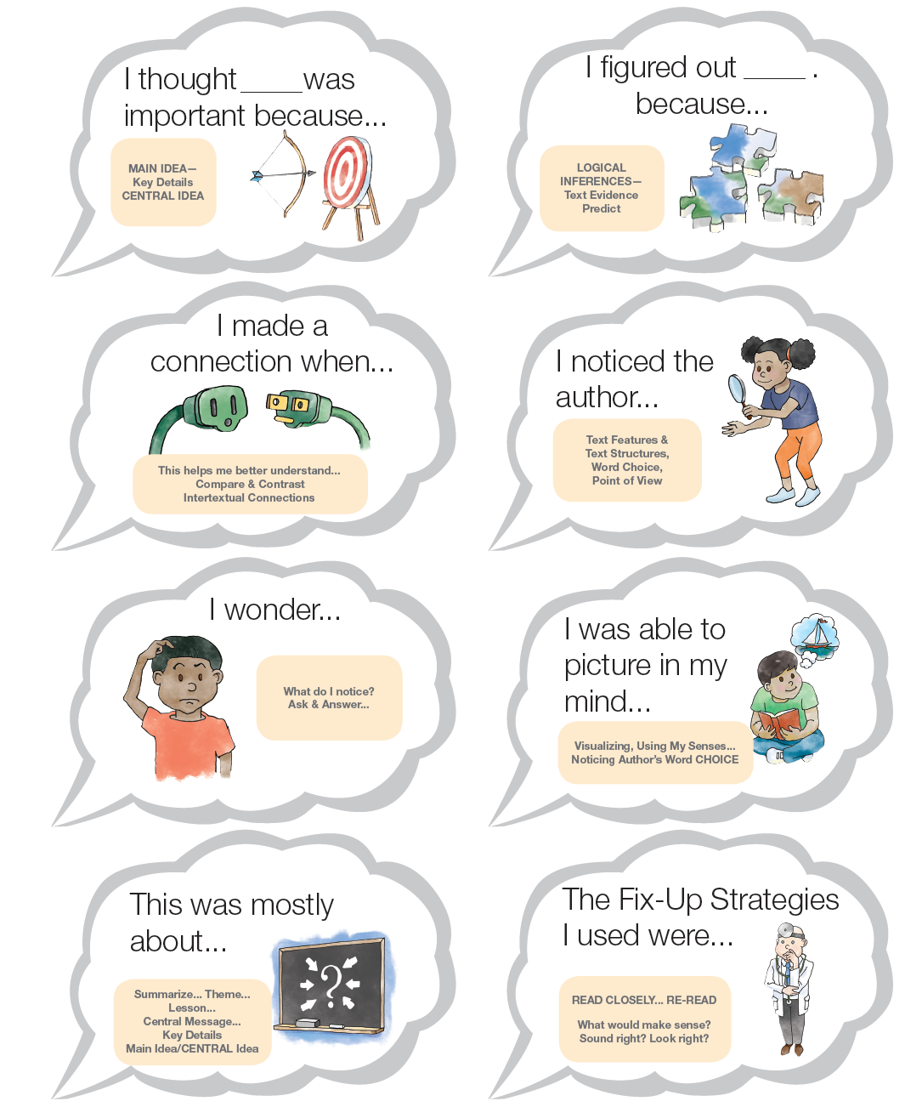

**2017 ©www.kbumreading.com**

**THINK ALOUD CLOUDS**