Burro Creek Field Trip 2025
Nov. 25-30, 2025
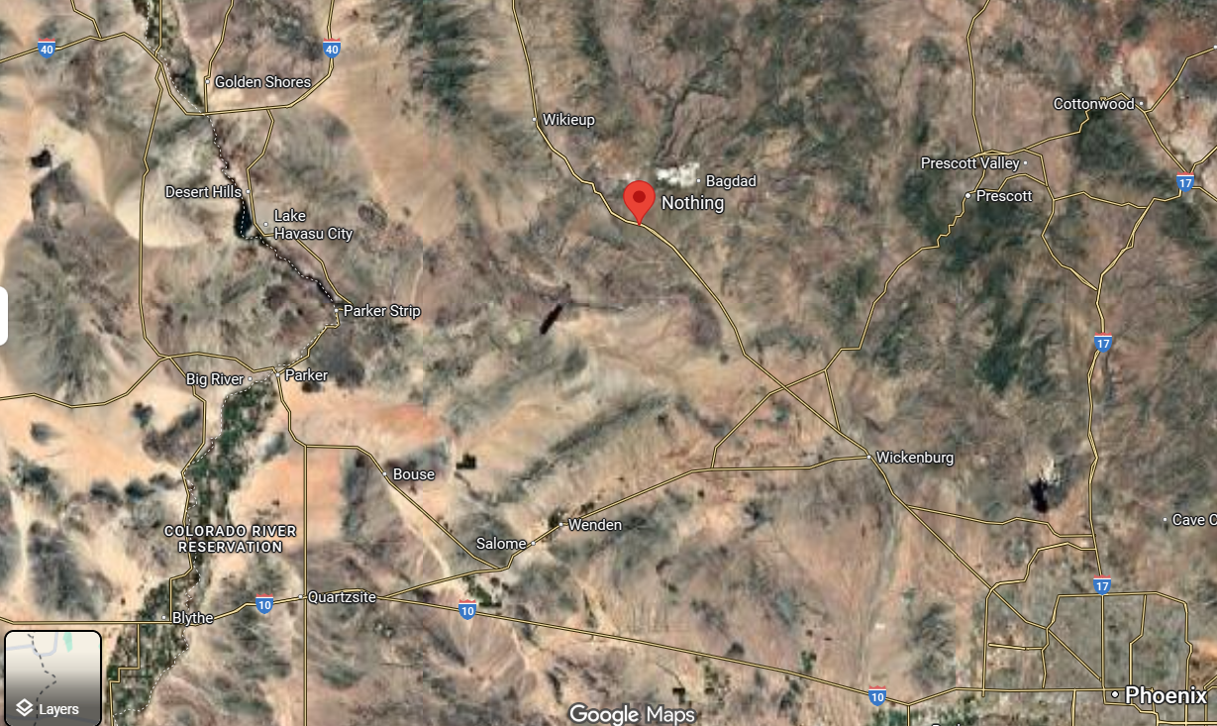
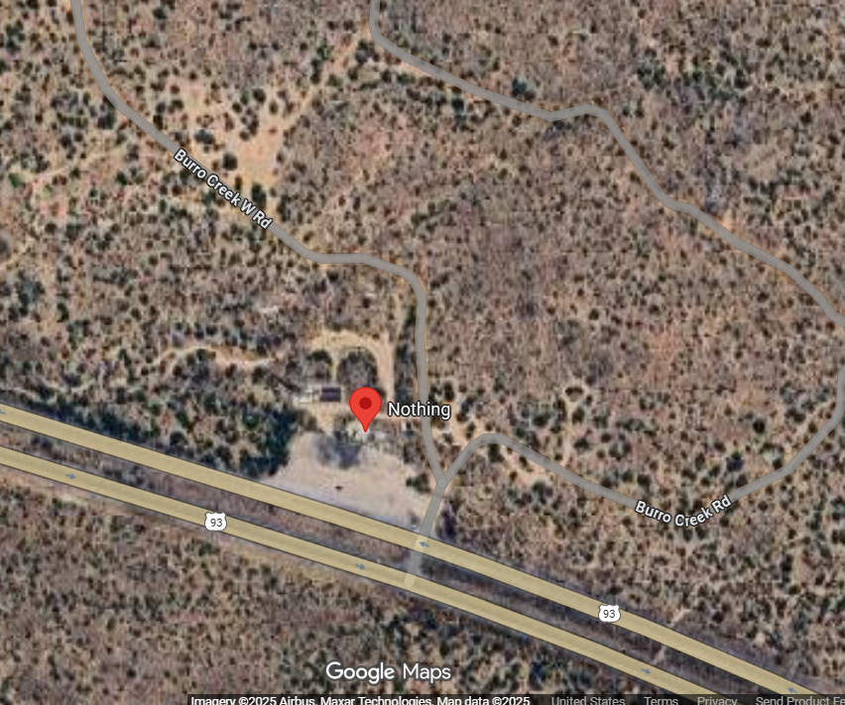
Exit Hwy 93 @ Nothing, AZ – approx. 5 ½ hour drive from El Cajon.
Dry camp and field trip meet up location. Plenty of room for everyone!
34.482076, -113.336965
Camping options:
In addition to the campsite shown above, there are other campgrounds and hotels within driving distance. Please choose what is best for your situation and plan to meet at the above location for all activities. Look for details in future emails and on the ECVGMS website.

