ANNUAL TOWN MEETING
March 9, 2021
Aurora, MN

IN ATTENDANCE: (15) Jon Skelton, Craig Anttila, Edward Kippley (Zoom), Jodi Knaus, Amanda Gross, Michael Kearney, Clark Niemi, Mike Palm, Alex Marafiot, Steve Peterson, Melanie Olmstead, Bill Maki, Chad Skelton, Doris Saarberg, Tim Saarberg

- The 2021 Annual Town Meeting of the Town of White was called to order by Chairman Skelton on Tuesday, March 9, 2021, at 6:00 P.M., at the Loon Lake Community Center.
- Pledge of Allegiance
- Skelton called for Nominations for Moderator
IT WAS MOVED BY BILL MAKI, SUPPORTED BY CHAD SKELTON TO NOMINATE JON SKELTON AS MODERATOR. NO OTHER NOMINATIONS. MOTION CARRIED
IT WAS MOVED BY MIKE PALM, SUPPORTED BY CHAD SKELTON THAT NOMINATIONS BE CLOSED. MOTION CARRIED
Jon Skelton took the chair as moderator.

4.) IT WAS MOVED BY CHAD SKELTON, SUPPORTED BY BILL MAKI TO ADJOURN THE 2020 ANNUAL TOWN MEETING. MOTION CARRIED

5.) IT WAS MOVED BY BILL MAKI, SUPPORTED BY MIKE PALM TO OPEN & CONDUCT THE 2021 ANNUAL TOWN MEETING. MOTION CARRIED
IT WAS MOVED BY CHAD SKELTON, SUPPORTED BY ALEX MARAFIOT TO ADOPT AND APPROVE THE AGENDA. MOTION CARRIED

6.) IT WAS MOVED BY MIKE PALM, SUPPORTED BY CHAD SKELTON TO WAIVE THE READING OF THE 2020 CONTINUATION OF THE ANNUAL TOWN MEETING MINUTES AS PRESENTED. MOTION CARRIED
IT WAS MOVED BY CHAD SKELTON, SUPPORTED BY ALEX MARAFIOT TO APPROVE THE 2020 CONTINUATION OF THE ANNUAL TOWN MEETING MINUTES AS PRESENTED. MOTION CARRIED

7.) IT WAS MOVED BY DORIS SAARBERG, SUPPORTED BY MIKE PALM TO SET THE DATE, TIME, AND PLACE FOR THE 2022 ANNUAL TOWN MEETING FOR TUESDAY, MARCH 8, 2022 AT THE LOON LAKE COMMUNITY CENTER AT 6:00 P.M. MOTION CARRIED

8.) Guest Speaker Melanie Olmstead, Ambulance Director for Tri-City Ambulance spoke to the community about a 13% increase in calls for 2020, responding to 953 calls total. Unfortunately, she can’t separate out the calls for the Palo area. There were 251 for the Aurora/Town of White zip code. They have been assisting Biwabik as well due to staffing shortages. The department has been successful with grant funding and a new ambulance is in the budget for 2021. The transition to ALS service has been good for the department and the community. The budget shows a profit. She distributed the 2020 Ambulance Report to the Board. Palo first responders are awesome! Jon Skelton added the transition to a full paid service in 2021 will also benefit the community. Mike Palm and Doris Saarberg added great job!!

9.) Moderator Skelton read the PowerPoint Presentation outlining the Clerk & Treasurer’s Report including Strategic Plan Outcomes and the 2020-2021 Budget Discussion (slides included at end of minutes). Copies of the 2020 Final Budget, Investment, Indebtedness, and Board of Audit Financial reports were distributed.
9a.) IT WAS MOVED BY TIM SAARBERG, SUPPORTED BY MIKE PALM APPROVING THE EMPLOYEE RECOGNITION POLICY ANNUAL AMOUNT OF $1,000.00 FOR 2021. MOTION CARRIED
9b.) IT WAS MOVED BY MIKE PALM, SUPPORTED BY BILL MAKI TO DELAY SETTING LEVY UNTIL THE CONTINUATION OF ANNUAL MEETING ON SEPTEMBER 7, 2021. MOTION CARRIED
9c.) IT WAS MOVED BY CHAD SKELTON, SUPPORTED BY MIKE PLAM TO ACCEPT THE CLERK & TREASURER’S REPORT. MOTION CARRIED
9.) Other Business – Mike Palm spoke of his Whitetail Unlimited event he is planning for 9/18/2021. Jon Skelton thanked all of the employees for doing a fabulous job through this pandemic and thanked the community for all their support.
10.) IT WAS MOVED BY MIKE PALM, SUPPORTED BY DORIS SAARBERG TO KEEP THE 2021 ANNUAL MEETING OPEN UNTIL THE CONTINUATION OF ANNUAL TOWN MEETING ON SEPTEMBER 7, 2021. MOTION CARRIED AT 6:59 P.M.

POWERPOINT PRESENTATION SLIDES ARE ATTACHED.

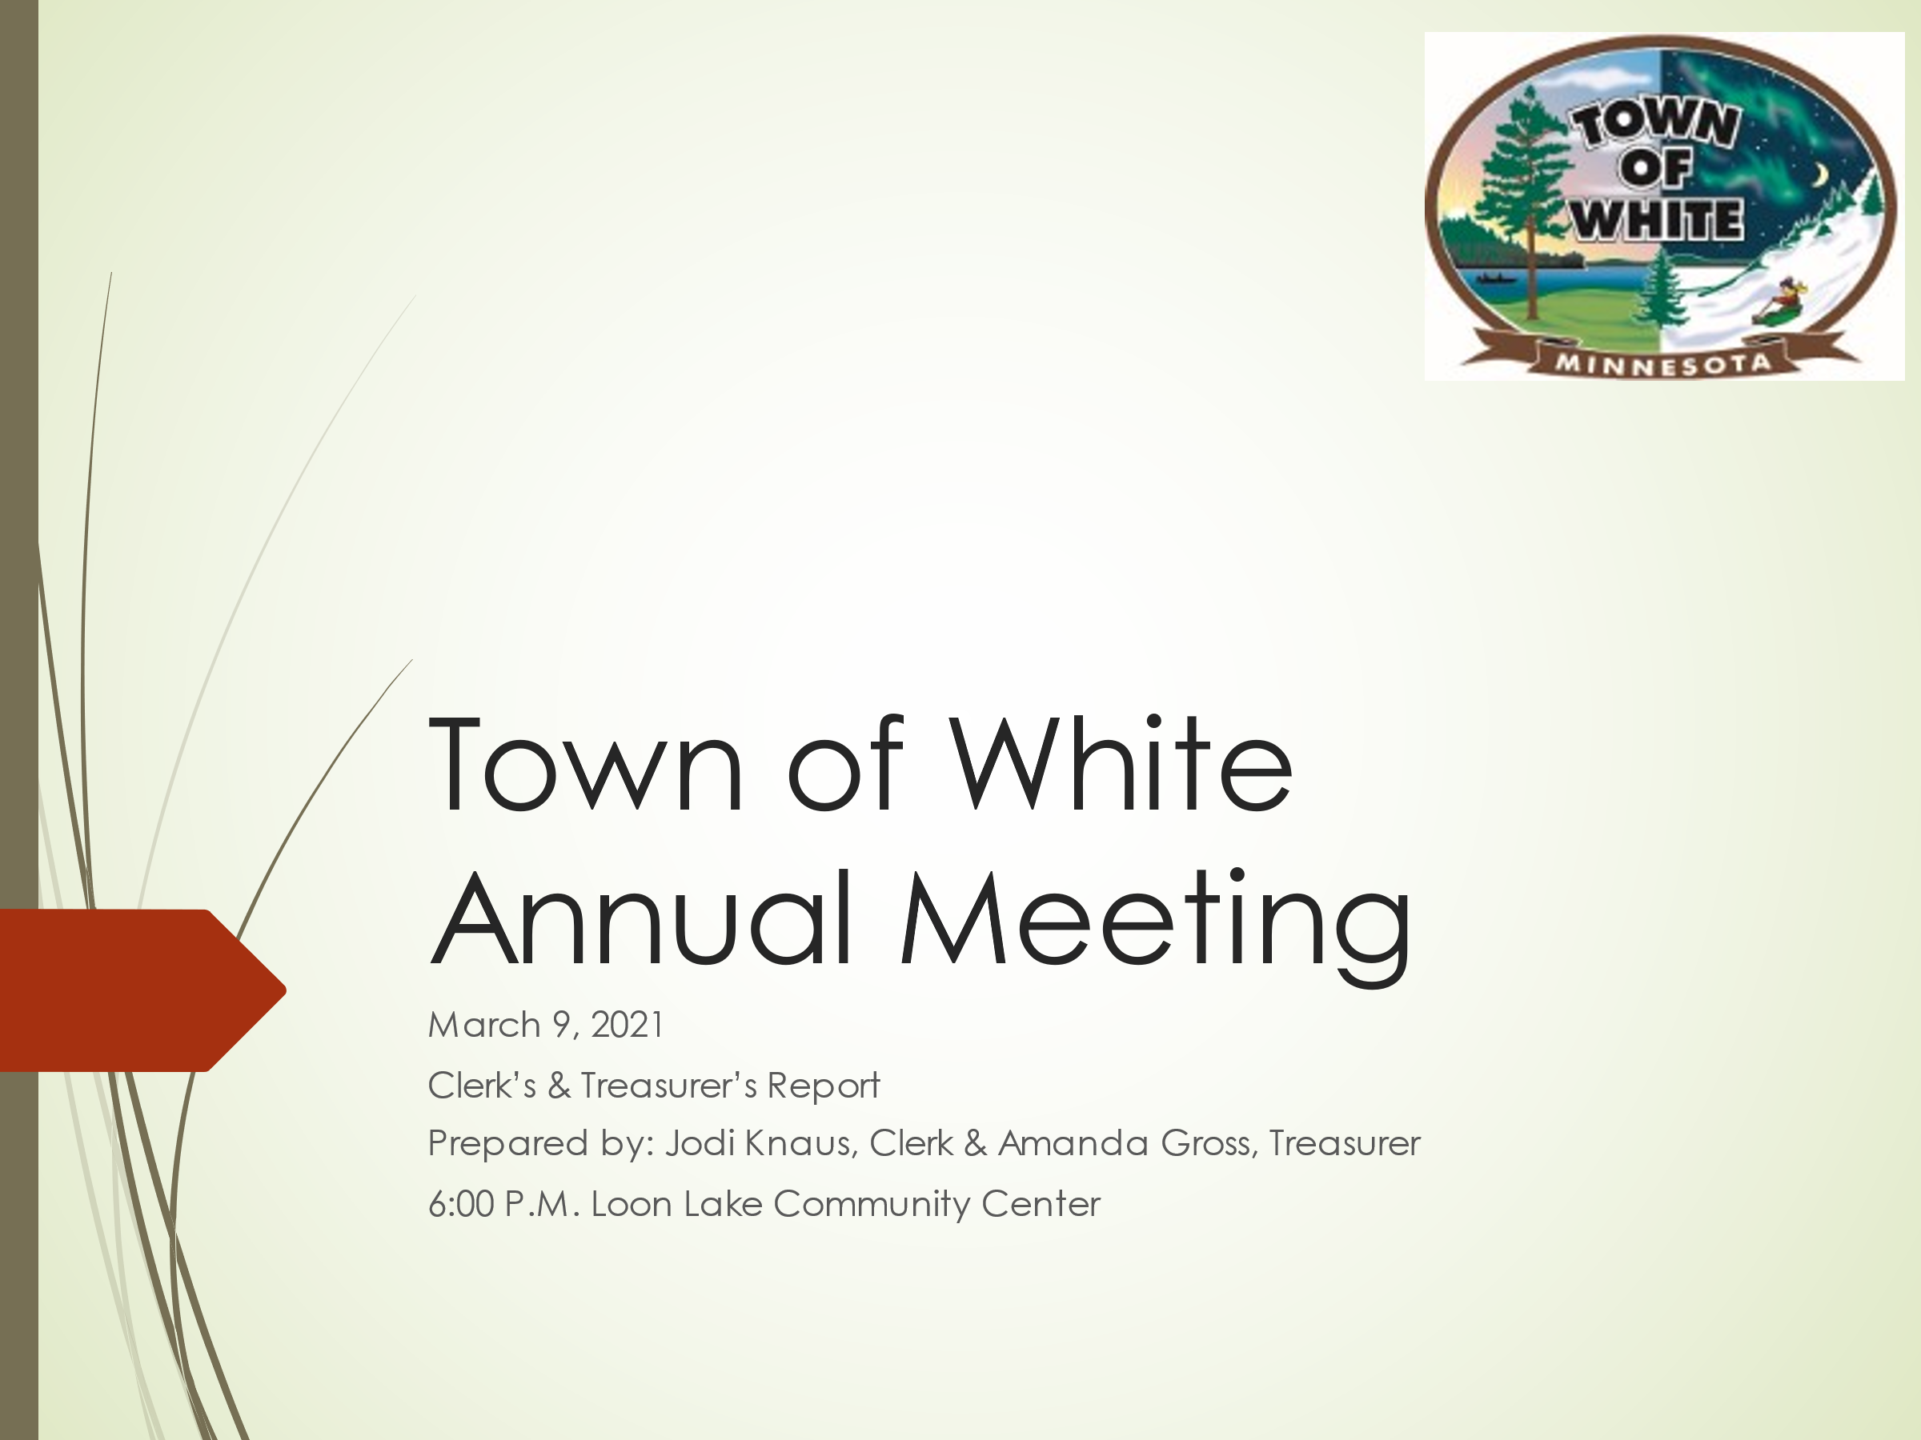

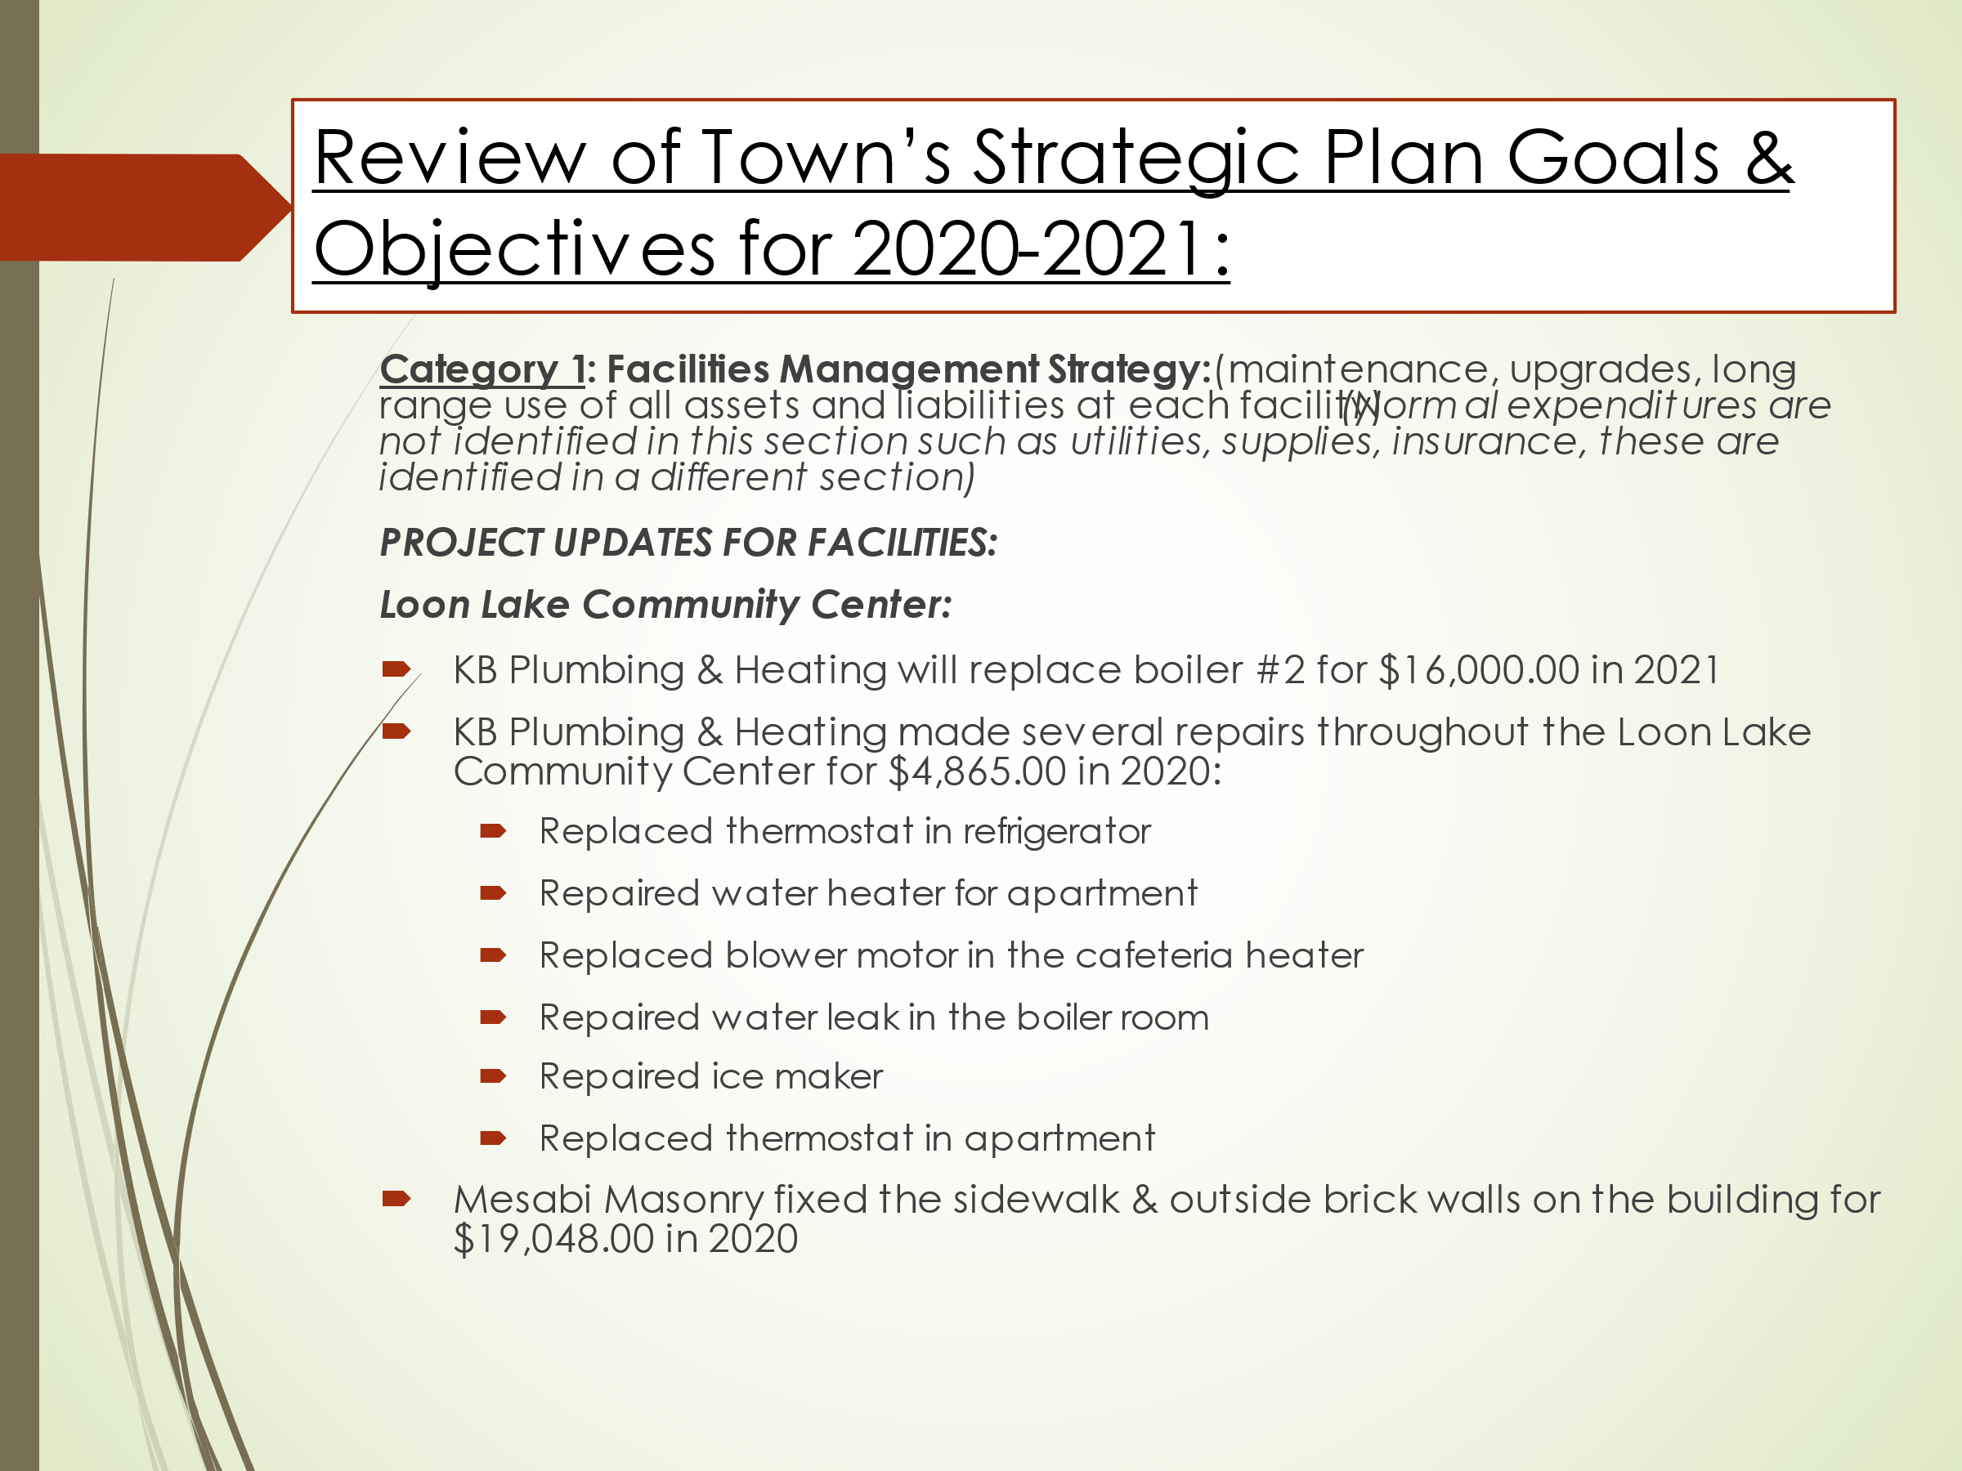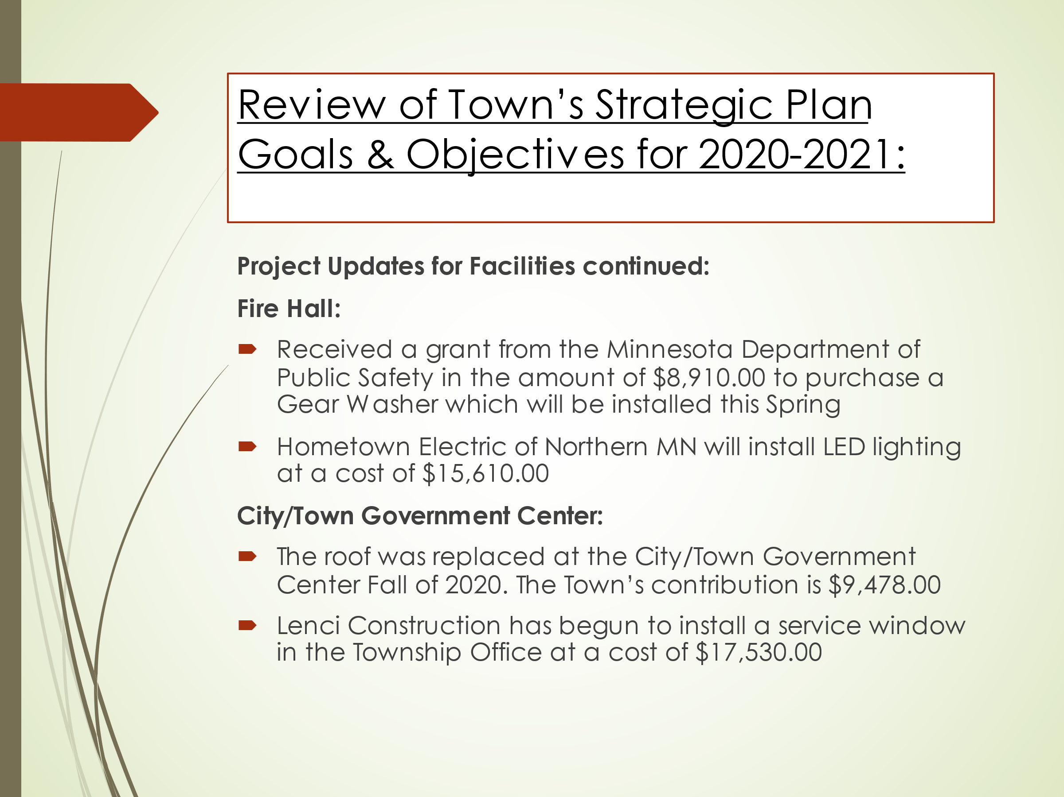

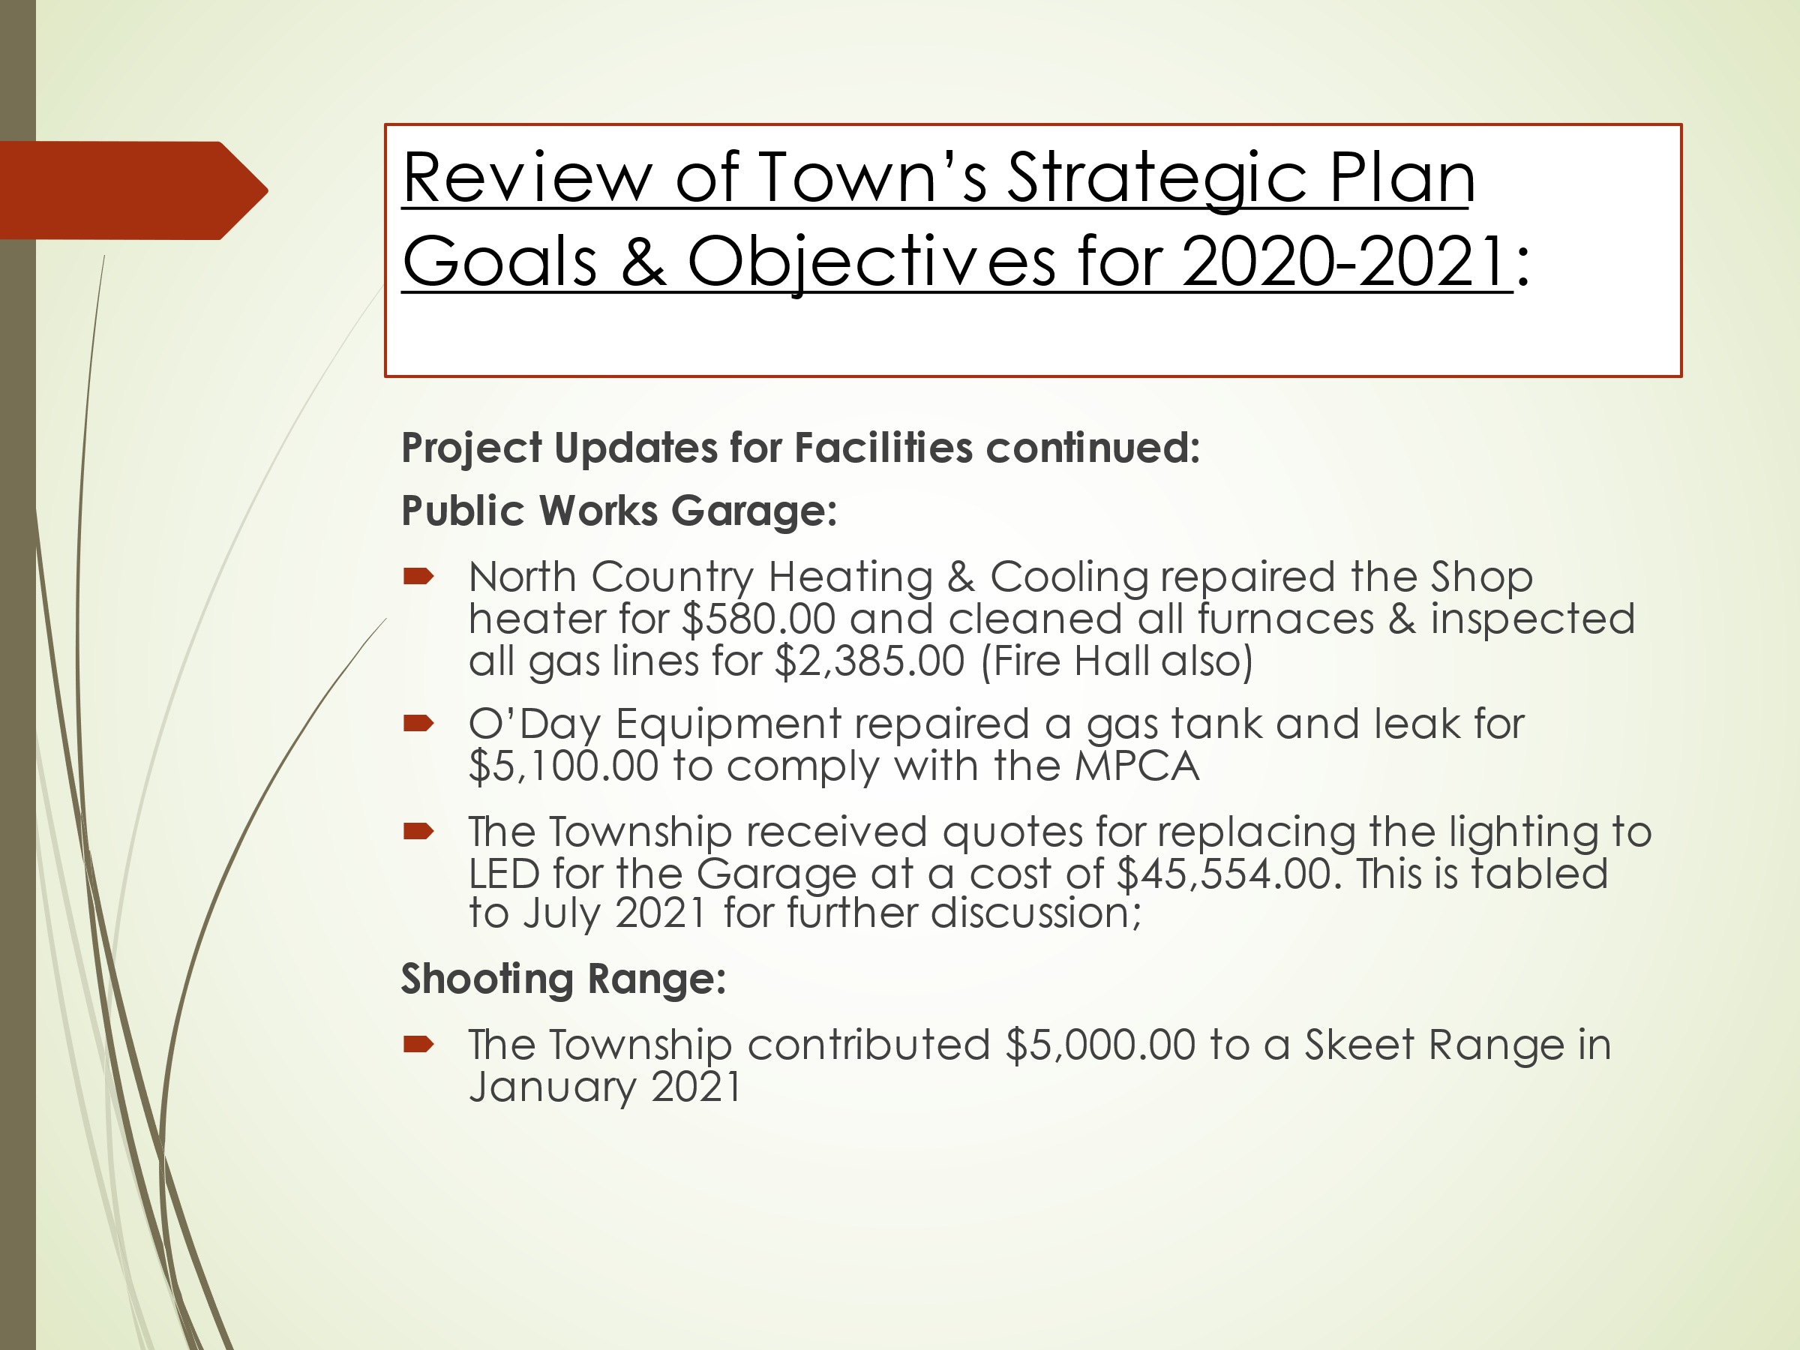

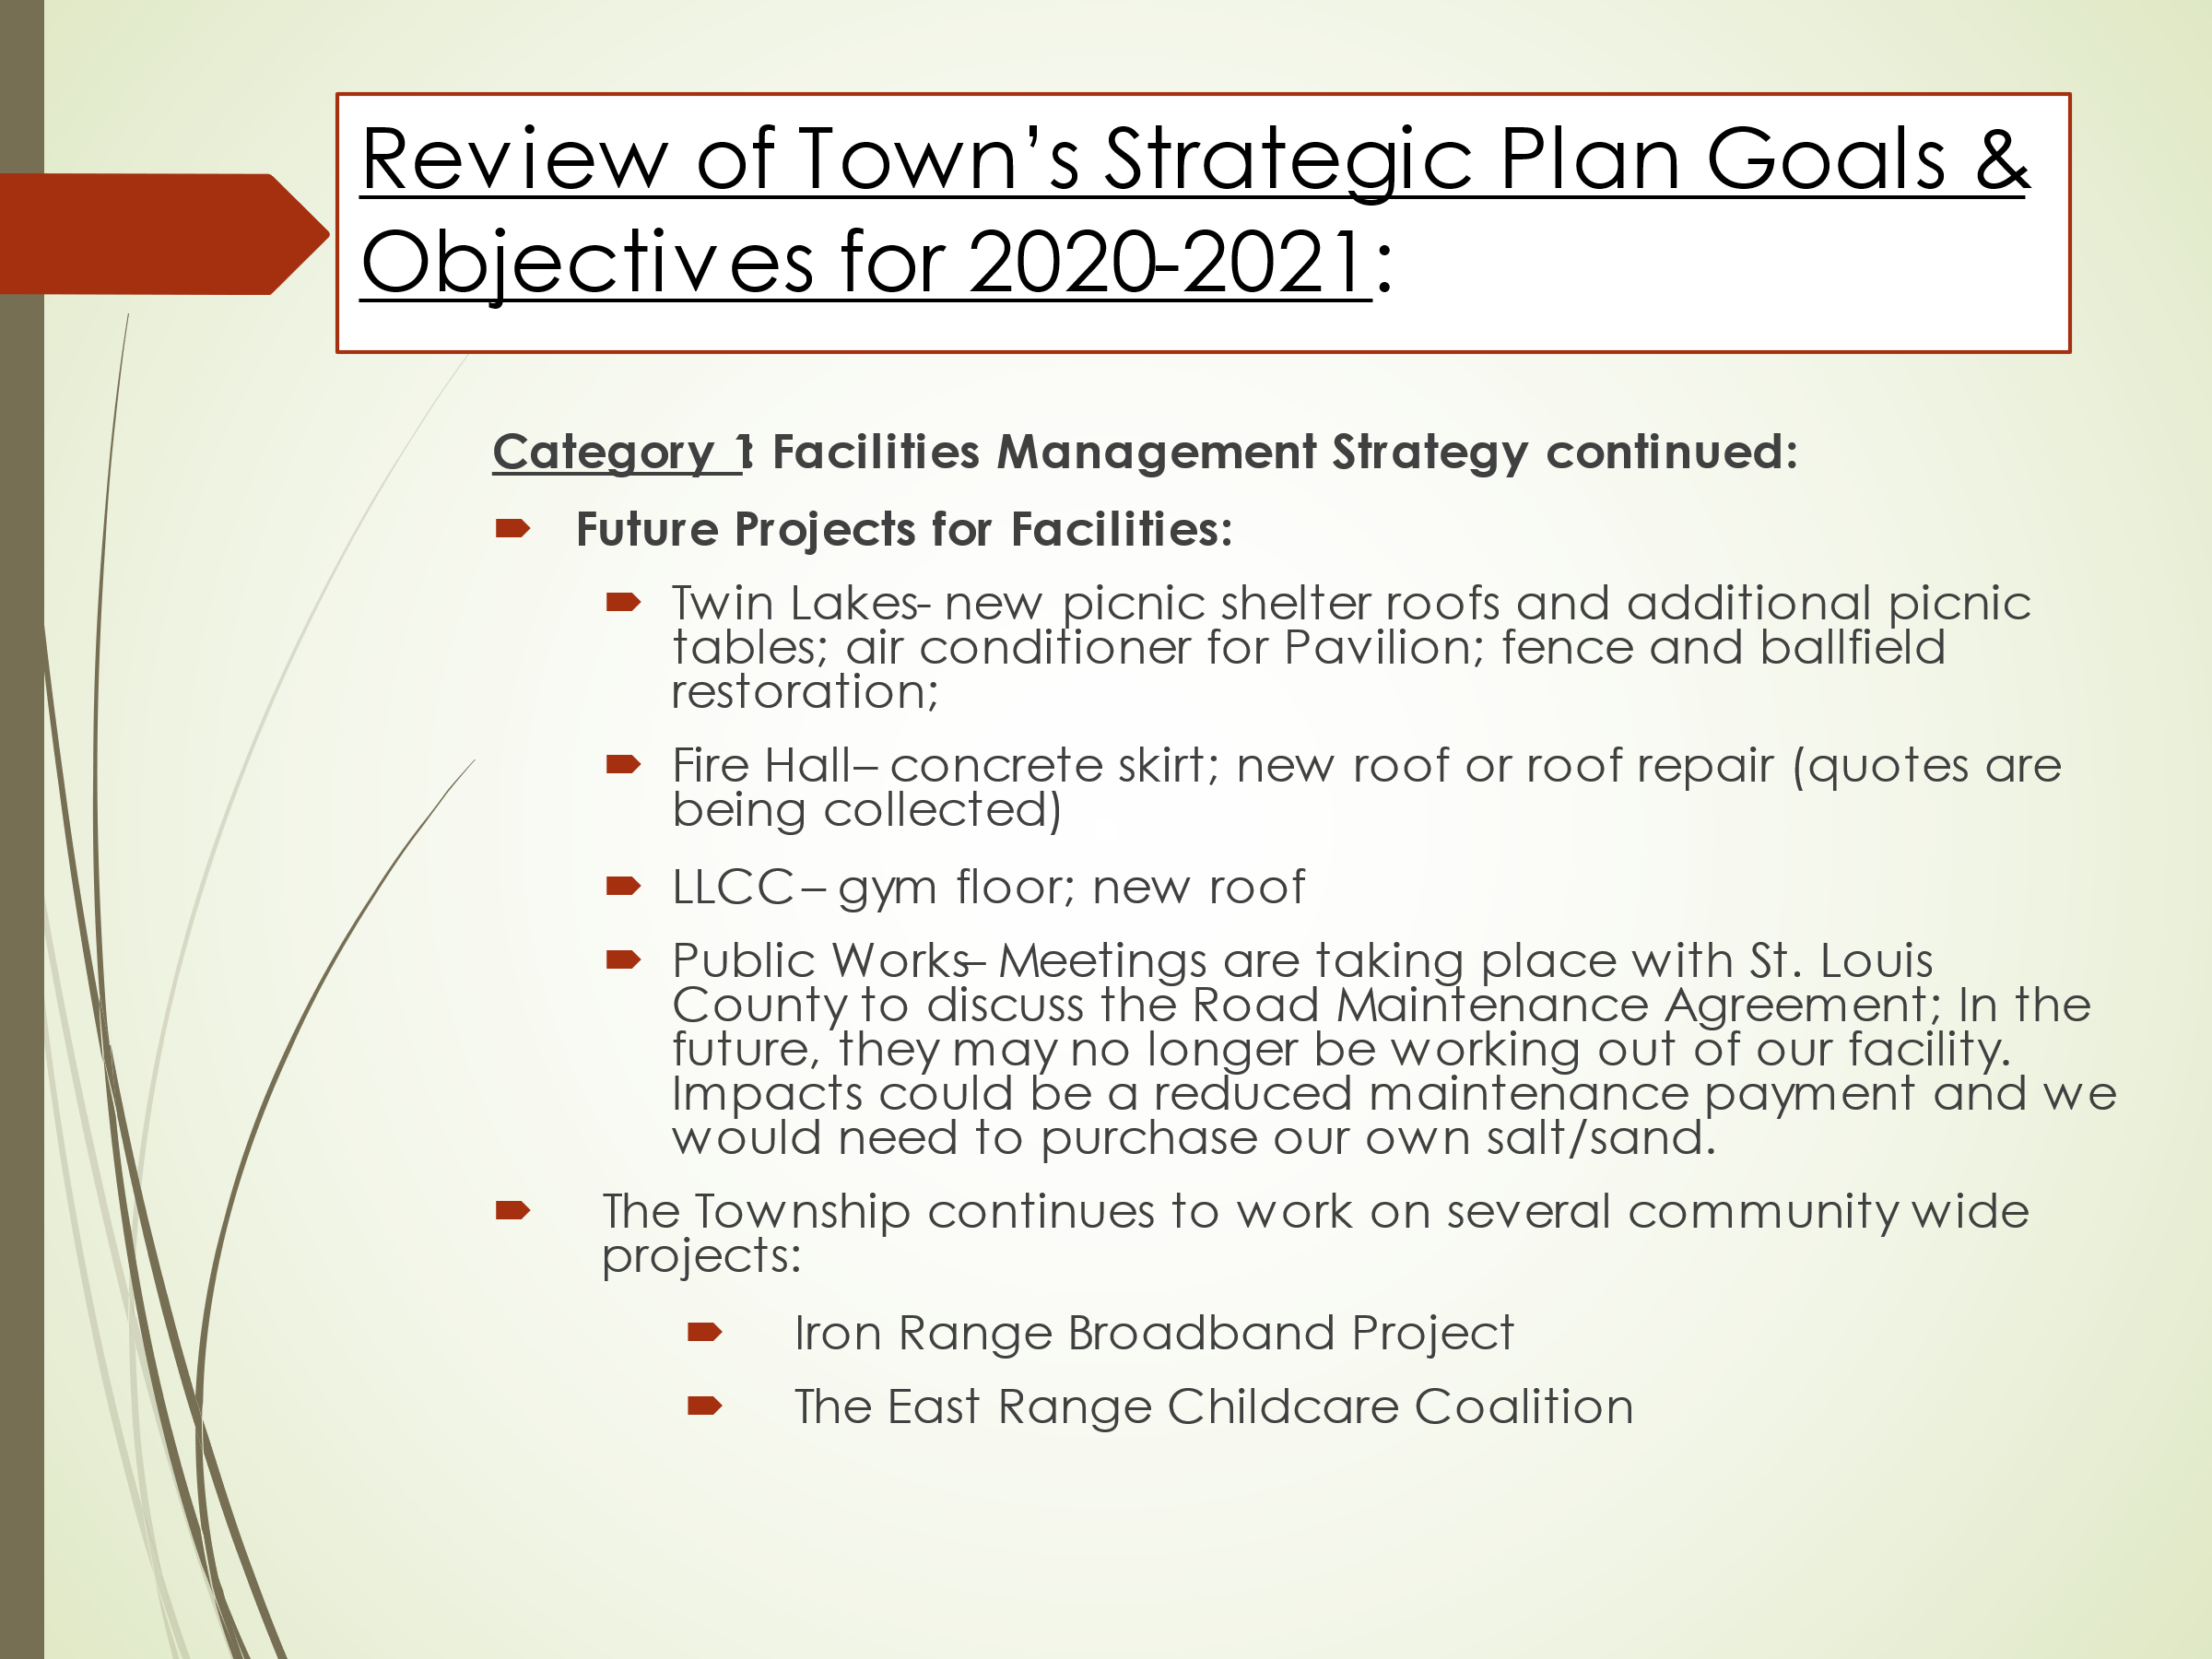

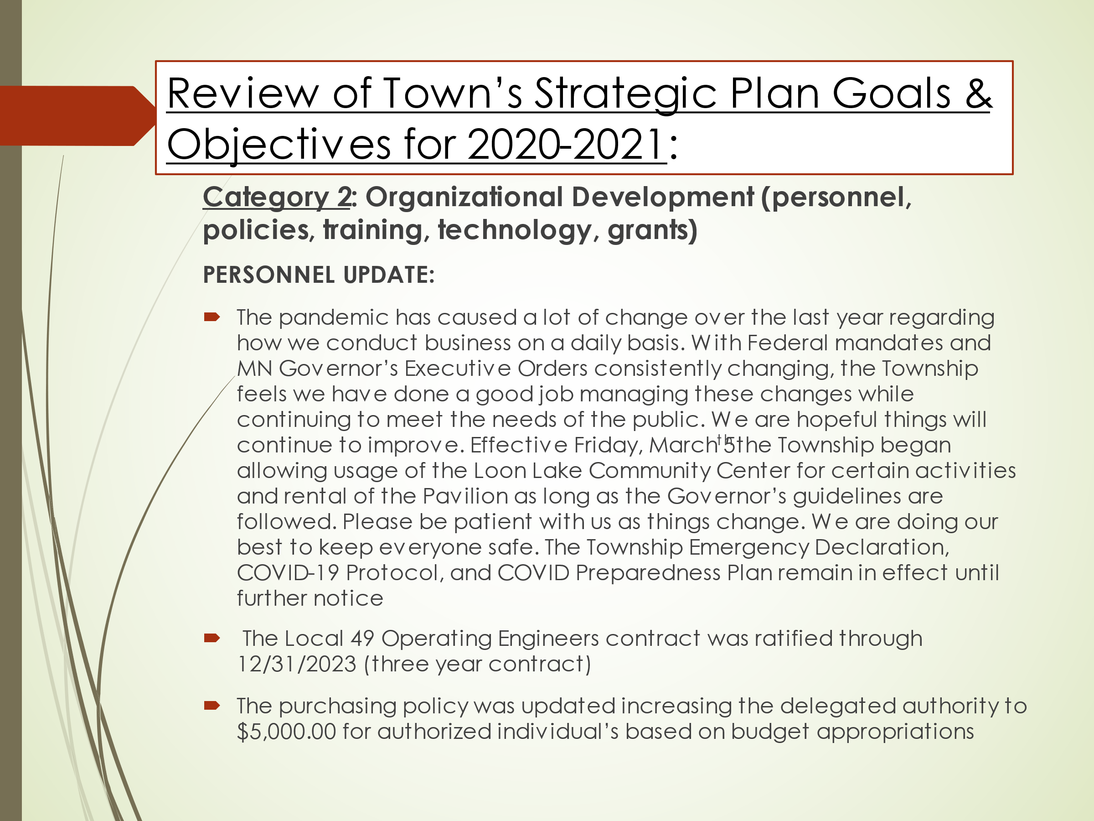

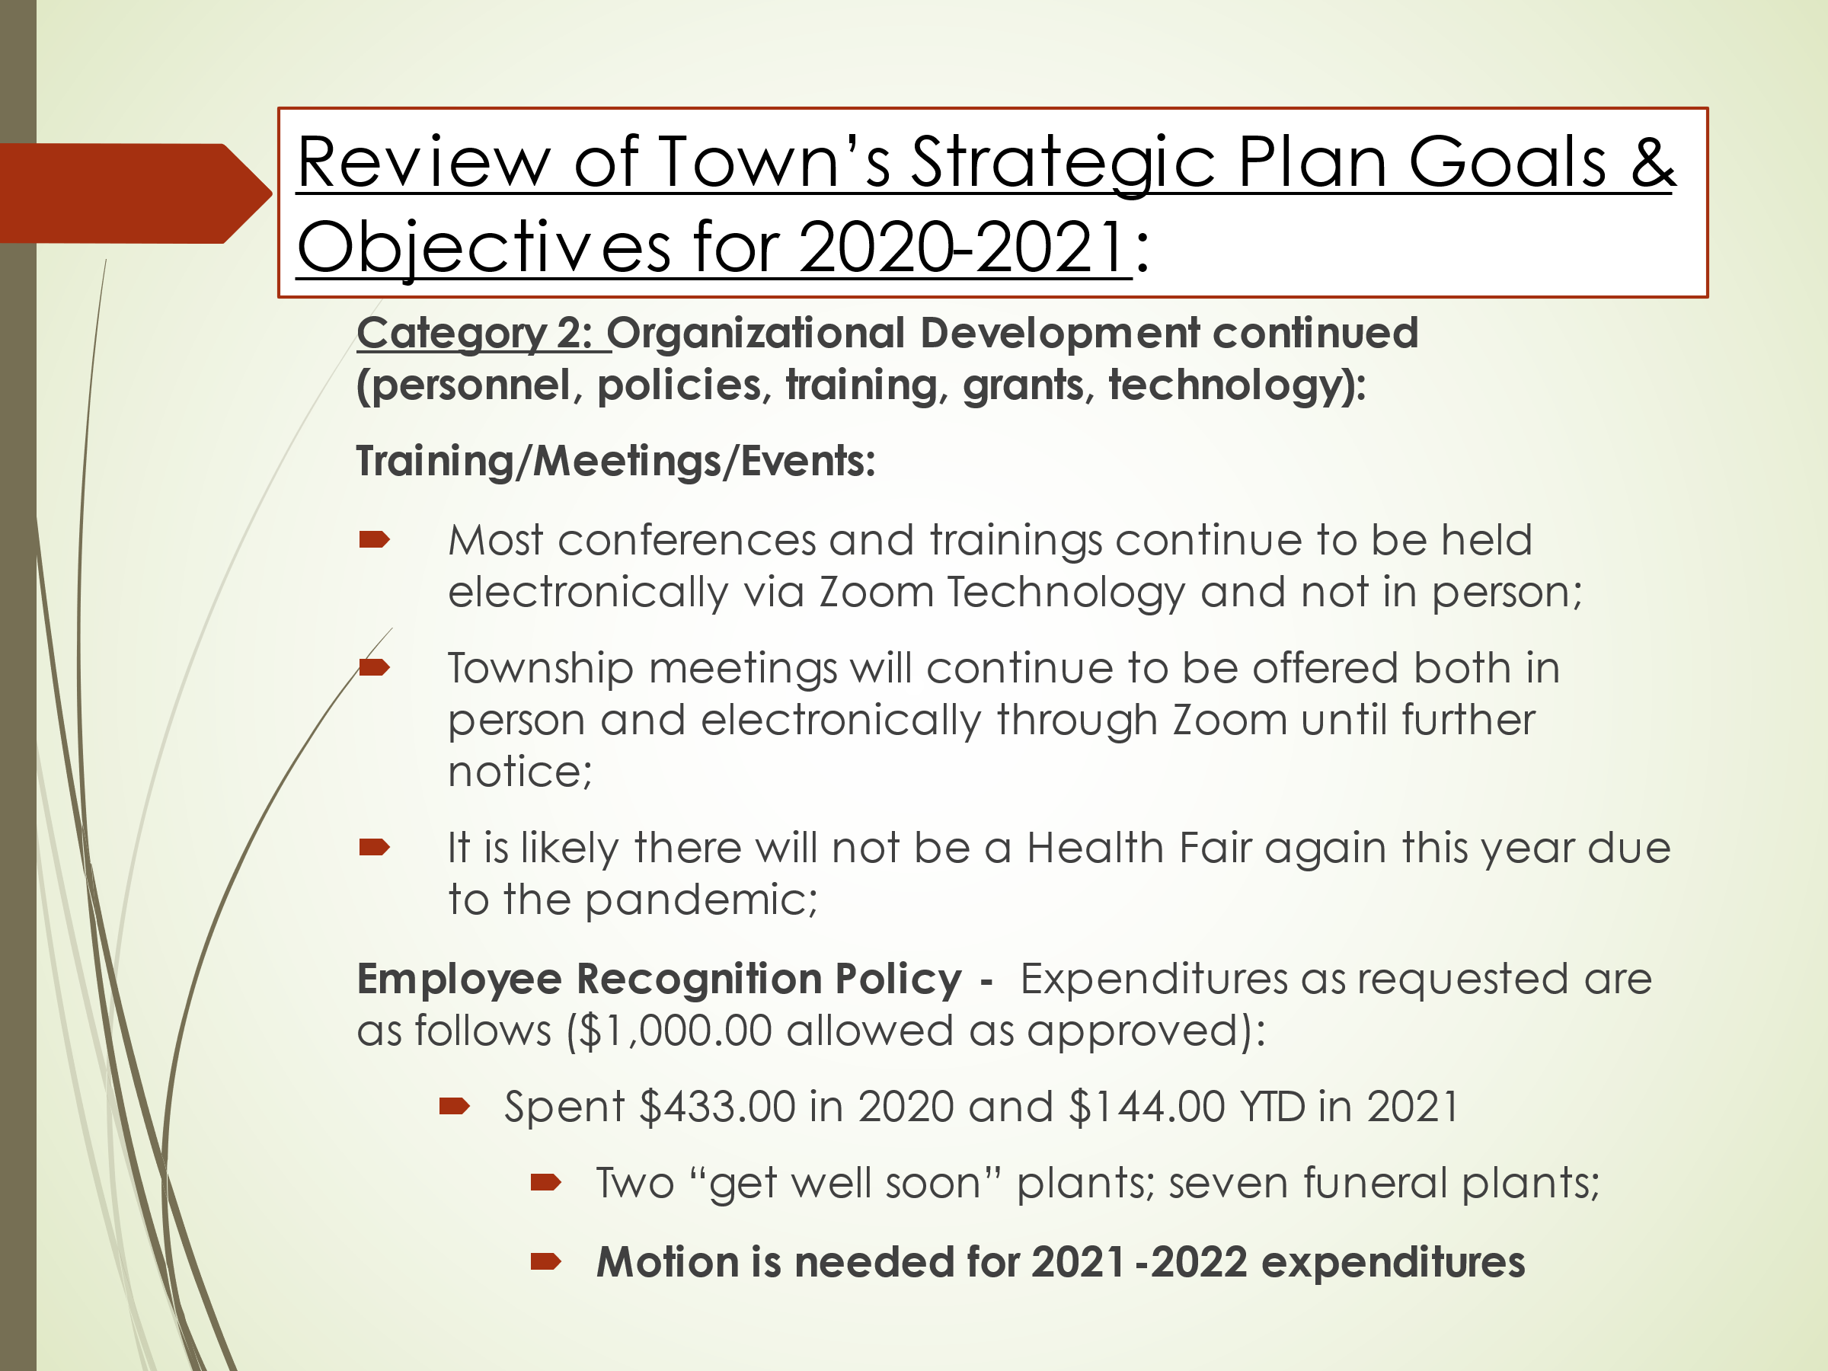

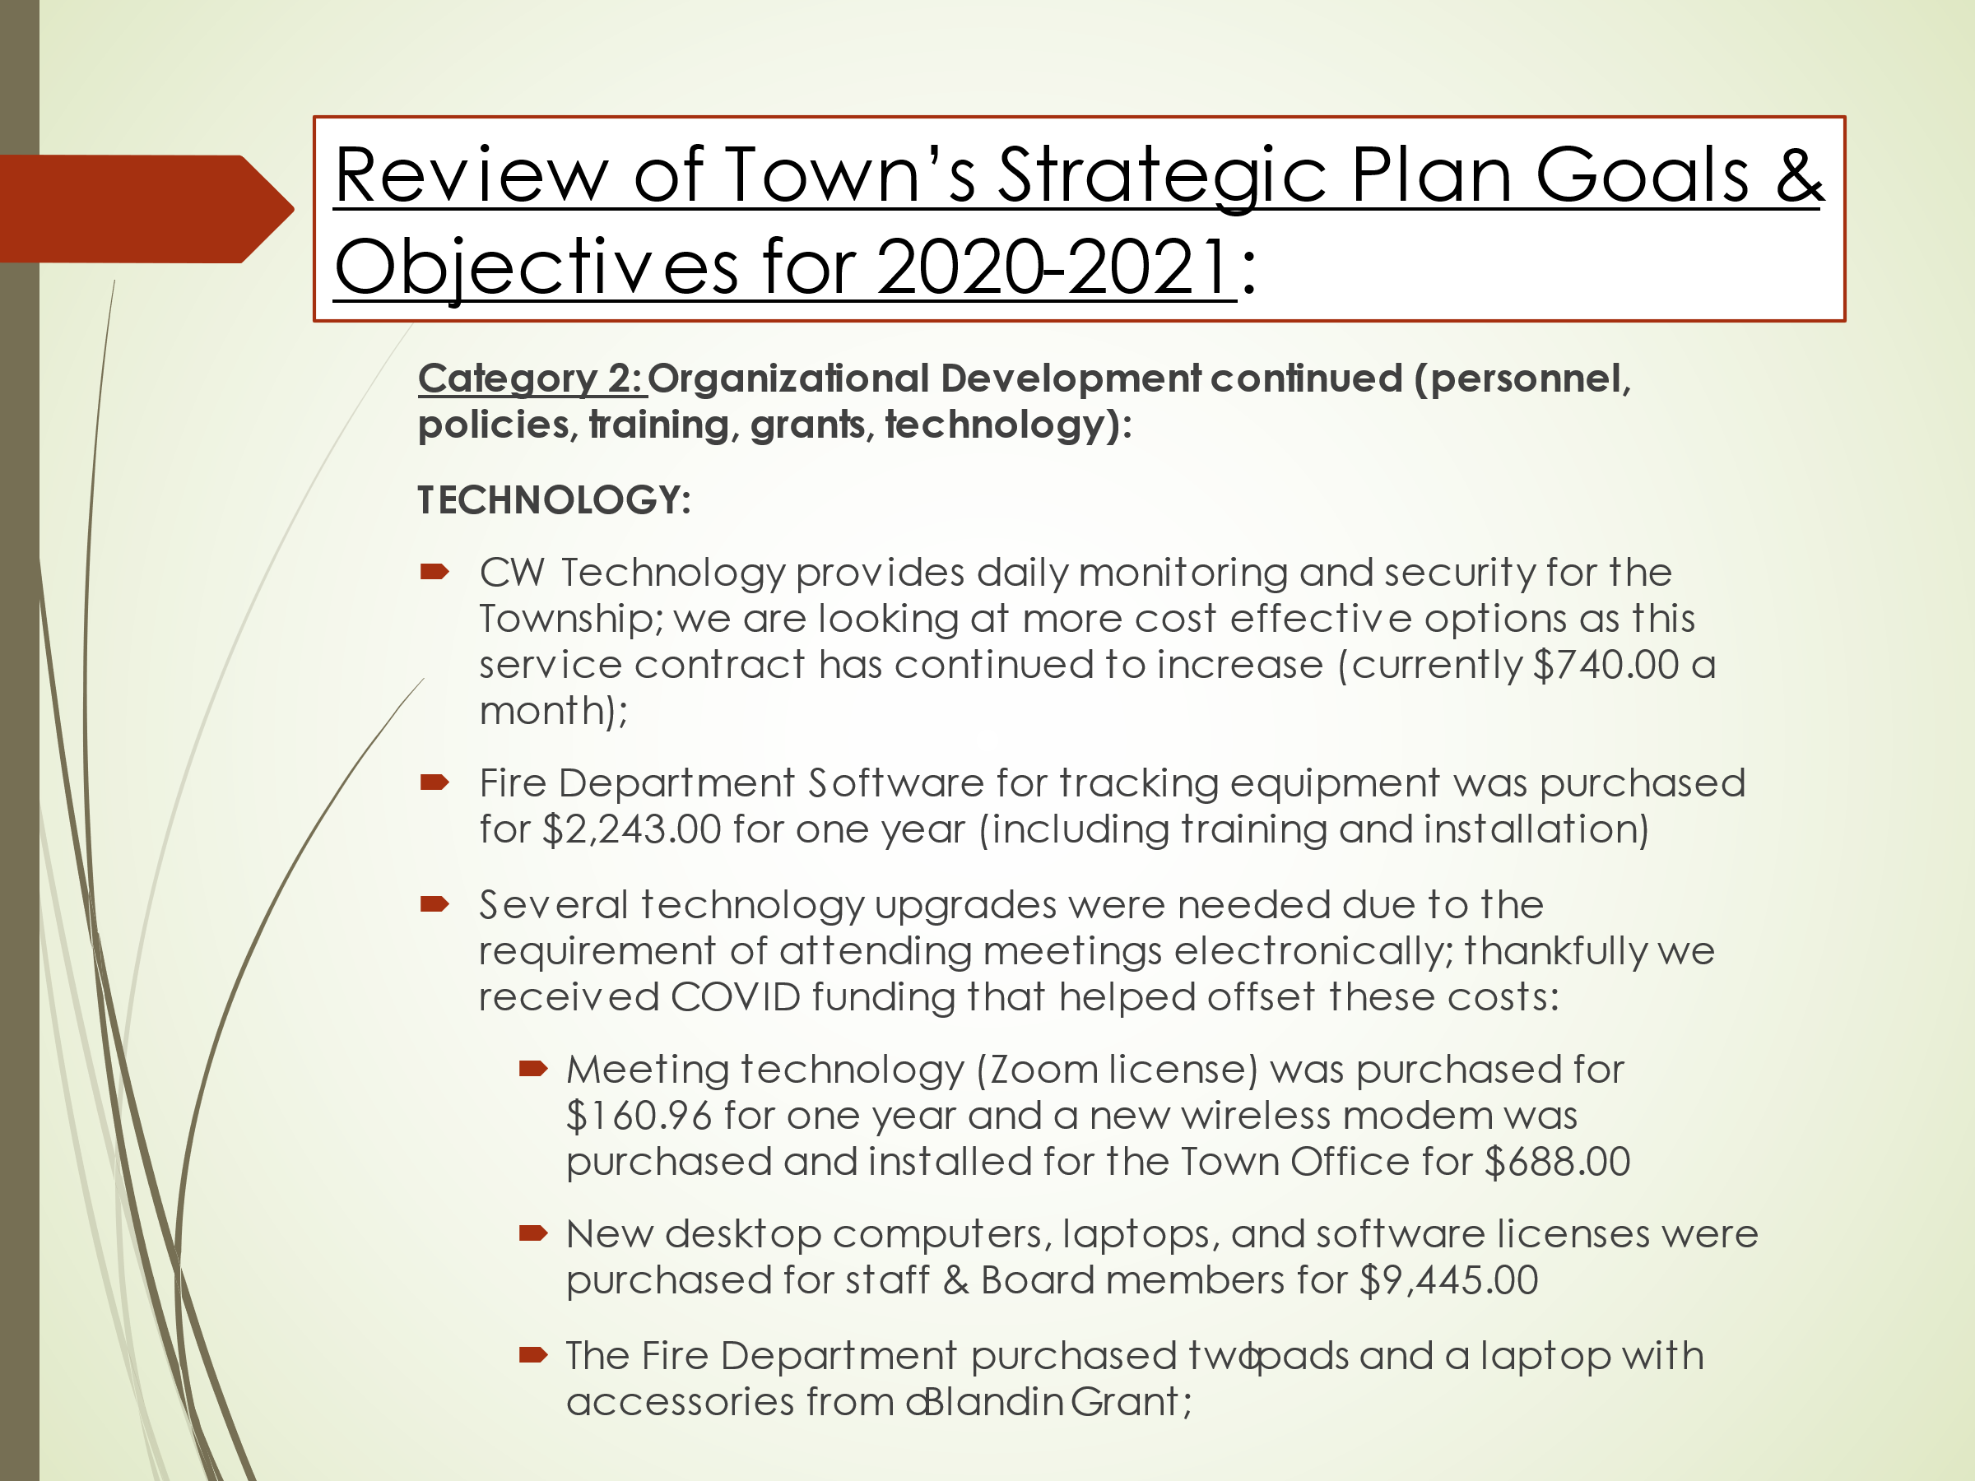

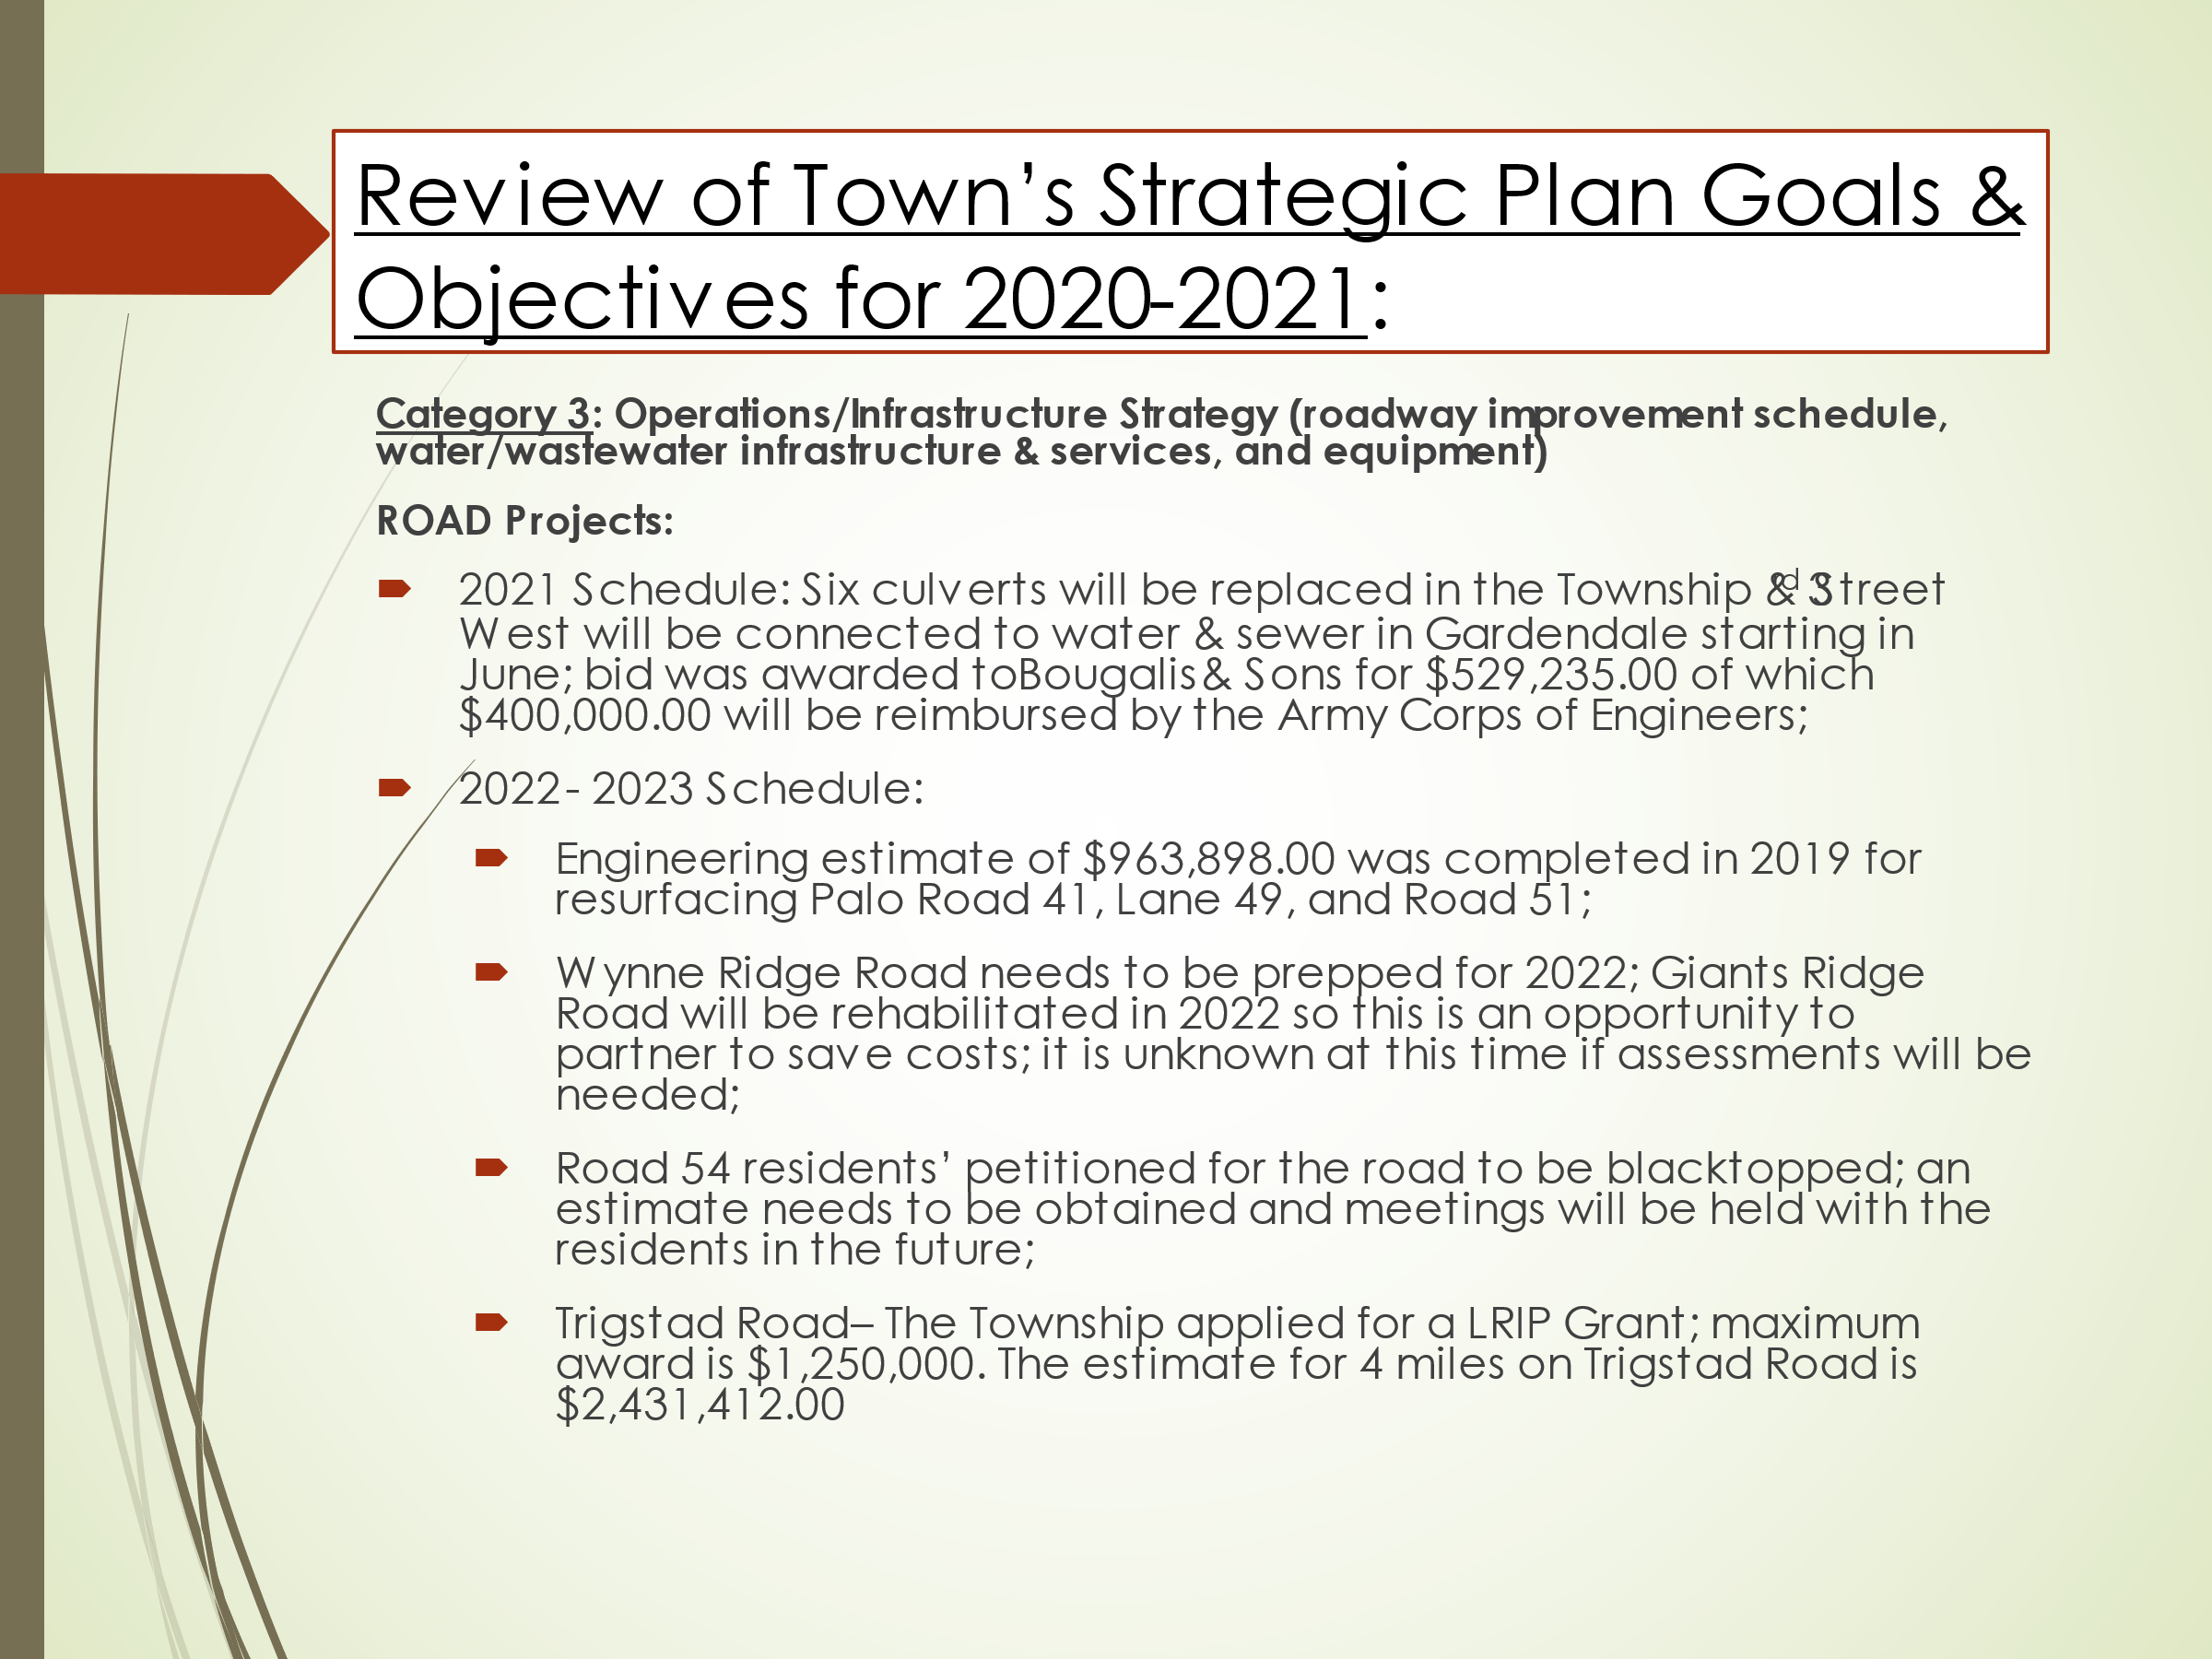

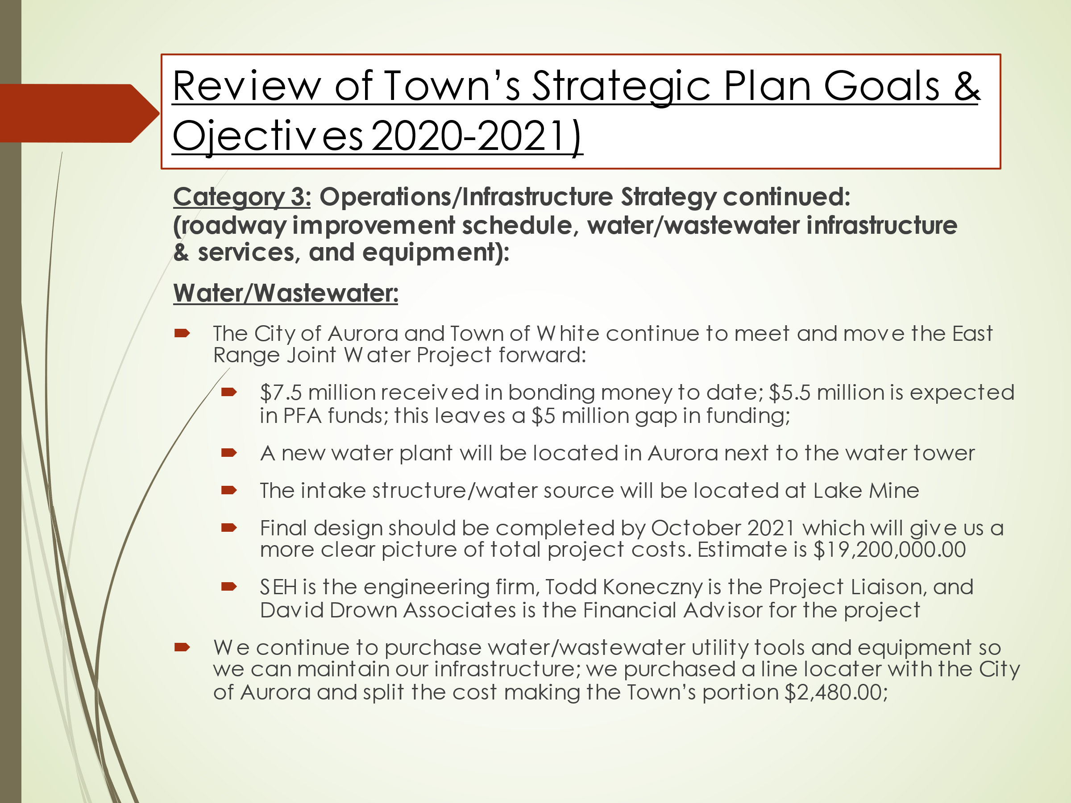

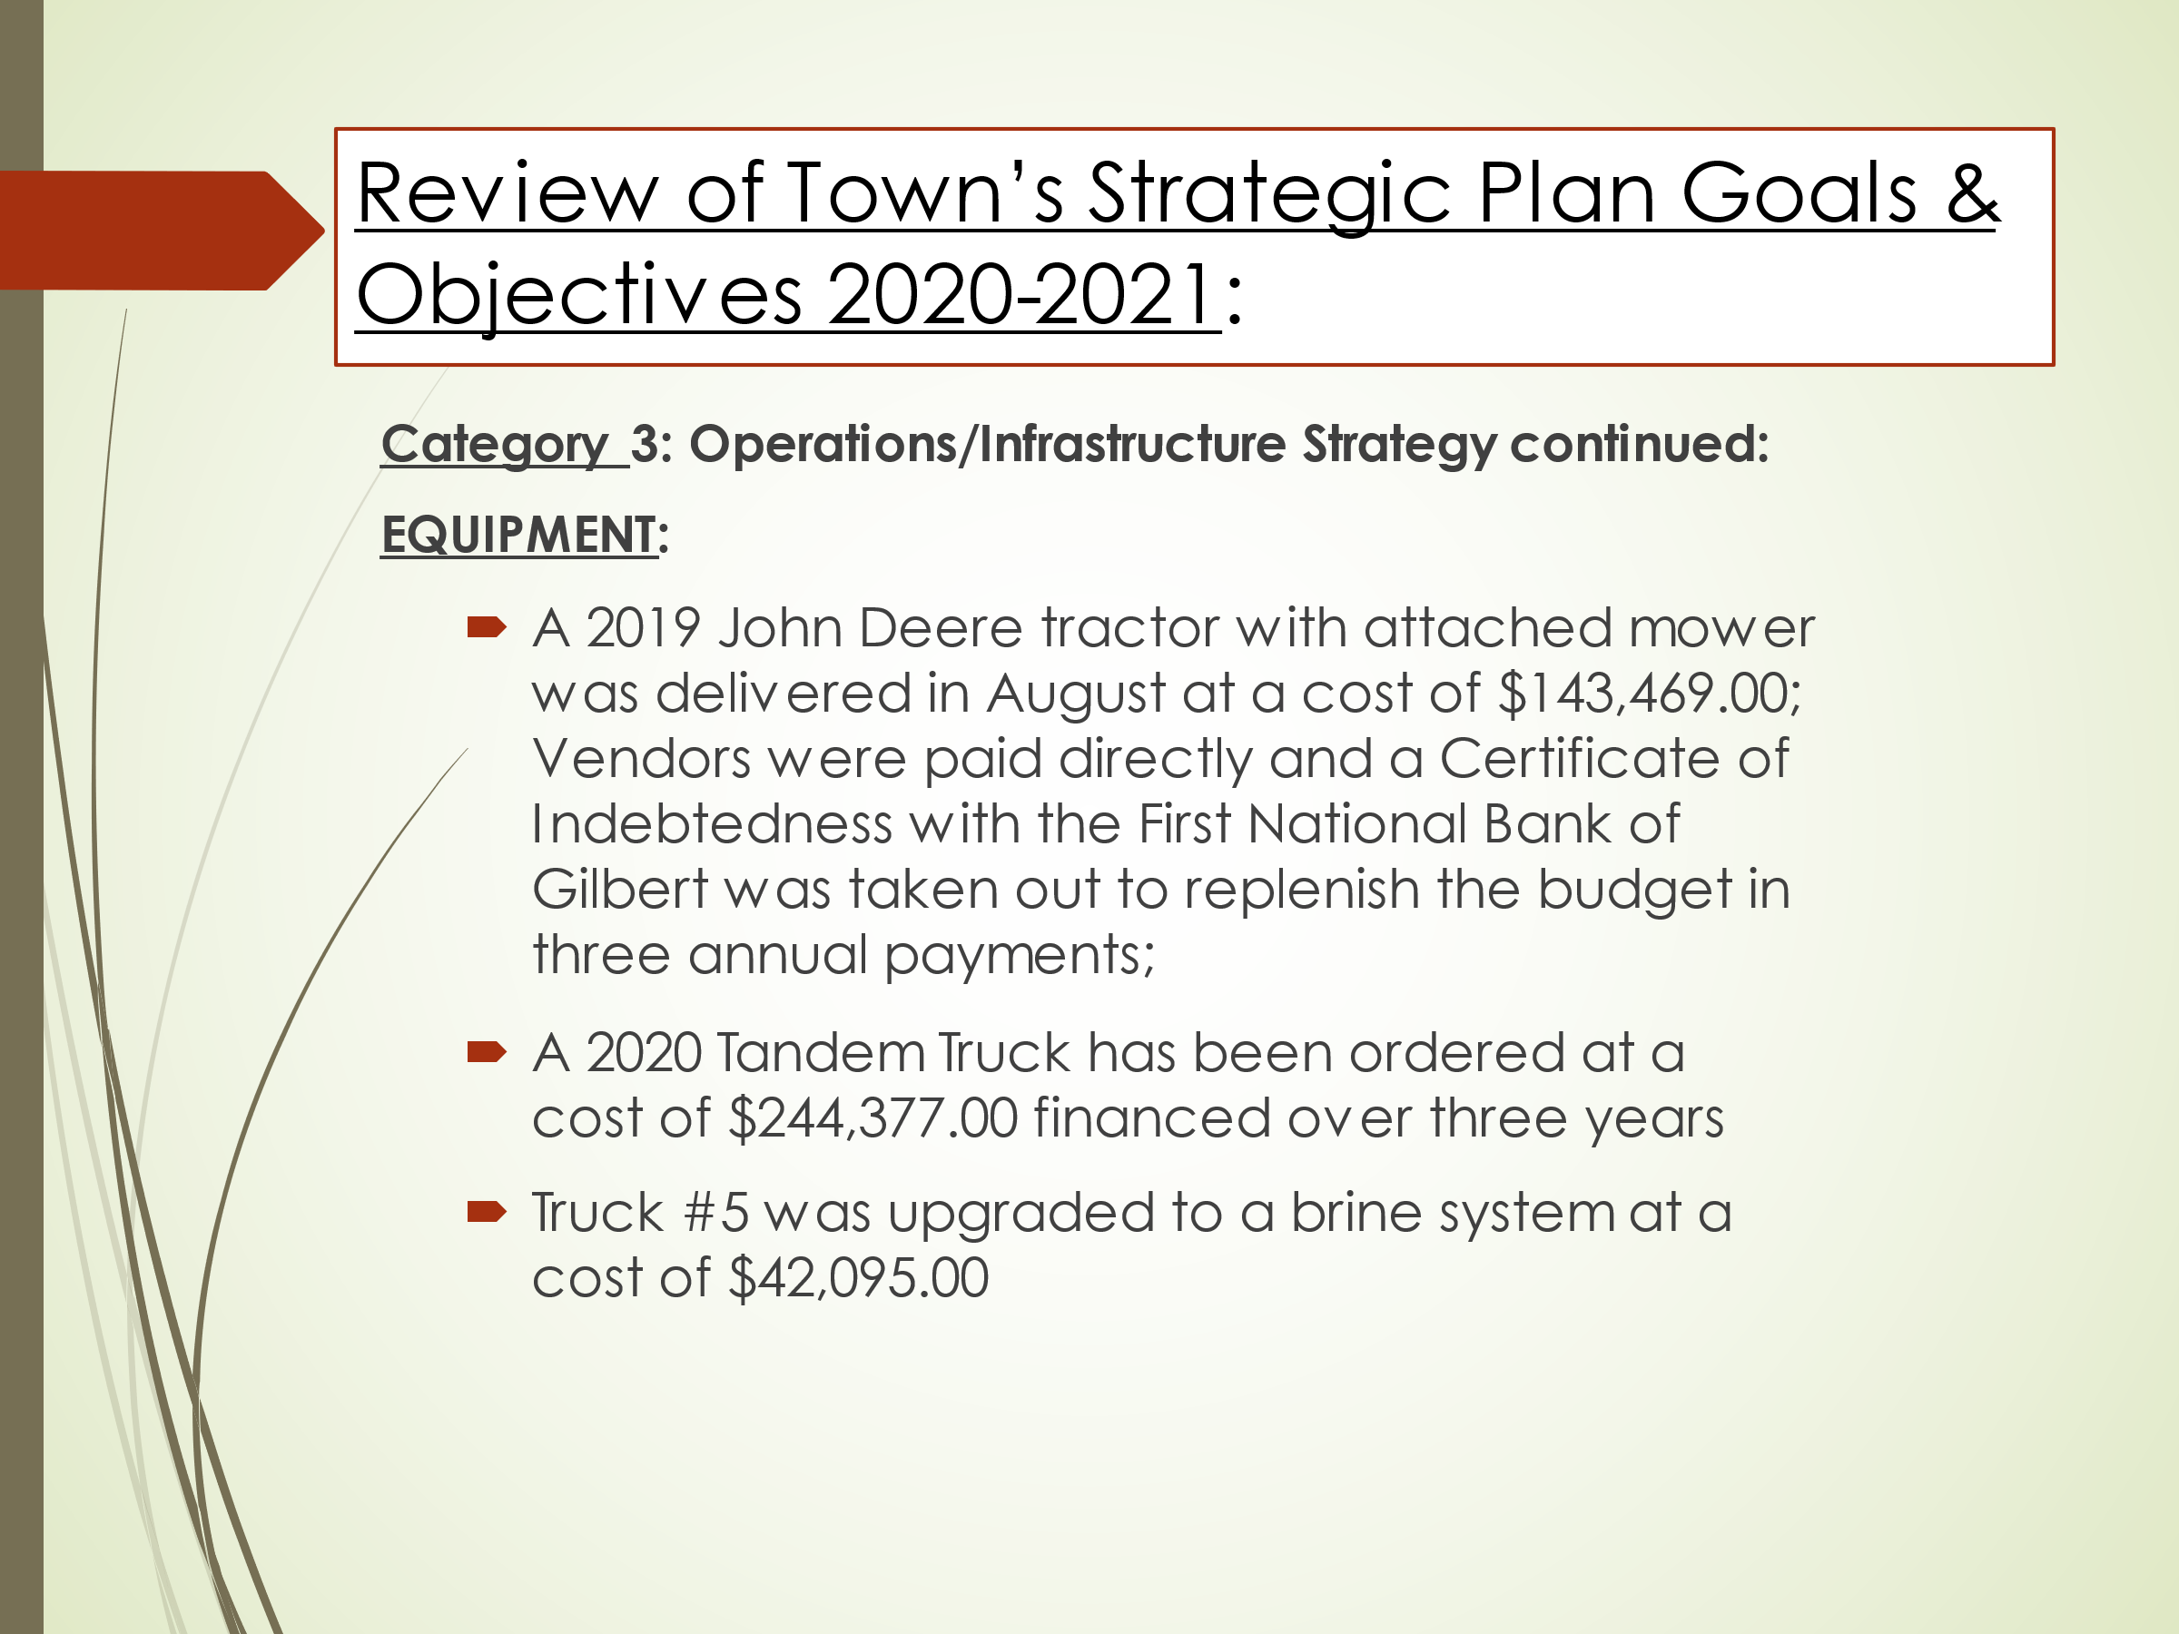

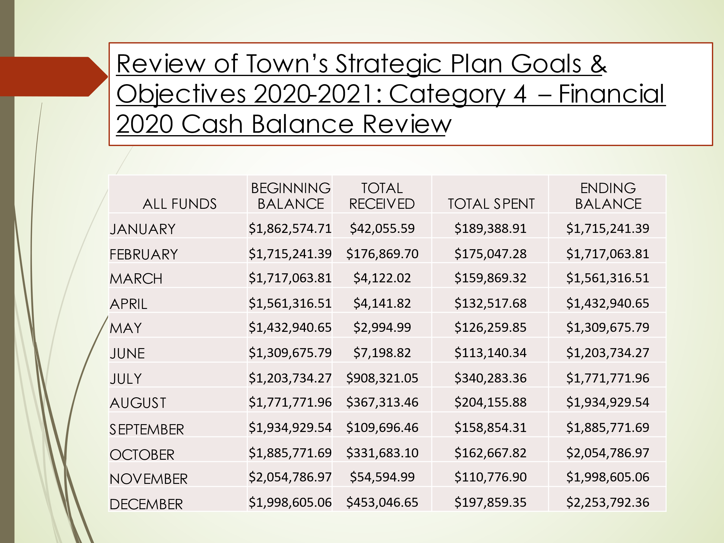

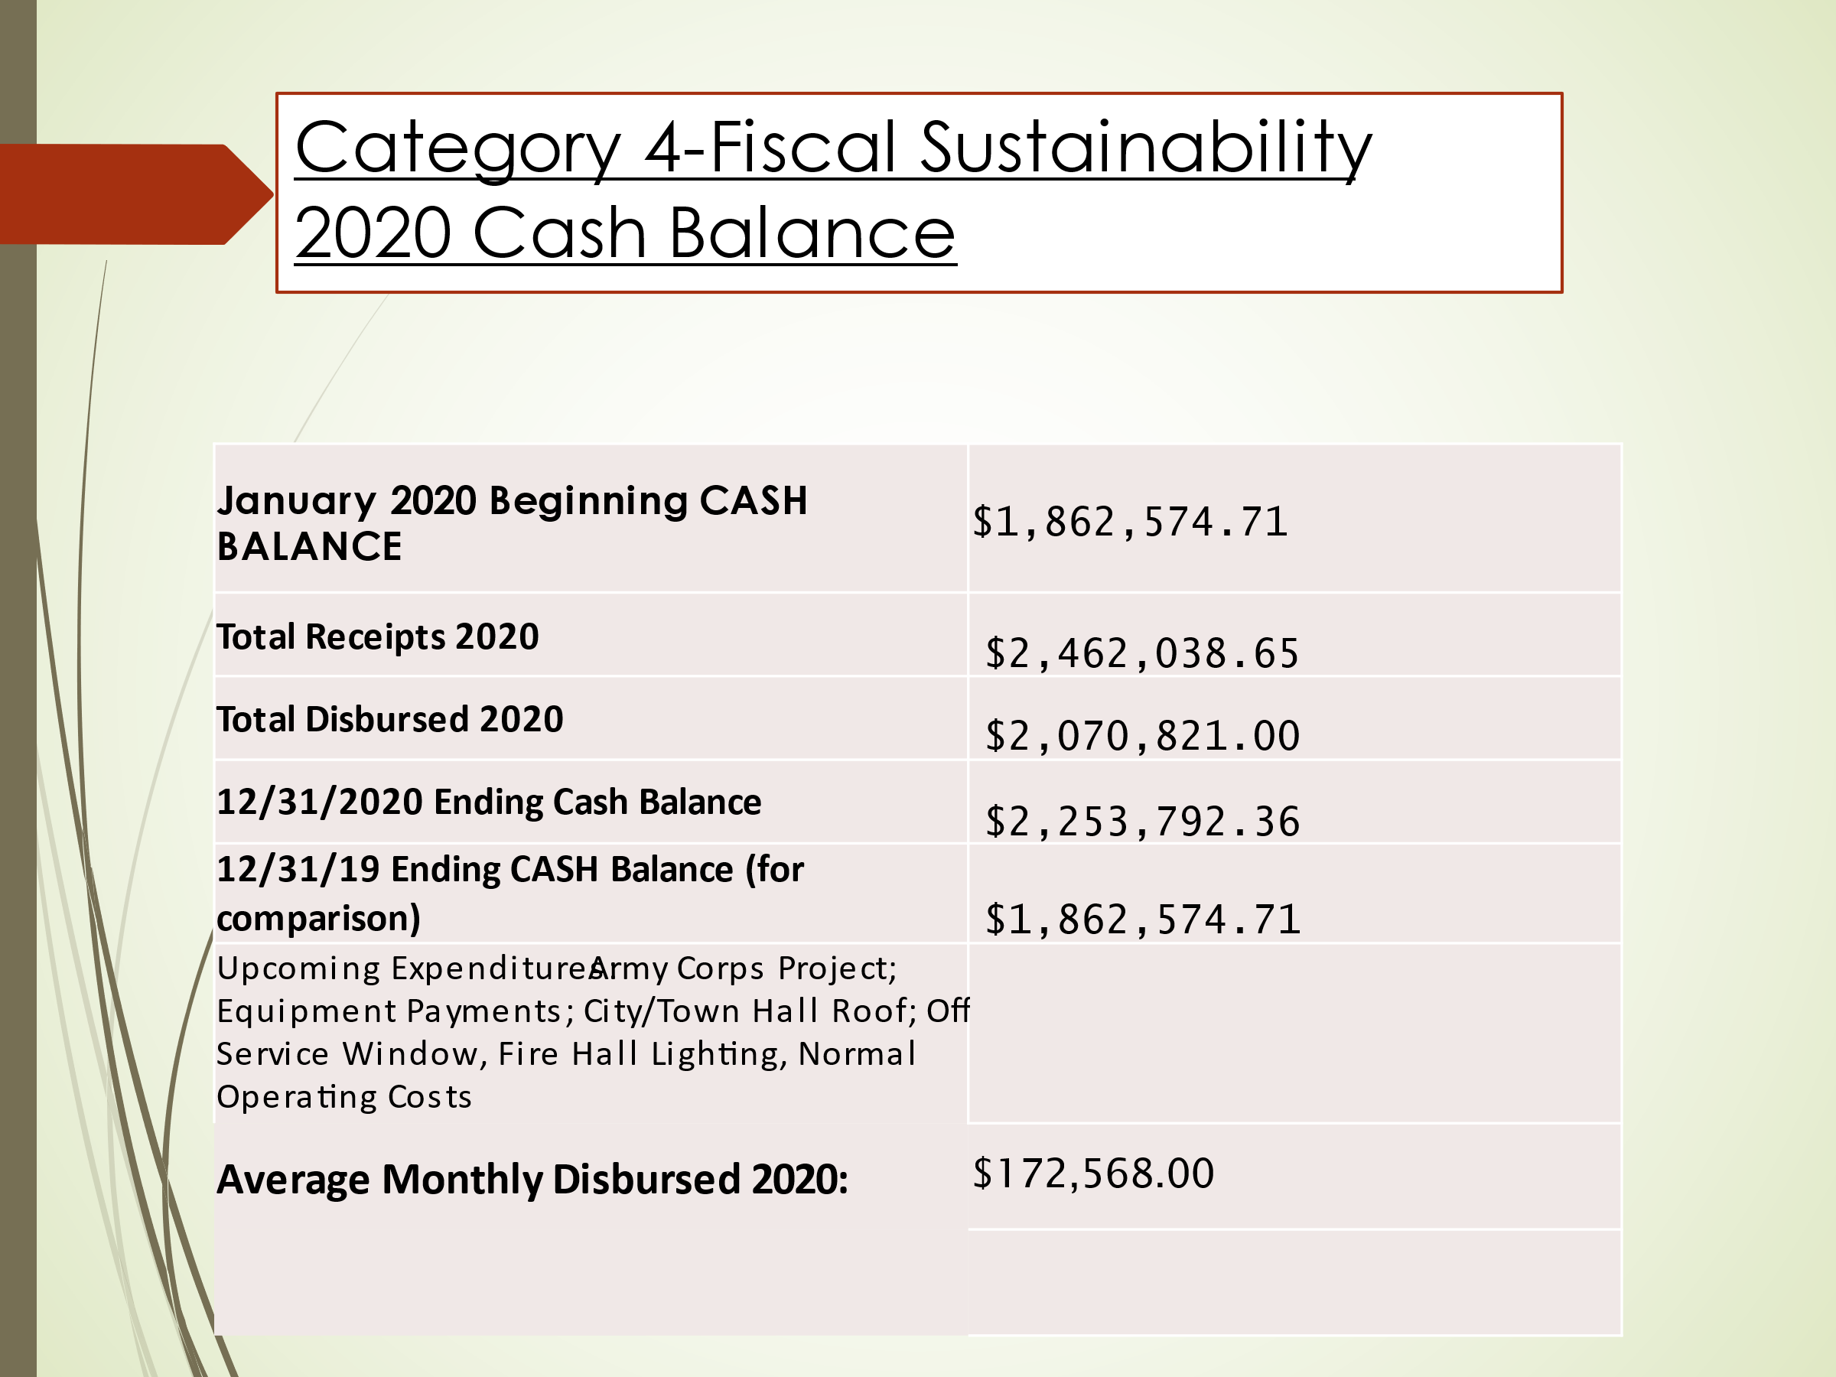

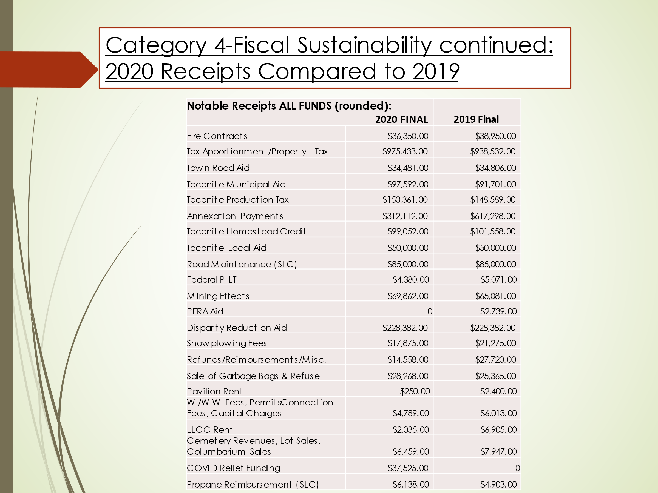

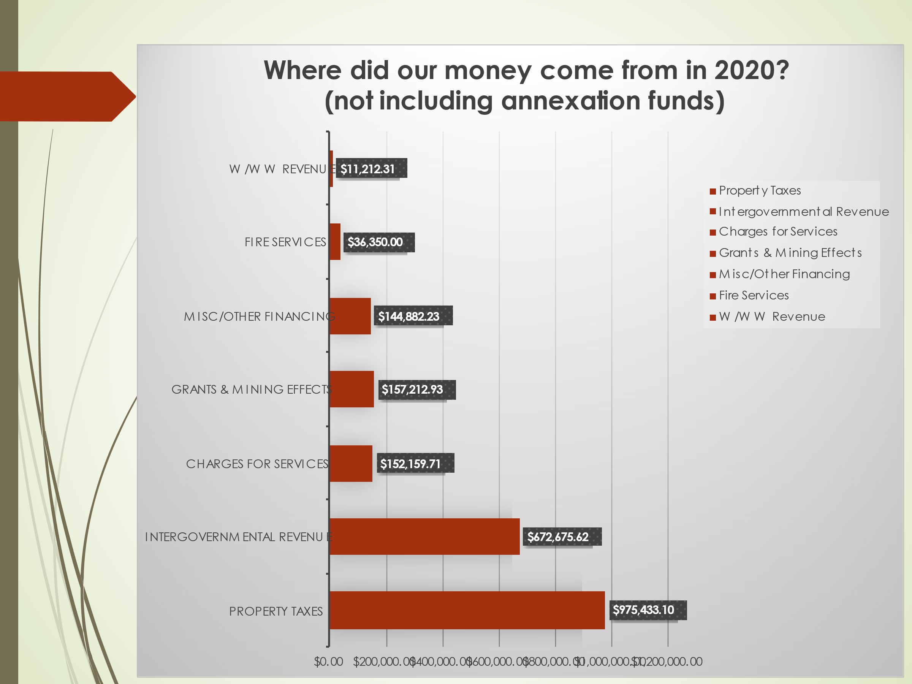

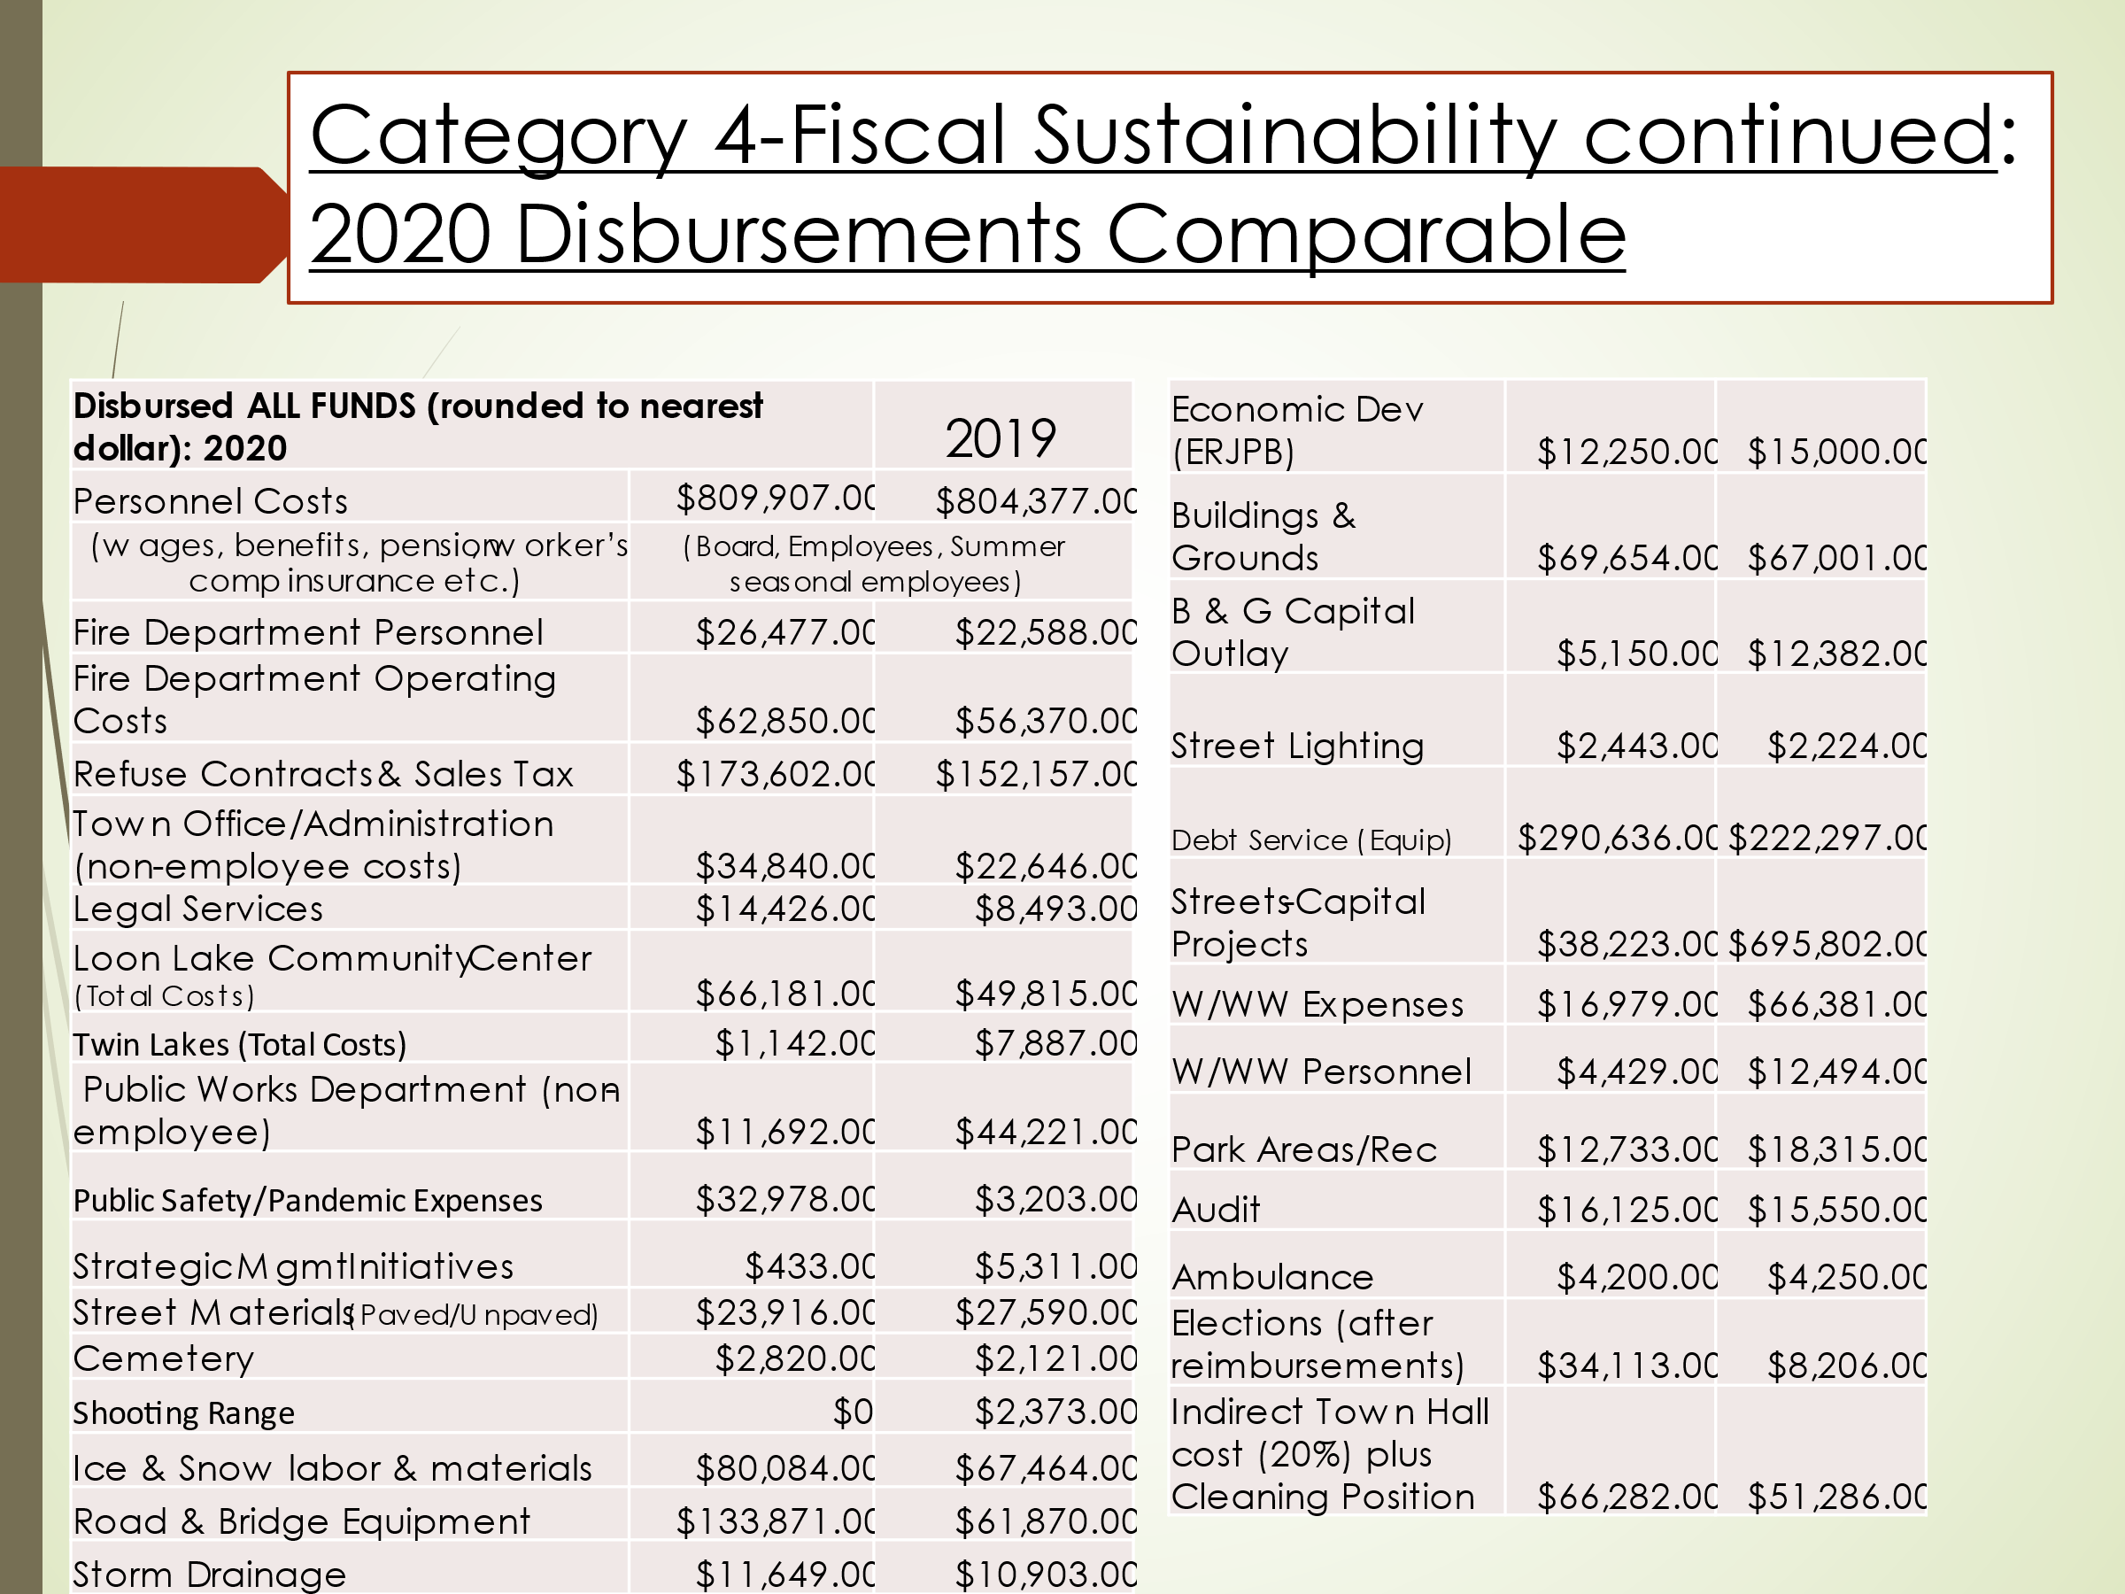

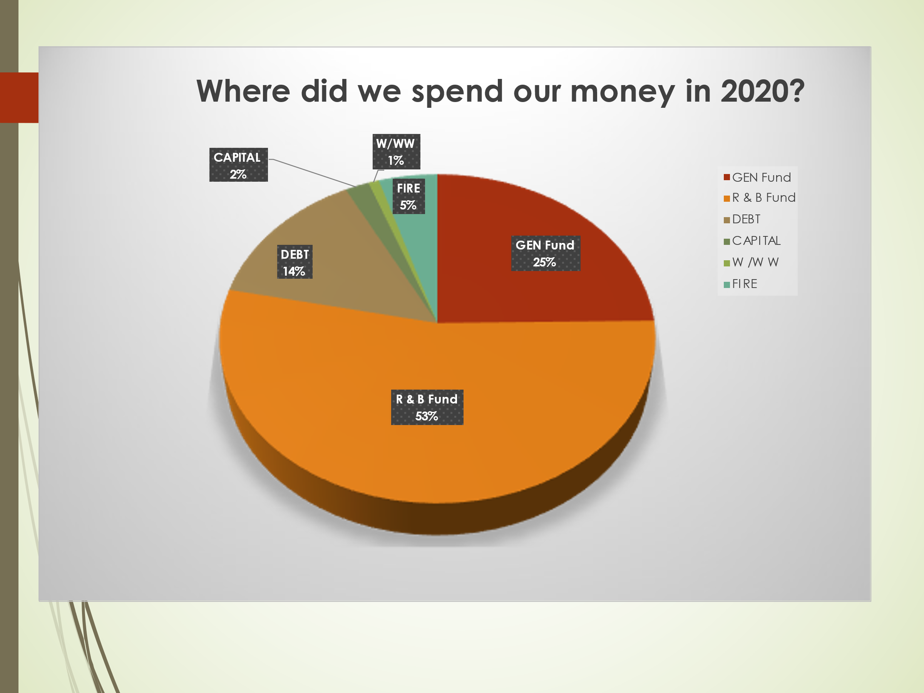

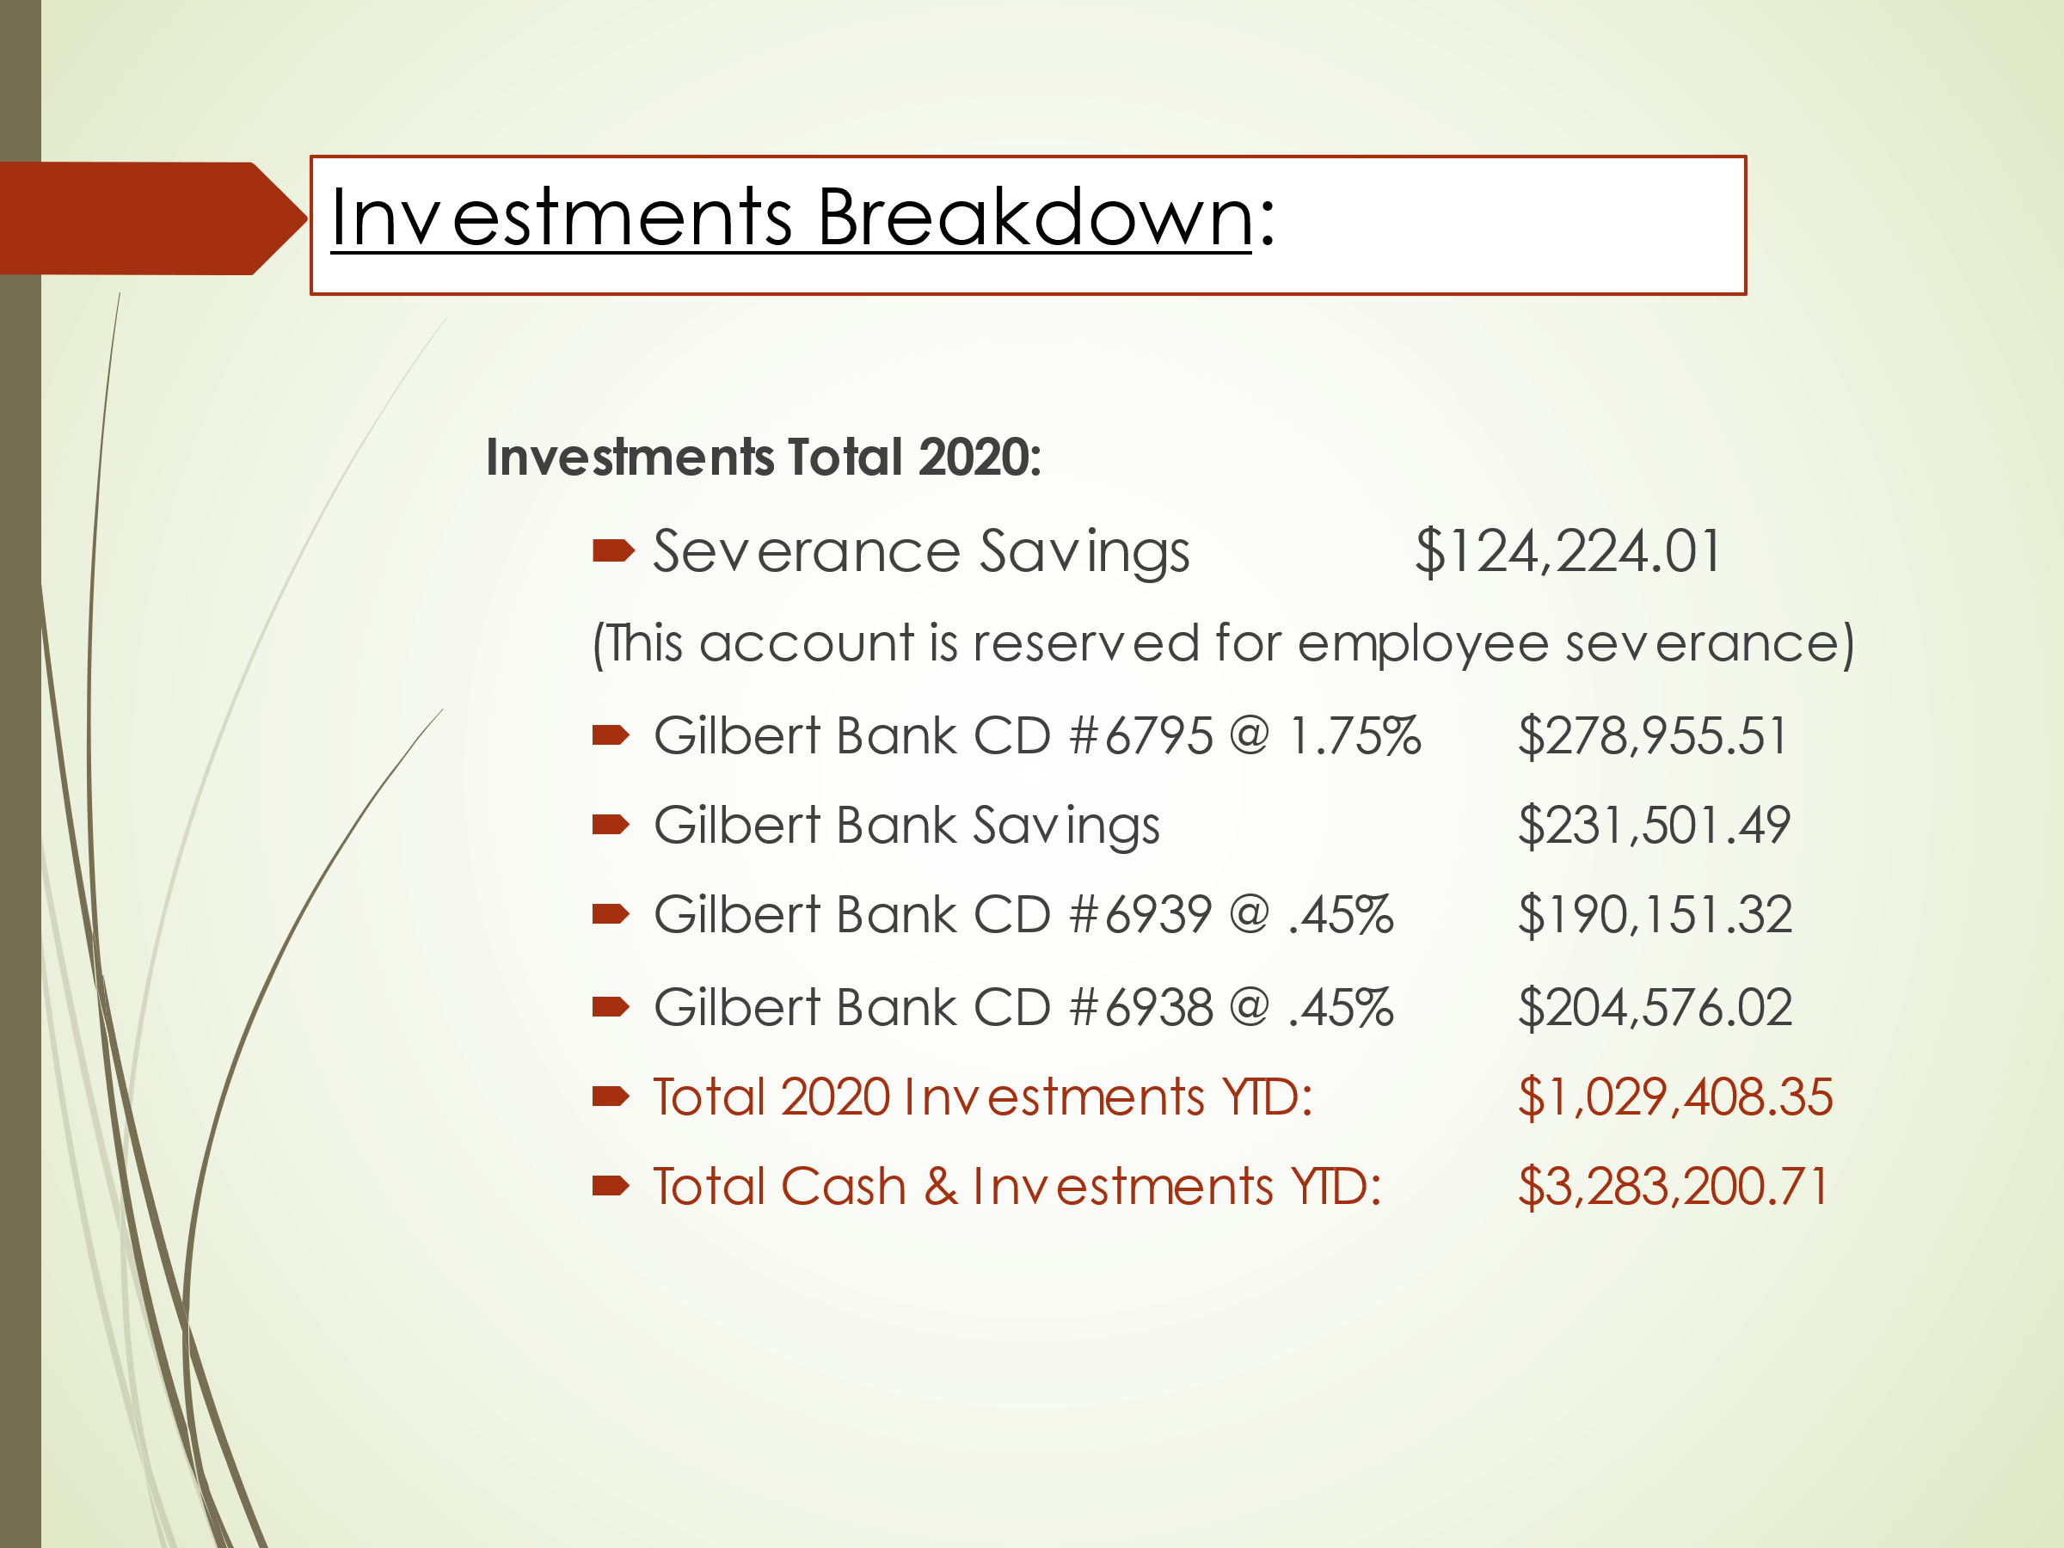

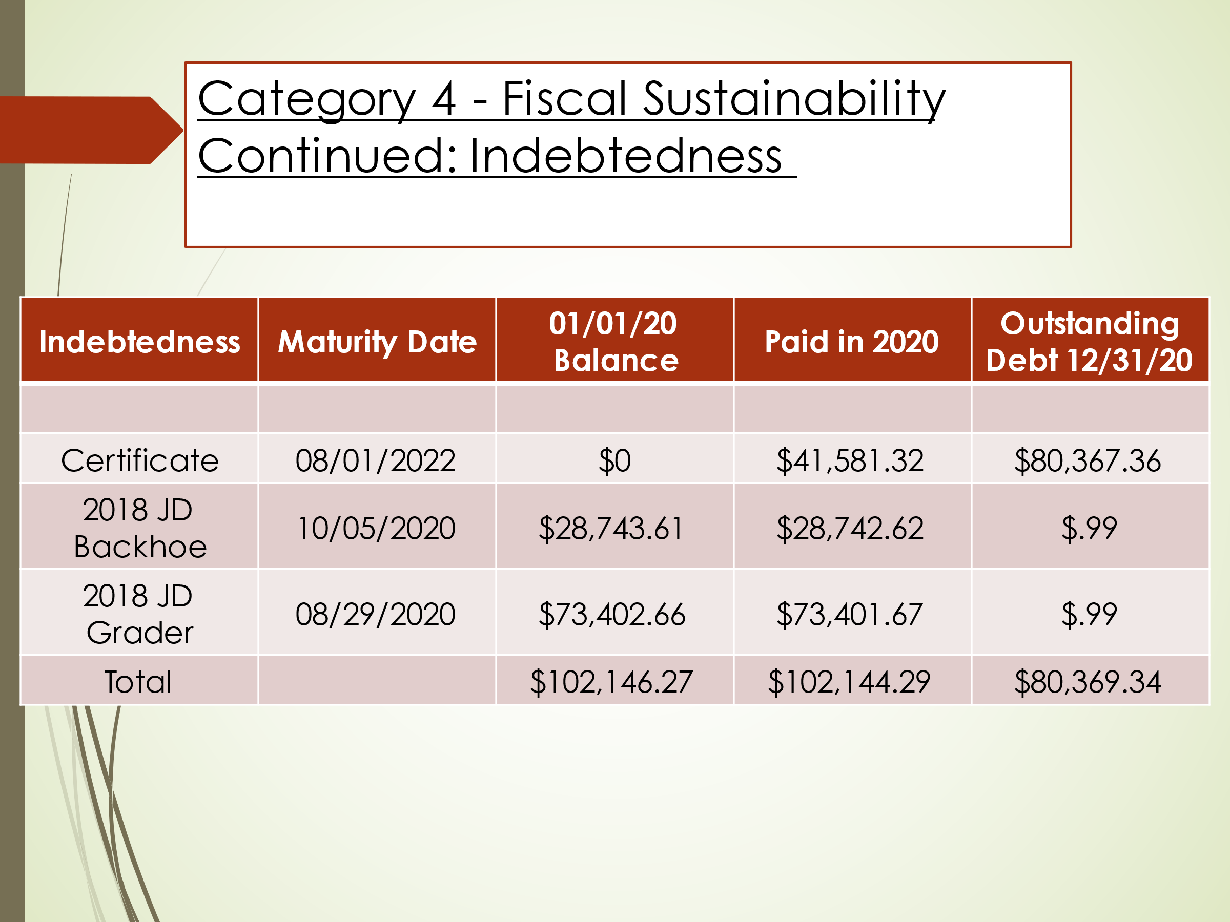

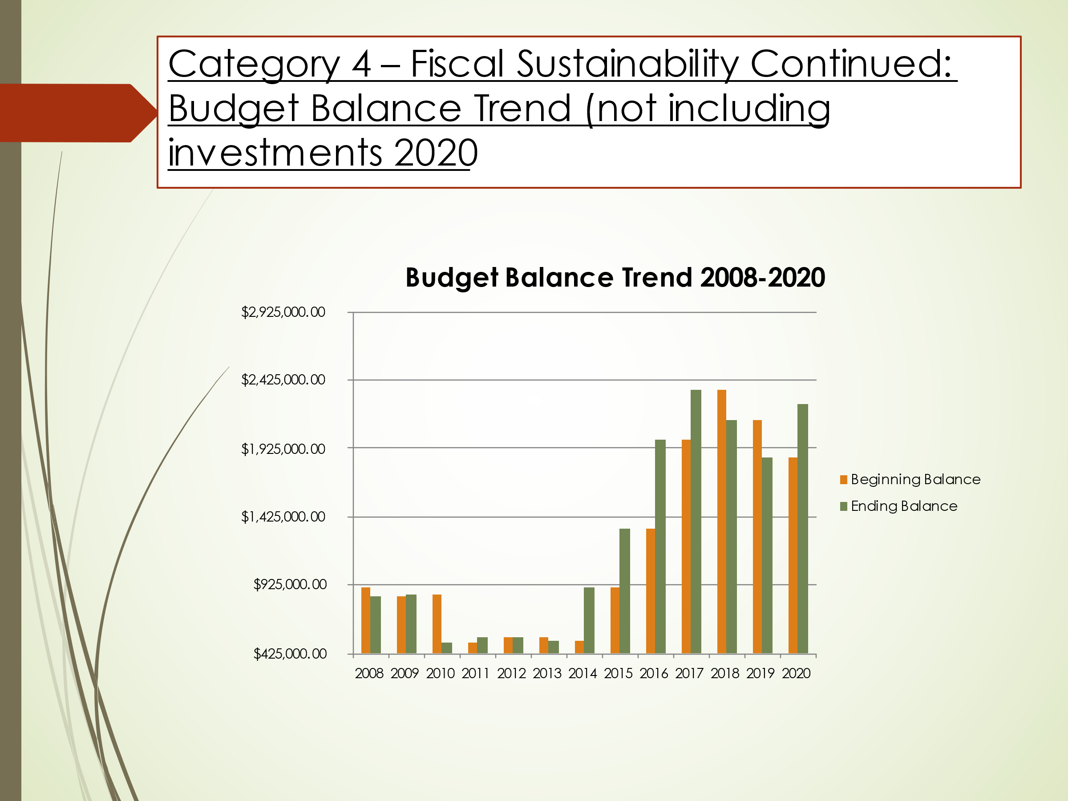

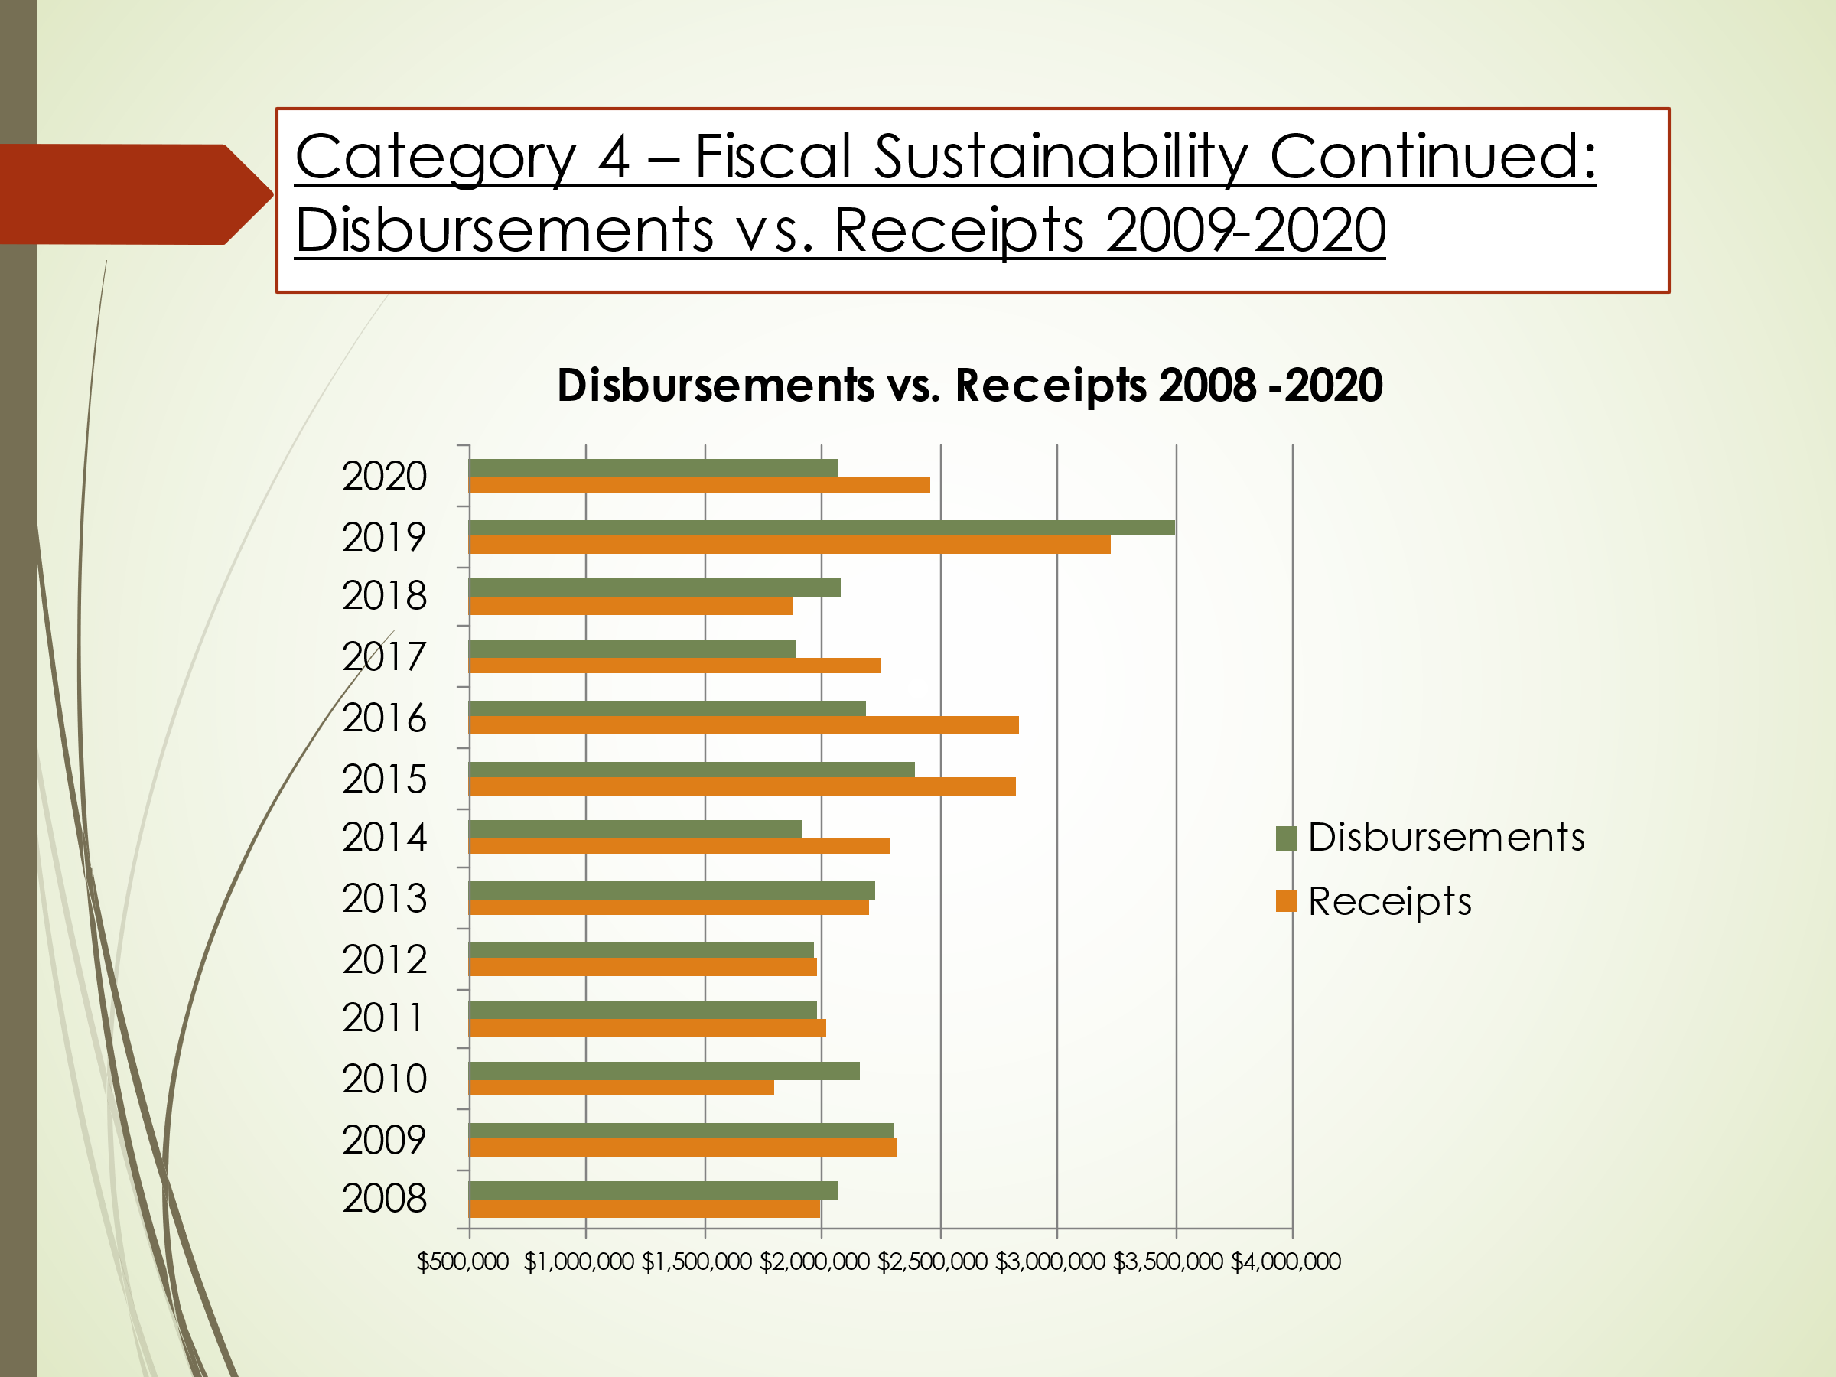

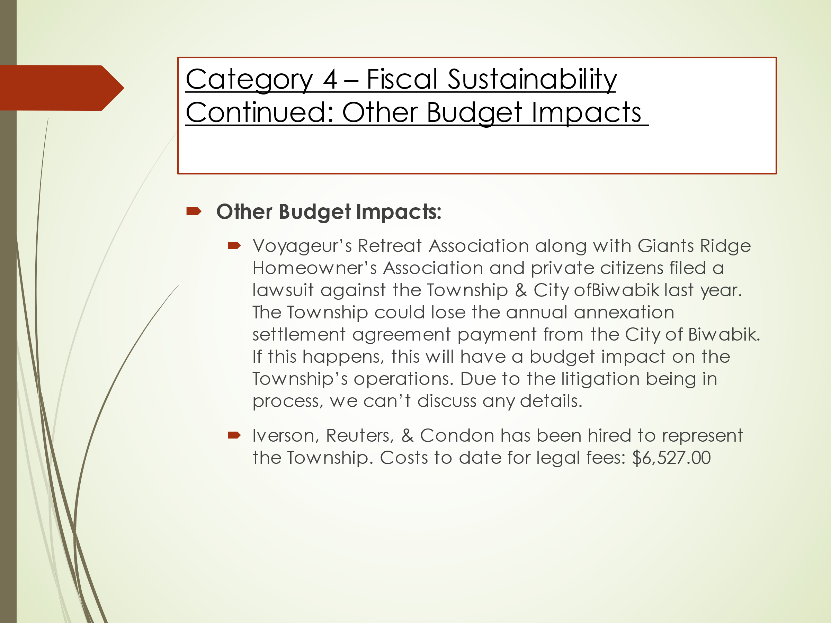

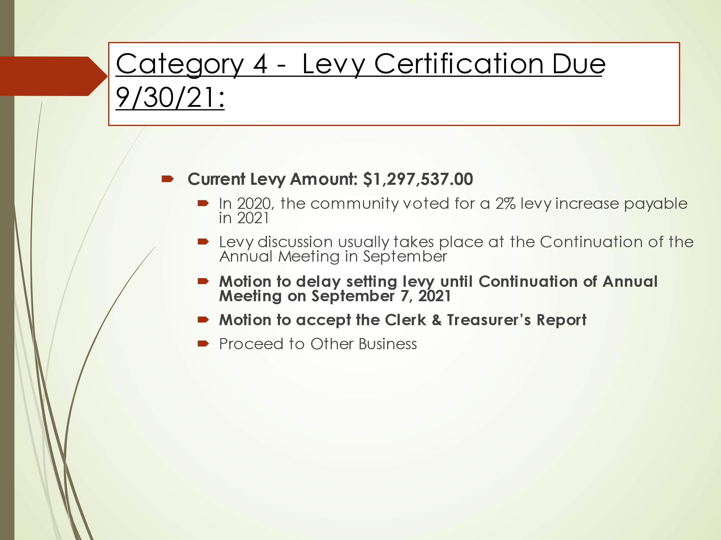

_____________________________________ _________________________________________
Jodi Knaus, Clerk Jon Skelton, Moderator

