At the end of the age three messengers (angels) will be sent forth from YaHuWaH to the peoples of the earth.

Revelation 14:6 And I saw another angel fly in the midst of heaven, having the everlasting gospel to preach unto them that dwell on the earth, and to every nation, and kindred, and tongue, and people,
7 Saying with a loud voice, Fear YaHuWaH, and give glory to Him; for the hour of His judgment is come: and worship Him that made heaven, and earth, and the sea, and the fountains of waters.
8 And there followed another angel, saying, Babylon is fallen, is fallen, that great city, because she made all nations drink of the wine of the wrath of her fornication.
9 And the third angel followed them, saying with a loud voice, If any man worship the beast and his image, and receive his mark in his forehead, or in his hand,
10 The same shall drink of the wine of the wrath of YaHuWaH, which is poured out without mixture into the cup of His indignation; and he shall be tormented with fire and brimstone in the presence of the holy angels, and in the presence of the Lamb:
11 And the smoke of their torment ascendeth up for ever and ever: and they have no rest day nor night, who worship the beast and his image, and whosoever receiveth the mark of his name.
12 Here is the patience of the saints: here are they that keep the commandments of YaHuWaH, and the faith of YAHUSHUA (Jesus).

1. The first message delivered: Fear YaHuWaH and give glory to Him, and worship Him that made heaven and earth.

2. The second message delivered: Babylon is fallen, is fallen.

3. The third message delivered: If any man worship the beast and his image, and receive his mark, the same shall shall suffer the wrath of Almighty YaHuWaH Elohim.

Deliverance from Wrath

Revelation 14:12 above: Notice that those who survive the coming wrath will be those who keep the commandments of YaHuWaH and have the faith of YAHUSHUA. This is the true gospel of Jesus Christ, the everlasting gospel. This is not the gospel that Paul preached.

Matthew 19:16 And, behold, one came and said unto Him, Good Master, what good thing shall I do, that I may have eternal life?
17 And He said unto him, Why callest thou me good? there is none good but one, that is, YaHuWaH: but if thou wilt enter into life, keep the commandments.

Fear the Creator

The teaching that man was created by a Being of greater intelligence isn't allowed in the public schools of the United States. Most people believe they evolved from animals. The Creator is now providing evidence of His existence in the heavens, a place where man can't erase the Truth from view. The bible has been expelled by man from public schools, but it won't be expelled by him from the heavens.

Psalms 19:1 The heavens declare the glory of YaHuWaH; and the firmament sheweth His handywork.

Here's the latest discovery from Daniel Matson as given him by YaHuWaH Elohim. It concerns the mathematical quantity known as the Golden Ratio, .618, which is present throughout nature and in the proportions of the human body. Because the Creator has placed this physical proportion in the creation of man's human body, Daniel Matson went looking to see if the Creator had also placed it in the heavens. Daniel just found some amazing relationships that were placed in the orbital mechanics of the earth and the planets at the time of Creation. These amazing mathematical relationships in the heavens are being revealed to Daniel Matson by YaHuWaH Elohim currently so that we may believe that He exists, and worship the Creator of the heavens, the earth, and mankind. This is the message of the first messenger in Revelation 14:6-7 above.

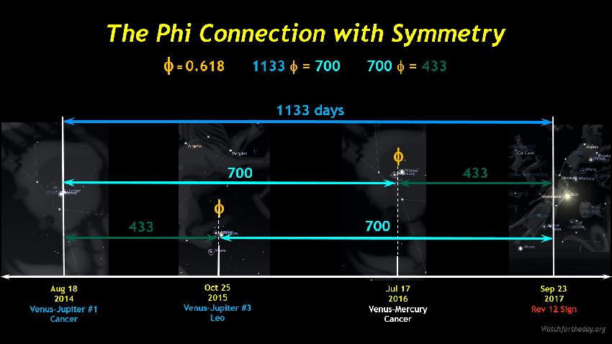

The Creator has placed these witnesses in the heavens that we might believe in Him. Graphic courtesy Daniel Matson, Watchfortheday.org

Here's a link to Daniel's webpage concerning the ratio phi (.618) and it's relationship with signs in the heavens pointing to the Day of Trumpets on 9/21/2017 and the sign of the Woman Clothed with the Sun on 9/23/2017: http://watchfortheday.org/phiconjunction.html

The Problem for the Unrepentant

The problem for most people will be that after the Creator sends a messenger who witnesses to His existence and instructs people to fear Him and worship Him, Babylon is then destroyed.

Babylon is the United States of America, and it will be destroyed after the Creator has given overwhelming evidence for His existence. That evidence is NOW being revealed by Daniel Matson and others.

The 3rd message concerns the mark of the beast which will be issued after Babylon is fallen. Revelation 14:10 above tells us that the pure undiluted wrath of YaHuWaH Elohim isn't poured upon the peoples of the earth until after the United States is destroyed!

There are other messages in the heavens revealed by YaHuWaH Elohim available here: http://www.joybysurprise.com/Message_in_the_Sky.html

