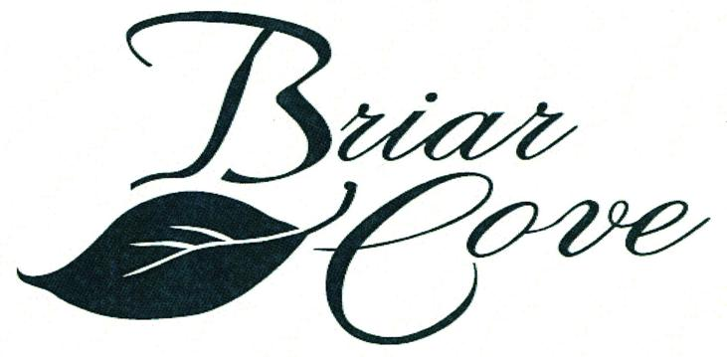 | NEWS  AROUND  THE  NEIGHBORHOOD  Winter 2015/2016
2016 Board of Directors

Ralph Flens, President Nick DeLaurentis, Director
Joe Arias, Treasurer Ron Szikora. Director
Tom Whitely, Secretary

A belated Merry Christmas and a Happy New Year to you and your families.May the
new year be filled with happiness, good health and peace.

The year of 2016 will be filled with much activity as you will see below.We have a
beautiful community and the planned activities will help to keep it attractive.

These activities and adherence to the Briar Cove rules/covenants will also help to
keep our community attractive.

Per our bylaws ALL Christmas decorations must be removed by the end of January.

To stay informed about community activities, alerts, and announcements and to receive future community newsletters make sure Peter Bylen pbylen@1stpropertymanagers.com has your EMAIL address.

As required by our community covenants, provide Peter Bylen with homeowners insurance information. This is for your safety as well as your attached neighbor.

Briar Cove will start the second phase in our painting program for our Community this year.
The painting will occur over a three-year period.

The second phase of our driveway asphalt resealing program will also start this year.
The process will be spread out over a two-year plan based on the year it was last sealed. The sealing material will be non-coal tar, in consideration of environmental issues.
Further information about both programs will be provided by email and future newsletters.

The installation of Rip-Rap along the shoreline of the pond is also on the agenda for 2016
Initially, this project will only be done near/around the pond outlet.

The 2016 Briar Cove Committees (*Chairperson) are as follows:
Architectural Review Committee
*Bill Sliepka, Bobbie Czajka, Jack Doherty, Virgil Jordan, Ron Szikora

Finance & Budget Committee
*Joe Arias, Ralph Flens

Landscaping & Beautification Committee
*Sue Arias, Beverly Perotti, Ken Darrow, Nancy Lyzenga, Leslie Slatter,
Chris Popp, Mary Szikora, Millie Baccino, Dee Niven

Nominating Committee
*Nick DeLaurentis, Diane Carroll, Betty Bryan, Beverly Perotti

Rules Committee
*Joe Arias, Patti Jongsma, Paul Hess, Virgil Jordan

Social & Welcoming Committee
*Kathy Skurauskis, Dee Niven, Leslie Slatter, Betty Bryan
Beverly Perotti, Rita Stopper -------Welcome Team
After a busy year, our “tandem welcoming team” of Rita and Beverly is again ready to make contact with about 3-4 expected new neighbors. Last year they welcomed 20 new residents. Along with a smiling “welcome to the neighborhood,” they provide a welcome packet that consists of general information, our governing document in a binder and a gift basket of fruit.

Website & Newsletter Committee
Kathy Skurauskis and Jay Popp

The Briar Cove Book Group is back from Christmas break . We are always looking for new members to join our current six (6) member group. Our January 20th selection is ‘Digging to America’ by Anne Tyler to be followed in February by a book entitled ‘Orphan Train’ by Christina Baker Kline. Anyone interested in joining may contact Brenda DeLaurentis at 219-322-9059.

In general, the Briar Cove snow removal will not start until the end of any single snow event where
The snowfall is 2 inches or greater.

Both Dyer and Schererville have ordinances that prohibit parking on the street when the snowfall
is 2 inches or greater. Violators are subject to fines and/or having their vehicles towed.

PLEASE adhere to the rules (in actuality and spirit) of the Briar Cove Community’ If unsure
whether your change idea is within the guidelines, please check the rules/covenants in the book that you received at closing. Also, the Welcoming Committee provides a copy when
they visit and welcome the new residents. Peter Bylen,1st American Management can also
be contacted.

Still need a few more votes to pass our three proposed amendments: (1) Association responsibility of trees and bushes, (2) Board member “good standing” requirements and (3) Architectural review committee jurisdiction. Please contact Peter Bylen or any Board member for further clarification.

This November, there will be two director positions open for election. Please consider running for
a position on the Board and share your ideas to help keep Briar Cove and attractive community.

Also, please consider becoming involved in your community of Briar Cove by joining one
of the committees .Please keep in mind that members of the Architectural Committee are
appointed by the Board of Directors.

The scheduled Briar Cove Board meetings are scheduled for April 21, July 21, October 20 and the
Annual meeting on November 17.

Last but not least, the Briar Cove Homeowners Association has successfully completed another year
in sound financial fashion.

The next open Board meeting is scheduled for 6:30 pm on Thursday,
April 21,2016. The meeting will be held at the Dyer/Schererville
public library in Schererville.

Peter Bylen 1st American Management 219-464-3536 Ext 310 / 800-990-3536
pbylen@1stpropertymanagers.com
www.briarcovehomeownersassociation.com

.

