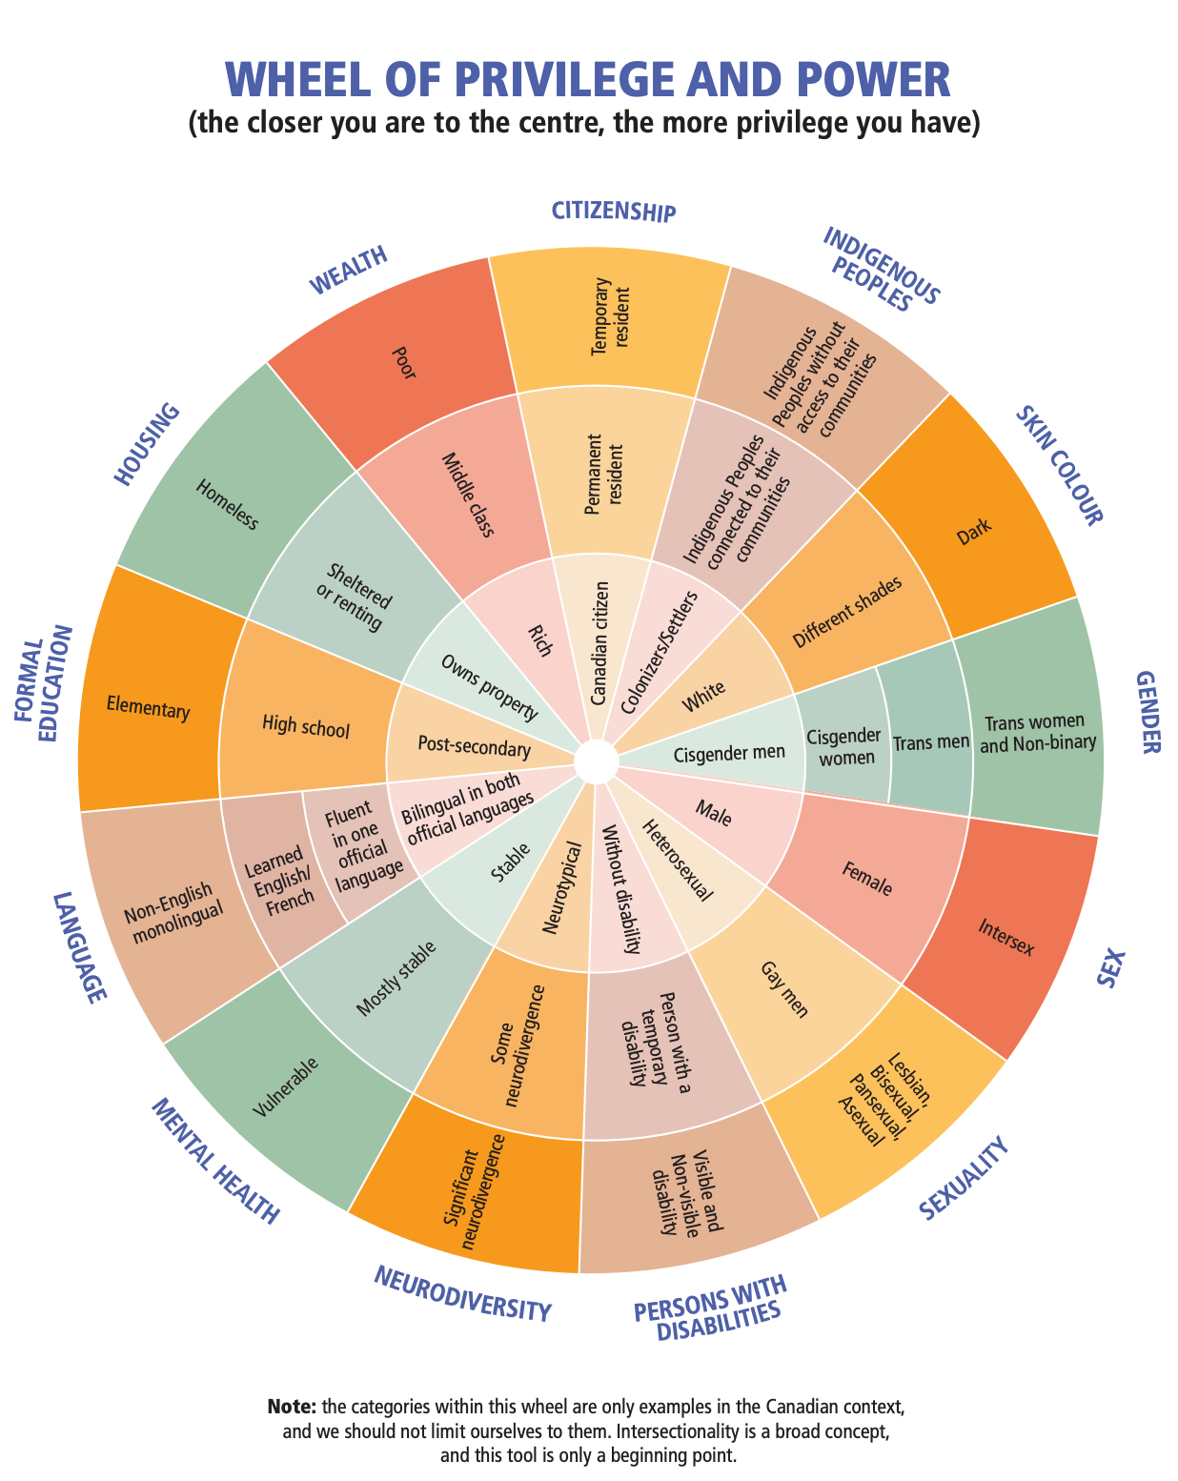
https://www.canada.ca/content/dam/ircc/documents/pdf/english/corporate/anti-racism/wheel-privilege-power.pdf

