2016 Spring Creek Ranch Hand Rodeo Winners
TOP HAND AWARD ~ Hy Wilkinson

CHAMPION TEAM ~ C RANCHES: Jim Filippini, Mike Mori, Luke Lancaster, Quinn Mori
2nd PLACE TEAM ~ JN RANCH: Will Knight, Marshall Smith, Jessica Kelly, Isaiah Jones
3rd PLACE TEAM ~ WALKER RANCH: Ira Walker, Alan Malotte, Gene Curtis, Daxton Jim
​
1st PLACE STEER STOPPER ~ Jessica Kelly
2nd PLACE STEER STOPPER ~ Michelle Rutan
3rd PLACE STEER STOPPER ~ Crystal Kelly

1st PLACE BRONC RIDING ~ Tommy Stowell
2nd PLACE BRONC RIDING ~ Kaysen Sorenson
3rd PLACE BRONC RIDING (4-WAY TIE) ~ Hy Wilkinson, Kyle Marchand, Lane Barton & Mason Lamb
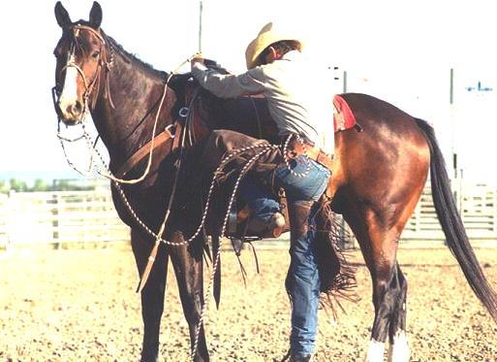

Thank you to everyone who participated in the 31st Annual Ranch Rodeo!
​
TEAMS
Anipro: Doug Rutan - Dennis Rutan - Dusty Easterday - Hy Wilkinson
Blossom Ranch: Myles Blossom - Cole Palfreyman - Mason Lamb - Taylor Lord
Brady Ranch: Preston Pirtle - Dakota Feyder - Clayton Brum - Jake Tervort
C Ranches: Jim Filippini - Luke Lancaster - Michael Mori - Quinn Mori
Gamble Ranch: John Symonds - James Baldwin - Brock Nilsson - Mark Lundy
Gibson Team: Norbert Gibson - Hezy McGarva - Michael Casey - JT Villagrana
Hoots Team: Pook Hoots - Rowley Lisle - Sam Marvel - Jim Young
Jim Ranch: Steven Jim - Dirk Jim - Daxton Jim - Dalton Jim
JN Ranch: Will Knight - Marshall Smith - Jessica Kelly - Isaiah Jones
Junior/Senior: Woody Harney - Jr. Harney - Nate Kelly - Jr. Kelly
Outlaw Natives: Jess Jones - Will Knight - RC Crutcher - Gene Curtis
Walker Ranch: Ira Walker, Alan Malotte, Gene Curtis, Daxton Jim
White Horse Ranch: Crystal Kelly, Tayler Teichert, Taren Hays, Jess Childress
SADDLE BRONC
Bergen Haney - Cole Estill - Daryl Henry - Dustin Borba - Hy Wilkinson - Jr. Harney - Justyn Trujillo Kaysen Sorenson - Koda Bledsoe - Kyle Marchand - Lane Barton - Mason Lamb - Matt Morrison Michael Casey - Rowdy Hutchison - Tommy Stowell - Tucker White
STEER STOPPING
Chanda Sollinger - Crystal Kelly – Dally Goemmer - Jessica Kelly - Jessica Lancaster – Lisa Bertalotto – Maggie Muratore – Michelle Rutan – Payton Feyder – Riata Goemmer – Sarah Barrington – Timmy Lyn DeLong

MINI- BULLS
Gage Schweer - Chandler Green - Payton Schweer - Michael Gibbs

