REGULAR MEETING

JUNE 19, 2025

The Regular Meeting of the Town Board of the Town of Hampton, County of Washington and the State of New York was held at the Town Hall, 2629 State Route 22A, Hampton, New York, on the 19th day of June 2025.

PRESENT: David K. O’Brien------------Supervisor

Donald Sady----------------- Councilman

Tamme Taran----------------Councilwoman

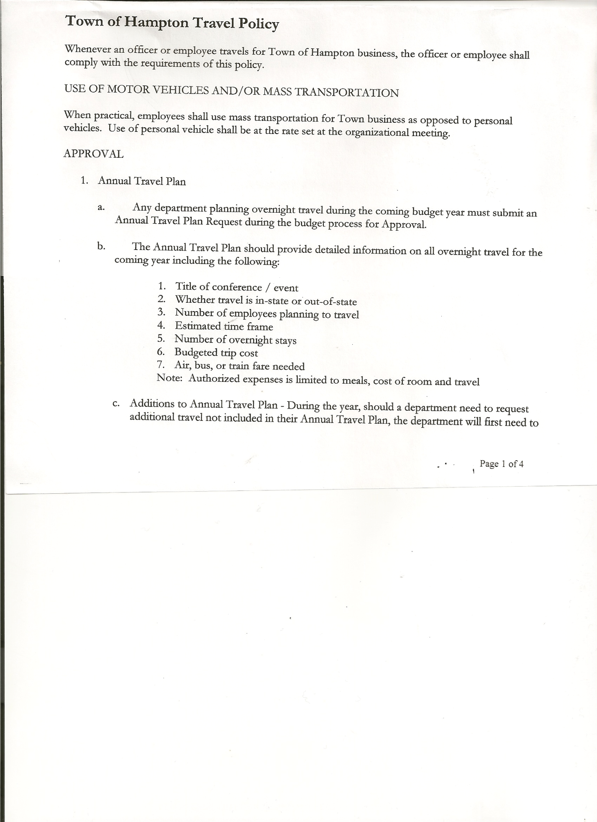 Michael Pietryka------------Councilman

Andrea Kugler---------------Councilwoman - absent

Rebecca Jones---------------Town Clerk

Camilla Shaw----------------Deputy Town Clerk

Tyler McClure---------------Highway Superintendent

Planning Board Member (s):… Bonnie Hawley, Chair, and Matthew Pratt

Others present: EJ Conzola (NYVT Media Reporter), Artie Pratt and Ali & Baby Callum Mitchell

The Regular Meeting was called to order by Supervisor O’Brien at 7:30pm, followed by the Pledge of Allegiance. Location of Fire Exits was given. Quorum of board members present.

**RESOLUTION NO. 53-2025**

**APPROVAL OF THE MINUTES**

On a motion of Councilman Sady, seconded by Councilman Pietryka, the following resolution was ADOPTED: AYES 4 O’Brien, Sady, Taran, Pietryka

NAYS 0

ABSENT 1 Kugler

RESOLVED, the Regular Town Board Meeting Minutes for May 15, 2025 are approved.

**PERMITS/SUBDIVISIONS**

A Lot Line Adjustment from Brad and Ali Mitchell was presented to the Board for consideration.

**RESOLUTION NO. 54-2025**

**MITCHELL-APPROVAL OF THE LOT LINE ADJUSTMENT**

On a motion of Councilman Sady, seconded by Councilwoman Taran, the following resolution was ADOPTED: AYES 4 O’Brien, Sady, Pietryka, Taran

NAYS 0

ABSENT 1 Kugler

RESOLVED, to approve the Mitchell Lot Line Adjustment.

Dog Control Officer….no report

Tax Collection Report….Zero balance. The Town Clerk/Collector had Board Members review and sign bank reconciliation statements for the Tax Collector Account dated May 31st, 2025.

TOWN BOARD MEETING

JUNE 19, 2025 PAGE 2

Bonnie Hawley, Chair Planning Board….Planning Board Meeting was held June 11th, 2025, copy of the minutes is attached. Next meeting will be July 9th, 2025 @7:00 at the Town Hall.

Tyler McClure, Highway Superintendent…submitted his report, copy of which is attached.

**SUPERVISOR’S REPORT/COUNTY UPDATES/COMMUNICATIONS**

**RESOLUTION NO. 55-2025**

**APPROVAL OF THE SUPERVISOR’S MONTHLY REPORT**

On a motion of Councilman Sady, seconded by Councilman Pietryka, the following resolution was ADOPTED: AYES 4 O’Brien, Sady, Taran, Pietryka

NAYS 0

ABSENT 1 Kugler

RESOLVED that, the Supervisor’s Monthlyreport be accepted as submitted for **MAY.**

ACCOUNT 05/01/25 Receipts Disbursed 05/31/25

Citizens Cemetery $ 3,029.34 $ .13 $ .00 $ 3,029.47

Citizens Total $ 3,029.34 $ .13 $ .00 $ 3,029.47

GFNB Fire, Trust & Agency $ 1,000.82 $ 0.00 $  0.00 $ 1,000.82

GFNB Fire, Trust & Agency ICS $ 66,718.00 $ 0.00 $ 0.00 $ 66,718.00

GFNB Health Insurance $ 2,591.23 $ $ $ 2,591.23

GFNB Trust & Agency $ 3,393.02 $ 4,467.29 $ 4,447.19 $ 3,413.12

GFNB General Fund $ 3,957.36 $ 14,485.10 $ 12,635.73 $ 5,806.73

GFNB General Fund ICS $ 68,849.65 $ 6,476.09 $ 8,000.00 $ 67,325.74

GFNB Total $146,510.08 $ 25,428.48 $ 25,082.92 $146,855.64

GFNB Highway Fund $ 9,164.25 $ 28,000.00 $ 24,448.36 $ 12,715.89

GFNB Highway Fund ICS $ 329,163.62 $ 1,073.46 $ 28,000.00 $302,237.08

GFNB Capital Reserve $ 1,005.02 $ 00.00 $ 00.00 $ 1,005.02

GFNB Capital Reserve ICS $ 138,231.75 $ 492.71 $ $138,724.46

GFNB Total $ 477,564.64 $ 29,566.17 $ 52,448.36 $454,682.45

TOTALS $627,104.06 $ 54,994.78 $ 77,531.28 $604,567.56

All Board Members present signed Supervisor’s Report.

**OLD BUSINESS**

Regarding a presentation at the May Town Board Meeting by Dr. Spillane and Dr. Leach (retired Glens Falls Hospital infectious disease Dr.) of the Healthcare Coalition for the North Country District 21, the following resolution was introduced:

**RESOLUTION NO. 56-2025**

MOTION BY: COUNCILMAN MICHAEL PIETRYKA

SECONDED BY: COUNCILWOMAN TAMME TARAN

**RESOLUTION URGING FEDERAL OFFICIALS TO CONSULT WITH HEALTHCARE PRACTITIONERS AND ELECTED OFFICIALS ON THE LOCALIZED EFFECTS OF MEDICAID SPENDING REDUCTIONS, TO EXERCISE CAUTION WHEN CONSIDERING SUCH REUCTIONS, AND TO IMPLDMDNG ONLY THOSE REDUCTIONS THAT ALOW FOR THE PRESERVATION OF A ROBUST HEALTHCARE DELIVERY SYSTEM**

TOWN BOARD MEETING

JUNE 19, 2025 PAGE 3

**WHEREAS,** Medicaid underpins the North Country’s healthcare delivery system and is a lifeline for hundreds of thousands of people in our region, with approximately 28% of our population receiving support from Medicaid and its constituent programs, and

**WHEREAS**, more than 50% of all childbirths in the North Country are paid for by Medicaid, and 34.5% of our children are covered by Medicaid, and

**WHEREAS**, more than 60% of nursing home residents in the North Country are covered by Medicaid, and our region has the second largest percentage of seniors in the nation, and

**WHEREAS**, 16.4% of the North Country’s population is employed by the healthcare sector, which is reliant on Medicaid as a major payor, and

**WHEREAS**, Medicaid provides low-income neighbors, children, pregnant women, and people who are disabled with access to essential healthcare services including doctor and clinic visits, hospital stays, emergency care, prescription drugs, medical supplies and equipment, lab tests,

x-rays. Vision care, dental care, nursing home services, home health services, and transportation to medical appointments, none of which are luxury services, and

**WHEREAS**, $880 billion in funding reductions to Medicaid have been proposed over ten years as part of the current federal fiscal year 2025-26 budget discussions, and

**WHEREAS**, there are many ways these cuts could be implemented, and although the specifics are as yet unknown, reductions of this magnitude relative to the overall size of Medicaid cannot be achieved by eliminating fraud and abuse, and would necessarily have a negative impact on the North Country, and

**WHEREAS**, the probable impacts of cuts of this magnitude include: North Country residents losing coverage, delaying care, being sicker when they do seek care, using emergency rooms more frequently, being hospitalized more frequently, and amassing debts related to medical bills; hospitals, nursing homes, and clinics cutting staff, offering fewer services, and accumulating more unpaid debt; and hospitals, nursing homes, clinics, and other offices and healthcare businesses that are already operating on the margins being forced to close, and

**WHEREAS**, the aforementioned results of large-scale Medicaid reductions would also impact those who do not directly receive Medicaid by: increasing the cost of emergency visits and hospitalizations; reducing healthcare services offered in our region; requiring patients who are not positioned to do so, including pregnant women, to travel much longer distances to get care; rendering thousands of North Country healthcare workers unemployed and unable to spend money supporting our local economy; stifling the growth of the North Country by making the region less attractive to people considering moving here who require adequate healthcare services, and thereby causing home values to drop and tax rates to rise, and

**WHEREAS**, healthcare providers in the North Country are concerned that the above impacts would take tremendous amounts of time and money to recover from, and in many cases, the healthcare resources this region would lose could be gone forever and

**WHEREAS**, a nonpolitical, volunteer coalition of active and retired healthcare professionals, caregivers, business and community leaders, Medicaid recipients, and other concerned citizens concerned about these dangers has formed to educate public officials, the news media, and other

TOWN BOARD MEETING

JUNE 19, 2025 PAGE 4

interested parties about the importance of Medicaid to the North Country and the potentially dangerous impact of irresponsibly cutting Medicaid, and

**WHEREAS,** this “Healthcare Coalition for the North Country” seeks to preserve access to Medicaid for all deserving recipients and preserve vital healthcare resources in our region by encouraging the adoption of sensible and carefully considered public policy, and

**WHEREAS**, the Healthcare Coalition of the North Country seeks to help decisionmakers in Washington achieve these goals, and has asked for this body’s support in doing so, now therefore, be it

**RESOLVED**, that the Town of Hampton hereby recognizes that careless cuts to Medicaid would endanger our local hospitals, nursing homes, and medical practices—in fact, the North Country’s entire healthcare system—and subject our residents to unnecessary pain and suffering and be it further

**RESOLVED**, that the Town of Hampton hereby joins the Healthcare Coalition of the North Country in calling upon Washington decisionmakers to adopt sensible, carefully considered public policy and ensure that attempts to cut Medicaid do not inadvertently gut Medicaid, and be it further

**RESOLVED**, that certified copies of this Resolution be transmitted to Congresswoman Elise Stefanik, Speaker of the House Mike Johnson, Senate Majority Leader John Thune, Office of Management & Budget Director Russell Vought, HHS Secretary Robert F. Kennedy, Jr., the Congressional DOGE Caucus, State Senator Jacob Ashby, State Assembly Member Matthew Simpson, and the Healthcare Coalition for the North Country.

**NEW BUSINESS**

Website redesign…This info was in last months minutes: “Quote received from GoDaddy is $3,080.11 (Includes one-time build fee, unlimited website updates for the year and hosting for the year). Annual Hosting Renewal is: $275.88 starting 4/2026.” Supervisor O’Brien will check for other quotes and discuss at the next meeting. The other quote received is from Blkdog, their cost is $14,230.00, cost proposal is attached. The following resolution was introduced:

**RESOLUTION NO. 57-2025**

**APPROVAL OF THE WEBSITE DESIGN SERVICE**

On a motion of Councilman Pietryka, seconded by Councilwoman Taran, the following resolution was ADOPTED: AYES 4 O’Brien, Sady, Taran, Pietryka

NAYS 0

ABSENT 1 Kugler

RESOLVED, to have GoDaddy do the Website redesign.

Equalization Rate….previously it was 77%. Received notice from NYS Dept. of Taxation & Finance, Office of Real Property Tax Service that are Final State Equalization Rate for the 2025 Assessment Roll is 100%. Arek Gordon, our Sole Assessor, did a great job with the revaluation.

TOWN BOARD MEETING

JUNE 19, 2025 PAGE 5

**RESOLUTION NO. 58-2025**

**APPROVAL TO PREPAY FOR CLEANING OF THE TOWN HALL**

On a motion of Councilman Sady, seconded by Councilman Pietryka, the following resolution was ADOPTED: AYES 4 O’Brien, Sady, Taran, Pietryka

NAYS 0

ABSENT 1 Kugler

RESOLVED, to prepay Geneva Diffee for cleaning the Town Hall, when the date she cleans falls after the regular monthly board meeting.

Pro Housing Community…..Supervisor O’Brien will have resolution for next meeting. Being a Pro Housing Community helps with grants, etc.

**RESOLUTION NO. 59-2025**

**TOWN HALL USE**

On a motion of Councilwoman Taran, seconded by Councilman Sady, the following resolution was ADOPTED: AYES 4 O’Brien, Sady, Pietryka, Taran

NAYS 0

ABSENT 1 Kugler

RESOLVED, to approve the request of Rebecca Jones to use the Town Hall on Saturday, July 12th, 2025 from 4 to 8 pm for Board Game Night.

**RESOLUTION NO. 60-2025**

**AUDIT OF CLAIMS**

On a motion of Councilman Sady, seconded by Councilwoman Taran the following resolution was ADOPTED: AYES 4 O’Brien, Sady, Pietryka, Taran

NAYS 0

ABSENT 1 Kugler

RESOLVED that the bills have been reviewed by the Town Board and are authorized for payment in the following amounts.

General Fund No. 63 through No. 76 $ 4,513.14

Highway Fund No. 68 through No. 89 $ 28,089.81

Total both funds $ 32,602.95

The Town Clerk’s report for May 2025 was submitted to the Board. The Town Clerk had Board Members review and sign bank reconciliation statements for the Town Clerk Account and Special Town Clerk Account dated May 31, 2025.

**RESOLUTION NO. 61-2025**

**MEETING ADJOURNED**

On a motion of Councilman Sady, seconded by Councilwoman Taran the following resolution was ADOPTED: AYES 4 O’Brien, Sady, Taran, Pietryka,

NAYS 0

ABSENT 1 Kugler

RESOLVED that the meeting adjourned at 8:23pm.

Respectfully submitted,

Rebecca S. Jones, RMC

Town Clerk