**Lab 2 Protocol  
Part 1:Determination of Concentration Using Spectrophotometry  
Part 2:Serial Dilutions  
  
Determination of Concentration Using Spectrophotometry**A **solution** is a homogeneous mixture consisting of a **solute** (a solid, liquid or gas) dissolved in a **solvent** (a solid, liquid, or gas). In biological systems, the solvent is *usually* water. The blood in our veins, the sap in a tree, the extracellular fluid that bathes all cells, and the cytoplasm that fills each cell are all solutions.

The *amount of solute* dissolved in a given volume of solvent = the **concentration** of that solution. A strong or concentrated solution has more solute per given volume of solvent than a weak or dilute solution. There are many different ways to express solution concentration. It may be expressed as a percentage of solute per volume, as mass per volume (for example, grams per milliliter, or g/mL) or as a molarity (moles/liter).

There are many different methods used to determine solute concentration. We will focus on a method that is useful for solutes that contain pigment (have color). Pigments are substances that absorb light. If the solute is a pigment, solutions with high solute concentration will be visibly darker than solutions with low solute concentrations. In order to quantify the degree of darkness (which corresponds to concentration), we will use a method to measure the amount of light absorbed by the pigment. We will see that more concentrated solutions will absorb more light than dilute ones.

Visible light is a type of **electromagnetic energy**. Electromagnetic energy travels in the form of waves. Electromagnetic waves are measured from crest to crest in nanometers (nm), and this distance is called the **wavelength**. The pic below shows a wave of electromagnetic energy with a wavelength of 500 nm.



The wavelengths of visible light waves are between 380 and 750 nm. All of these waves *combined* produce what appears to our eyes as white light. However, individual wavelengths have particular colors. For example, light waves between 380 and 450 nm in wavelength are violet, and light waves between 620 – 750 nm in length are red. You can see all of the colors when you pass light through a prism, which separates the wavelengths. A rainbow is produced in the sky when rain droplets serve as tiny prisms to separate white light into its component colors. 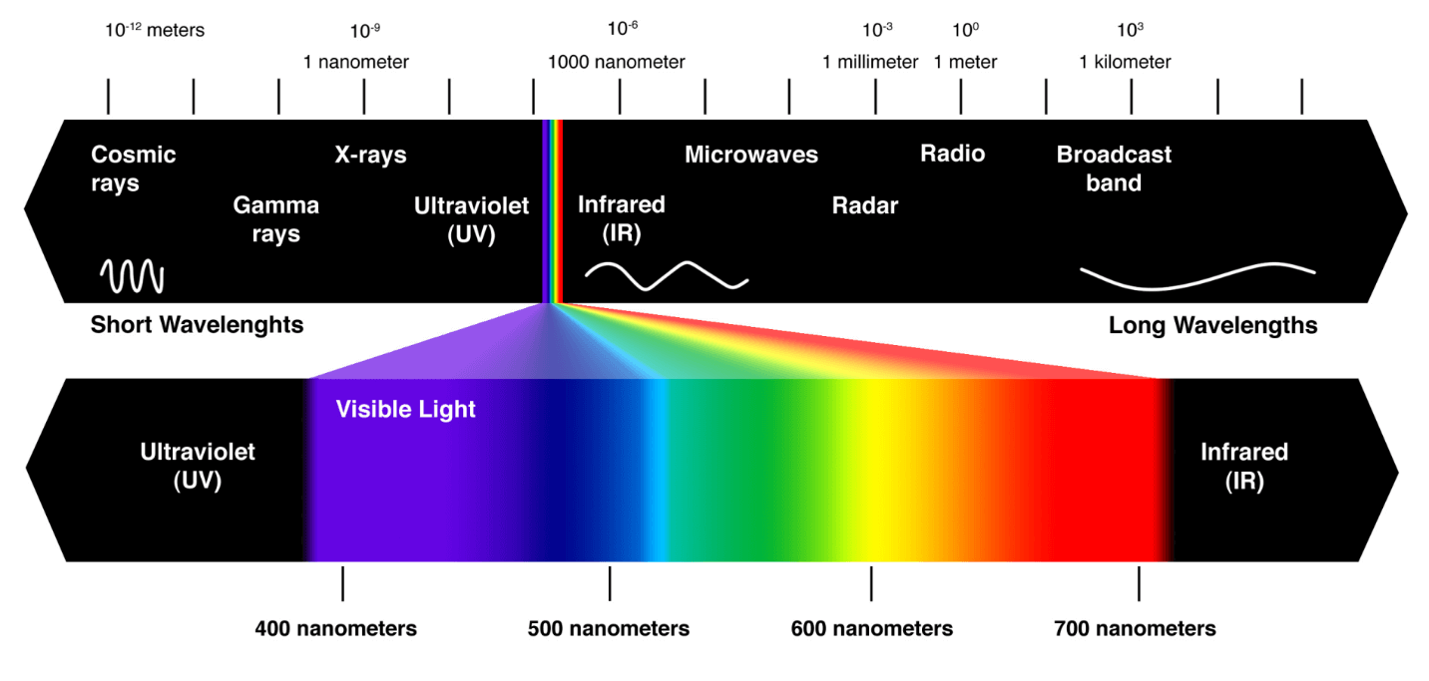  
 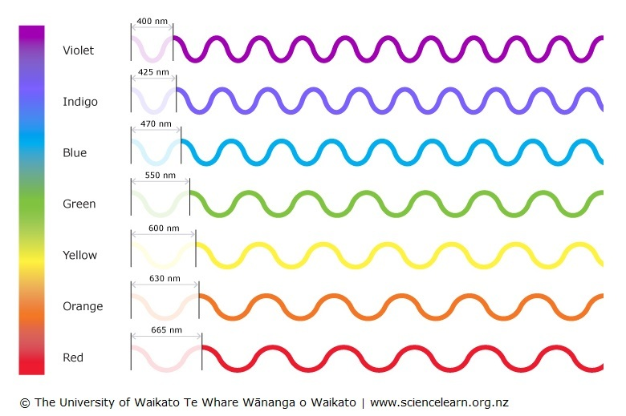  
  
  
How the wavelengths of light interact with pigments determines how we see color. Different wavelengths of light can be either **absorbed**, **transmitted** (passing straight thorough), or **reflected** (bouncing off) by pigments. If all of the wavelengths of light combined (all colors) are absorbed by a pigment, it appears black to our eyes. In contrast, if all of the wavelengths of light combined are reflected by a pigment, it appears white to our eyes. If you observe that an object is red, that is because the red wavelengths of light are being reflected by the pigments in that object back to your eyes. That means that the wavelengths of light *other* than red are either being absorbed or transmitted by the pigments in the object.

In this lab, you will be determining the amount of light (wavelength 500 nm) that is absorbed by several different concentrations of red Kool-aid. The more concentrated the pigment solution is, the more light it can absorb. We will accurately measure the amount of light absorbed by each solution with a device called a **spectrophotometer**. A spectrophotometer (“spec” for short) is a device that shines light, set to a specific wavelength, through a sample solution. The light shines through the sample and hits a detector on the other side. The detector reads how much of the light was absorbed by the sample solution. The figure below illustrates how a spectrophotometer works.  
  
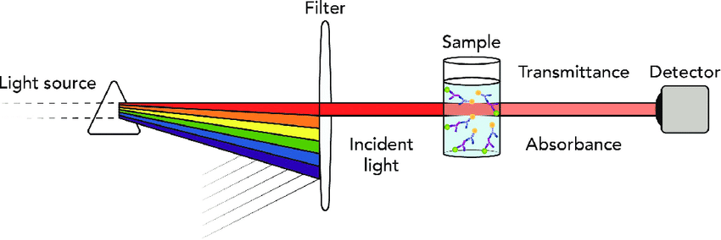

**Exercise 1: making Serial dilutions and calculating the   
 concentrations of Kool-aid solutions**

In this exercise, you will carry out **serial dilution** of Kool-aid according to the procedure and the diagram below. In a serial dilution, an initial solution is made and used to make a second solution. Then the second solution is used to make a third solution, and so on.  
First, let’s look at how to make a particular solutions…  
Example:  
*2 g of Kool aid added to 100 mL of water to the flask, the percent concentration of the solution measured g/mL would = a 2% Kool aid solution.  
*0.2 g of Kool aid added to 10 mL of water to the flask would also = a 2% Kool aid solution.  
 a. Are the two solutions the same? _____

b. Following the example above, how many grams of Kool aid do you need to make a 20% solution in 100mL water? _____g  
c. Following the example above, how many grams of Kool aid do you need to make a 20% solution in 200mL water? _____g

Protocol:  
1. Place a small square of wax weighing paper on the digital balance and press the button labeled “tare” or “auto-zero”.

2. Use a metal spatula to weigh 500 mg (= ½ gram or 0.50 g) of cherry Kool-Aid.

3. Transfer the Kool-Aid to a beaker and add 100mL water. Stir with a glass rod until all of the solute dissolves. This is solution A.

4. Label 4 test tubes B, C, D, and E.

5. Use a 10 mL pipette and a green pipette pump to add the correct volume of water to each of the four tubes as listed below and on the diagram:

Test tube B: 8 mL

Test tube C: 5 mL

Test tube D: 5 mL

Test tube E: 6 mL

6. Solution B will be prepared by diluting a portion of solution A. To do this, measure 2mL of solution A and transfer to tube B which should already contain 8mL of water. Mix by pipetting up and down.

7. Draw 5 mL from tube B and add to the 5 mL of water in tube C. Mix as before. Draw 5 mL from tube C and add to the 5 mL of water in tube D. Mix as before.

8. Finally, draw 4 mL from tube D and add to the 6 mL of water in tube E.   
Mix as before.   
See the pic below for a visual reference…

100 mL water

+

500 mg Kool-aid

Solution A

Solution B

Solution C

Solution D

Solution E

8 mL water

+

2 mL of Solution A

5 mL water

+

5 mL of Solution B

5 mL water

+

5 mL of Solution C

6 mL water

+

4 mL of Solution D

Now you will calculate the concentration of each solution you have made in units of **mg/mL.** First, calculate the concentration of solution A:

Concentration of solution A:  
500 mg of solute (remember 500mg = 0.5g) dissolved in 100 mL of water  
 = __________mg/ml

Because we are not sure exactly how many mg of Kool-aid has been added to solutions B, C, D, and E, we must use a different method to calculate their concentrations. To calculate the concentration of a solution that has been made from another solution, as in serial dilutions, you can use the following equation.

**C1V1=C2V2**

Where:

**C1** is the concentration of the first solution you are using to make the second (new) solution,

**V1** is the volume you add of the first solution to make the second (new) solution,

**C2** is the final concentration of the second (new) solution, and

**V2** is the final volume of the second (new) solution.

We will typically be trying to calculate the value for C2, so we can rearrange the above equation to solve for C2 and calculate the concentration of each solution using the equation:

**C2 = C1 V1**

**V2**

Remember that the identity of C1, V1 and C2 changes with each step!

**Recall your start point…c**oncentration of solution A = _____ mg/mL  
Record the concentrations in mg/ml of solution B through E on the table on the next page.  
 **Exercise 2: Measuring Absorbance at 500 nanometers (nm)**

The pigment in Kool-aid absorbs light at 500 nanometers (nm). Therefore, you will be measuring the absorbance of your samples with the wavelength set at 500 nm on the spectrophotometer. Check to be certain the spectrophotometer is set for the correct wavelength and for absorbance (not transmittance).

**Protocol:**1. Follow the directions I’ll provide to set the blank (water) to zero absorbance on the spec.  
2. Read the absorbance of samples B through E, (**not solution A**) **starting with the most dilute first** (E). Record each absorbance value.

3. Pour all wastes in the beaker provided.

4. Measure the absorbance of the Kool-aid sample labeled “UNKNOWN” and record below:  
**Absorbance of the unknown Kool-aid sample: ______**

**Complete the table below:**

|  |  |  |  |  |  |
| --- | --- | --- | --- | --- | --- |
| Identity of Solution | Volume and identity of Kool-aid added (V1) | Volume of water | Total volume of solution  (V2) | Concentration  (mg/mL) | Absorbance |
| Solution B | 2 mL of A | 8 mL | 10 mL |  |  |
| Solution C | 5 mL of B | 5 mL | 10 mL |  |  |
| Solution D | 5 mL of C | 5 mL | 10 mL |  |  |
| Solution E | 4 mL of D | 6 mL | 10 mL |  |  |

**Exercise 3. Graphing the relationship between concentration and absorbance and using it to determine an unknown sample concentration**

Now that you have measured the absorbance for solutions B - E, you will graph your data. Your graph will show the mathematical relationship between concentration and absorbance for Kool-Aid. To create the graph, use the following procedure.

1. Using the graph paper provided.   
2. Label the X-axis “Concentration in mg/mL.”   
3. Number the X-axis from 0 – 1 mg/mL using the lines to represent  
 0.1 mg/mL intervals.  
4. Label the Y-axis “Absorbance.”  
5. Number the Y-axis from 0 – 1, using the lines to represent 0.1 intervals.  
6. Plot and label the values from the above table.   
 The “Concentration” and “Absorbance” columns are your X and Y   
 values for each plotted point, respectively.  
7. Once each point is placed on the graph, use a ruler to draw a straight   
 slope line that is the best fit with most of the points. This line does not   
 have to be exact but just gives you a rough estimate of the linear relationship between concentration (the independent variable) and absorbance of Kool-Aid solutions (the dependent variable). This is called a **standard curve**.

When the linear relationship between concentration and absorbance (the standard curve) is known, **determination of an unknown concentration, when the absorbance is known, can be done in two ways:** **visually or mathematically.**

**Visual determination**

To visually determine the concentration of an unknown, locate its absorbance value on the Y-axis of the graph and draw a horizontal line to intersect your best-fit line. Then draw a vertical line downward from that intersection to the X-axis. Where this vertical line hits the X-axis is the value of X, or the concentration of the unknown solution.   
  
  
 **An example is shown below:.**

**Visual determination of the concentration  
 of an unknown solution**.

Use the visual method to determine the concentration of your unknown sample.  
**Concentration of the unknown Kool-aid sample = ______mg/ml**

**Mathematical determination**

Determine the slope of your line by first selecting 2 points on your best-fit line. These points should be spaced well apart and CANNOT be data points that you have already plotted. Then, calculate the slope (m) of the line by using the following the equation:  
  
m = y2 - y1 m = _______________  
 ______  
 x2 - x1  
Using the equation for a straight line **y = mx + b**, you can determine the concentration or absorbance of any Kool-Aid solution, even beyond the limits of your graph.

y = absorbance

m = slope

x = concentration

b = y intercept (zero in this case, because pure water of 0 mg/mL concentration has zero absorbance)

Use the equation for a straight line to calculate the concentration of your unknown sample:  
**Concentration of the unknown Kool-aid sample: _____mg/ml**

Using the equation for a straight line and your slope value, **determine**:  
1) the *absorbance* you would expect from a solution with a concentration of 46 mg/ml.   
answer =____________

2) the *concentration* of a solution with an absorbance of 2.10.  
answer = __________mg/ml

**Why do we care about concentrations and spectrophotometry?**

In biological systems, the maintenance of certain solution concentrations is critical. The oxygen (O2) concentration in the blood is an example of this. The blood oxygen concentration of a patient undergoing surgery is continuously measured by a device called a Pulse-Ox monitor. Oxygen is transported through the blood bound to a protein called hemoglobin. This protein is red when oxygen is bound to it and a slightly different color in its deoxygenated form. The monitor measures the amount of red, oxygenated hemoglobin. This measurement is done using a variation of spectrophotometry.

The measurement of glucose concentration in blood or “blood sugar” is done using spectrophotometry. A diabetic patient places a drop of blood on a sample strip containing an enzyme. The enzyme reacts with the glucose in the blood, producing a colored product that is then measured in a home spec. These instruments are mini specs called blood sugar monitors.