Saturday & Sunday, November 1 / 2, 2025
All Saints Day
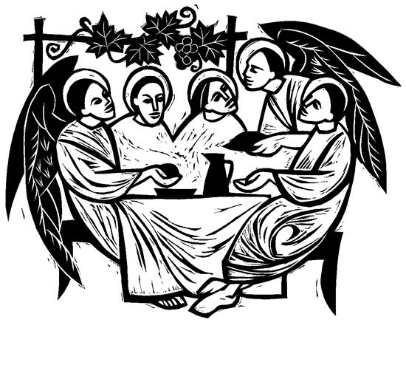
Christ Lutheran Church
“A Place Where You are Always Welcome”
Services: Saturday 5:30 pm and Sunday 10:00 am
Sunday School: 9:00 am (September- May)
600 North Main Street, Stockton, IL 61085 Office: 815-947-2033
Email: christlutheranchurch70@gmail.com http://www.christlutheranstockton.com
Ministers: ALL members of the congregation
Pastor: Rev. Chrissy Salser chrissytherev@att.net 815-988-9450
From Sundays and Seasons.com. Copyright 2017 Augsburg Fortress. All rights reserved. Reprinted by permission under Augsburg Fortress Liturgies Annual License #40643.New Revised Standard Version Bible, copyright 1989, Division of Christian Education of the National Council of the Churches of Christ in the United States of America. Used by permission. All rights reserved.
WELCOME: Thank you for joining us for worship today. We are glad you are with us. Communion will be served in the aisle or in your pew. All are welcome to share this meal. Jesus is our host and invites everyone. Those who would like to come forward, bread and wine will also be available in the front. When directed by the usher, come forward down the center aisle, Pr Chrissy will give you bread (she will be masked and wearing cloves) and then you will take a cup of wine (grape juice) from the tray. After taking communion, you will return to your seat by the side aisle. For those who are unable to come forward, communion elements can be found as you entered worship. At that part of the service, you are invited to take the bread and wine (or grape juice) when Pr. Chrissy leads. On Saturday’s offering is collected as you enter or leave worship. On Sunday we will pass the plate as a response to God’s grace. Online giving is available. Please see QR code on back of bulletin or visit our website.

Introduction: In holy baptism God makes saints out of sinners. In holy communion God forgives the sins of all the saints. In worship today we give thanks for all the saints “who from their labors rest.” In the same breath we petition our God for the strength to hear and to heed the admonitions of Jesus in today’s gospel. Sealed by the Spirit and sustained by the Savior’s body and blood, we live with joy as God gives us breath, to the praise of God’s glory.

Gathering: The Holy Spirit calls us together as the people of God.
PRELUDE
WELCOME AND ANNOUNCEMENTS
Call to worship Please stand.
P: We remember, O God,
C: the countless saints of history who have blazed a trail of courage through time.
P: We remember, O God,
C: the tender touch of loved ones, the examples of heroes, the healing words of comforters, the remarkable acts of fearless ones.
P: We remember, O God,
C: the gentle strength of grandmothers, the loyalty of friends, the kindness of strangers, the joy of children, the sacrifice of parents.
P: We remember, O God,
C: the love of Jesus, the blessing of his Spirit, the reminder of his words, the sharing of his suffering, the glory of his resurrection shown forth in the lives of his disciples, young and old, dead and living, articulate and silent, strange and familiar, brilliant and ordinary.
P: We remember in every time and place the saints of God who have shown us the Lord.
C: Since we are surrounded by so great a cloud of witnesses…let us worship God with joy!
GATHERING HYMN Welcome Table ACS 969
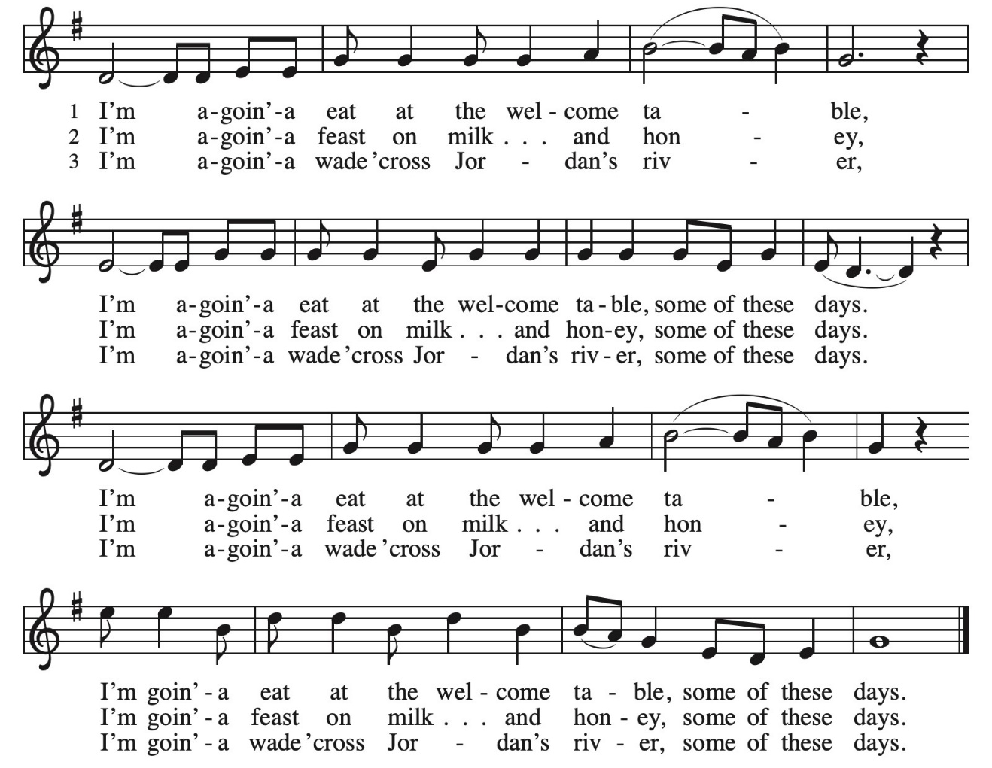

Greeting:
P: The grace of our Lord Jesus Christ, the love of God, and the communion of the Holy Spirit be with you all. C. And also, with you.
PRAYER OF THE DAY:
P: Almighty God, C: you have knit your people together in one communion in the mystical body of your Son, Jesus Christ our Lord. Grant us grace to follow your blessed saints in lives of faith and commitment, and to know the inexpressible joys you have prepared for those who love you, through Jesus Christ, our Savior and Lord, who lives and reigns with you and the Holy Spirit, one God, now and forever. Amen.

Word: God speaks to us in scripture reading, preaching, and song.
First Reading: Jeremiah 7:1-3, 15-18
The book of Daniel was written in the second century BCE, when the Syrian king Antiochus Epiphanes was severely persecuting the Jews. Daniel’s vision of the four beasts proclaims that human kings will come and go, but the kingdom will ultimately belong to God and to God’s people.
¹ In the first year of King Belshazzar of Babylon, Daniel had a dream and visions of his head as he lay in bed. Then he wrote down the dream: ² I, Daniel, saw in my vision by night the four winds of heaven stirring up the great sea, ³ and four great beasts came up out of the sea, different from one another.
¹⁵ As for me, Daniel, my spirit was troubled within me, and the visions of my head terrified me. ¹⁶ I approached one of the attendants to ask him the truth concerning all this. So he said that he would disclose to me the interpretation of the matter: ¹⁷ “As for these four great beasts, four kings shall arise out of the earth. ¹⁸ But the holy ones of the Most High shall receive the kingdom and possess the kingdom forever—forever and ever.” R: The Word of the Lord. C: Thanks be to God.

Psalm: Psalm 149
¹ Hallelujah! Sing to the Lord a new song, God’s praise in the assembly of the faithful.
² Let Israel rejoice in their maker; let the children of Zion be joyful in their ruler.
³ Let them praise their maker’s name with dancing; let them sing praise with tambourine and harp.
⁴ For the Lord takes pleasure in the people and adorns the poor with victory.
⁵ Let the faithful rejoice in triumph; let them sing for joy on their beds.
⁶ Let the praises of God be in their throat and a two-edged sword in their hand,
⁷ to wreak vengeance on the nations and punishment on the peoples,
⁸ to bind their kings in chains and their nobles with links of iron,
⁹ to inflict on them the judgment decreed;
Second Reading: Ephesians 1:11-23
After giving thanks for the faith of the Ephesians, the writer of this letter prays that they might understand the wisdom, hope, and power of God that is embodied in Jesus Christ.
¹¹ In Christ we have also obtained an inheritance, having been destined according to the purpose of him who accomplishes all things according to his counsel and will, ¹² so that we, who were the first to set our hope on Christ, might live for the praise of his glory. ¹³ In him you also, when you had heard the word of truth, the gospel of your salvation, and had believed in him, were marked with the seal of the promised Holy Spirit; ¹⁴ this is the pledge of our inheritance toward redemption as God’s own people, to the praise of his glory.
¹⁵ I have heard of your faith in the Lord Jesus and your love toward all the saints, and for this reason ¹⁶ I do not cease to give thanks for you as I remember you in my prayers, ¹⁷ that the God of our Lord Jesus Christ, the Father of glory, may give you a spirit of wisdom and revelation as you come to know him, ¹⁸ so that, with the eyes of your heart enlightened, you may perceive what is the hope to which he has called you, what are the riches of his glorious inheritance among the saints, ¹⁹ and what is the immeasurable greatness of his power for us who believe, according to the working of his great power. ²⁰ God put this power to work in Christ when he raised him from the dead and seated him at his right hand in the heavenly places, ²¹ far above all rule and authority and power and dominion and above every name that is named, not only in this age but also in the age to come. ²² And he has put all things under his feet and has made him the head over all things for the church, ²³ which is his body, the fullness of him who fills all in all.
R: The Word of the Lord. C: Thanks be to God.
GOSPEL ACCLAMATION Listen God is Calling ELW 513
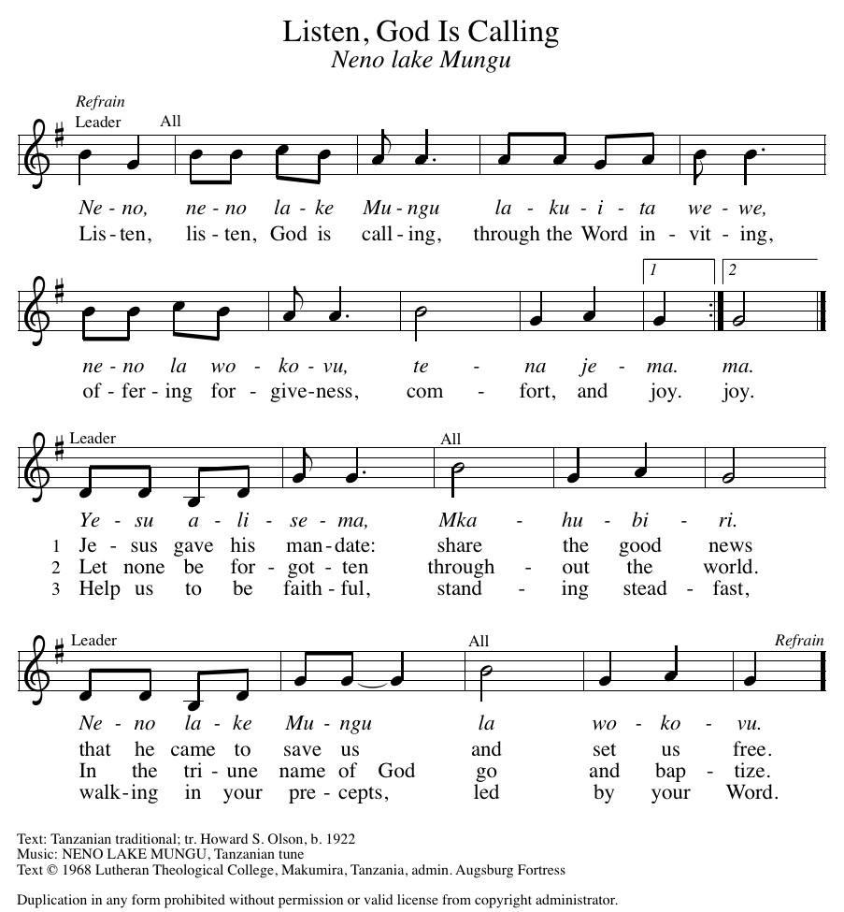

Gospel: Luke 6:20-31

P: The Gospel according to Luke C: Glory to you, O Lord
In echoes of the prophet Isaiah and Mary’s song of praise, Jesus reveals surprising things about who enjoys blessing and who endures woe. He invites his disciples to shower radical love, blessing, forgiveness, generosity, and trust even on enemies and outsiders.
²⁰ Then [Jesus] looked up at his disciples and said: “Blessed are you who are poor,
for yours is the kingdom of God. ²¹ “Blessed are you who are hungry now,
for you will be filled. “Blessed are you who weep now, for you will laugh.

²² “Blessed are you when people hate you and when they exclude you, revile you, and defame you on account of the Son of Man. ²³ Rejoice on that day and leap for joy, for surely your reward is great in heaven, for that is how their ancestors treated the prophets. ²⁴ “But woe to you who are rich, for you have received your consolation. ²⁵ “Woe to you who are full now, for you will be hungry. “Woe to you who are laughing now, for you will mourn and weep. ²⁶ “Woe to you when all speak well of you, for that is how their ancestors treated the false prophets.
²⁷ “But I say to you who are listening: Love your enemies; do good to those who hate you; ²⁸ bless those who curse you; pray for those who mistreat you. ²⁹ If anyone strikes you on the cheek, offer the other also, and from anyone who takes away your coat do not withhold even your shirt. ³⁰ Give to everyone who asks of you, and if anyone takes away what is yours, do not ask for it back again. ³¹ Do to others as you would have them do to you.”
P: The Gospel of Our Lord. C. Praise to you, O Christ.

CHILDREN’S MESSAGE
MESSAGE
HYMN OF THE DAY Shall We Gather at the River ELW 423 (next page)

NICENE CREED:
We believe in one God, the Father, the Almighty, maker of heaven and earth, of all that is, seen and unseen.
We believe in one Lord, Jesus Christ, the only Son of God, eternally begotten of the Father, God from God, Light from Light, true God from true God, begotten, not made, of one Being with the Father. Through him all things were made. For us and for our salvation, he came down from heaven; was incarnate of the Holy Spirit and the virgin Mary and became truly human. For our sake, he was crucified under Pontius Pilate; he suffered death and was buried. On the third day, he rose again in accordance with the Scriptures; he ascended into heaven and is seated at the right hand of the Father. He will come again in glory to judge the living and the dead, and his kingdom will have no end. We believe in the Holy Spirit, the Lord, the giver of life, who proceeds from the Father and the Son. Who with the Father and the Son is worshiped and glorified. Who has spoken through the prophets.
We believe in one holy catholic and apostolic Church. We acknowledge one baptism for the forgiveness of sins. We look for the resurrection of the dead, and the life of the world to come. Amen.

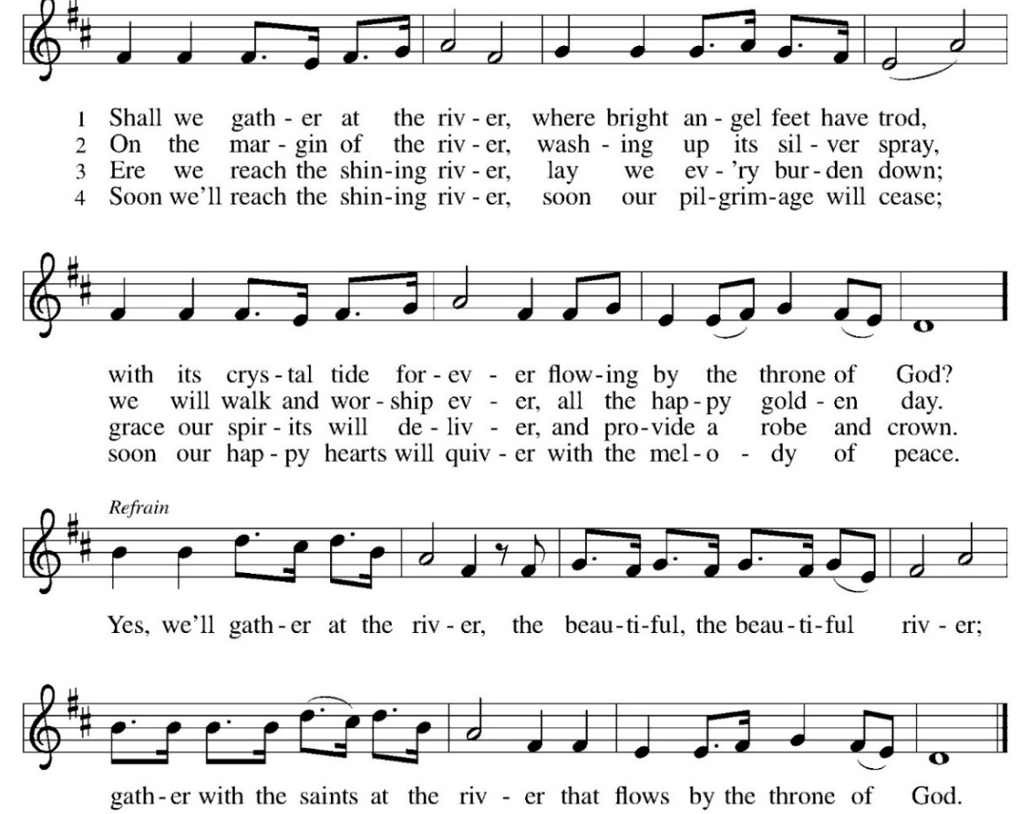
PRAYERS OF INTERCESSION:
P. Merciful God, C. Receive our prayer.
REMEMBERANCE OF SAINTS
P: Gracious God, you are to be praised for the faithful people who witness to your love in every generation.
C: Mindful of all who have gone ahead of us, help us to follow their example:
P: Let us clearly and publicly call ourselves children of God, confessing ourselves to be both saint and sinner,
C: Saved and called, not by our own deserving, but by your mercy and grace in Jesus Christ our Lord.
P: Living God, you are the strength of those who mourn, you are the rest of the blessed dead. We rejoice in the company of all the saints. Let us give thanks for these brothers and sisters whom God has granted rest from their labors- all those servants whom we remember today.
Reading of Names (bell rings as name is read)
family is invited to light a candle after name is read

Brock Alan Kappes Terry Lee Cesli Vaccaro
Aleta Mae Lawfer Ronald Aurand Sue Conkling
Jean Marie Tesmer Larry Olthoff Karen Sue Fuller

P: Grant us grace to follow Christ as they did. Bring us with them as those things no eye has seen, nor ear heard, which you have proposed for those who love you.
C: Give us faith to look beyond touch and sight and seeing that we are surrounded by so great a cloud of witnesses, enable us to run with perseverance the race that is set before us, looking to Jesus, the author and finisher of our faith.
P: Bring us at last to your eternal peace, through Jesus Christ, our Lord.
C: Amen.

PEACE
P: The peace of Christ be with you always. C. And also with you.
OFFERING: Our offering is a significant act of worship; we worship God through our giving. The ministry of this congregation is completely dependent upon your partnership and generosity. Offering is collected as you enter worship on Saturday. We will pass the offering plate on Sundays. Online giving is available.
OFFERING HYMN: Take, oh, Take Me as I Am ELW 814
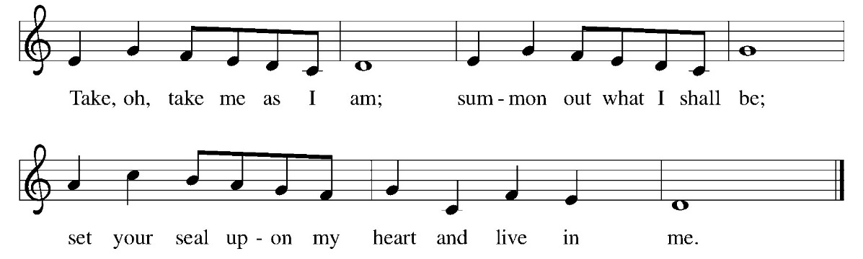

OFFERING PRAYER:
P: God of healing and hope,
C: you bless those who are hungry, promising to fill them with good things. Fulfill that promise through us and these your gifts. Nourish us with the abundance of your feast and unite us into the blessed body of Jesus Christ our Savior, now and forever. Amen.
COMMUNION LITURGY:
In the night in which he was betrayed, our Lord Jesus took bread, and gave thanks, broke it and gave it to his disciples, saying: take and eat; this is my body, given for you. Do this for the remembrance of me. Again, after supper, he took the cup, gave thanks and gave it for all the drink, saying: this cup is the new covenant in my blood, shed for you and for all people for the forgiveness of sin. Do this for the remembrance of me.
THE LORD’S PRAYER:
Our Father, who art in heaven, hallowed be thy name, thy kingdom come, thy will be done on earth as it is in heaven. Give us this day our daily bread; and forgive us our trespasses, as we forgive those who trespass against us; and lead us not into temptation but deliver us from evil. For thine is the kingdom, and power, and the glory, forever and ever. Amen
INVITATION TO COMMUNION:
P: There is a place for you at the table of God. Come, receive the food that does not perish, a taste of life eternal.
Please come down the center aisle, take the bread, then receive a cup (wine is dark, juice is light, return to your seats via side aisle.) Those who prefer to take communion in your pews, we will take all together after all are served.
DISTRIBUTION OF COMMUNION:
P: This is the body of Christ given for you. (All take bread).
P: This is the blood of Christ shed for you. (All take the wine).

COMMUNION HYMN: Rock of Ages ELW 623 (Next page)
TABLE BLESSING:
P: May the body and blood of our Lord Jesus Christ strengthen you and keep you in His grace. C: Amen.
PRAYER AFTER COMMUNION:
P: O God, C: through this meal you have strengthened us and appointed us to be your servants. Send us to do good and to share our possessions with all in need. We ask this in Jesus’ name. Amen
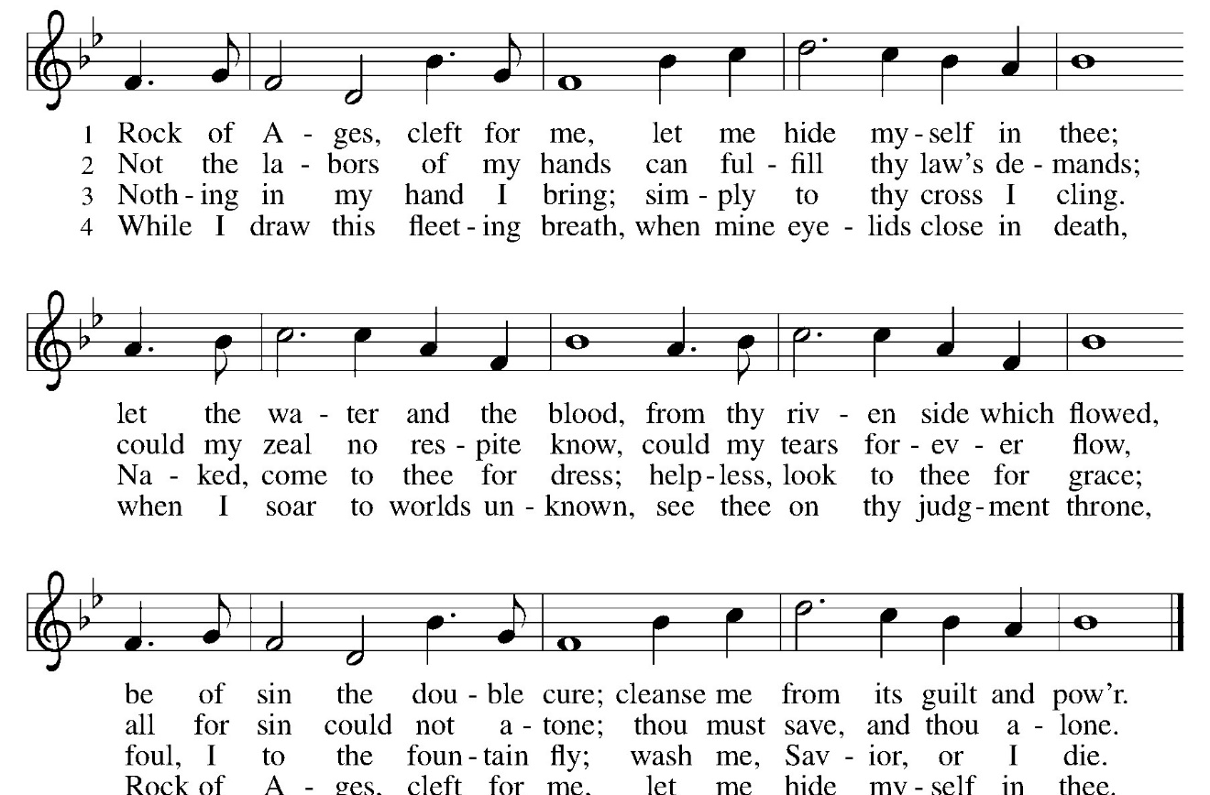

SENDING: God blesses us and sends us in mission to the world.
BLESSING:
P: The God of righteousness, who gives justice to the oppressed, who gives food to the hungry, who sets the prisoners free, ☩ bless you now and forever. C: Amen.
SENDING HYMN Oh When the Saints Come Marching In ACS 950 (next page)
DISMISSAL:
P: Go in peace. Do not lose heart.
C: Thanks be to God.
POSTLUDE
IN OUR PRAYERS TODAY: Teresa Hesselbacher, Elaine Schlicting, Darlene and Walt Steffes, Bob Schreck, Delores Wampfler, Marge and Gerald Arnold, Don & Judy Brudi, Diego Gonzalez, Grayson Raab, James Dieter, Christine Happ, Kay Hesselbacher, Mary Lou Bunker, Lillian Sefford, Jeff Encheff, Judy Wilson, Russ Synder, Don Kunz, Johnny Blair, Jim Sullivan, Sally Duran Salser, Darrell Lindstrom To add someone to the prayer list please contact Pastor Chrissy
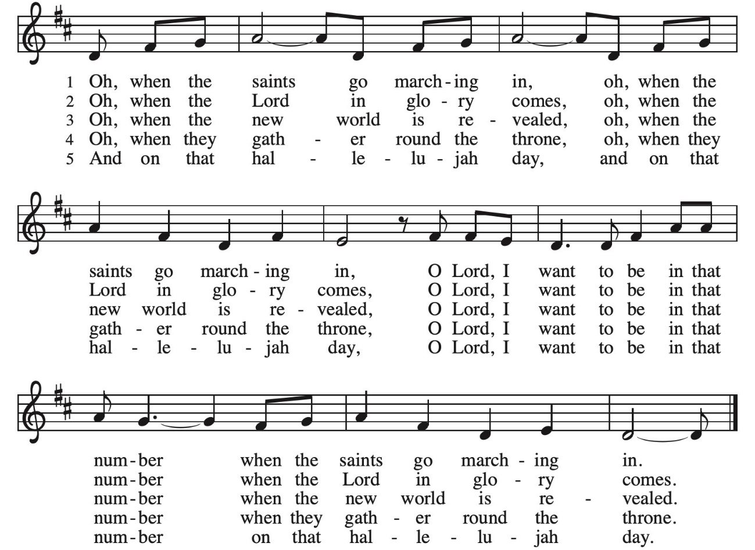

CELEBRATING BIRTHDAYS / ANNIVERSARIES: Deb Jordan, Shirley Toepfer, Travis VenHuizen, Trent VenHuizen, Shay Wright, Tristin Tucker, Allison Kehl, Mark and Patricia Rice
Thanks be to God for your gifts for the ministry of  Christ Lutheran Church *these numbers do not reflect online giving- only offering in worship |  |  |  | Offering/ Attendance  Sat Oct 25  Sunday Oct 26
Current Expense | $1,500.00 | Sunday School | $20.00 | Oct 25 | 17
Benevolence  Building Fund | $10.00  $10.00 |  |  | Oct 26  Sunday School | 42  35
 |  | Total
  $1,540.00

SeptemberTotals: As a way to improve communication around finances, we are sharing the following information: *these numbers reflect online giving contribution
2025
 | September | Year to date
Offerings: | $10,542 | $89,968
Expenses: | $10.168 | $93,340
Overall Gain / Loss | $375 | ($3,871)

AMAZON WISH LIST: did you know that everyday items used at the church are items you could contribute? Find our list here or on our Facebook page. Thank you! https://www.amazon.com/hz/wishlist/ls/TWP5U0RAGGAY?ref_=wl_share

Upcoming Events

- November 1st 5:30 All Saints Worship
- November 2nd 9 am Sunday School
- November 2nd 10 am All Saints Day Worship
- November 4- 11:30 am Community Table
- November 5- 9 am Bible Study
- November 6- NISynod Boundaries Training for Pastors at Christ
- November 8/9 Stewardship Weekend
- November 9- 8:30 am Confirmation Class
- November 12- 1 pm Naomi Circle
- November 13- 9 am Rebecca Circle
- November 15- 8 am Breaking Bread at Copper Leaf Cafe
- November 15/16 WELCA Thank offering
- November 17-25 Operation Christmas Shoe Box Drop off
- November 21-22 Confirmation Retreat at LOMC

