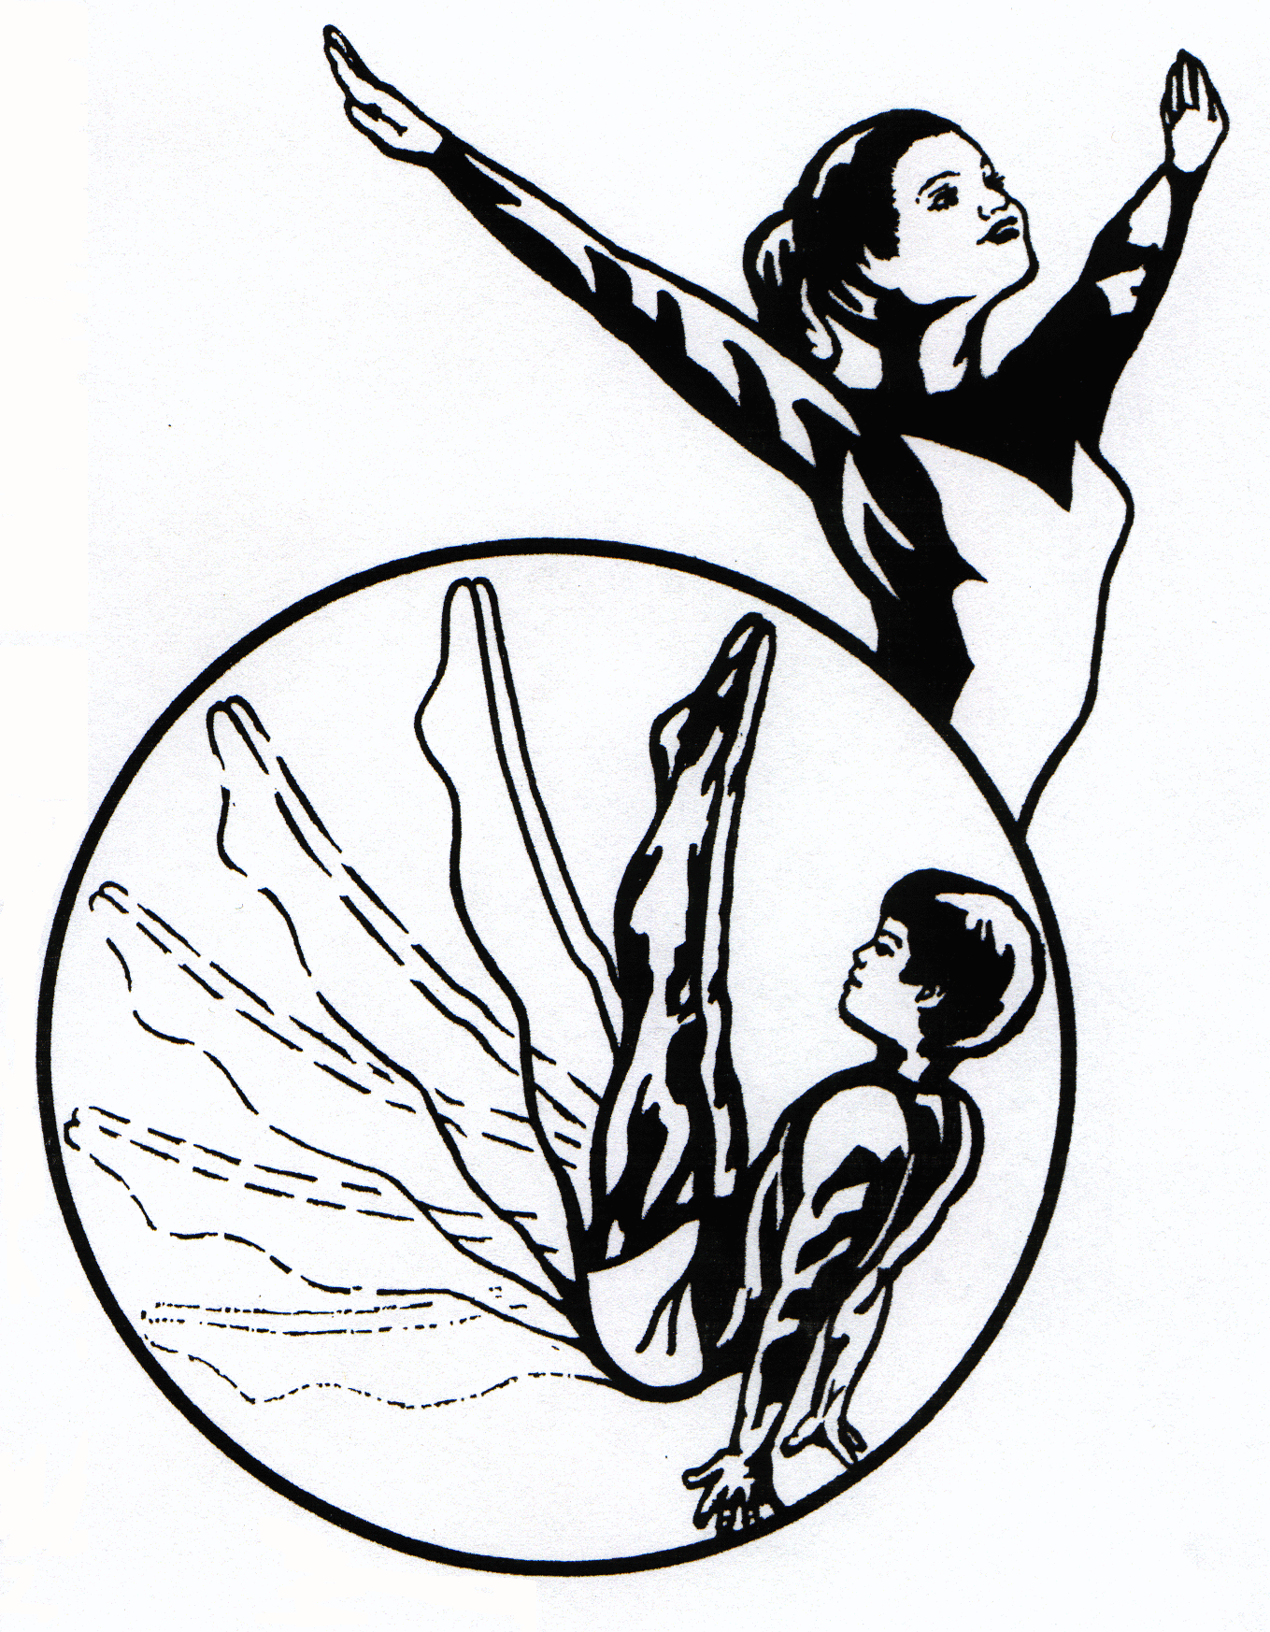
The Ohio Gymnastics Institute, Inc.
5701 West Webb Rd., Austintown Ohio 44515
330-652-4386 / MyTeamOGI.com

Build-a-Birthday Party at OGI for
______________________(Name)
Standard Party
$215 for up to 8 children
$290 for up to 16 children
1.5 hours total party consisting of 1 hour in the Gym and ½ hour in the Party Room
Invitations
Trained OGI Coaches
Party room set up with table & chairs for each child, napkins, food table & gift table
¼ sheet cupcake cake (20 cupcakes) and drinks provided
You bring table covers, plates, decorations, and any additional permitted food & drinks
You serve the guests
Participants will receive a free Open Gym pass & discount to join OGI classes
Staff will clean up after party

Circle your choices below:

Up to 8 children Standard Party Up to 16 children Standard Party

Add-ons:
$10 per 8 children: Individual Ice Cream Cups

$20 per 8 children: Pizza * Individual Chips Bags & Veggie Tray with Dip * 2 Balloon Bundles (6 balloons each)

$25 per 8 children: Goodie Bags * Inflatable Bouncy House (100 lb limit)

Themed Party Decorations & Tableware: $50 Flat Rate

Sunday parties must be scheduled 1 month in advance and have a 10% surcharge.

*Birthday Parties are structured around the age of the Birthday Child. Any extreme age variations will require an additional coach at an additional charge.
The Ohio Gymnastics Institute, Inc.
5701 West Webb Rd., Austintown Ohio 44515
330-652-4386 / MyTeamOGI.com

Build-a-Birthday Party at OGI for
______________________(Name)
Premium Party
$275 for up to 8 children
$350 for up to 16 children
2 hours total party consisting of 1 hour in the Gym and 1 hour in the Party Room
Invitations
Trained OGI Coaches
Party room set up with tables & chairs, food & gift tables, table covers, plates, napkins
¼ sheet cupcake cake (20 cupcakes) and drinks provided
You bring any additional permitted food & drinks desired
Staff member will service party by passing out pizza, cake, & drinks
Participants will receive a free Open Gym pass & discount to join OGI classes
Staff will clean up after party
Choose one free add-on from the lists below (up to a $25 value per 8 children!)

Circle your choices below:

Up to 8 children Premium Party Up to 16 children Premium Party

Add-ons:
$10 per 8 children: Individual Ice Cream Cups

$20 per 8 children: Pizza * Individual Chips Bags & Veggie Tray with Dip * 2 Balloon Bundles (6 balloons each)

$25 per 8 children: Goodie Bags * Inflatable Bouncy House (100 lb limit)

Themed Party Decorations & Tableware: $50 Flat Rate

Sunday parties must be scheduled 1 month in advance and have a 10% surcharge.

*Birthday Parties are structured around the age of the Birthday Child. Any extreme age variations will require an additional coach at an additional charge.

