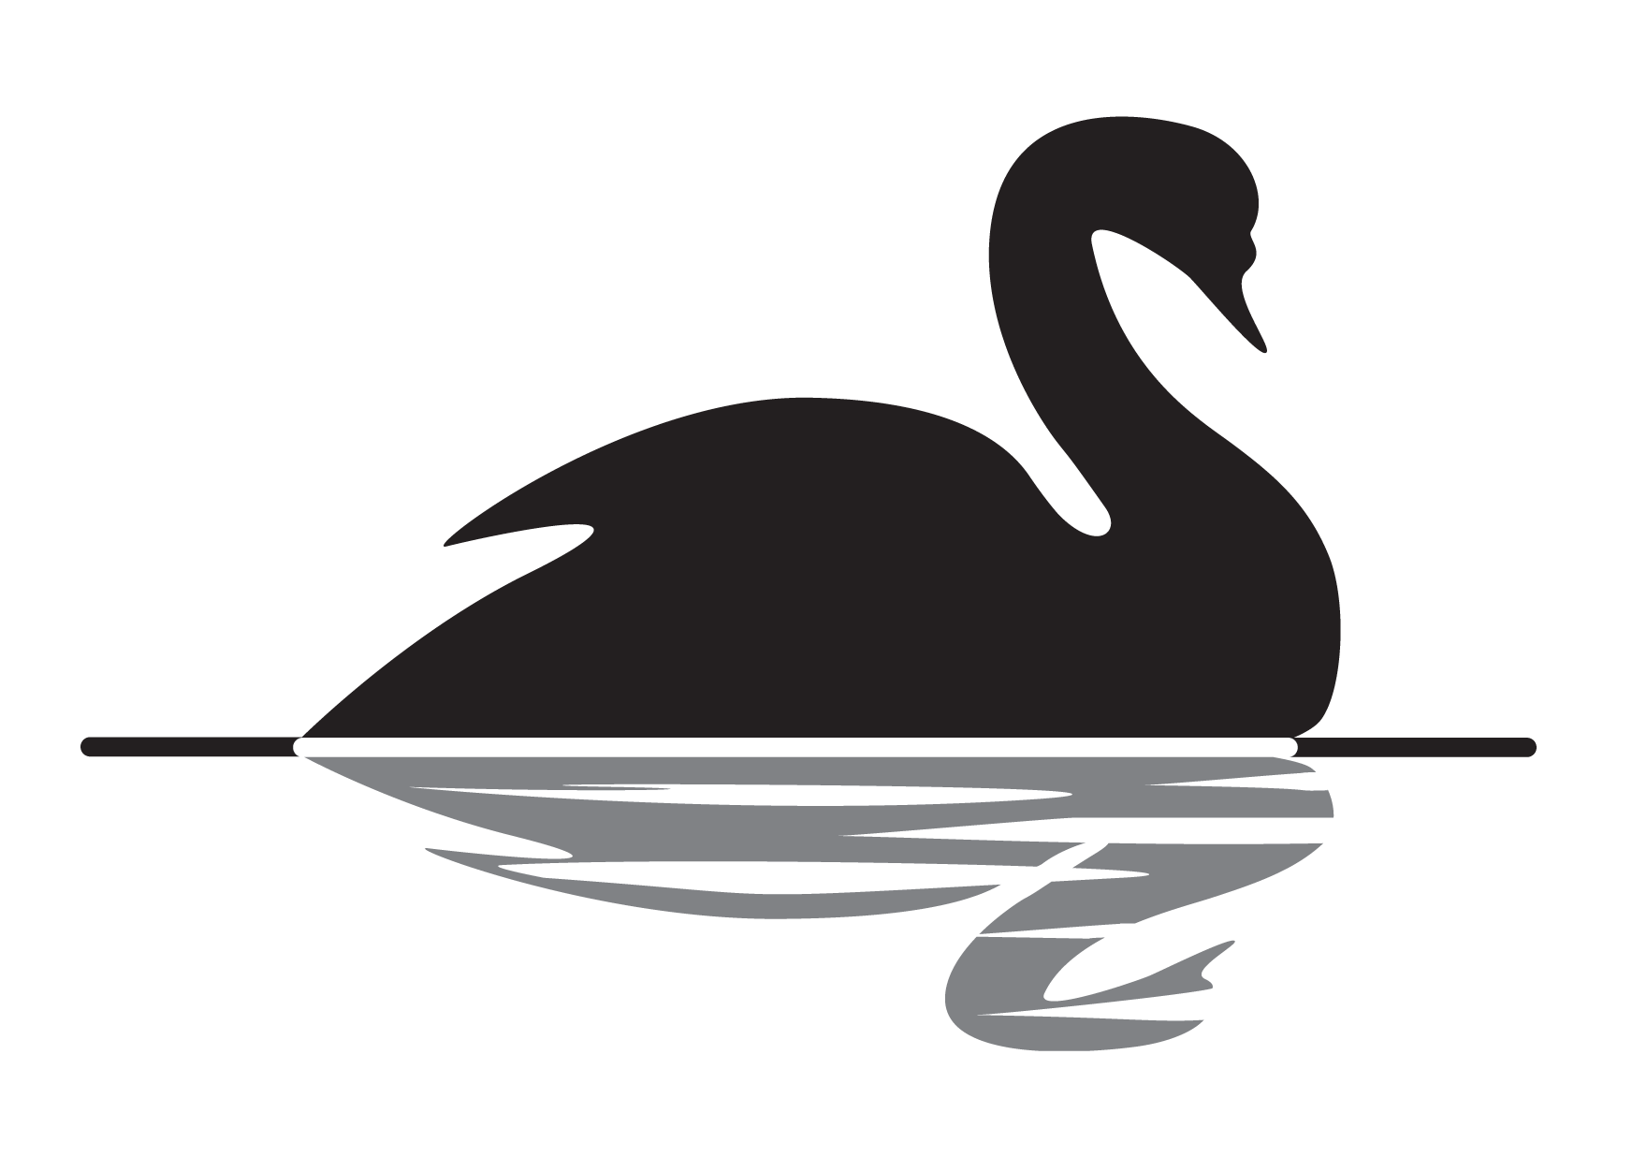
Lunch time Light Bites
Served Monday to Saturday 12PM till 2PM
Burgers
All burgers are served in a bun with chips and a garnish.
1/4lb Burger £6.25
1/4lb Cheese Burger £6.55
1/4lb Stilton Burger £7.00
1/2lb Burger £7.00
1/2lb cheese burger £7.35
1/2lb Stilton Burger £7.95
Chicken Fillet Burger £6.75

Add bacon to your burger for 80P ~ instead of chips for an extra 35p

Omelettes
match your choice of fillings, Served with chips or salad.

Plain Omelette £5.25
Tomato or Onion, or peppers add 20P per item
Ham or Cheese, or Mushrooms add 50P per item
Prawn or Tuna or, Bacon add £1.25 per item

Jacket potatoes

Served with a salad garnish.

Filled with cheese, beans or coleslaw £5.80
Prawns with Marie rose sauce or tuna mayo £6.95
Chilli and cheese £7.25
(Extra fillings 80p)
Ploughman’s
Cheddar, Stilton or ham £8.25
Mixed Ploughman’s £8.95

Lunch time Light Bites
Served Monday to Saturday 12PM till 2PM

Baguettes and Sandwiches

Baguettes ~Freshly baked, white, foot long baguette with your choice of filling.
Sandwiches served white or brown with your choice of filling.

Cheese/ham/turkey/beef/pork £5.10
Sausages £5.30
cheese & bacon £5.50
Steak mushroom & onions £7.00
Prawn & Marie rose £6.25
Tuna £6.10
tuna & Cheese £6.25
With chips an extra £1.00

Potatoes
Chips £2.60 Lg Chips £3.10
Chips & Cheese £4.00
Chips, cheese & beans £4.50
Southern fried spiral fries £4.00
Spirals & cheese £4.50
Spirals, cheese and beans £5.00

Extra fillings

Cheese/ham/turkey/beef/pork 50p
Tuna/sausage/bacon/tuna & cheese 80p
Salad/coleslaw 50p
Fried mushrooms & onions 50p

All subject to availability.

