CAPE FEAR POULTRY ASSOCIATION
DOUBLE
OPEN SHOW
SINGLE
JUNIOR SHOW

APA/ABA SANCTIONED OPEN DOUBLE SHOW
JUNIOR SHOW AND YEPA JUNIOR SHOWMANSHIP

THE CAPE FEAR POULTRY ASSOCIATION MEMBERS WISH TO EXTEND A SPECIAL INVITATION TO YOU, YOUR FAMILY, AND YOUR FRIENDS TO EXHIBIT BIRDS WITH US AT OUR
FEBRUARY 22, 2020 SHOW. THANK YOU FOR YOUR SUPPORT OF OUR SHOW AND CLUB.

SHOW DATE
FEBRUARY 22, 2020
Entry Deadline – FEBRUARY 17, 2020
JOHNSTON COUNTY LIVESTOCK ARENA
520 COUNTY HOME ROAD
SMITHFIELD, NORTH CAROLINA 28577
COMPETITION OPEN TO THE FOLLOWING:
BANTAMS, LARGE FOWL, WATERFOWL, TURKEYS, AND GUINEAS
JUDGES
Jonathan Patterson, Danny Dysart, Glenn See, Matt Lhamon, and Mike Sayre
*********************************************************************************************
SHOW DIRECTOR: WILBUR HANLEY
SHOW SECRETARY: CAROLYN D. LYNN & DONNA WORTHINGTON
PRESIDENT: JEFF SUMNER
VICE PRESIDENT: JANICE WEAVER
TREASURER/CLUB SECRETARY: DONNA WORTHINGTON
WEBSITE
www.capefearpoultryassociation.com
(Entry Forms & Catalog available online)

SHOW RULES AND REGULATIONS
- Competition is open to all breeds of poultry listed in the APA and ABA Standards. All entries, exhibitors and visitors are subject to these rules and regulations.
- Open Show Entry fee is $6.00 per bird. We are accepting entries as single birds only. Double cooping is available on a limited basis at a fee of $5.00 per double cooped entry. Clean up fee of $1.00 per exhibitor. Junior Entry fee is $3.00 per bird, a double coop is $3.00 and Clean up fee is $1.00.
- Birds will be entered at the sole risk of the owner. Cape Fear Poultry Association will not be responsible for the loss or accident to any birds or persons. Ample supervision of the birds and facilities will always be provided. Birds are to be handled only by the owner, Judge, or CFPA Administration.
- Every person making an entry is responsible for the entry fee, even if the individual is unable to attend. Checks and Money Orders must be made payable to Cape Fear Poultry Association. All fees must be paid before birds are cooped in. All returned checks are subject to a $30.00 return fee!
- deadline for all MAIL-IN entry forms MUST BE RECEIVED BY FEBRUARY 17, 2020, and must be accompanied by the entry fee. Any entries RECEIVED AFTER FEBRUARY 17, 2020 WILL BE RETURNED.
- ALL BIRDS for exhibition in NC shall originate from U.S. Pullorum-Typhoid Clean Flocks or have a negative Pullorum-Typhoid Test within 90 days, 30 DAYS FOR OUT OF STATE BIRDS, of the day of the exhibition. All NC owned birds must be tested by agents of N.C. Department of Agriculture. For North Carolina birds and for out of state birds from U.S. Pullorum-Typhoid clean states, these test requirements may be satisfied by a negative test conducted by an N.C. Department of Agriculture agent at the time of entry. Poultry for exhibition shall not have been vaccinated with a live virus vaccine within the last 30 days preceding exhibition. Each bird must be identified with a “tamper-proof” band at the time of the Pullorum-Typhoid test. A copy of the Pullorum-Typhoid test chart must accompany birds to the exhibition. Birds are subject to examination (including blood test and swabs) by a representative of N.C. Department of Agriculture. Birds shall not be accepted which are infected with or showing any clinical signs of a contagious disease or infested with lice or mites. OUT OF STATE BIRDS shall be admitted provided they are from an area that is not under quarantine for an infectious disease and have a negative ANITGEN detection test for Avian Influenza performed within 21 days prior to the exhibition, or paperwork proving flock is AI certified. YOU MUST HAVE YOUR AI TEST PAPERWORK WITH YOU AT THE SHOW TO COOP IN.
- ALL PERSONS SELLING POULTRY ON THE PROPERTY AT THE SHOW MUST HAVE DISPLAYED A CURRENT LICENSE/CERTIFICATE FOR POULTRY/RATITE DEALER card AND BIRDS MUST MEET THE NC HEALTH REQUIREMENTS AS STATED ABOVE.
- To obtain your exhibitor number please go to the ENTRY CHECK-IN table before cooping in.
- Aisles will be CLOSED during judging. Only the JUDGE, CLERK, and Show Officials will be allowed in these areas.
- The club provides feed, BUT IT IS YOUR RESPONSIBILITY TO FEED AND WATER YOUR BIRDS.
- NO ALCOHOLIC BEVERAGES ARE ALLOWED ON PREMISES!! SMOKING IS NOT ALLOWED IN THE BUILDING. THIS IS A COUNTY OWNED COMPLEX.
- All matters not covered herein should be addressed as needed to the Executive Board of the club, and/or Judges. ALL DECISIONS ARE FINAL. The Show Committee reserves the right to refuse any entry submitted.
- No entries will be taken from any state having active AI.
- The Cape Fear Poultry Association will use every precaution to guard against accident, mistake, loss or damage, but will not be responsible should any occur.
- The CFPA reserves the right to substitute and/or add judges as necessary.
- ABSOLUTELY NO EARLY COOPING OUT! This rule will be strictly enforced by the CFPA Administration. Please remember that your entry form SIGNATURE states that you understand and agree to follow this rule. PLEASE RESPECT YOUR FELLOW EXHIBITORS by observing this rule! No exceptions unless approved by the CFPA Administration.

JUNIOR SHOW RULES AND REGULATIONS
The rules and regulations for the Junior Show are the same as the open show,
Including the following guidelines:
1. The Junior Show is open for ages 5 to 18 years of age. Showmanship is open for ages 5 to 18.
2. The Junior exhibitors are solely responsible for cooping and grooming their own birds.
3. The Junior exhibitors will be judged separately from the open exhibitors.
4. Juniors are NOT required to show in the Junior Show. They CAN show in BOTH
Shows if they make SEPARATE entries for both shows. However, the same bird
CANNOT be shown in BOTH SHOWS.
5. Junior exhibitors are required to handle their own birds.
6. Junior exhibitors must be present to receive any awards they may win.
7. Please specify on the JUNIOR entry form, the exhibitor’s age at the time of the show, and
indicate if you will participate in the showmanship program. Please do not use the open show entry form for a Junior entry.
ENTRY FEES are $3.00 per bird, $3.00 double coop, $1.00 cleanup fee.

ENTRIES
PHONE ENTRIES: Deadline - Monday, February 17, 2020 no later than 9:00 pm
CALL-IN TIME: 5:00 pm – 9:00 pm
JEFF SUMNER – 910-298-5755
CALL-IN TIME: 1:00 pm – 9:00 pm – Donna Worthington 252-827-2491
EMAIL ENTRIES: - Deadline - Tuesday, February 18, 2020 by 3:00 PM please allow 24 hours for acknowledgment of entry,
PLEASE INCLUDE ALL INFORMATION AS SHOWN ON THE ENTRY FORM
EMAIL TO: donna.worthington@aol.com
MAIL ENTRIES: MUST be IN HAND no later than February 17, 2020
Mail to: Donna Worthington
118 Kincalf Lane
Macclesfield, NC 27852
Please verify your name and address to make sure it is listed the same as the APA and ABA to ensure that your earned points from the show are recorded correctly.

EVENTS SCHEDULE
FRIDAY, FEBRUARY 21, 2020 SATURDAY, FEBRUARY 22, 2020 SHOW HALL OPENS 4:00 PM FOR EXHIBITORS SHOW HALL OPENS AT 6:00 AM FOR EXHIBITORS
NC TESTERS AVAILABLE FOR NPIP TESTING NC TESTERS AVAILABLE FOR NPIP TESTING
4:00 PM to 8:00 PM 6:00 AM TO 8:55 AM
Meet & Greet Social 5:30 PM -7:00 PM JUDGING STARTS AT 9:00 AM
SHOW HALL CLOSES AT 8:00 PM AND LOCKED CONCESSIONS: OPENS 7:00 AM AND CLOSES 2:30 PM

ALL BIRDS MUST BE COOPED IN NO LATER THAN 8:55 AM
NC TESTERS WILL LEAVE AT THIS TIME

JUDGING BEGINS AT 9:00 AM
Judges and Clerks will break for lunch between 12:00 and 1:00 pm
Close of Show and Awards around 3:00 pm (or sooner) SHOW HALL CLOSES AS SOON AS
ALL EXHIBITORS ARE COOPED OUT
OPEN SHOW AWARDS

CHAMPION OF SHOW PLAQUE/$100.00
RESERVE CHAMPION OF SHOW PLAQUE/$75.00
***************************************************
Champion Land Fowl and Reserve Land Fowl are paper awards made only
on the APA Show Report

CHAMPION LARGE FOWL PLAQUE/$50.00
RESERVE CHAMPION LARGE FOWL PLAQUE/$25.00

CHAMPION BANTAM PLAQUE/$50.00
RESERVE CHAMPION BANTAM PLAQUE/$25.00

THE FOLLOWING BREED CLASSES OF BOTH THE OPEN AND JUNIOR SHOW WILL RECEIVE PLAQUES FOR CHAMPION AND RESERVE CHAMPION
AMERICAN, ASIATIC, ENGLISH, MEDITERRANEAN, CONTINENTAL, AOSB, MODERN GAME BANTAMS, OLD ENGLISH GAME BANTAMS, SCCL, RCCL, FEATHER LEGGED, AOCCL, BANTAM DUCKS, TURKEY, GEESE, DUCKS, GUINEA, AND WATERFOWL

JUNIOR SHOW AWARDS
CHAMPION OF SHOW PLAQUE/$20.00
RESERVE CHAMPION OF SHOW PLAQUE/$10.00

YEPA (APA/ABA) SANCTIONED SHOWMANSHIP
NOVICE CLASS AGES 8 & UP (HAS NEVER DONE SHOWMANSHIP) PRE-JUNIOR CLASS: AGES 5-7
JUNIOR CLASS: AGES 8-10 INTERMEDIATE CLASS: AGES: 11-13 SENIOR CLASS: AGES 14-18
(ALL SHOW PERSONS SHOULD BE CLEAN, WELL GROOMED, AND NEATLY DRESSED)
Junior Exhibitors must have a separate bird for showmanship (no additional cost). If you are not an Exhibitor in the Junior Show, you will need to have a bird available and there is a $3.00 fee for showmanship.

SHOWMANSHIP
A TROPHY WILL BE GIVEN FOR 1ST AND 2ND PLACE IN THE JUNIOR, INTERMEDIATE,
AND SENIOR CLASS
PARTICIPATION RIBBONS WILL BE GIVEN TO EVERYONE PARTICIPATING IN THE NOVICE CLASS
AND PRE-JUNIOR CLASS

CAPE FEAR POULTRY ASSOCIATION SHOW EVENTS
CHINESE RAFFLE ***** 50/50 DRAWING
A BIG “THANK YOU” TO ALL THE CLUB MEMBERS FOR THEIR DONATIONS. TICKETS WILL BE ON SALE STARTING AT $1.00 PER TICKET – SO GET YOUR TICKETS AND TRY YOUR LUCK AT WINNING YOUR FAVORITE ITEM. THE RAFFLE TICKETS WILL BE DRAWN STARTING AT 12:30 PM
BUY A TICKET STARTING AT $1.00 FOR A CHANCE TO WIN CASH IN THE 50/50 DRAWING. YOU WILL RECEIVE ONE HALF OF THE CASH COLLECTED FROM THE TICKET SALES

.SILENT AUCTION
THIS IS WHERE YOU WILL FIND QUALITY BIRDS FROM SOME OF THE TOP BREEDERS. BECAUSE THE INTENT IS TO PROVIDE FANCIERS AN OPPORTUNITY TO ACQUIRE QUALITY BIRDS TO EXPAND THEIR FLOCK OR BREEDING PROGRAM, THERE WILL BE A REASONABLE MINIMUM STARTING BID PLACED ON ALL OF THE BIRDS. A SPECIAL THANK YOU FOR YOUR DONATIONS. THE BIDDING WILL END AT 1:30 PM
“MEET AND GREET”
CAPE FEAR POULTRY ASSOCIATION MEMBERS INVITE OUR EXHIBITORS TO JOIN THEM FOR LIGHT REFRESHMENTS FRIDAY, FEBRUARY 21, 2020, FROM 5:30 PM TO 7:00 PM AT THE JOHNSTON COUNTY LIVESTOCK ARENA. THIS WILL BE EVERYONE’S TIME TO SAY “HELLO” TO OLD FRIENDS AND MEET NEW FRIENDS”! WE WANT TO THANK EACH OF YOU FOR YOUR SUPPORT OF OUR CLUB AND SHOW. COME JOIN US!
ACTIVITY TABLE
THIS IS WHERE THE YOUNG AND OLD CAN PLAY GAMES, COLOR, CROSSWORD PUZZLES, CRAFT CREATIONS, and more. HOPE EVERYONE ENJOYS THEIR TIME WHILE AT OUR SHOW!!

CONCESSIONS
BREAKFAST WILL BE AVAILABLE AT 7:00 AM
LUNCH WILL BE AVAILABLE AT 11:00 AM
THANK YOU FOR YOUR SUPPORT BY EATING IN WITH US!!!

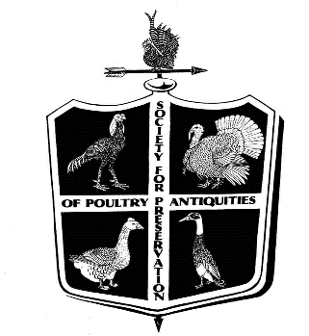
STATE MEETS
SPPA- THE SOCIETY FOR THE PRESERVATION OF POULTRY ANTIQUITIES
For Rosettes you must be a paid member of the SPPA by the time judging begins at 9:00 am, A listing of these breeds will be available at the awards table. New members are welcome to participate in this Meet by signing up and
paying dues by 9:00 am.
Dr. Charles Everett will be present the morning of the Show, to sign up new members and take renewal dues

RHODE ISLAND RED CLUB OF AMERICA
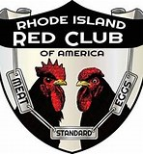
The Rhode Island Red Club of America offers meets in order to boost the breeding, exhibiting and promotion of the most exceptional of all breeds, the Rhode Island Red. Only members in good standing may compete for points for the Red Club Master Exhibitor and Master Breeder Awards. To join the Rhode Island Red Club of America, send dues of $15.00 for adult ($20 US Funds for Foreign) or $5 for junior membership to:
Toni Candea 16 Ackerman Rd, Warwick, NY 10990 (281) 770-4750 tcandea@optonline.net All members receive the Chronicle, the official club publication.

Special meets

INTERNATIONAL CORNISH BREEDERS ASSOCIATION
ICBA members all compete for exhibitor points at all sanctioned meets and the top point earners are recognized on an annual basis.
Sam Brush - slbrush@verizon.net
President, International Cornish Breeders Association

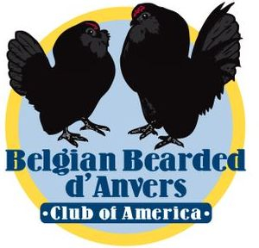
BELGIAN BEARDED d’ANVERS CLUB OF AMERICA

If you would like to join the club dues are $12 per year, $20 for two years per Adult Single Membership. Dues for Junior Members are $10 per year or $18 for two years.
We do offer a Family Membership which includes 1 Adult and up to 3 youth living in the same household for $20 per year, or $35 for two years.
***All memberships start the first full month after membership is received and run for a full 12-24 months *** Website: https://danverclub.webs.com
You can fill this out and submit it via postal mail to the Club Secretary or
Email: secretaryBBDCA@gmail.com

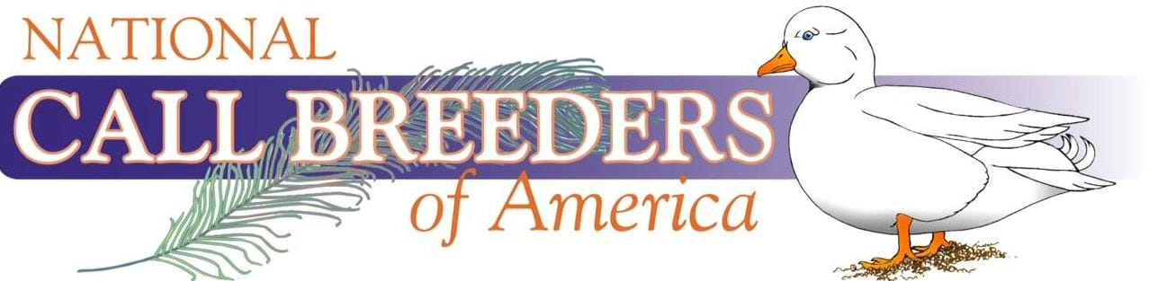

Join a large group of Call duck breeders, exhibitors and enthusiasts from around the world today! Your membership includes our official Yearbook, occasional newsletters, and the ability to start collecting points at our shows. Compete for numerous awards including the yearly high-point exhibitor, master breeder, and master exhibitor. Join us today and connect with fellow members!

AMERICAN LANGSHAN CLUB
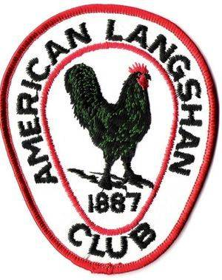
To enjoy the benefits of the American Langshan Club, you must be a current member of the club. The club offers a quarterly newsletter, special awards and
recognition for its members.
PLEASE SEND DUES (PAYABLE TO AMERICAN LANGSHAN CLUB) TO
MICHELLE OAKLEY, 15643 ST. RT. 720, LAKEVIEW, OHIO 43331 977-539-6588
YOUTH MEMBERSHIP $5.00, ADULT MEMBERSHIP $15.00,
LIFETIME MEMBERSHIP $200.00

SPECIAL MEETS

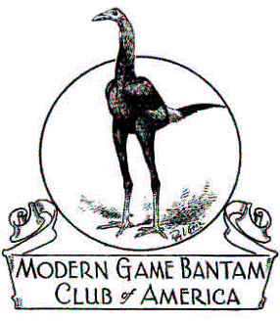
MODERN GAME BANTAM OF AMERICA

Secretary/Treasurer - Lee A. Traver
4134 NY Highway 43
Wynantskill, NY 12198
traverfarm@wildblue.net

AWARD REQUIREMENTS-ONLY PAID UP MGBCA MEMBERS, PRIOR TO JUDGING ARE ELIGIBLE FOR CLUB AWARDS, THERE MUST BE A MINIMUM OF 28 MODERNS ENTERED, WITH A MINIMUM OF 3 MEMBERS SHOWING
ANNUAL DUES $20.00- SEND DUES TO THE SECRETARY OR MAY BE PAID TO THE DISTRICT DIRECTOR
.
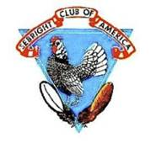
SEBRIGHT CLUB OF AMERICA

President: Jerry Bonds – P O Box 136, Ila. Ga, 30647
Vice President: William Sandoe – 1606 Joe Goldsborough Rd., Smyra, De. 19977
Secretary-Treasurer: H. R. Rogers – 1023 Beam Road, Demer, Pa., 17517
717-314-5323 - hrrogers1@yahoo.com
Craig Fields – District #3 Director – craigandlayla@yahoo.com
ANNUAL DUES: $20.00
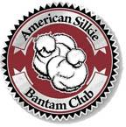
AMERICAN SILKIE BANTAM CLUB
ASBC Meet Awards: Special, District, and State meet – receive Flat Ribbons for Best of Breed and Reserve of Breed. Must have 2 exhibitors present and 10 Silkies shown to receive awards. Points are awarded regardless. Awards mailed twice a year, January and June
Secretary/Treasurer Sherri Humphreys,
P.O. Box 276, New Roads, La. 70760
admin@americansilkiebantam.org

Other meets include
American Poultry Association, American Bantam Association,
Old English Game Bantam Club of America
Belgian d’Uccle and Booted Bantam Club,

MARK YOUR CALENDAR NOW FOR OUR NEXT SHOW
OCTOBER 24, 2020

CAPE FEAR POULTRY ASSOCIATION

JEFF SUMNER, PRESIDENT JANICE WEAVER, VICE PRESIDENT
910-298-5755 910-916-9744
DONNA WORTHINGTON, SECRETARY/TREASURER
252-827-2491

DRIVING DIRECTIONS
JOHNSTON COUNTY LIVESTOCK ARENA
520 COUNTY HOME ROAD
SMITHFIELD, NC 27577 - PHONE # 919-934-9569

COMING FROM I-95 NORTH OR SOUTH TAKE EXIT 95 WEST (SMITHFIELD) ON TO
HWY 210/70 (MARKET STREET) GOING WEST 2.7 MILES THEN VEER OFF TO THE LEFT ONTO
HWY 210. CONTINUE ON HWY 210 ABOUT 6.6 MILES TURN RIGHT ON TO COUNTY HOME ROAD, GO ABOUT 1/4 MILE AND WE ARE ON THE RIGHT.

COMING FROM I-40 NORTH OR SOUTH TAKE EXIT 319 EAST (TOWARD COATS CROSSROADS) ON TO HWY 210 EAST, CONTINUE ON HWY 210 ABOUT 7.9 MILES UNTIL YOU SEE COUNTY HOME ROAD ON THE LEFT, TURN ON TO COUNTY HOME ROAD, GO DOWN ABOUT 1/4 MILE WE ARE ON THE RIGHT.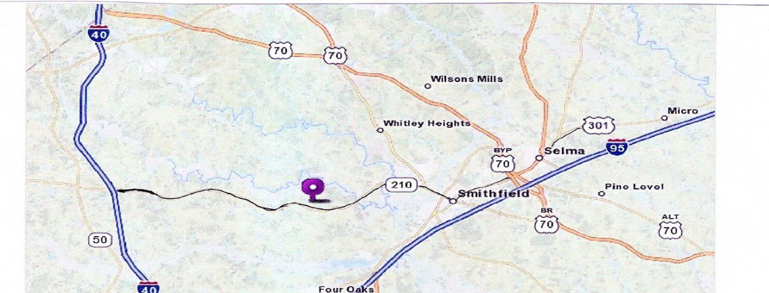

LODGING
COMFORT INN BECKY’S LOG CABIN 126 CLEVELAND CROSSING DRIVE 2491 US HWY 70 BUSINESS EAST
GARNER, NC 27577 SMITHFIELD, NC 27577
PHONE # 919-773-1110 PHONE # 919-934-1534
½ MILE OFF I-95 AT EXIT 95
LODGING, RESTAURANT AND LOUNGE

HOST HOTEL

SUPER 8 MOTEL
735 INDUSTRIAL PARK DR
SMITHFIELD, NC 27577
PHONE: 919-989-8988

LET THEM KNOW YOU ARE WITH THE CAPE FEAR POULTRY SHOW

Exhibitor #_________ Received ___________ Amount Paid_________ check no._________ received by __________
CAPE FEAR POULTRY ASSOCIATION OPEN SHOW ENTRY FORM
DATE OF SHOW: FEBRUARY 22, 2020 ENTRY DEADLINE: FEBRUARY 17, 2020
OPEN DOUBLE SHOW
I, ___________________________________________, make the following entry subject to the rules and regulations in the show catalog. By making this entry I give Cape Fear Poultry Association permission to use my contact information (address, phone #, email) for the Exhibitors List, club members, etc., I agree and accept the NO EARLY COOPING OUT rule. I understand all entries fees must be paid even if I am unable to attend. I acknowledge and accept the North Carolina State Health Requirements for exhibiting poultry in North Carolina.

STREET ADDRESS_________________________________________________________ PHONE: (________) ________ ______________

CITY______________________________________________________________________________STATE_____________ZIP___________

EMAIL ADDRESS ____________________________________________________________________________________________________
PLEASE USE YOUR SAME NAME AND ADDRESS AS RECOGNIZED BY THE APA/ABA & BREED CLUBS SO
YOU WILL RECEIVE YOUR POINTS.
UNDER TYPE USE “L” LARGE FOWL, “B” BANTAM, “T” TURKEY, “Ga” GUINEA, “D” ALL DUCKS “G” ALL GEESE
UNDER VARIETY use Bearded or Non-Bearded, SC (single comb) or RC (rose comb) only if it applies with that color or breed
FORMS MAY BE COPIED FOR MORE SPACE OR, MORE THAN ONE ENTRY
BREED | VARIETY | TYPE | COCK | HEN | COCKEREL | PULLET | TOTAL  BIRDS
EXAMPLE: PLYMOUTH ROCK  EXAMPLE: SILKIE  EXAMPLE: RHODE ISLAND RED | WHITE  NON-BEARDED  ROSE COMB | L  B  L | 1 DC  2  3 DC | 2  3  2 | 3 DC  4  4 DC | 2  5  3 | 8  14  12
Total number of birds entered_______ X $6.00 per bird Entry Fee ________________
Number of double coops ______ X $5.00 (Please specify bird for Double Coop) DC Fee _________________
Clean Up Fee $1.00 per Exhibitor Clean UP $ 1.00
Total Amount Due $______________
Send the completed form with check or money order payable to Cape Fear Poultry Association, C/O Donna Worthington, 118 Kincalf Lane, Macclesfield, NC 27852 Phone: 252-827-2491 Email donna.worthington@aol.com Pay Pal available on web site www.capefearpoultryassociation.com
Exhibitor #_________ Received ___________ Amount Paid_________ check no._________ received by __________
CAPE FEAR POULTRY ASSOCIATION JUNIOR SHOW ENTRY FORM
DATE OF SHOW: FEBRUARY 22, 2020 ENTRY DEADLINE FEBRUARY 17, 2020
JUNIOR AGE __________ JUNIOR SHOWMANSHIP YES ______ NO_______
I, ___________________________________________, make the following entry subject to the rules and regulations in the show catalog. By making this entry I give Cape Fear Poultry Association permission to use my contact information (address, phone #, email) for the Exhibitors List, club members, etc., I agree and accept the NO EARLY COOPING OUT rule. I understand all entries fees must be paid even if I am unable to attend. I acknowledge and accept the North Carolina State Health Requirements for exhibiting poultry in North Carolina
.STREET ADDRESS_________________________________________________________ PHONE: (________) ________ ______________
CITY______________________________________________________________________________STATE_____________ZIP___________

EMAIL ADDRESS ____________________________________________________________________________________________________
PLEASE USE YOUR SAME NAME AND ADDRESS AS RECOGNIZED BY THE APA/ABA & BREED CLUBS SO YOU WILL
RECEIVE YOUR POINTS.
UNDER TYPE USE “L” LARGE FOWL, “B” BANTAM, “T” TURKEY, “Ga” GUINEA, “D” ALL DUCKS “G” ALL GEESE
UNDER VARIETY use Bearded or Non-Bearded, SC (single comb) or RC (rose comb) only if it applies with that color or breed
FORMS MAY BE COPIED FOR MORE SPACE OR, MORE THAN ONE ENTRY
BREED | VARIETY | TYPE | COCK | HEN | COCKEREL | PULLET | TOTAL  BIRDS
EXAMPLE: PLYMOUTH ROCK  EXAMPLE: SILKIE  EXAMPLE: RHODE ISLAND RED | WHITE  NON-BEARDED  ROSE COMB | L  B  L | 1 DC  2  3 DC | 2  3  2 | 3 DC  4  4 DC | 2  5  3 | 8  14  12
Total number of birds entered_______ X $3.00 per bird Entry Fee ________________
Number of double coops ______ X $3.00 (Please specify bird for Double Coop) DC Fee _________________
Clean Up Fee $1.00 per Exhibitor Clean UP $ 1.00
Total Amount Due $______________
Send the completed form with check or money order payable to Cape Fear Poultry Association
C/O Donna Worthington, 118 Kincalf Lane, Macclesfield, NC 27852
Phone: 252-827-2491 Email: donna.worthington@aol.com
Pay Pal available on web site www.capefearpoultryassociation.com

