DIRECTIONS TO ROSEMORE MIDDLE SCHOOL
ON A QUEST TO BE THE BEST!
HANSHI RICK MOORE

4800 LANGLEY AVE., WHITEHALL, OHIO 43213 (614) 235-1036

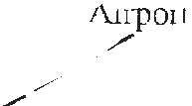
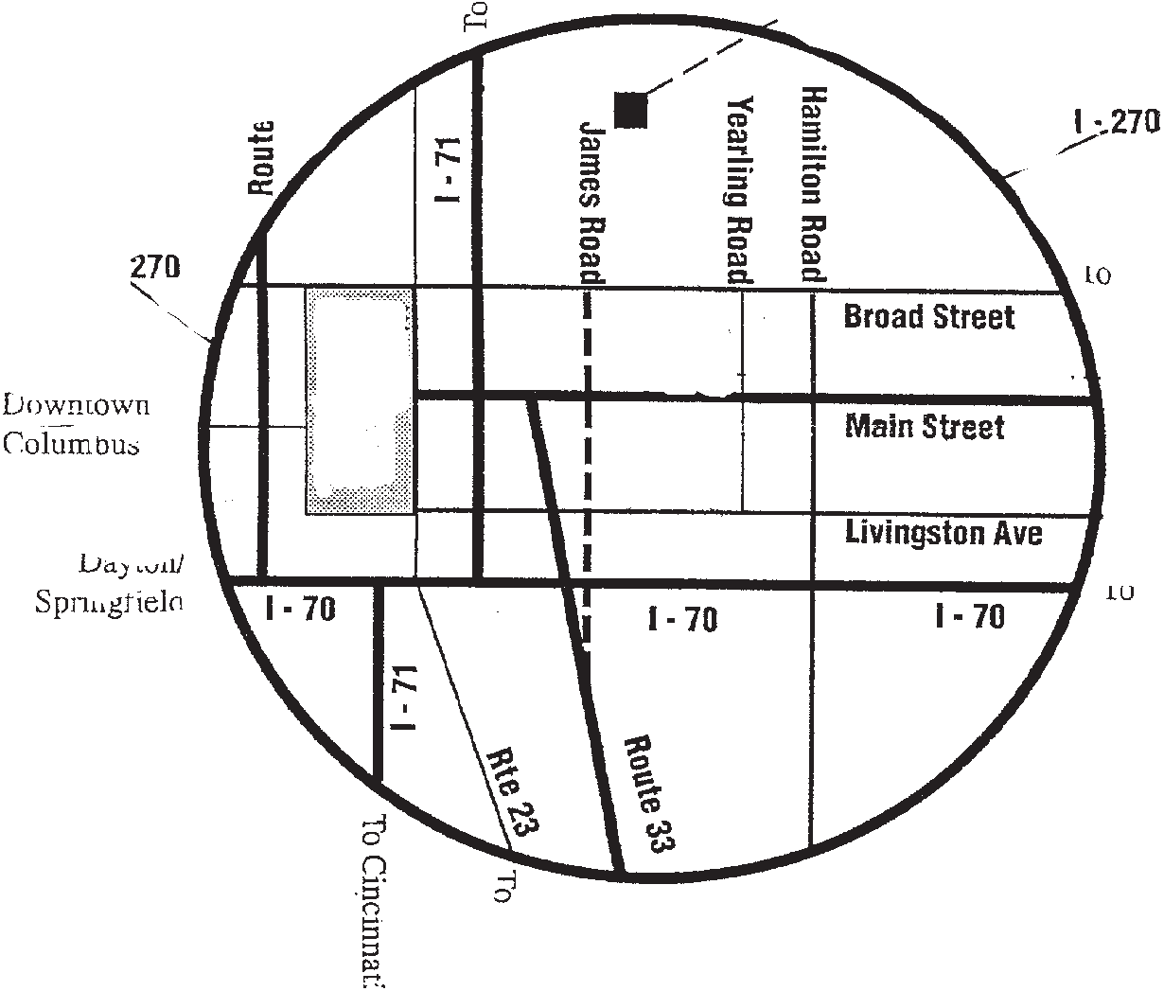
N
Rosemore Middle School
4800 Langley Ave.,
Whitehall. OH 43213
To Cleveland
Airport

I-270
Route 315

I-270 To Newark
★
Downtown Columbus

To Dayton/
W
E
Springfield To Zanesville

WELCOMES YOU TO THE FALL SESSION OF
To Circleville
To Cincinnati

SPECIAL NOTICE
Please respect the schools property. Don’t trash it up - Don’t mess it up - Don’t tear it up - Don’t smoke it up. We are all Karate people, we are taught and live with respect. He who respects himself, respects others. A Karate Tournament is an extension of our Dojo training. Let us respect the schools as we would our own Dojo.
S
Thank you,
Hanshi Rick Moore

The Rick Moore Academy, Inc. 4367 East Main Street Columbus, Ohio 43213
THE 44th ANNIVERSARY FALL

FOUR SEASONS OPEN

CHAMPIONSHIPS

KARATE — KUNG FU — TAE KWON DO
SATURDAY, October 5th 2019
ROSEMORE MIDDLE SCHOOL

4800 LANGLEY AVE.
IMA
Sanctioned
WHITEHALL, OH 43213
REGISTRATION BEGINS - 8:30 AM BLACK BELT MEETING - 10:00 AM
GRAND CHAMPIONS

BLACK BELT KATA $100 BLACK BELT (MEN) SPARRING $100

JR BLACK BELT UNDER BLACK BELT
YOUTH GRAND CHAMPIONS

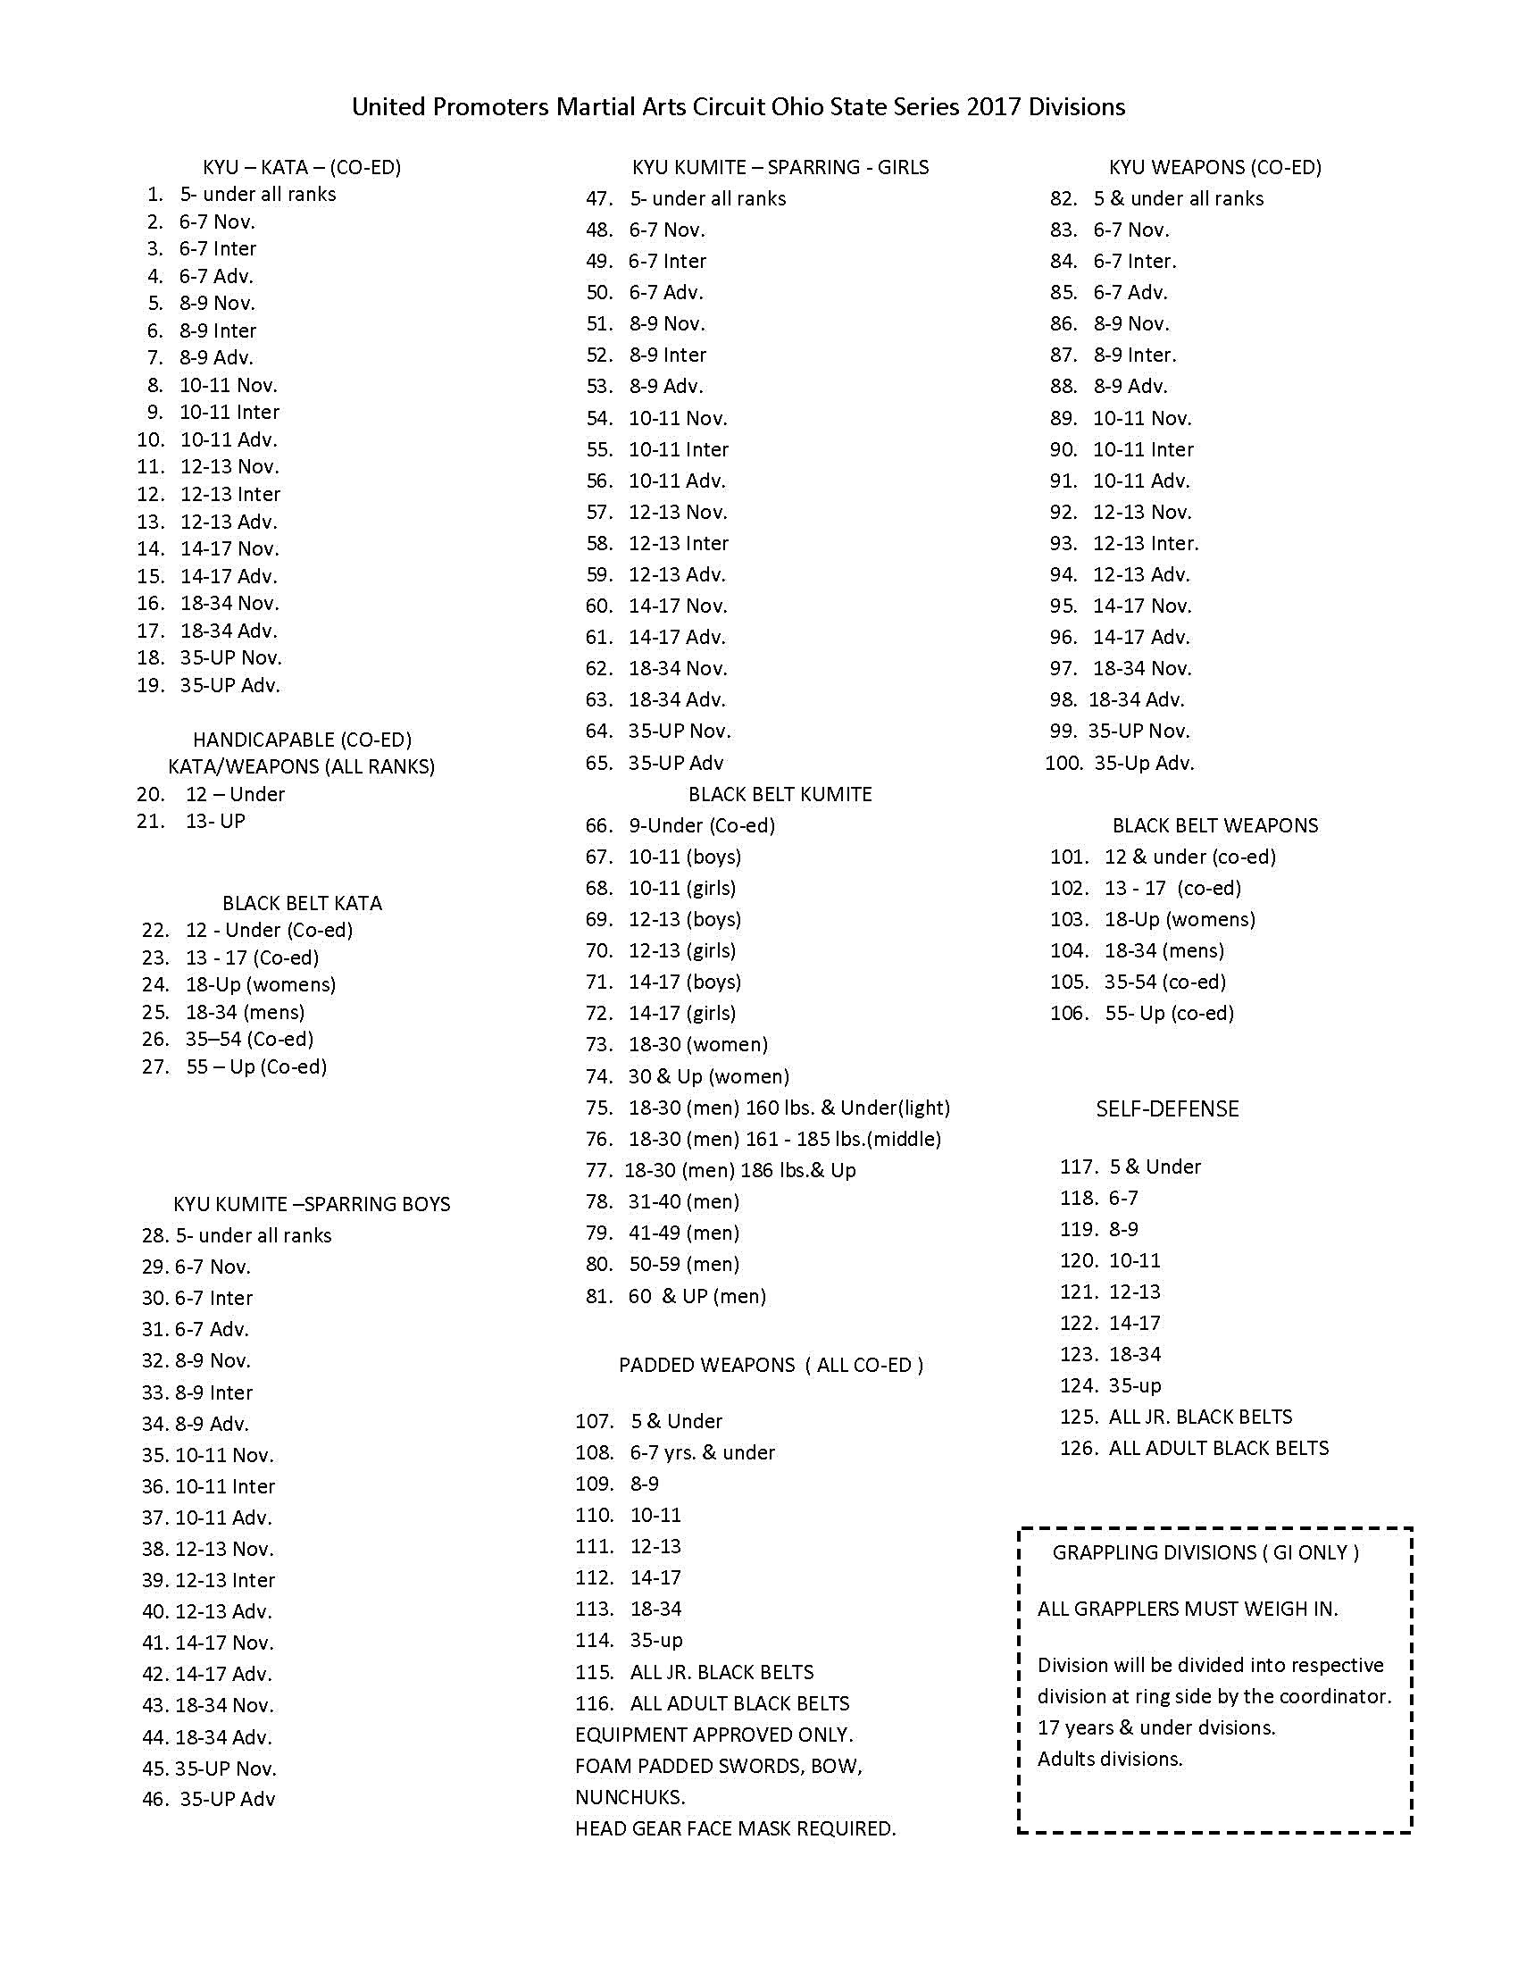

When & Where:

October 5th 2019 • Rosemore Middle School (614) 235-1036
Doors open at 8:30 A.M. for Registration

TOURNAMENT BEGINS AT 11:00 A.M. SHARP! Please be on time. No refunds if you are late!
Pre-registration - $45.00 for All events September 25th 2019
Registration at the door - $45.00 for 1 event:
$5.00 for Every Additional Event.

Spectators - Adults - $10.00;
Children 6-12 yrs. - $5.00

Senior Citizens (65 & over) and children under 6 - FREE
Call Hanshi Moore at (614) 235-1036 for family discount information.
PLEASE NOTE: **Required Equipment: only soft foam equipment for head, hands and feet. Mouthpiece; groin cup for males. Birth Certificate must be provided to show proof of age upon request.
Unsportsman-like conduct will result in your removal from this tournament. There will be no refund if you are asked to leave.

Fall - Four Seasons Open Championship - Preregistration Form
PLEASE PRINT CLEARLY . . . . ALL FORMS MUST BE SIGNED IN ORDER TO COMPETE
SEND MONEY ORDER OR CASHIER’S CHECK TO HANSHI RICK MOORE, 4367 E. MAIN STREET, COLUMBUS, OHIO 43213

NAME AGE MALE FEMALE WEIGHT
ADDRESS CITY STATE/PROV
ZIP CODE PHONE ( )
INSTRUCTOR’S NAME DOJO ADDRESS
YOUR BELT COLOR IN YOUR STYLE ARE YOU: NOVICE INTER. ADV. BLACK BELT (CIRCLE ONE)

EVENTS: KATA
PADDED WEAPONS ________
KUMITE
GRAPPLING________
WEAPONS SELF-DEFENSE

SPECTATORS: QTY X $10.00 = $ . QTY X $5.00 = $ . COMPETITOR: # OF EVENTS = $ FAMILY DISCOUNT? Y / N TOTAL AMOUNT ENCLOSED FOR SPECTATORS AND COMPETITORS = $

PRE-REGISTRATION DEADLINE IS: September 25,, 2019
Waiver: I assume full responsibility for any and all injuries or damages that I may suffer as a participant at the Rick Moore Academy and Staff/Spring Four Seasons Open Championship/U.P.M.A.C.. I realize this is a contact sport, if sparring. Any medical treatment I may receive will in no way hold The Rick Moore Academy, Inc., Hanshi Rick Moore or Rosemore Middle School, any staff of this tournament responsible. I assume all responsibility for my belongings and will not take action against parties mentioned for theft or damage of property. I am aware of any physical limitations I may have and will not hold the above-mentioned parties responsible for any unforeseen accidents. I waive the right to the use of any photograph(s) or videotape(s) by the promoter of this tournament.

SIGNATURE CO-SIGNER (IF UNDER 18)

DATE

