5/21/2017 The Iran and Libya Tavs

On 5/20/2017, YaHuWaH Elohim brought to mind Zechariah 12:3, the scripture about Jerusalem being a burdensome stone. He specifically brought to mind the words "cut in pieces". I looked at the verse using Strong's Concordance and a Hebrew Interlinear bible.

Here's the passage from the King James version of the bible:

Zechariah 12:1 The burden of the word of YaHuWaH for Israel, saith YaHuWaH , which stretcheth forth the heavens, and layeth the foundation of the earth, and formeth the spirit of man within him.
2 Behold, I will make Jerusalem a cup of trembling unto all the people round about, when they shall be in the siege both against Judah and against Jerusalem.
3 And in that day will I make Jerusalem a burdensome stone for all people: all that burden themselves with it shall be cut in pieces, though all the people of the earth be gathered together against it.

We mentioned the word "cup" (Hebrew "Saf") in a prior article. The word "Saf" means the threshold of a door where a sacrifice was offered before a visitor was allowed to enter the home. There was a cup sculpted into the stone threshold at the bottom of the door that was there to catch the blood of the sacrificed animal. Verses 2 & 3 above imply that when nations are gathered against Jerusalem in the last days, their armies will be cut in pieces at the entrance to Jerusalem.

This is reminiscent of a Cherubim being placed at the entrance to the garden of Eden along with a whirling sword to prevent man from re-entering the garden after he was expelled.

Cut Twice

Zechariah 12:3 actually reads like this in the Hebrew manuscript "...all that burden themselves with it will be lacerated, they will be lacerated,...". The King James version translates the double laceration as being "cut in pieces".

The double laceration concerning those who burden themselves with Jerusalem immediately reminded me of the total solar eclipse Tavs, "X", Paleo Hebrew end marks that were placed on certain countries. The solar eclipses are inscriptions ordained to be placed on the earth on certain dates by our Creator Elohim using the moon's shadow as an incising instrument.

The pair of solar eclipses that comprised each Tav had unique qualities. Each pair was separated by 2422 days. The first eclipse in the sequence revealed the constellation Leo, significant of the "Lion of Judah", Israel's King Messiah. The second eclipse of the "X" revealed the precise astronomical beginning of the 1st day of the 1st Hebrew month, Aviv, or Nisan. Not many eclipse pairs have been found that meet these exacting criteria. Those that have been found have definite biblical relevance.

Babylon is Cut Twice

As this article is being written around midnight EDT 5/12/2017, President Donald Trump should be entering Israel for an official visit on the morning of 5/22/2017.

Here's a graphic of the Tav that will soon begin to be placed on the USA in less than 3 months:

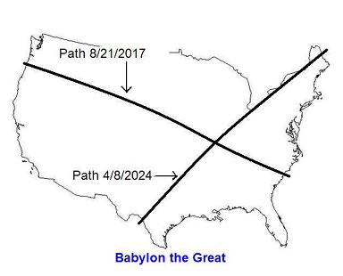
President Donald Trump enters Israel on 5/22/2017. YaHuWaH Elohim inscribes the first solar eclipse path of the Tav precisely 3 inclusive months to the day later, on 8/21/2017. Babylon the Great will receive a double slash in accordance with Zechariah 12:3 above.

Double Cuts in the Middle East

The graphic below shows the special Tav solar eclipse paths that will lacerate the Middle East.

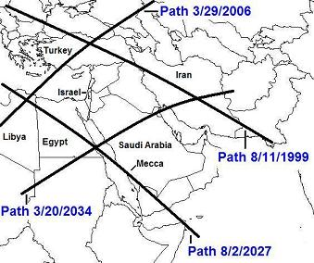

Although there are only 2 original Tavs in the graphic above, there are actually 4 intersection points, each of which would be considered a double inscription on each of the 4 countries involved.

The four countries involved are Turkey, Iran, Egypt, and Libya.

The New Information

Here's the information that YaHuWaH Elohim has just revealed. Our Creator Elohim have placed an End Mark on Iran. Both of the solar eclipse paths in the graphic below are a part of the original Tavs with 2422 day spacing revealed by YaHuWaH Elohim about 2 years ago.

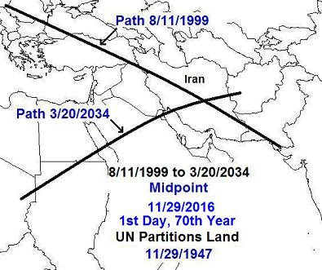

There are 12,640 days between the solar eclipses indicated in the graphic above. The exact midpoint date 6,320 days after 8/11/1999 is 11/29/2016, the 69th anniversary of the partitioning of the land promised entirely to the descendants of Jacob by the United Nations to Arabs and Jews. YaHuWaH Elohim has specifically commanded that His land not be divided up and given to other peoples.

The center date of 11/29/2016 in the graphic above reveals a chiasm, an emphasized central date, that's the reason for the timing of these two solar eclipses. Iran is being marked, symbolically "cut twice", and the reason why is the dividing of Israel's land.

The fact that they are 12,640 days apart with a central date that is the 1st day of the 70th year from the partitioning of the Promised Land attests to the existence and mighty abilities of our Creator Elohim. YaHuWaH Elohim has told us that He has created the heavens and the earth. He also told us that He has chosen Israel, and told us of the events that will befall Israel in the end times. The events noted in the graphic above show a combination of events orchestrated by a Being having abilities beyond human comprehension.

We know that Iran has determined to annihilate Israel from the face of the earth. The graphic above reveals the existence of Israel's Elohim who has said that He would place Israel in its land in the last days and that no one would pluck it up. Iran has a big problem.

Another Witness

The graphic below shows another country that has received a double inscription by our Creator Elohim.

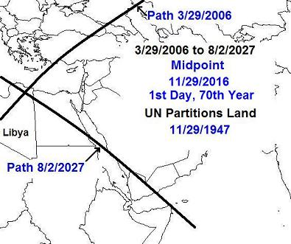

Libya has been marked by solar eclipses that are 7,796 days apart. Both eclipse paths in the graphic above are a part of the original TAV eclipses that have a separation of 2422 days.

Like the "X" placed on Iran, the central date of the eclipses placed on Libya is again 11/29/2016, the 1st day of the 70th year from the UN partitioning of the Promised Land, giving part of it to the people who today call themselves the "Palestinians".

Ezekiel 38 and 39

Both Iran (ancient Persia) and Libya are specifically mentioned in Ezekiel chapters 38 & 39 as nations who will invade Israel in the last days. When they do, 5/6 of their armies will be destroyed.

Ezekiel 38:1 And the word of YaHuWaH came unto me, saying,
2 Son of man, set thy face against Gog, the land of Magog, the chief prince of Meshech and Tubal, and prophesy against him,
3 And say, Thus saith the Master YaHuWaH ; Behold, I am against thee, O Gog, the chief prince of Meshech and Tubal:
4 And I will turn thee back, and put hooks into thy jaws, and I will bring thee forth, and all thine army, horses and horsemen, all of them clothed with all sorts of armour, even a great company with bucklers and shields, all of them handling swords:
5 Persia, Ethiopia, and Libya with them; all of them with shield and helmet:
6 Gomer, and all his bands; the house of Togarmah of the north quarters, and all his bands: and many people with thee.
7 Be thou prepared, and prepare for thyself, thou, and all thy company that are assembled unto thee, and be thou a guard unto them.
8 After many days thou shalt be visited: in the latter years thou shalt come into the land that is brought back from the sword, and is gathered out of many people, against the mountains of Israel, which have been always waste: but it is brought forth out of the nations, and they shall dwell safely all of them.
9 Thou shalt ascend and come like a storm, thou shalt be like a cloud to cover the land, thou, and all thy bands, and many people with thee.
10 Thus saith the Master YaHuWaH ; It shall also come to pass, that at the same time shall things come into thy mind, and thou shalt think an evil thought:
11 And thou shalt say, I will go up to the land of unwalled villages; I will go to them that are at rest, that dwell safely, all of them dwelling without walls, and having neither bars nor gates,

Ezekiel 38:17 Thus saith the Master YaHuWaH ; Art thou he of whom I have spoken in old time by My servants the prophets of Israel, which prophesied in those days many years that I would bring thee against them?
18 And it shall come to pass at the same time when Gog shall come against the land of Israel, saith the Master YaHuWaH , that My fury shall come up in My face.
19 For in My jealousy and in the fire of My wrath have I spoken, Surely in that day there shall be a great shaking in the land of Israel;
20 So that the fishes of the sea, and the fowls of the heaven, and the beasts of the field, and all creeping things that creep upon the earth, and all the men that are upon the face of the earth, shall shake at My presence, and the mountains shall be thrown down, and the steep places shall fall, and every wall shall fall to the ground.

Ezekiel 39:1 Therefore, thou son of man, prophesy against Gog, and say, Thus saith the Master YaHuWaH ; Behold, I am against thee, O Gog, the chief prince of Meshech and Tubal:
2 And I will turn thee back, and leave but the sixth part of thee, and will cause thee to come up from the north parts, and will bring thee upon the mountains of Israel:
3 And I will smite thy bow out of thy left hand, and will cause thine arrows to fall out of thy right hand.
4 Thou shalt fall upon the mountains of Israel, thou, and all thy bands, and the people that is with thee: I will give thee unto the ravenous birds of every sort, and to the beasts of the field to be devoured.
5 Thou shalt fall upon the open field: for I have spoken it, saith the Master YaHuWaH .
6 And I will send a fire on Magog, and among them that dwell carelessly in the isles: and they shall know that I am YaHuWaH .
7 So will I make My holy Name known in the midst of My people Israel; and I will not let them pollute My holy Name any more: and the heathen shall know that I am YaHuWaH , the Holy One in Israel.

Zechariah 14:12 And this shall be the plague wherewith YaHuWaH will smite all the people that have fought against Jerusalem; Their flesh shall consume away while they stand upon their feet, and their eyes shall consume away in their holes, and their tongue shall consume away in their mouth.

Note that strange cattle mutilation has been found in the presence of UFO activity in the western USA. The cattle have been found to be missing their eyes and their tongues.

Angelic armies stand ready to defend Israel.

