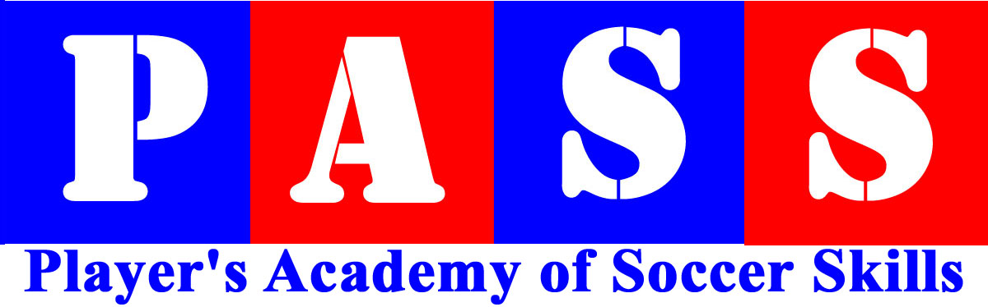
Program:
PASS Player Registration: www.pass1on1.com: e mail: NeilHull@pass1on1.com : Phone (210) 286 3070
PLAYER INFORMATION:
Name ________________________________________________ Sex __________ Age _______ DOB _______/_______/_______
Home Phone (___________)___________-_____________ Alt. / Emergency (___________)___________-_____________
Address ___ _______________________________________________________ City ___________________ State ___________ Zip _________
Parents Name _________________________ Cell Phone (________)________-__________
Email _______________________________________
Parents Name ________________________ Cell Phone (________)________-__________
Email _______________________________________
Club/Organization:___________________________
Playing Level: ___________________________
Medical Conditions or allergies to which we should be alerted______________________________________________________________________

PROGRAM INFORMATION
Program Location _______________________________ Date(s) ________________________ Uniform Size Shirt _______
PAYMENT INFORMATION: PAY ONLINE AT: www.Pass1on1.com
Regular Mail:
Neil Hull c/o PASS, 21011 Cactus Loop, San Antonio, TX 78258
ASSUMPTION OF RISK - WAIVER OF LIABILITY - MEDICAL AUTHORIZATION – PHOTOGRAPHY RELEASE
It is to be understood on all documentation, registration and representation of, and by, the Players Academy of Soccer Skills, also known and represented as ‘PASS’, is a registered entity under the Limited Liability group of Hull Holdings LLC. As a parent / guardian of the applicant, I understand that participation in soccer can result in serious injury and I hereby give permission for my child to participate in the PASS activities, and agree to comply with all program regulations, and hereby remove PASS from any and all liability for injuries incurred while participating in this program. I release their Staff and associates of any and all liability in relation to my child taking part in their programs. I/We the undersigned hereby certify that I (we) am (are) the parent(s) or legal guardian(s) of the player/student. I (We) hereby give permission for the staff of the activity to seek appropriate medical attention for the camper/student and for the medical attention to be given and for the player/student to receive medical attention in the event of an accident, injury or illness. I will be responsible for any and all costs of medical attention and treatment, incurred in the safety of the PASS participant. I will not hold PASS or any of its associates liable for any monies, actions, liability or payments in line with the above statements. I/We, the undersigned for ourselves, our heirs, executors and administrators waive, release and forever discharge PASS and it staff, officers, agents, employees, representatives and successors and assign of and from all liabilities, rights and claims for damages, personal injury or loss to person or property which may be sustained or occur during participating in PASS Soccer activities, whether or not damages, injury or loss are due to negligence or through natural actions incorporated through athletic activity. I agree to pay any, and all legal and medical costs, to and of both parties in full, in the event of any legal or medical action undertaken, mediated or culminating in any and all liability concerning The Players Academy Of Soccer Skills employees or contractors.
I hereby grant to PASS the right to photograph my dependent and use the photo and or other digital reproduction of him/her or other reproduction of his/her physical likeness for publication processes, whether electronic, print, digital or electronic publishing via the Internet.
This form has no expiry date and holds in perpetuity the above named player to any and all programs administered or coached by PASS.
I/We hereby acknowledge that our child is physically fit and mentally capable of participating in PASS soccer camp/school activities.
PARENT/LEGAL GUARDIANʼs Signature ______________________________________________Date_______________________

