WELCOME TO
HOLY SPIRIT LUTHERAN CHURCH
A Member of the Evangelical Lutheran Church in America, New Jersey Synod
1220 Bayshore Rd., Villas, NJ 08251, 609-886-2414,
holyspiritlutheran@comcast.net, holyspiritvillas.com, facebook.com/holyspiritvillas
Vicar Vince Piekarski can be contacted at any time for conversation or prayer through call or text at 412-225-0287, or through email at vpie8282@gmail.com.
SUNDAY, MARCH 29TH, 2026
SUNDAY OF THE PASSION / PALM SUNDAY
10:30AM WORSHIP SERVICE WITH HOLY COMMUNION


We, the Evangelical Lutheran Church of the Holy Spirit, are People of God, who
are called by the Holy Spirit to pray, worship, joyfully proclaim Jesus Christ,
and compassionately witness and serve others in Christian Love.


We are glad that you joined us for Worship today! Thank you for enriching our time together! We would like to get to know you better, and for you to get to know us better too. Brochures, welcome gifts, prayer shawls, Bibles, and other items are available throughout the church. We would be happy to show you around and share about our ministries. Please do not hesitate to speak up and ask questions.
Also, please make sure you sign-in on our clipboard on the podium in the lobby.


Our Worship Services are conducted in coordination with our Conference Call.
Join us at 657-390-7423 or 701-802-5170, with access code 8221190#.
You may need to dial 1 first depending on your phone plan. After logging in please announce your name and feel free to talk with others until we get started.


SANCTUARY CANDLE FOR MARCH
Given to the Glory of God & In Memory of DOROFFEY KIROW
by Rose Lang, Vicar Vince & Heather Piekarski.
ALTAR CANDLES FOR MARCH
Given to the Glory of God & In Memory of DONNA GAIN
by Jean, Phil, & Bob Zimmerman.
CONFERENCE CALL CHECK-IN, WELCOME, & ANNOUNCEMENTS
(Vicar (V), Assistant (A), Reader (R), and Congregation (C).)

INTRODUCTION
A. Today, we encounter the paradox that defines our faith: Jesus Christ is glorified
king and humiliated servant. We too are full of paradox: like Peter, we fervently
desire to follow Christ, but find ourselves afraid, denying God. We wave palms in
celebration today as Christ comes into our midst, and we follow with trepidation
as his path leads to death on the cross. Amid it all we are invited into this
paradoxical promise of life through Christ’s broken body and outpoured love in a
meal of bread and wine. We begin this week that stands at the center of the
church year, anticipating the completion of God’s astounding work.

PRELUDE
(Music offered by our Organist at the start of our Worship Service.)
The Palms

CHIMES
(Music offered by our Organist at the start of our Worship Service.)
Lamb of Glory

(We invite you to stand as you are able.)

PROCESSIONAL GOSPEL
V. We are blessed to continue utilizing our Conference Call with In-Person Worship
so, we all can be together. As we set the scene here, let us remember that we
traditionally would be processing into the church symbolizing Jesus entering
Jerusalem.

And, as we enter into these final days we start with a message from the Holy
Gospel According to Matthew. (Chapter 21, Verses 1-11).
C. Hosanna in the highest.

V. 1 When they had come near Jerusalem and had reached Bethphage, at the
Mount of Olives, Jesus sent two disciples, 2 saying to them, “Go into the village
ahead of you, and immediately you will find a donkey tied and a colt with her;
untie them and bring them to me. 3 If anyone says anything to you, just say this,
‘The Lord needs them.’ And he will send them immediately.” 4 This took place to
fulfill what had been spoken through the prophet:
5 “Tell the daughter of Zion,
Look, your king is coming to you,
humble and mounted on a donkey,
and on a colt, the foal of a donkey.”
6 The disciples went and did as Jesus had directed them; 7 they brought the
donkey and the colt and put their cloaks on them, and he sat on them. 8 A very
large crowd spread their cloaks on the road, and others cut branches from the
trees and spread them on the road. 9 The crowds that went ahead of him and that
followed were shouting,
“Hosanna to the Son of David!
Blessed is the one who comes in the name of the Lord!
Hosanna in the highest heaven!”
10 When he entered Jerusalem, the whole city was in turmoil, asking, “Who is
this?” 11 The crowds were saying, “This is the prophet Jesus from Nazareth in
Galilee.”

V. This is the Gospel of the Lord,
C. Hosanna in the highest.

CONFESSION & FORGIVENESS
(All may make the sign of the cross, the sign that is marked at baptism.)
V. Blessed be the holy Trinity, ☩ one God,
who forgives all our sin,
whose mercy endures forever.
C. Amen.

V. Let us confess our sin before God, who removes our guilt
and blots out all offenses.

(Silence is kept for reflection.)

V. Gracious God,
C. have mercy on us according to your steadfast love.
V. For seeking worldly delights that deceive us and dishonor you:
Gracious God,
C. have mercy on us according to your steadfast love.
V. For desiring self-reliance instead of hungering for your word:
Gracious God,
C. have mercy on us according to your steadfast love.

V. For failing to recognize your coming reign,
and for hindering the work of the Spirit:
Gracious God,
C. have mercy on us according to your steadfast love.
V. For drawing from the well of self-serving ambition,
and for disdaining the living water Christ offers:
Gracious God,
C. have mercy on us according to your steadfast love.
V. For disregarding voices from the margin,
and for distrusting signs of your healing and hope in the world:
Gracious God,
C. have mercy on us according to your steadfast love.
V. For dwelling in tombs of self-pity and discontent,
and for disregarding Christ’s call to come forth to life:
Gracious God,
C. have mercy on us according to your steadfast love.

V. God’s steadfast love, grace, and forgiveness abound.
Through faith, the free gift of God,
you have been clothed in the righteousness of Christ.
In the name of ☩ Jesus Christ, your sins are forgiven.
The Spirit of the One who raised Christ from the dead dwells in you,
pours God’s love into your hearts,
and gives you life and peace.
C. Amen.

GATHERING HYMN
(We invite you to sing along.)
Lutheran Book of Worship—Green Book
108—All Glory, Laud, and Honor

APOSTOLIC GREETING
V. May the grace of our Lord Jesus Christ, the love of God,
and the communion of the Holy Spirit be with you all.
C. And also with you.

KYRIE
V. In peace, let us pray to the Lord.
C. Lord, have mercy.

V. For the peace from above, and for our salvation, let us pray to the Lord.
C. Lord, have mercy.

V. For the peace of the whole world, for the well-being of the church of God,
and for the unity of all, let us pray to the Lord.
C. Lord, have mercy.

V. For this holy house, and for all who offer here their worship and praise,
let us pray to the Lord.
C. Lord, have mercy.

V. Help, save, comfort, and defend us, gracious Lord.
C. Amen.

PRAYER OF THE DAY
V. The Lord be with you.
C. And also with you.

V. Let us pray,
Everlasting God, in your endless love for the human race you sent our Lord
Jesus Christ to take on our nature and to suffer death on the cross. In your mercy
enable us to share in his obedience to your will and in the glorious victory of his
resurrection, who lives and reigns with you and the Holy Spirit, one God, now and
forever.
C. Amen.

(We invite you to be seated for our Readings and Psalm.)

FIRST READING
The servant of the Lord expresses absolute confidence in his final vindication,
despite the fact that he has been struck and spit upon. This characteristic of the
servant played an important role in the early church’s understanding of the
suffering, death, and resurrection of Jesus.

R. Our First Reading is from Isaiah (Chapter 50, Verses 4-9a).

R. 4 The Lord God has given me
a trained tongue,
that I may know how to sustain
the weary with a word.
Morning by morning he wakens,
wakens my ear
to listen as those who are taught.
5 The Lord God has opened my ear,
and I was not rebellious;
I did not turn backward.
6 I gave my back to those who struck me
and my cheeks to those who pulled out the beard;
I did not hide my face
from insult and spitting.

7 The Lord God helps me;
therefore I have not been disgraced;
therefore I have set my face like flint,
and I know that I shall not be put to shame;
8 he who vindicates me is near.
Who will contend with me?
Let us stand in court together.
Who are my adversaries?
Let them confront me.
9a It is the Lord God who helps me;
who will declare me guilty?

R. This is the Word of the Lord.
C. Thanks be to God.

PSALM
R. Our Responsorial Psalm is from the 31st Psalm (Verses 9-16).
C. Into your hands, O Lord, I commend my spirit. (Ps. 31:5)

R. 9 Have mercy on me, O Lord, for I am in trouble;
my eye is consumed with sorrow, and also my throat and my belly.
10 For my life is wasted with grief, and my years with sighing;
my strength fails me because of affliction, and my bones are consumed.
11 I am the scorn of all my enemies, a disgrace to my neighbors,
a dismay to my acquaintances;
when they see me in the street they avoid me.
12 Like the dead I am forgotten, out of mind;
I am as useless as a broken pot.
C. Into your hands, O Lord, I commend my spirit. (Ps. 31:5)

R. 13 For I have heard the whispering of the crowd; fear is all around;
they put their heads together against me; they plot to take my life.
14 But as for me, I have trusted in you, O Lord.
I have said, “You are my God.
15 My times are in your hand;
rescue me from the hand of my enemies, and from those who persecute me.
16 Let your face shine upon your servant;
save me in your steadfast love.”
C. Into your hands, O Lord, I commend my spirit. (Ps. 31:5)

SECOND READING
Paul uses an early Christian hymn to help us comprehend Jesus’ obedient
selflessness on the cross and how God has made Christ lord over all reality. The
perspective of the cross becomes the way we rightly understand God, Christ, our
own lives, and fellowship within the community of Christ.

R. Our Second Reading is from Philippians (Chapter 2, Verses 5-11).

R. 5 Let the same mind be in you that was in Christ Jesus,
6 who, though he existed in the form of God,
did not regard equality with God
as something to be grasped,
7 but emptied himself,
taking the form of a slave,
assuming human likeness.
And being found in appearance as a human,
8 he humbled himself
and became obedient to the point of death—
even death on a cross.

9 Therefore God exalted him even more highly
and gave him the name
that is above every other name,
10 so that at the name given to Jesus
every knee should bend,
in heaven and on earth and under the earth,
11 and every tongue should confess
that Jesus Christ is Lord,
to the glory of God the Father.

R. This is the Word of the Lord.
C. Thanks be to God.

V. I invite you to remain seated for the reading of the Passion. I invite you to
announce the Gospel Acclamation with me.

GOSPEL ACCLAMATION
C. Christ humbled himself and became obedient to the point of death—even
death on a cross. Therefore God also highly exalted him and gave him the
name that is above ev’ry name. (Phil. 2:8-9)

GOSPEL READING
In fulfillment of scripture and obedience to God’s will, Jesus goes to the cross so
that a new covenant in his blood may bring forgiveness of sins. Even the soldiers
who crucify him recognize him to be the Son of God.

V. The Holy Gospel According to Matthew (26:14—27:66).
C. Glory to you, O Lord.

V. 14 One of the twelve, who was called Judas Iscariot, went to the chief priests
15 and said, “What will you give me if I betray him to you?” They paid him thirty
pieces of silver. 16 And from that moment he began to look for an opportunity to
betray him.

17 On the first day of Unleavened Bread the disciples came to Jesus, saying,
“Where do you want us to make the preparations for you to eat the Passover?”
18 He said, “Go into the city to a certain man and say to him, ‘The Teacher says,
My time is near; I will keep the Passover at your house with my disciples.’ ” 19 So
the disciples did as Jesus had directed them, and they prepared the Passover
meal.

20 When it was evening, he took his place with the twelve disciples, 21 and while
they were eating he said, “Truly I tell you, one of you will betray me.” 22 And they
became greatly distressed and began to say to him one after another, “Surely not
I, Lord?” 23 He answered, “The one who has dipped his hand into the bowl with
me will betray me. 24 The Son of Man goes as it is written of him, but woe to that
one by whom the Son of Man is betrayed! It would have been better for that one
not to have been born.” 25 Judas, who betrayed him, said, “Surely not I, Rabbi?”
He replied, “You have said so.”

26 While they were eating, Jesus took a loaf of bread, and after blessing it he
broke it, gave it to the disciples, and said, “Take, eat; this is my body.” 27 Then he
took a cup, and after giving thanks he gave it to them, saying, “Drink from it, all of
you, 28 for this is my blood of the covenant, which is poured out for many for the
forgiveness of sins. 29 I tell you, I will never again drink of this fruit of the vine
until that day when I drink it new with you in my Father’s kingdom.”

30 When they had sung the hymn, they went out to the Mount of Olives.

31 Then Jesus said to them, “You will all fall away because of me this night, for it
is written,
‘I will strike the shepherd,
and the sheep of the flock will be scattered.’

32 “But after I am raised up, I will go ahead of you to Galilee.” 33 Peter said to
him, “Even if all fall away because of you, I will never fall away.” 34 Jesus said to
him, “Truly I tell you, this very night, before the cock crows, you will deny me
three times.” 35 Peter said to him, “Even though I must die with you, I will not
deny you.” And so said all the disciples.

36 Then Jesus went with them to a place called Gethsemane, and he said to his
disciples, “Sit here while I go over there and pray.” 37 He took with him Peter and
the two sons of Zebedee and began to be grieved and agitated. 38 Then he said
to them, “My soul is deeply grieved, even to death; remain here, and stay awake
with me.” 39 And going a little farther, he threw himself on the ground and prayed,
“My Father, if it is possible, let this cup pass from me, yet not what I want but
what you want.” 40 Then he came to the disciples and found them sleeping, and
he said to Peter, “So, could you not stay awake with me one hour? 41 Stay
awake and pray that you may not come into the time of trial; the spirit indeed is
willing, but the flesh is weak.” 42 Again he went away for the second time and
prayed, “My Father, if this cannot pass unless I drink it, your will be done.”
43 Again he came and found them sleeping, for their eyes were heavy. 44 So
leaving them again, he went away and prayed for the third time, saying the same
words. 45 Then he came to the disciples and said to them, “Are you still sleeping
and taking your rest? Now the hour is at hand, and the Son of Man is betrayed
into the hands of sinners. 46 Get up, let us be going. Look, my betrayer is at
hand.”

47 While he was still speaking, Judas, one of the twelve, arrived; with him was a
large crowd with swords and clubs, from the chief priests and the elders of the
people. 48 Now the betrayer had given them a sign, saying, “The one I will kiss is
the man; arrest him.” 49 At once he came up to Jesus and said, “Greetings,
Rabbi!” and kissed him. 50 Jesus said to him, “Friend, do what you are here to
do.” Then they came and laid hands on Jesus and arrested him. 51 Suddenly one
of those with Jesus put his hand on his sword, drew it, and struck the slave of the
high priest, cutting off his ear. 52 Then Jesus said to him, “Put your sword back
into its place, for all who take the sword will die by the sword. 53 Do you think that
I cannot appeal to my Father, and he will at once send me more than twelve
legions of angels? 54 But how then would the scriptures be fulfilled, which say it
must happen in this way?” 55 At that hour Jesus said to the crowds, “Have you
come out with swords and clubs to arrest me as though I were a rebel? Day after
day I sat in the temple teaching, and you did not arrest me. 56 But all this has
taken place, so that the scriptures of the prophets may be fulfilled.” Then all the
disciples deserted him and fled.

57 Those who had arrested Jesus took him to Caiaphas the high priest, where
the scribes and the elders had gathered. 58 But Peter was following him at a
distance, as far as the courtyard of the high priest, and going inside he sat with
the guards in order to see how this would end. 59 Now the chief priests and the
whole council were looking for false testimony against Jesus so that they might
put him to death, 60 but they found none, though many false witnesses came
forward. At last two came forward 61 and said, “This fellow said, ‘I am able to
destroy the temple of God and to build it in three days.’ ” 62 The high priest stood
up and said, “Have you no answer? What is it that they testify against you?”
63 But Jesus was silent. Then the high priest said to him, “I put you under oath
before the living God, tell us if you are the Messiah, the Son of God.” 64 Jesus
said to him, “You have said so. But I tell you,
From now on you will see the Son of Man
seated at the right hand of Power
and coming on the clouds of heaven.”

65 Then the high priest tore his clothes and said, “He has blasphemed! Why do
we still need witnesses? You have now heard his blasphemy. 66 What do you
think?” They answered, “He deserves death.” 67 Then they spat in his face and
struck him, and some slapped him, 68 saying, “Prophesy to us, you Messiah!
Who is it that struck you?”

69 Now Peter was sitting outside in the courtyard. A female servant came to him
and said, “You also were with Jesus the Galilean.” 70 But he denied it before all
of them, saying, “I do not know what you are talking about.” 71 When he went out
to the porch, another female servant saw him, and she said to the bystanders,
“This man was with Jesus the Nazarene.” 72 Again he denied it with an oath, “I
do not know the man.” 73 After a little while the bystanders came up and said to
Peter, “Certainly you are also one of them, for your accent betrays you.” 74 Then
he began to curse, and he swore an oath, “I do not know the man!” At that
moment the cock crowed. 75 Then Peter remembered what Jesus had said:
“Before the cock crows, you will deny me three times.” And he went out and wept
bitterly.

27:1 When morning came, all the chief priests and the elders of the people
conferred together against Jesus in order to bring about his death. 2 They bound
him, led him away, and handed him over to Pilate the governor.

3 When Judas, his betrayer, saw that Jesus was condemned, he repented and
brought back the thirty pieces of silver to the chief priests and the elders. 4 He
said, “I have sinned by betraying innocent blood.” But they said, “What is that to
us? See to it yourself.” 5 Throwing down the pieces of silver in the temple, he
departed, and he went and hanged himself. 6 But the chief priests, taking the
pieces of silver, said, “It is not lawful to put them into the treasury, since they are
blood money.” 7 After conferring together, they used them to buy the potter’s field
as a place to bury foreigners. 8 For this reason that field has been called the Field
of Blood to this day. 9 Then was fulfilled what had been spoken through the
prophet Jeremiah, “And they took the thirty pieces of silver, the price of the one
on whom a price had been set, on whom some of the people of Israel had set a
price, 10 and they gave them for the potter’s field, as the Lord commanded me.”

11 Now Jesus stood before the governor, and the governor asked him, “Are you
the king of the Jews?” Jesus said, “You say so.” 12 But when he was accused by
the chief priests and elders, he did not answer. 13 Then Pilate said to him, “Do
you not hear how many accusations they make against you?” 14 But he gave him
no answer, not even to a single charge, so that the governor was greatly amazed.

15 Now at the festival the governor was accustomed to release a prisoner for the
crowd, anyone whom they wanted. 16 At that time they had a notorious prisoner
called Jesus Barabbas. 17 So after they had gathered, Pilate said to them,
“Whom do you want me to release for you, Jesus Barabbas or Jesus who is
called the Messiah?” 18 For he realized that it was out of jealousy that they had
handed him over. 19 While he was sitting on the judgment seat, his wife sent
word to him, “Have nothing to do with that innocent man, for today I have suffered
a great deal because of a dream about him.” 20 Now the chief priests and the
elders persuaded the crowds to ask for Barabbas and to have Jesus killed.
21 The governor again said to them, “Which of the two do you want me to release
for you?” And they said, “Barabbas.” 22 Pilate said to them, “Then what should I
do with Jesus who is called the Messiah?” All of them said, “Let him be
crucified!” 23 Then he asked, “Why, what evil has he done?” But they shouted
all the more, “Let him be crucified!”

24 So when Pilate saw that he could do nothing but rather that a riot was
beginning, he took some water and washed his hands before the crowd, saying,
“I am innocent of this man’s blood; see to it yourselves.” 25 Then the people as a
whole answered, “His blood be on us and on our children!” 26 So he released
Barabbas for them, and after flogging Jesus he handed him over to be crucified.

27 Then the soldiers of the governor took Jesus into the governor’s headquarters,
and they gathered the whole cohort around him. 28 They stripped him and put a
scarlet robe on him, 29 and after twisting some thorns into a crown they put it on
his head. They put a reed in his right hand and knelt before him and mocked him,
saying, “Hail, King of the Jews!” 30 They spat on him and took the reed and
struck him on the head. 31 After mocking him, they stripped him of the robe and
put his own clothes on him. Then they led him away to crucify him.

32 As they went out, they came upon a man from Cyrene named Simon; they
compelled this man to carry his cross. 33 And when they came to a place called
Golgotha (which means Place of a Skull), 34 they offered him wine to drink,
mixed with gall, but when he tasted it, he would not drink it. 35 And when they
had crucified him, they divided his clothes among themselves by casting lots;
36 then they sat down there and kept watch over him. 37 Over his head they put
the charge against him, which read, “This is Jesus, the King of the Jews.”

38 Then two rebels were crucified with him, one on his right and one on his left.
39 Those who passed by derided him, shaking their heads 40 and saying, “You
who would destroy the temple and build it in three days, save yourself! If you are
the Son of God, come down from the cross.” 41 In the same way the chief priests
also, along with the scribes and elders, were mocking him, saying, 42 “He saved
others; he cannot save himself. He is the King of Israel; let him come down from
the cross now, and we will believe in him. 43 He trusts in God; let God deliver him
now, if he wants to, for he said, ‘I am God’s Son.’ ” 44 The rebels who were
crucified with him also taunted him in the same way.

45 From noon on, darkness came over the whole land until three in the afternoon.
46 And about three o’clock Jesus cried with a loud voice, “Eli, Eli, lema
sabachthani?” that is, “My God, my God, why have you forsaken me?” 47 When
some of the bystanders heard it, they said, “This man is calling for Elijah.” 48 At
once one of them ran and got a sponge, filled it with sour wine, put it on a stick,
and gave it to him to drink. 49 But the others said, “Wait, let us see whether Elijah
will come to save him.” 50 Then Jesus cried again with a loud voice and breathed
his last. 51 At that moment the curtain of the temple was torn in two, from top to
bottom. The earth shook, and the rocks were split. 52 The tombs also were
opened, and many bodies of the saints who had fallen asleep were raised.
53 After his resurrection they came out of the tombs and entered the holy city and
appeared to many. 54 Now when the centurion and those with him, who were
keeping watch over Jesus, saw the earthquake and what took place, they were
terrified and said, “Truly this man was God’s Son!”

55 Many women were also there, looking on from a distance; they had followed
Jesus from Galilee, ministering to him. 56 Among them were Mary Magdalene,
and Mary the mother of James and Joseph, and the mother of the sons of
Zebedee.

57 When it was evening, there came a rich man from Arimathea named Joseph,
who also was himself a disciple of Jesus. 58 He went to Pilate and asked for the
body of Jesus; then Pilate ordered it to be given to him. 59 So Joseph took the
body and wrapped it in a clean linen cloth 60 and laid it in his new tomb, which he
had hewn in the rock. He then rolled a great stone to the door of the tomb and
went away. 61 Mary Magdalene and the other Mary were there, sitting opposite
the tomb.

62 The next day, that is, after the day of Preparation, the chief priests and the
Pharisees gathered before Pilate 63 and said, “Sir, we remember what that
impostor said while he was still alive, ‘After three days I will rise again.’
64 Therefore command the tomb to be made secure until the third day; otherwise,
his disciples may go and steal him away and tell the people, ‘He has been raised
from the dead,’ and the last deception would be worse than the first.” 65 Pilate
said to them, “You have a guard of soldiers; go, make it as secure as you can.”
66 So they went with the guard and made the tomb secure by sealing the stone.

V. This is the Gospel of the Lord,
C. Thanks be to God.

(We invite you to be seated.)

SERMON
(Delivered by Vicar Vince Piekarski.)

(Following the Sermon, we invite you to stand as you are able.)

HYMN OF THE DAY
(We invite you to sing along.)
Lutheran Book of Worship—Green Book
26—Prepare the Royal Highway

APOSTLES’ CREED
V. God has made us his people through our Baptism into Christ. Living together in
trust and hope let us confess our faith together using the Apostles’ Creed.
C. I believe in God, the Father almighty,
creator of heaven and earth.

I believe in Jesus Christ, God’s only Son, our Lord,
who was conceived by the Holy Spirit,
born of the Virgin Mary,
suffered under Pontius Pilate,
was crucified, died, and was buried;
he descended to the dead.
On the third day he rose again;
he ascended into heaven,
he is seated at the right hand of the Father,
and he will come to judge the living and the dead.

I believe in the Holy Spirit,
the holy catholic church,
the communion of saints,
the forgiveness of sins,
the resurrection of the body
and the life everlasting.
Amen.

PRAYERS OF INTERCESSION
V. Reconciled by God’s mercy and sustained by God’s presence, let us pray for the
world and its needs.

(A brief silence.)
A. O God, you announce words of grace and truth. Give wisdom to all preachers in
your church both globally and locally. Open our hearts to encounter the infinite
life you offer in Jesus. Hear us, O God.
C. Your mercy is great.

A. You hold the whole universe. Gather sun and moon, clouds and stars, land and
sea, and plants and animals around the cross, so that all creation bears witness to
your saving love. Hear us, O God.
C. Your mercy is great.

A. Your power is sure. Destroy inequity and division in every place, and build your
beloved community among all people. Guide judges, attorneys, and juries so that
they act with justice and fairness. Hear us, O God.
C. Your mercy is great.

A. Your heart breaks open at our pain. Send healing and vindication to all who, like
Jesus, know the sting of betrayal, denial, abuse, or false accusations. Be with
those experiencing pain or loss this day; especially:
BettyAnn Rich-White (Church Member)
Chip & Marie Hand (Church Members)
Lynn Bargstadt (Church Member)
Frank Ford (Church Member)
Carol Amundsen (Church Member)
Kim & Theresa McGinley (Church Member)
Anthony DeLuca (Church Member)
Frank Brunner (Church Member)
Paul Bowker (Church Member)
Joan Sommerman (Church Family)
Arleen Kinka (Church Family)
Rick Lang (Church Family)
Suzie Clark (Rose Lang's Friend)
Francis Clock (Dianna DeNote’s Family)
Andrew Hudak (Rose Lang’s Friend)
Viena Murtha (Bob Fritsch’s Friend)
Sharon Waicus (Skip & Bonnie Millard's Friend)
Karen O'Brien (Paul Bowker's Friend)
Dustin Irizzary (Mary Melnicoff's Family)
The Bryan Family (Wanda Bryan's Family)
Craig Brearey (Judy Brannan & Mary Melnicoff's Friend)
Sarah Dutton (Frank Ford's Family)
Christina McNasby (Fran Green’s Family)
Mark Stephen Dennis (Diana DeNote's Family)
Bill Lodge (Skip & Bonnie Millard's Friend)
Ron Anderson (Bill Kelly's Friend)
Bud Brearey (Judy Brannan & Mary Melnicoff's Friend)
Mary Skain (Kathy Poehler's Friend)
Robert Chaplin (Mary Melnicoff's Friend)
Jack Wieckouski (Theresa & Kim McGinley's Family)
Carolyn Santarpio (Bob Fritsch's Friend)
Harry (Judy Brannan's Friend)
Janet K (Philomena Noak's Friend)
Michael Hart (Diana DeNote's Friend)
Rocco Leonard DeNote (Diana DeNote's Family)
Sherri Lynn (Bob Fritsch's Friend)
John Bannco (Bob Fritsch's Friend)
Nancy Pazarinie (Bob Fritsch's Family)
Jane & Paul Eiben (Rose Lang's Friend)
Joe DiMassimo (Judy Brannan & Mary Melnicoff's Friend)
Denny Papst (Rose Lang’s Friend)
Mike & Alice Rhoades (Rose Lang’s Friends)
Chris (Judy Brannan's Friend)
Helen Ehlers (Judy Brannan's Friend)
Leanne Bueth (Joan Kilcoyne's Family)
Janett MacFarlane (Carol Amundsen's Friend)
Thish Kelly (Theresa & Kim McGinley's Family)
Scott Levin (Rose Lang's Friend)
Alice Ann Dennis (Diana DeNote's Family)
Nancy Taylor (Ted & Diane Bell's Family)
​​​​​ Santa Isabel Lutheran Church (Elizabeth, NJ)
Messiah Lutheran Church (Oakland, NJ)
Joyce Thompson (TDPWC Member)
Barbara Paynter (Leon Stitt’s Family)
Bob Poole (Kathy Poehler's Family)
David Smith (Heather & Vicar Vince Piekarski’s Family)
Barbara Hoitink (Lucas & Sabrina Munson's Family)
Kathy Raynor (Philomena Noak & Mary Melnicoff’s Friend)
Jordan (Carol Amundsen's Friend)
Ann Wieckouski (Theresa & Kim McGinley's Family)
Rich (Kim McGinley's Friend)
Amy Johnson (Ted Bell's Sister)
Jerry & Marlana (Carol Amundsen's Friends)
Theresa Dolan (Joan Kilcoyne's Family)
Sandy Bloomberg (Judy Brannan's Family)
Simon (Carol Amundsen's Family)
Bill Ransing & Family (Frank Ford’s Friends)
Barbara Brosius (Philomena Noak's Friend)
Barbara Schmiedel (Bob Fritsch's Family)
Cathy Bell (Ted & Diane Bell's Family)
Linda Stonelake (Kathy & Butch Poehler's Friend)
Anne Pfaff (Bonnie Millard & Vicki Rinier's Friend)
Anna Perez (Bob Fritsch's Family)
Denise Graham (Mary Melnicoff's Friend)
Ann Duhadway (Community Member)
Louise Helmes (Wayne & Eleanor Rand's Family)
Marion & Ernie Rink (Fran Green's Friends)
Paul Rand (Wayne & Eleanor Rand's Family)
Dr. Ed. Tinney (Bonnie & Skip Millard's Friend)
Dorothy (Carol Amundsen's Friend)
(Additional Names Added Prior to the Worship Service.)
A. Hear us, O God.
C. Your mercy is great.

A. Your ways show compassion. Let this same mind be in us as we enter Holy
Week. Bless those here who will lead worship and tell the story of Jesus’ death
and resurrection. Hear us, O God.
C. Your mercy is great.

A. O God, your embrace is eternal. Praise and thanks to you for all the faithful
departed who rest in your mercy. Deliver us all from death’s power and raise us
to life in you. Hear us, O God.
C. Your mercy is great.

(Here other intercessions may be offered.)

V. Watch over all of us who are worried and suffering, and especially those whose
names we now say aloud or hold within our hearts (pause). Hear us, O God.
C. Your mercy is great.

V. Receive our prayers, O God, through Jesus Christ, our strength and salvation.
C. Amen.

SHARING OF THE PEACE
V. May the peace of the Lord be with you always.
C. And also with you.
V. Now, let us share God’s Peace with one another.



(Please respect your neighbor if they desire to still only offer a peace sign or wave.)

(Following the Sharing of the Peace, we invite you to be seated.)

OFFERING
V. We now worship God with our tithes and offerings, wine and bread for use in holy
communion, and monetary gifts to support our ministry for service in God’s name.
Our Ushers will be around to your pews to pass the Offering Plates.

(Ushers come forward to get the Offering Plates from the Assistant.)

(Vicar and Assistant prepare the Altar for Communion.)

OFFERING SONG
(We invite you to sing along.)
Worship & Praise
156—What Have We to Offer?
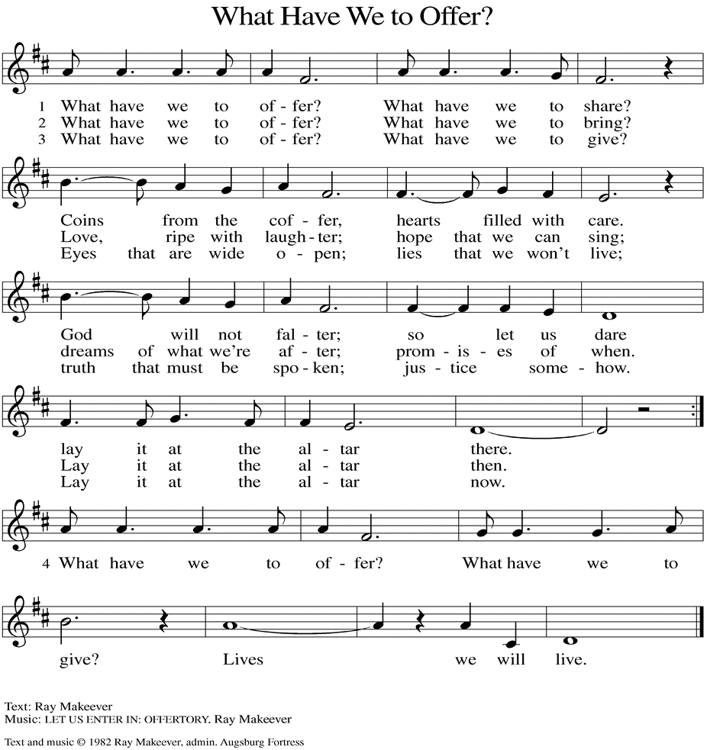
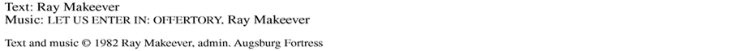

(Usher(s) brings the Tithes and Offerings up front to the Assistant.)
V. We invite you to stand as you are able.

OFFERING PRAYER
V. Let us pray,
O God, maker of heaven and earth,
your steadfast love embraces all creation.
You send rain and sunshine to nourish the earth
and bring forth its bounty.
Through these gifts of bread and wine,
draw us into the death and life of your Son,
who calls us to bear witness to his saving work.
We ask this in Jesus’ name.
C. Amen.

GREAT THANKSGIVING
V. The Lord be with you.
C. And also with you.

V. Lift up your hearts.
C. We lift them to the Lord.

V. Let us give thanks to the Lord our God.
C. It is right to give him thanks and praise.

V. It is indeed right and salutary that we should at all times and in all places offer
thanks and praise to you, O Lord, holy Father, through Christ our Lord; who rose
beyond the bounds of death and, as he promised, poured out your Spirit of life
and power upon the chosen disciples. At this the whole earth exults in boundless
joy. And so, with the Church on earth and the hosts of heaven, we praise your
name and join their unending hymn:

SANCTUS
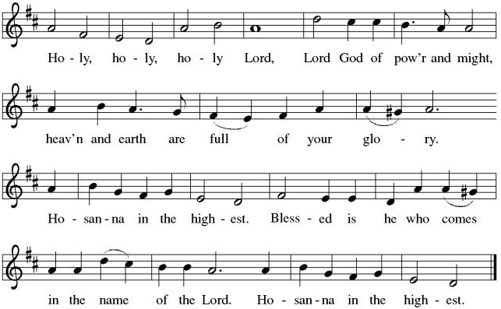

THE EUCHARISTIC PRAYER
V. Blessed are you, Lord of heaven and earth, in mercy for our fallen world you gave
your only Son, that all those who believe in Him should not perish, but have
eternal life. We give thanks to you for the salvation you have prepared for us
through Jesus Christ. Send now your Holy Spirit into our hearts that we may
receive our Lord with a living faith as He comes to us in His holy supper.
C. Amen. Come, Lord Jesus.

V. In the night in which he was betrayed our Lord Jesus took bread,
he gave thanks; broke it, and gave it to his disciples, saying:
Take and eat; this is my body, given for you.
Do this for the remembrance of me.

V. Again, after supper, He took the cup, he gave thanks,
and gave it for all to drink, saying:
This cup is the new covenant in my blood,
shed for you and for all people for the forgiveness of sin.
Do this for the remembrance of me.

THE LORD’S PRAYER
(We ring the bell throughout the Lord’s Prayer at all services to
invite those in the community to join in praying the Lord’s Prayer.)
V. May we now join with one another and pray together as Jesus has taught us.
C. Our Father, who art in heaven, hallowed be thy name, thy kingdom come,
thy will be done, on earth as it is in heaven. Give us this day our daily
bread; and forgive us our trespasses, as we forgive those who trespass
against us; and lead us not into temptation, but deliver us from evil. For
thine is the kingdom, and the power, and the glory, forever and ever.
Amen.

LAMB OF GOD

(We invite you to be seated.)

HOLY COMMUNION
V. We extend the invitation to Communion to all who are baptized and believe in
Jesus Christ.

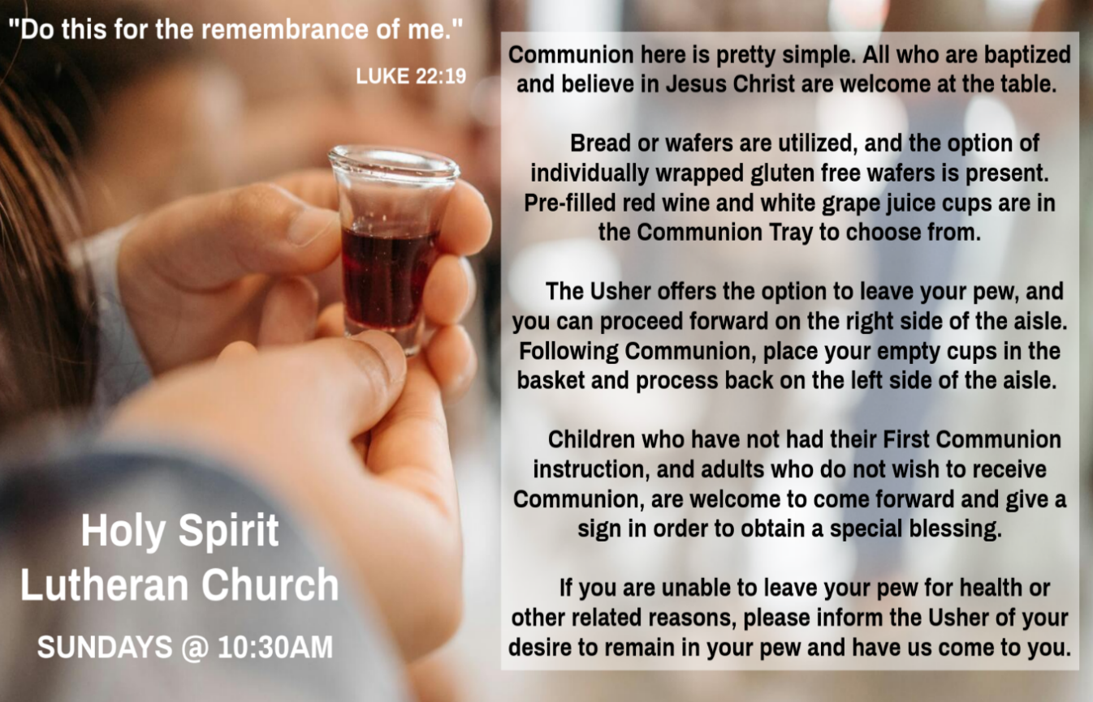

INVITATION TO COMMUNION
V. Come to the table.
Feast on God’s goodness and mercy.
C. Amen.

(Distribution of Holy Communion)

COMMUNION HYMN
(Please enjoy various music offered by our Organist during your
quiet time, prayer, and reflection following Holy Communion.)

(Vicar and Assistant remove Communion Vessels from the Altar.)

V. We invite you to stand as you are able.

POST COMMUNION BLESSING
V. May the body and blood of our Lord Jesus Christ strengthen us and keep us
always in His grace.
C. Amen.

POST COMMUNION CANTICLE
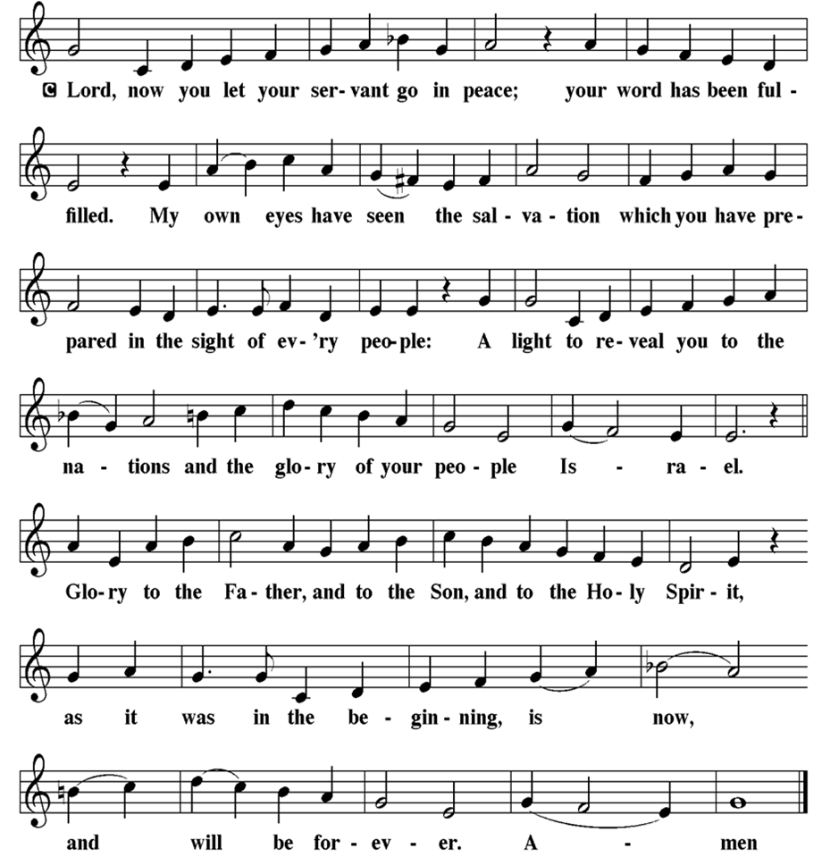

PRAYER AFTER COMMUNION
A. Let us pray,
God of our salvation,
we give you thanks for this meal that restores our souls,
reconciles us to you, and strengthens us for the journey.
Through the body and blood of your Son,
may we become Christ’s body in the world,
bearing witness to your love for all creation,
through Jesus Christ, our Savior and Lord.
C. Amen.

BLESSING
V. Receive the blessing of the holy Trinity:
God, who calls all things into existence,
Jesus Christ, who redeems us,
and the Holy Spirit, whose breath sustains creation,
☩ bless you now and always.
C. Amen.

SENDING HYMN
(We invite you to sing along.)
Lutheran Book of Worship—Green Book
92—Were You There

(Assistant extinguishes the Altar Candles half way through the Sending Hymn.)

(Vicar processes out once the Altar Candles have been extinguished.)

(We invite you to be seated.)

BIRTHDAYS, ANNIVERSARIES, & ANNOUNCEMENTS
(Offered by Assistant and Congregation.)

BIRTHDAYS
30th Joe Jost
3rd Vicki Schaller
4th Gloria Sutton

DISMISSAL
A. Go in peace. Believe the good news.
C. Thanks be to God.

POSTLUDE
(Music offered by our Organist as we depart following our Worship Service.)
And Can It Be?

LICENSES & EXPIRATION DATES
Worship Service Content is used via permission through Augsburg Fortress Liturgies Annual License #SB144368. The next Subscription Renewal Date is 2/28/2027.
Our Hymns and Worship Music are used via permission through CCLI One
License #11327166. The next Subscription Renewal Date is 1/31/2027.

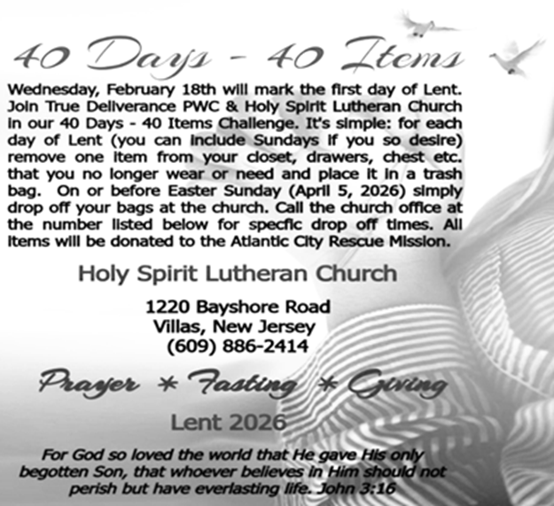


CONFIRMATION & SUNDAY SCHOOL
“Here We Stand” allows our young folks to go through a 2-year process focusing on the Bible and Luther’s Small Catechism. Classes are on Sundays from 9-10AM.

WORSHIP MINISTRY
The most important thing we do each week is gather together as God's people to Worship. God is the center and focus of everything we do. Participating in Worship is active, as Liturgy means the work and actions of the people gathered. Everything we do during the week to prepare for Worship, and everything we do as we Assist in leading Worship is important. We are thankful for all the wonderful work being done. If you have questions, or are interested in any position, reach out to Vicar Vince.
Sign-up sheets are located on the bulletin board between the church offices.

NEWSLETTER
Collect information, stories, pictures, and reports for our next publication. Everything needs submitted to Vicar Vince in-person or via email at vpie8282@gmail.com.
Your Spring Publication will be out to you soon!

BIBLE STUDY & FAITH DISCUSSIONS
Bible Study & Faith Discussions focuses on various readings, books, Bible verses, people of faith, and other general topics. Group Members offer various points of view while being respectful and supportive of one another. Join us on Tuesdays at 6PM.
SPECIAL BULLETIN ENTRY DEADLINE
The Bulletin will be printed on Wednesday during special Church Office Hours. Changes need submitted to Vicar Vince no later than Wednesday by 4PM. Thanks!

SPECIAL CHURCH OFFICE HOURS
Open Wednesday from 6PM to 8PM during special Hours due to Holy Week.
It is open to serve the Congregation, the Community, and to handle the business
of the Church. Feel free to stop in to talk, pick-up or drop off something, pray in
the Sanctuary, or for whatever reason.

FOOD PANTRY
Open every Thursday, and the last Saturday of every month, from 10AM to 1PM. 106 people were served in February and 240 people have been served in 2026. Donations can be dropped in the outdoor drop-box, in the money jug in the back of the Church, mailed into the Church Office, or placed in the Offering Plate. Volunteers are needed. Sign-up sheets are located on the bulletin board between the church offices. If you have questions or need training see Heather, Vicar Vince, or Bonnie.
A special thank you goes out to all who donate, pray, and help in any way!

Thursday, 4/2 | Thursday, 4/9 | Thursday, 4/16
Garnet & Joe | Garnet & Joe | Volunteers Needed

COMMUNITY FOOD DONATIONS, DELIVERIES, & MORE
North Cape May Acme provides us with Expiring, Recently Expired, and Slightly Damaged Food and Items. Kathy delivers on Saturdays in the community, brings items to church and the food pantry, and to the Branches Outreach in Rio Grande.

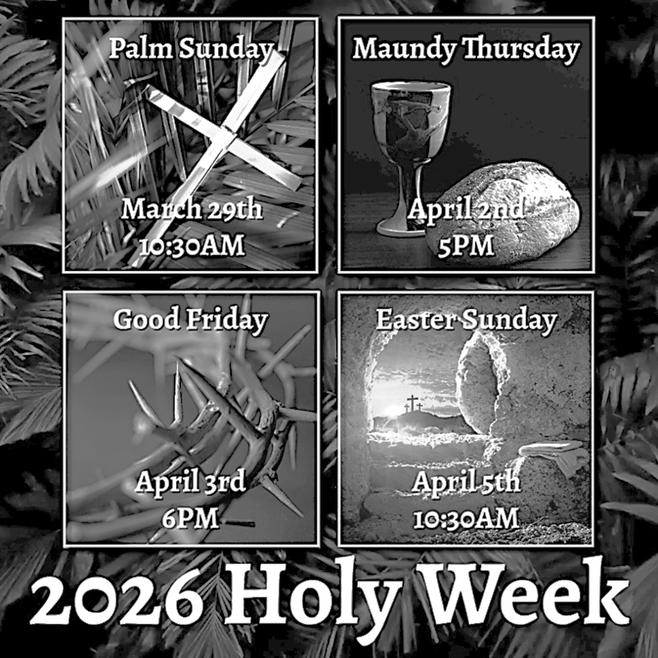
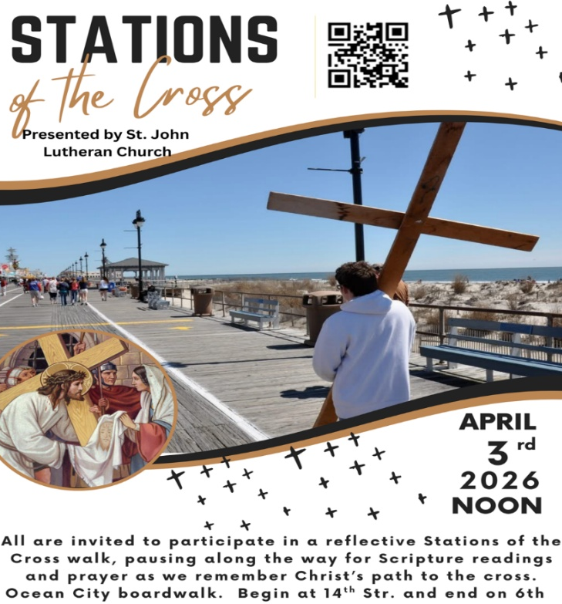

EASTER VIGIL INVITATION
Father Marcel has extended an invitation again this year to celebrate the Easter Vigil together. Please consider joining us at St. Simeon’s By The Sea in North Wildwood, on Saturday, April 4th, at 5PM. Vicar Vince will assist with various points of the service. Vicar Ken from Holy Trinity in Wildwood will be delivering the Sermon. Please see Vicar Vince with any questions, or to confirm your interest in attending.

DONATION STATION
Get on the train and place all purchased items in the specified project donation bins located on the counter by the front doors. See Heather for more information.


WOMEN OF THE CHURCH
Their next meeting is on Monday, April 6th, at 6PM. New members are always invited and welcome to attend! Contact Judy for more information.

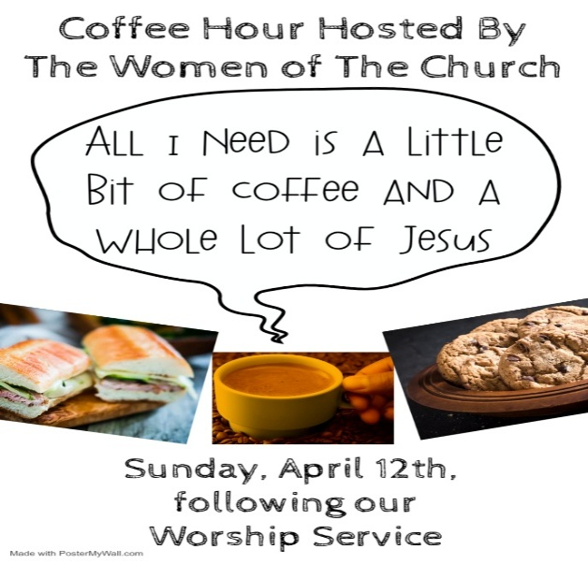

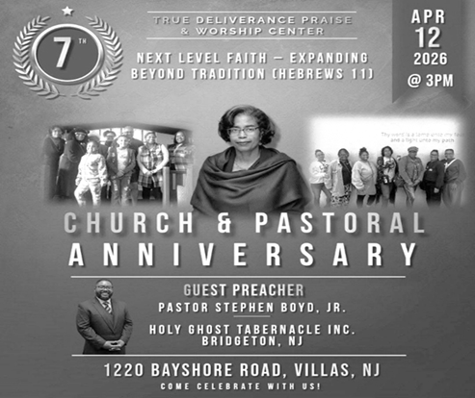
What a blessing it has been to have TDPWC as our Church Family and Ministry Partners. 7 years and many more to go! Congratulations and many more blessings to this Congregation! Come join us on this special day!

CHURCH COUNCIL
Share your comments, concerns, questions, or joys with one of our Church Council Members who can bring them back to our meetings. Visitors are always welcome to attend and listen to what is going on in and around the church. Join us In- Person or on our Conference Call at our next Meeting on Tuesday, April 21st, at 6PM.


SPECIAL PREACHER
Chip Hand is looking forward to Preaching on Sunday, April 26th, as Vicar Vince will be back in Pittsburgh for a few days for the NFL Draft and some vacation time. Please be aware that there will not be Holy Communion this Sunday as a result.


Our NJ Synod Assembly will be on Saturday, May 30th, 2026. Wayne & Judy are attending with Vicar Vince. Registration will need completed and paid for soon.


Confirmation is a journey of faith filled with new questions and answers, new discoveries, new relationships, new responsibilities, and new possibilities. Clearly confirmation is intended to be a milestone, not a destination; it is not graduation! Rather, Confirmation is a tool that equips for the life-long process of living out Christian identity. Traditionally we would be celebrating Confirmation on Pentecost Sunday. However, due to it falling on Memorial Day Weekend, and the schedules of our young folks, we will be moving it to Sunday, June 14th, during our 10:30AM Worship Service. Please come out and join Caylee Thomas and Robert Thomas on this special day and celebrate with them at the Coffee Hour afterwards.

INTERESTED IN BECOMING A NEW MEMBER
Have you been attending our church for a while? Have you just recently returned to church after being away for a bit? Maybe you transitioned from another church, or just started to recently attend our church. We are glad to have you, and would love to have you as a member of our Congregation. We are looking forward to having new member classes in the near future. Please stay posted. Feel free to ask Vicar Vince any questions or for more information as well.

CHURCH DIRECTORY
2026 Church Directories are by the Church Office on the bookshelves. We continue keeping it updated, but we undoubtedly miss a few changes or have made a few errors. Please inform the Church Office of updates or changes to keep us up to date.

TITHES, OFFERINGS, & ENVELOPES
We worship God with our tithes and offerings. We hear in scripture, “Each of you must give as you have made up your mind, not reluctantly or under compulsion, for God loves a cheerful giver.” (2 Corinthians 9:7) Envelopes can be dropped in the offering plate, mailed to the church, or dropped in the locked mailbox. Thanks for your support in the mission of our church, its ministries, the NJ Synod, etc!

SPACE AVAILABLE
​​​​​Interested in utilizing our Fellowship Hall for a Party or Event? There is a suggested $50 refundable security deposit, and it is $250 for facility use. No alcohol or games of chance permitted due to ELCA policy. Please contact Vicar Vince for more info.

ED GREEN CAPITAL IMPROVEMENT FUND
We continue to raise money for any unforeseen costs or repairs. We are currently exploring a new Annual Fundraising opportunity where we will be handing out coffee cans to raise money at home. We also have the donation bin in the back of the church. Thanks for your continued prayers, support, and donations!

HOME COMMUNION MINISTRY
A Minister is available if you have a loved one, or if you desire services. We look forward in sharing the Word and Holy Communion! Please inform Vicar Vince, Kathy, or the Church Office so plans can be made for visits.
PRAYER SHAWL MINISTRY
Prayer Shawls, Lap Quilts, Scarves, and other items have been made with love. Blessed items are located in the Narthex, and are free for anyone. Members of the group continue working at home on new stitches and patterns. We are blessed to be able to continue collecting new items. We have a donation station of yarn and other items located in the Narthex. You can find some new supplies for your next creation!

PRAYER LIST
Our Prayer List continues to lengthen and we realize the important need for prayers and healing. Sometimes the unfortunate result is that someone has passed away, and the words “The Family & Friends of” appear before someone’s name. However, sometimes we forget names are still on the list and their health has improved and they can be removed. Please share various stories as we continue to pray for strength and healing. Names can be added or removed from the list on the clipboard in the Narthex prior to the Worship Service, by calling the church office, or addressing it on the Conference Call. Please let us know the relation to the person(s) you listed so we can be more mindful with our prayers.

LIBRARY
New books are added to our library from time to time. Several are borrowed and read and exchanged. Who knows, you might find one particularly interesting and share that with someone. Reading is a great way to pass spare time, learn, and explore. You may find some fresh ideas for prayer, ways to grow more spiritually, ways to grow closer to God, or some opportunities to understand our faith more. We have an extended library located in Vicar Vince’s office. There are Bibles of various translations, books from his personal collection, books inherited from Pastor Leah, movies, past Bible Study Curriculums, and more. Come check things out.

FAVORITE HYMNS
Carol is willing to play some of your favorite hymns for the Prelude & Postlude each Sunday during our Worship Service. Feel free to let her know of your suggestions.

BAPTISM
We are a church whose unity is in Jesus Christ, who gathers us around word and water, wine and bread. Baptism is a significant part of our faith journey as we come from the baptismal waters to live a new life as children of God. Our baptism sets us out on a lifelong journey that is characterized by our relationship to God, our relationship to our faith community, our relationships in our community and the wider world. Living our baptismal covenant means living a life of growth in the faith practices of discipleship. Please see Vicar Vince for more information.
FIRST COMMUNION
Although no particular age for first communion is prescribed by The Use of the Means of Grace, one guideline is offered. Because admission to the Sacrament is by invitation of the Lord to the baptized, "baptized children begin to commune on a regular basis at a time determined through mutual conversation that includes the pastor/vicar, the child, and the parents or sponsors involved, within the accepted practices of the congregation.” Each congregation is encouraged to ask the question of readiness for first communion, establish their own policies regarding age and practice, and accompany that practice with catechesis appropriate to the age of the communicant. If anyone has questions, please see Vicar Vince.

VICAR APPOINTMENT ON MARCH 19TH, 2023
A Memorandum of Understanding on the Matter of Pastoral Appointment
In Theological Education for Emerging Ministries (TEEM) Candidacy
TO: Congregation Council, Holy Spirit Lutheran Church, Villas
FROM: The Rev. Tracie L. Bartholomew, Bishop, New Jersey Synod

Dear Brother and Sisters in Christ,
This memorandum is in support of your discussions with Vincent Piekarski as pastor of Holy Spirit, Villas. Because this is not the usual pattern for completing the educational and candidacy requirements for ordination, it is my hope that this memorandum will both provide guidelines and engage in conversation with those who are invested in this process.

I would say at the outset that because Vincent is an outstanding candidate for the Ministry of Word and Sacrament, we will all want to do whatever is necessary to assure that his placement serves the mission of the church in the best possible fashion.

The following notes reflect my own understanding of this matter:
(1) The appointment for Vincent will begin on April 1, 2023. At this time, Vincent
will assume all responsibilities of a regularly called pastor, including presiding at
the Sacrament of Holy Communion and Baptism at Holy Spirit, Villas.
(2) A pastoral appointment in the TEEM process is an option for completing
seminary educational requirements and the steps of the candidacy process.
Upon completion of the candidacy process and seminary education, the
candidate may receive and accept a call to ordained ministry from the
congregation where the appointment is being served.

(3) This appointment is jointly supervised by the Office of the Bishop and the TEEM
pastor’s seminary. A mentoring relationship with a local pastor is required for the
length of this appointment.
(4) The synod of candidacy origin will be responsible for the approval process.
(5) Upon approval for ordination, the congregation would be expected to extend a
call to the pastoral appointee.
(6) Compensation for the TEEM pastor will be according to the guidelines of the New
Jersey Synod. All normal forms of compensation should be in place for the term
of the appointment, including stipulation that base salary and housing shall be in
accord with synod guidelines for first call at time of ordination.
(7) The ELCA Portico benefit plan for lay persons in full-time church service should
be used for the pastoral appointee up to the time of ordination, whereupon the
benefit package is to be converted to the plan for ELCA clergy.
(8) A decision for Pastoral Appointment is made with the agreement of a synod and
its candidacy committee, and the ELCA, normally represented by the regional
staff person of each in consultation with the seminary and its Director for
Contextual Education.
(9) Pastoral Appointment in a TEEM Candidacy is an option that is to serve the
mission of the Church in a particular and vital way and is not to be viewed or
used as a means to circumvent the normal candidacy process and/or first call
placement process.

In the specific case of Vincent, the New Jersey Synod remains responsible for the candidacy and approval process, and has agreed to this proposal for Appointment at Holy Spirit, Villas.

Continued blessings to both Holy Spirit and Vincent Piekarski as you embark on this journey of mutual ministry. As partners in ministry, we walk with you and rejoice in this new relationship.

VICAR VINCE’S DAY OF REST
A day of rest can have physical, mental, and spiritual benefits. “Mittwoch,” German for mid-week, or Wednesday, is the day that Vicar Vince will use to recharge and do some other things. Please do not hesitate to reach out if there is an emergency!

VICE PASTOR UPDATE
Pastor William Hodgetts continues to attend our Church Council Meetings
and provides Supervision and Support to Vicar Vince.

2026 FINANCIAL STANDING
FEBRUARY INCOME | $8,570.00
FEBRUARY SPENDING | $6,702.26
FEBRUARY GAIN OR (LOSS) | $1,867.74
2026 INCOME | $11,480.00
2026 SPENDING | $12,124.07
2026 GAIN OR (LOSS) | ($644.07)
ED GREEN CAPITAL IMPROVEMENT FUND | $2,958.55
FOOD PANTRY FUND (SOCIAL MINISTRY) | $13,515.13
CD | $26,414.45

WHAT IS THE EVANGELICAL LUTHERAN CHURCH IN AMERICA?
The ELCA was formed in 1987 by the merger of three Lutheran Church bodies –
the ALC (American Lutheran Church), the LCA (Lutheran Church in America), and the AELC (Association of Evangelical Lutheran Churches). Learn more at elca.org.

NEW JERSEY SYNOD
The New Jersey Synod is a geographical grouping of Evangelical Lutheran Church in America (ELCA) congregations that share the mission and ministry of the Church on the New Jersey territory. It is one of 65 synods in the ELCA. The NJ Synod is comprised of 143 congregations, which include over 45,000 baptized members.

JERSEY JOTTINGS
There is a weekly e-newsletter connecting our synod together with weekly prayer, upcoming events, synod and churchwide activities, mission stories, congregational activities, & more. Download the app or sign up at www.njsynod.org/stay-connected.

TRUE DELIVERANCE PRAISE & WORSHIP CENTER
TDPWC utilizes our facilities from 1-4PM on Sundays. TDPWC hosts or assists with other events. TDPWC hosts a Prayer Line on Mondays, Wednesdays, & Fridays at 5PM on the Conference Call 1-657-390-7957; & Bible Study on Thursdays at 6:30PM on Zoom. See Rev. Brooks for more information.

JUST FRIENDS
The group promotes a spirit of fellowship among adults 50 years and older. Bring your own lunch, beverages and deserts are provided. Everyone is welcome. The group meets in Our Lady Star of The Sea Parish Hall on the last Wednesday of the month from 12Noon to 2PM from September through May. For information, please call Martine Simonis 609-884-5312 x 110.
ADDITIONAL OFFERINGS FROM OUR FRIENDS & NEIGHBORS
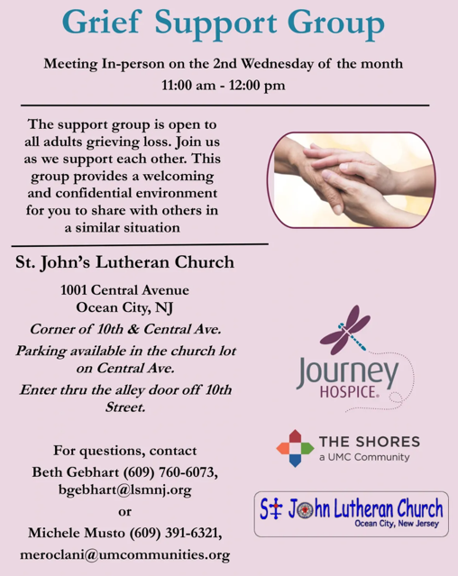

CHURCH STAFF & VOLUNTEERS
VICAR
Vicar Vince Piekarski
VICE PASTOR
Pastor William Hodgetts
ORGANIST & PIANIST
Carol Amundsen
CHURCH OFFICE, SUNDAY SCHOOL, & FOOD PANTRY
Heather Piekarski
CHURCH COUNCIL PRESIDENT & CHURCH PROPERTY
Wayne Rand
CHURCH COUNCIL VICE PRESIDENT & WOMEN OF THE CHURCH
Judy Brannan
CHURCH COUNCIL TREASURER
Bonnie Millard
CHURCH COUNCIL SECRETARY
Vicki Rinier



