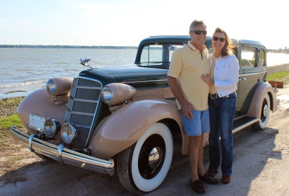
Real Restorations
By Pistorius Collectible Autos
This part of the restoration is my favorite, assembling the car. Now all the hard work you have done to get here is going to pay off.
Steps to take:
- If you have a frame off restoration, assemble your running chassis first. Pay close attention to the places on chassis and other areas where electric connections will be grounded. Make sure these areas are free of paint and/or powder coating.
You had to start your engine if it wasn’t bench tested before. It is easier to work on your engine before final assembly.
- Put the body on the chassis. Run all electric and pipes on body as required.
- Install the dash and gauges.
- Install your headliner, but make sure your dome light works before doing this!
- Fit all doors and install door windows and other windows and windshield. Make sure all moving parts are well lubricated. Pay special attention to linkages and rods inside doors and the rest of the car for rattle prevention. Open and close doors, hit on and around the interior window panels with your hand to make sure that there are NO rattles before you close everything up.
- Fit all exterior trim work that will require fastening from the inside.
- Fit all door panels and other interior panels that can be fitted before laying carpet. Special Note: Make sure if your car requires slotted screws that you leave them in line to form a straight. Pay special attention to all exposed screws and bolts and nuts for correctness or at least uniformity. It is time to take a break! Step back and enjoy the results of your efforts thus far!
- Lay your carpet only after everything inside is completed. Finish installment of the rest of the panels.
- Make sure any adjustable parts are moving freely and are lubricated before you fit the seats.
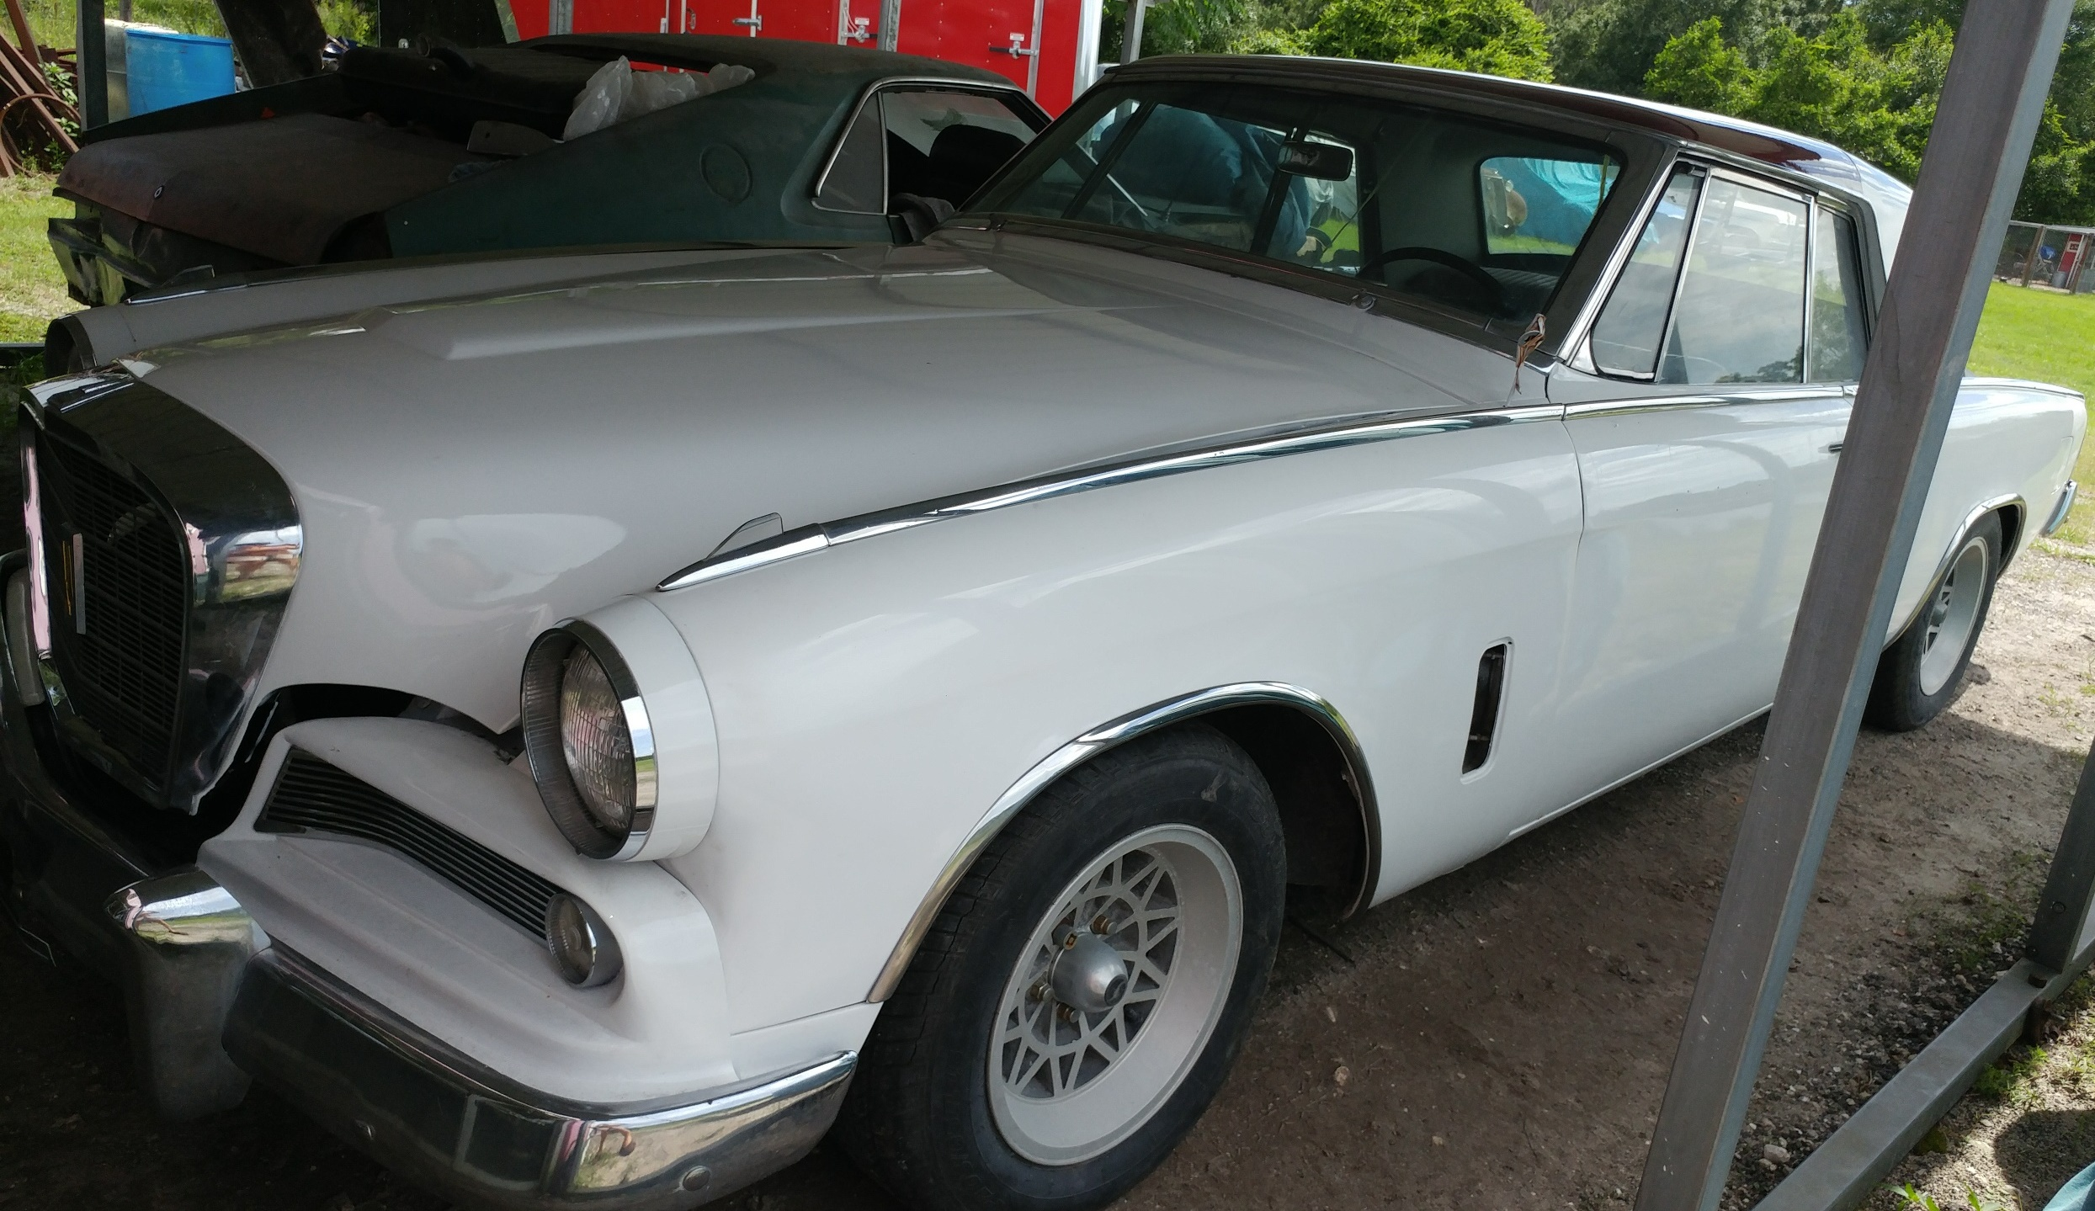
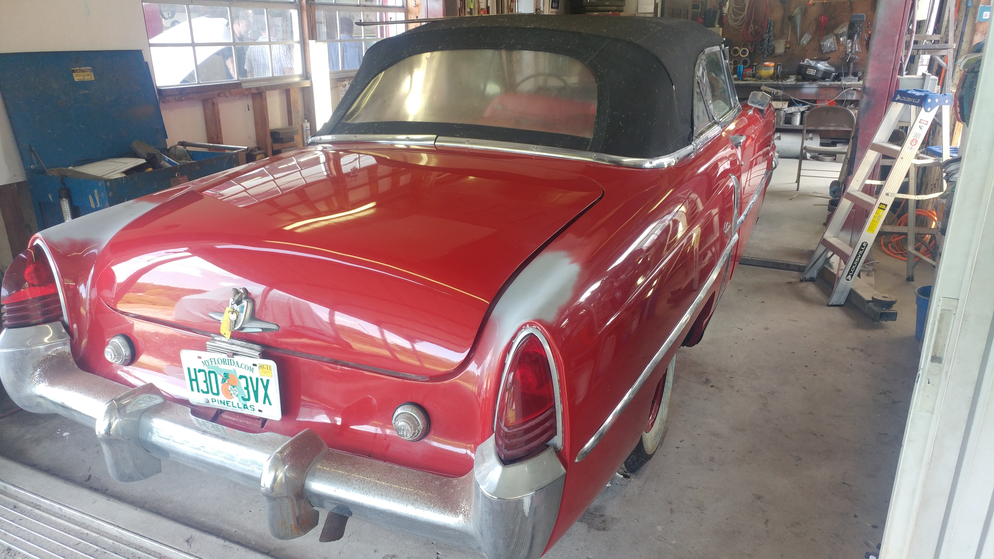
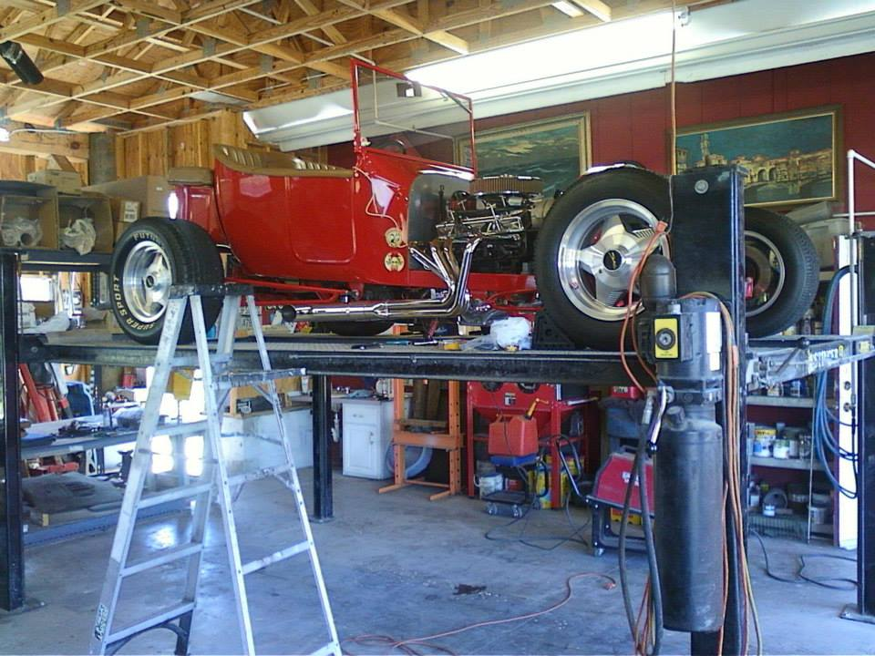
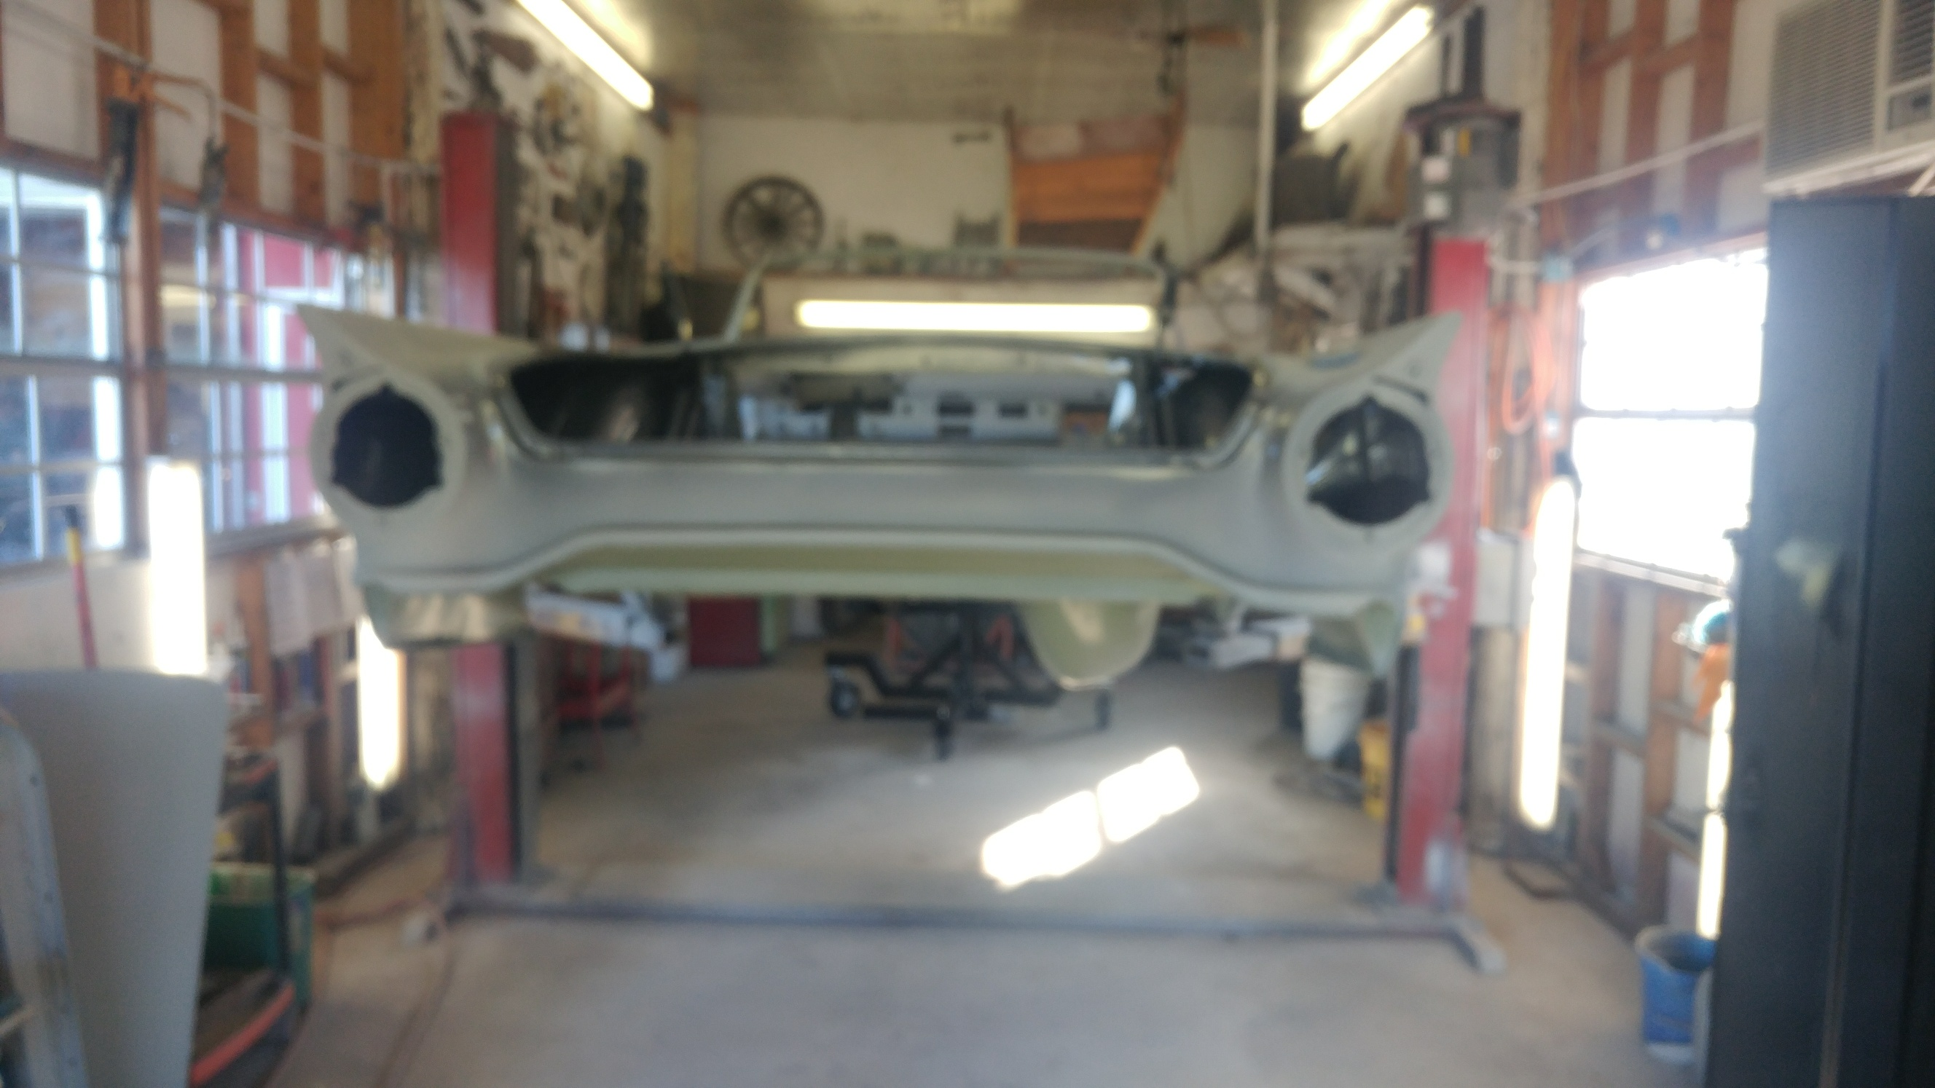
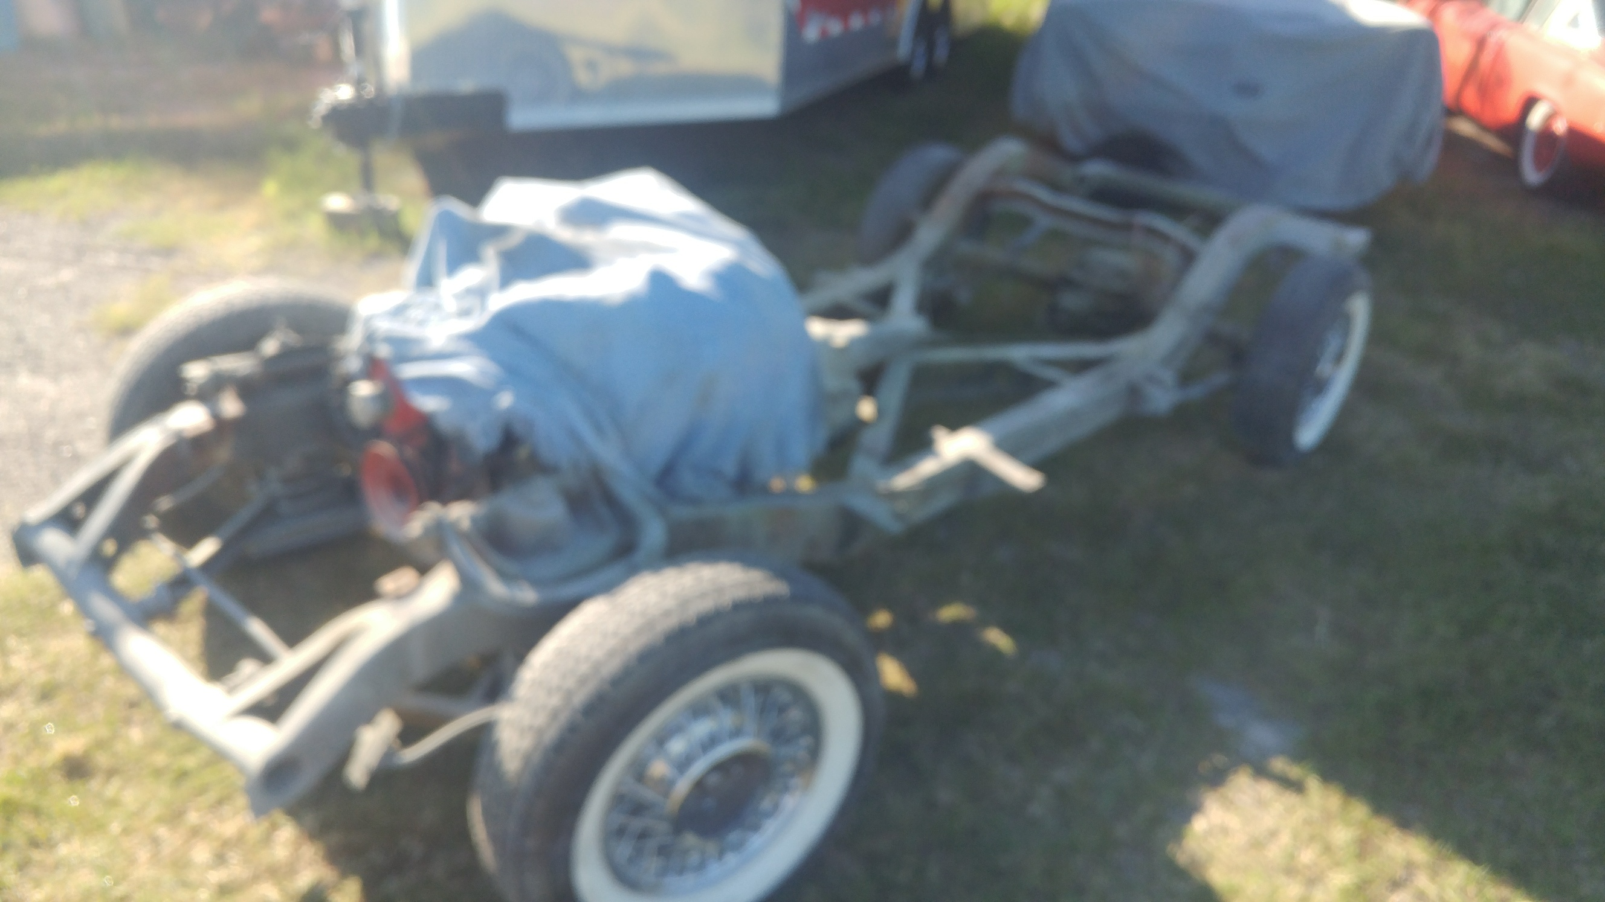

Next month the final assembly of your car! Cheers! Brando & Joanne Pistorius

