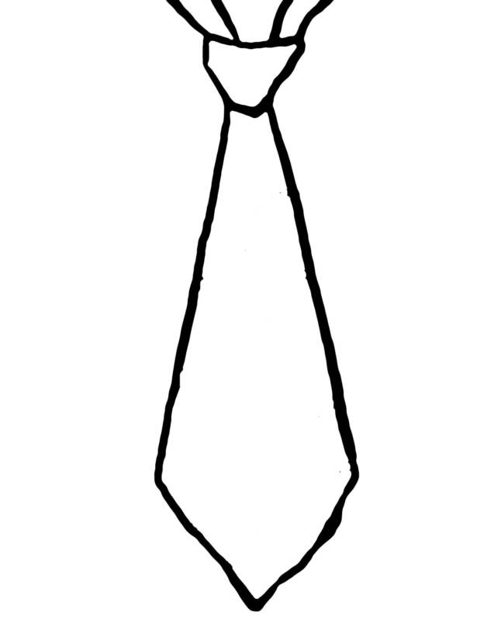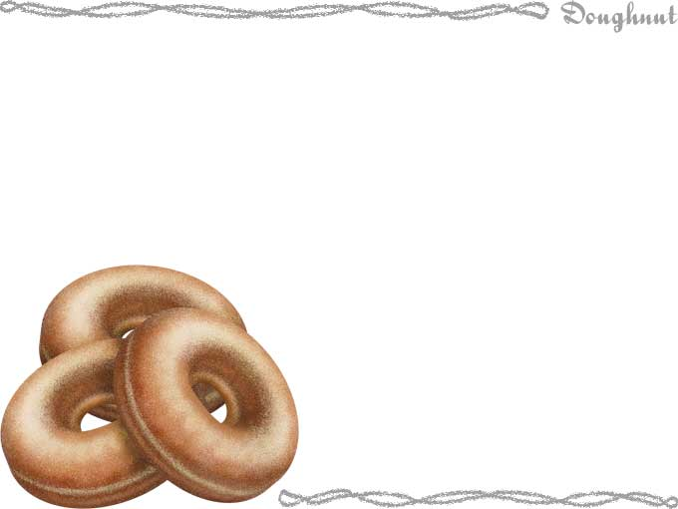

**Time**

TO

THE

DAD IN

MY LIFE:

I know

you’re

*really*

busy, but could you ***pleeeease***

come have breakfast

with me at School? It would mean the world to me.

Love,

**Date**

Kids

1. Sign the tie.

Give to Dad (Grandad, brother, uncle).

Adults

1. RSVP.

2. Cut out tie.

3. Attach string.

4. Wear to Dads & Donuts.

5. Watch your kid smile!

**__________________ School PRESENTS**

**RSVP:**

**Save My Donut!**

Adult________________

Student______________

Grade______

Teacher_____________

*Return by ____________*